Diwali Giftings from Four Seasons Hotel Bengaluru

Celebratory hampers for the festive season
October 11, 2022, Bengaluru, India

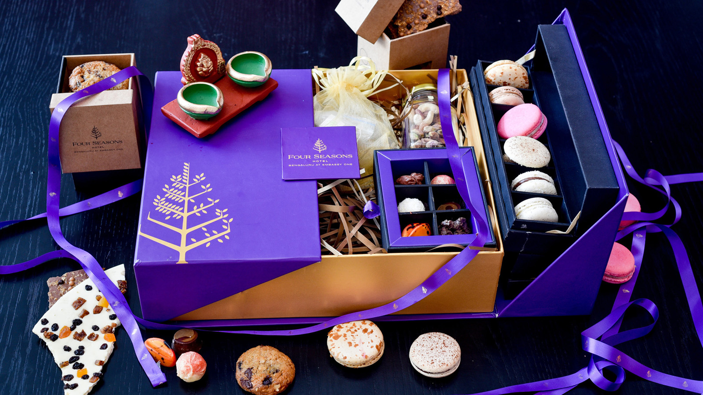
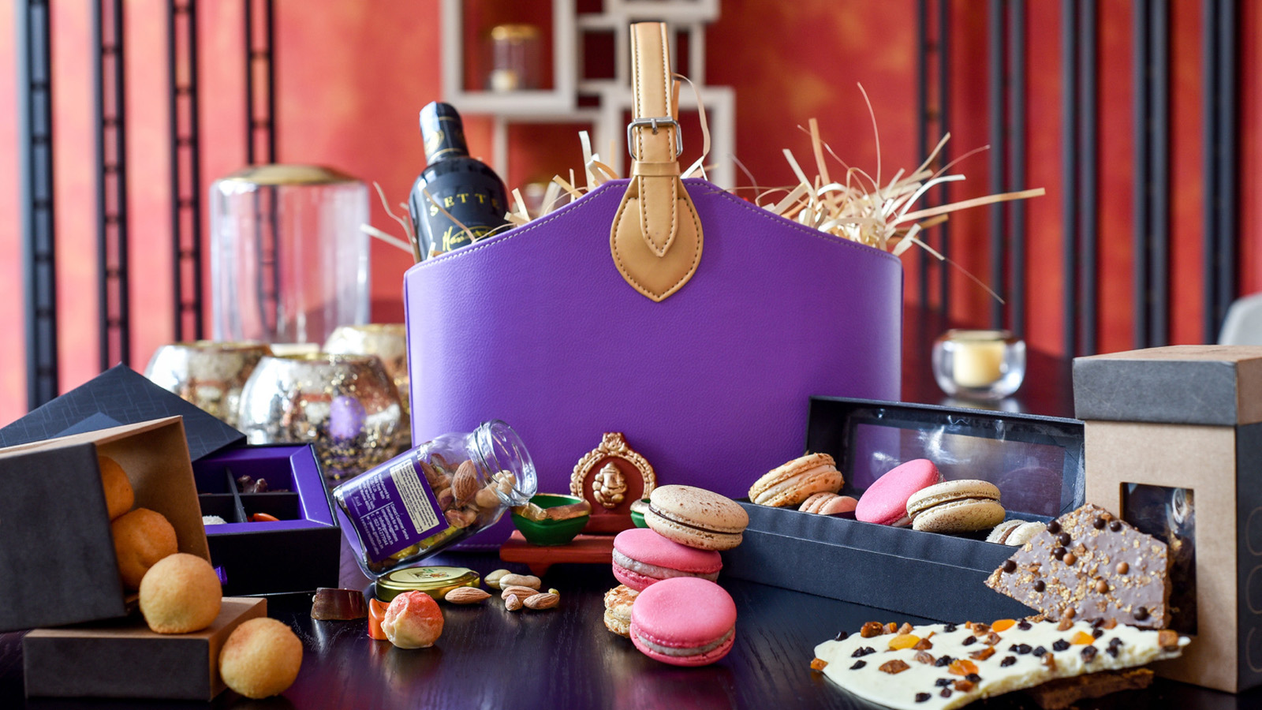 | 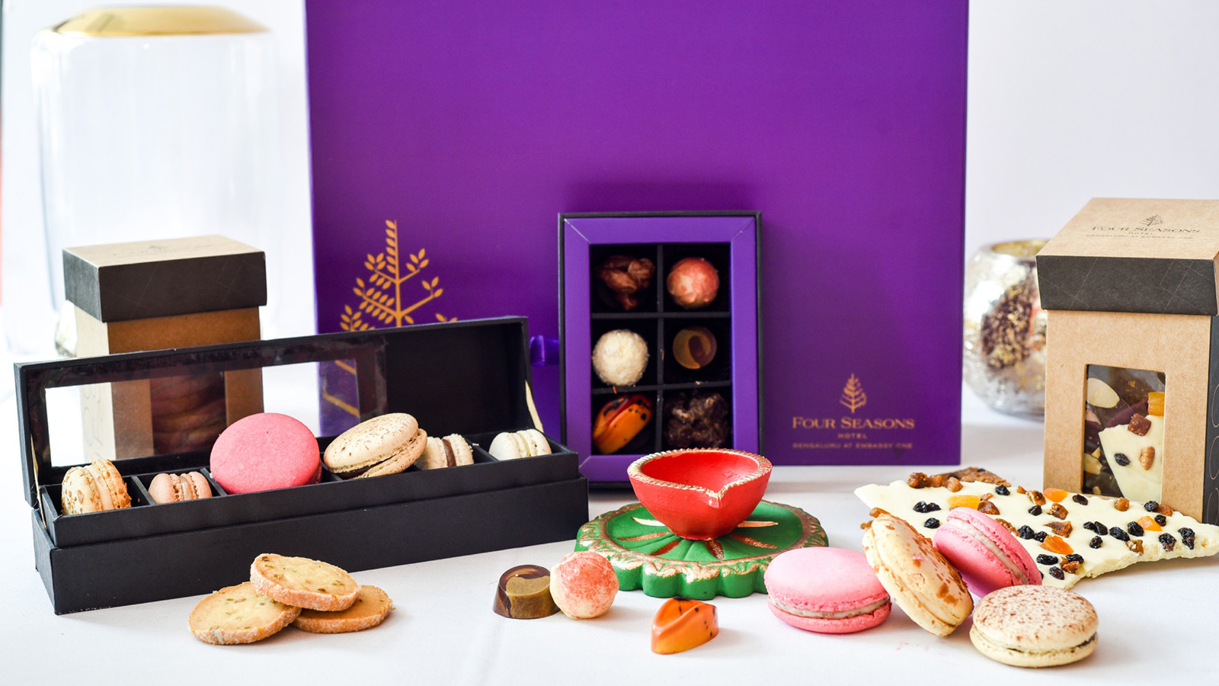 | 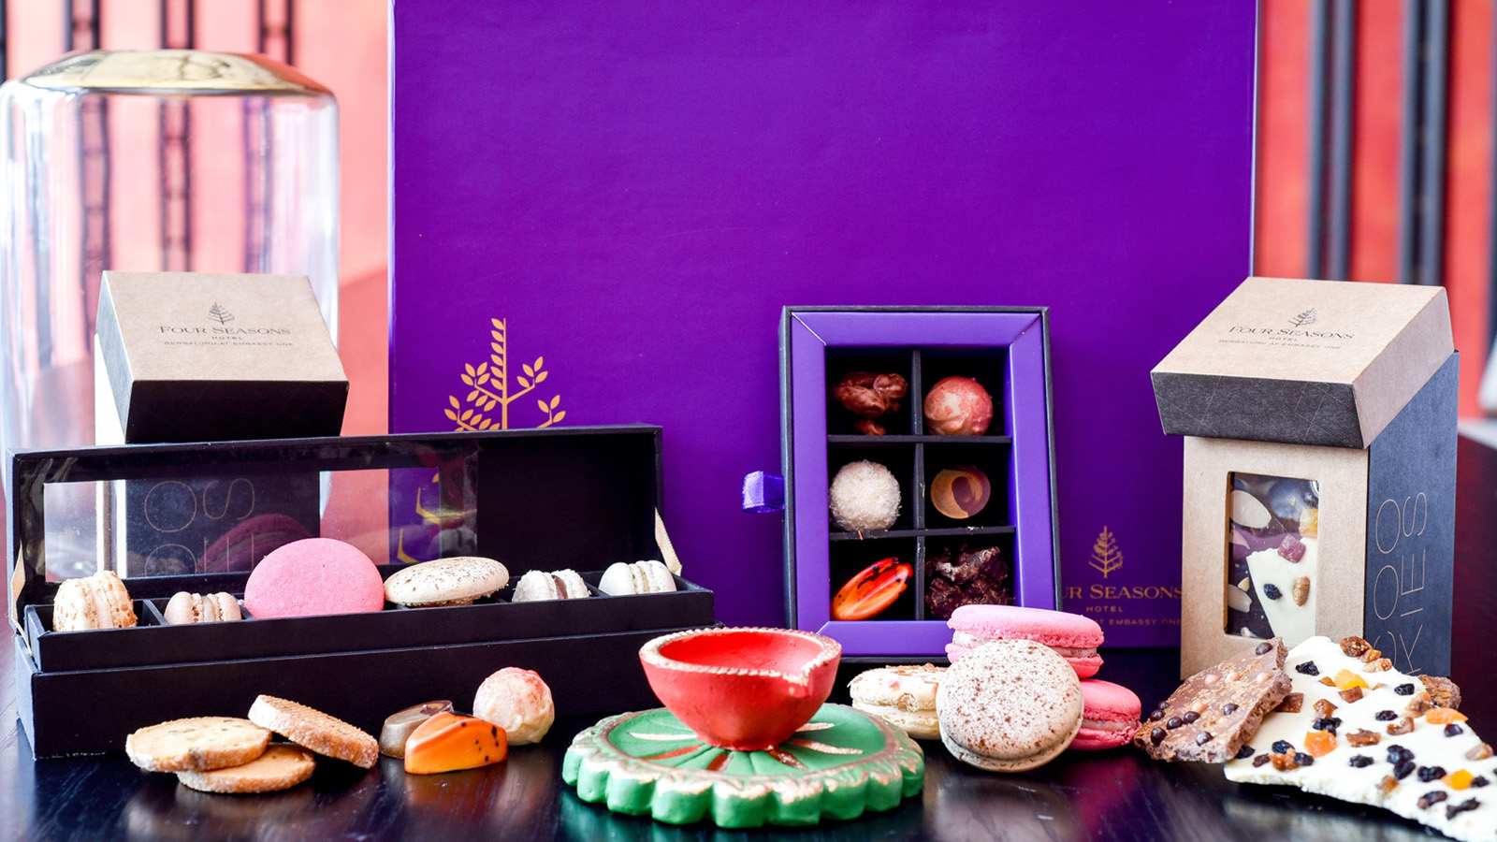
Diwali, one of the grandest celebrations in the Hindu culture, is celebrated with an exhilaration, at the heart of which is giving and receiving gifts.
The quintessential thought is that of the triumph of good over evil, with the lighting of the diyas, which signify the eradication of all obstacles. Family and friends gather and a spirit of jubilation inspires the ritual of exchanging gifts, sweets and other deliciousness.
As a customary tradition and to wish patrons luck and prosperity in the coming days, chefs at Four Seasons Hotel Bengaluru have curated selections of sweet treats.
A line-up of festive hampers, replete with homemade goodies are up for sale until Diwali.
Silver
In a beautiful festive packaging, this hamper is an elegant offering of deliciously fragrant, cardamom flavoured nankhatai cookies, macarons, Indian mithais and savouries such as namakpara, festive gujiyas, a single origin Valrhona chocolate bar and a decorative diya.
The Silver Hamper is priced at INR 3500 + taxes.
Gold
A sumptuous selection of cookies, mignardines, handcrafted macarons in flavours such as Chennai filter coffee and dharwad rose, gourmet Indian mithai range, loose leaf teas, and a beautiful terracotta diya, an emblem of Diwali, this box has a veritable hallmark of quality about it. A locally inspired saffron travel cake, assorted Indian savouries such as methi mathi and namakpara along with the customary gujiya lend their own special touches. A gourmet jar sampler, Valrhona chocolate bar and salted almond spread add an interesting and exotic touch.
This year’s special is the organic Ganesha idol made of terracotta and seeds, which can be replanted into a sapling; a veritable nod towards sustainability.
The Gold Hamper is priced at INR 5000 + taxes.
Diamond
This Hamper selection is the perfect gifting option, and a tad on the generously abundant side. Replete with delicious cookies, macarons in delicious flavours such as Chennai filter coffee, rose and Kerala coconut, the season's staple gujiya, selection of mithais and savouries such as methi mathi and namakpara, collection of loose-leaf teas, salted almond spread, a bottle of lush red wine, and a handpainted terracotta diya.
The Diamond Hamper is priced at INR 6500 + taxes.
Platinum
This opulent hamper selection is the last word on luxury gifting. Bursting with handcrafted goodies, it will have an indulgent bottle of imported wine to enjoy during the festivities.
The Platinum Hamper is priced at INR 10,000 + taxes.
Gift Boxes
A blend of handcrafted traditional Indian mithais and macarons with local infusions can be curated in assorted gift-ready boxes.
Choose from well-loved Indian confections such as kaju khas khas roll, gulkand peda or a decadent mawa dry fruit glory. Light and airy macarons with local infusions of rose, coconut or coffee make for indulgent treats.
Here are some delicious options:
- Box of Nankhatai Cookies (cardamom flavour), 200 g, INR 500
- Indian Artisanal Mithais, Mignardines (9 pcs) INR 700
- Macarons 6pc(Flavors- Chennai Filter Coffee, Dharwad Rose, Kerala Coconut), INR 700
- Macarons 12 pc (Indian Flavors- Chennai Filter Coffee, Dharwad Rose, Kerala Coconut), INR 1300
- Gujiya 200Gm (Pistachio, Almond and Mawa), INR 500
- 55% Single Origin Cinnamon Valrhona Chocolate Bar, 120 g, INR 600
- Saffron Travel Cake 500 g INR 700
- Saffron Travel Cake 750 g INR 1000

RELATED

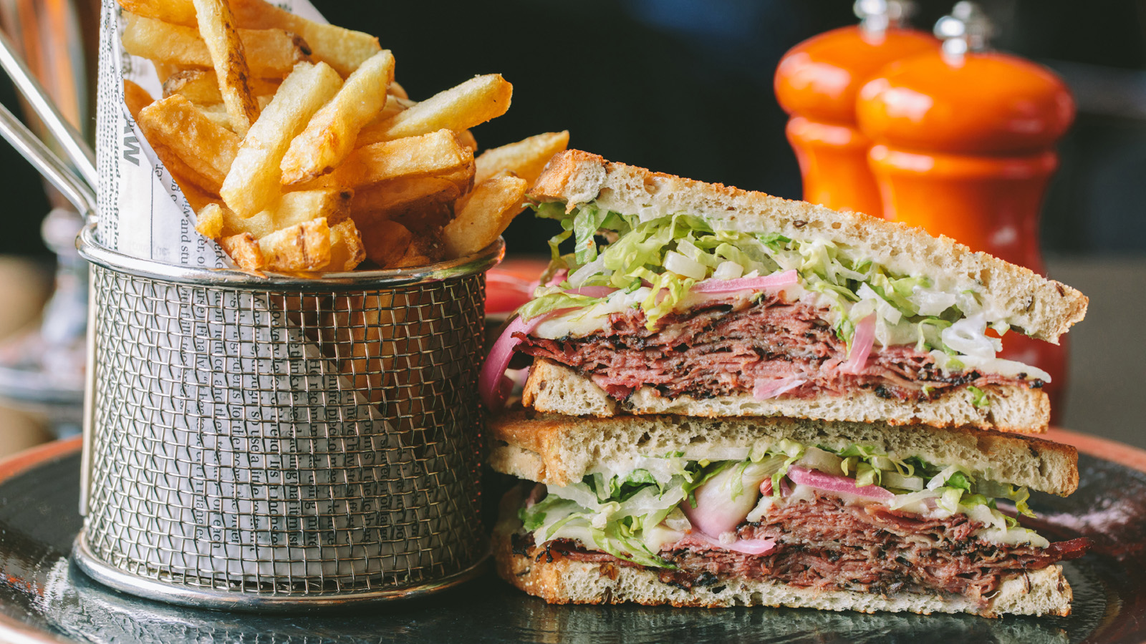 | October 3, 2022, Bengaluru, India  Gourmet Sandwiches at Four Seasons Hotel Bengaluru  https://publish.url/bengaluru/hotel-news/2022/gourmet-sandwich-menu.html
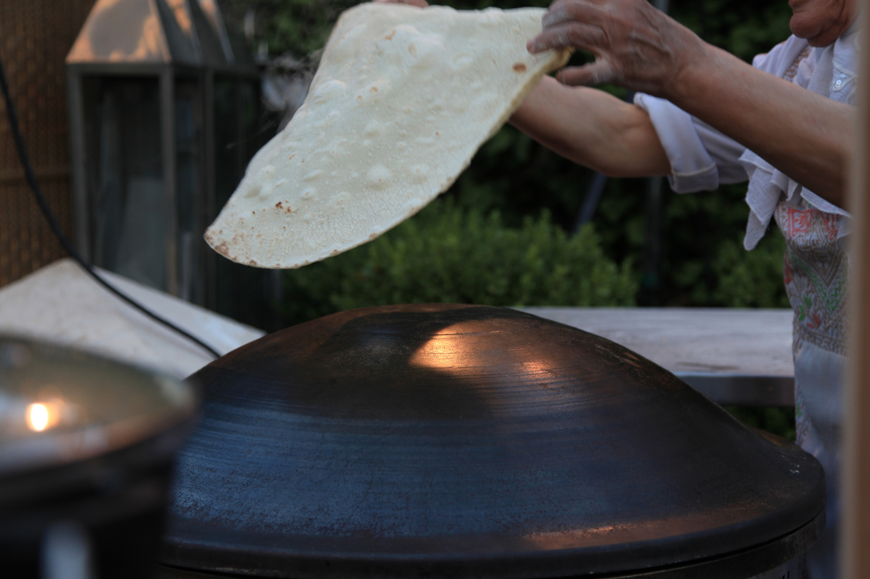 | September 23, 2022, Bengaluru, India  Grand Trunk Road Specials at Four Seasons Hotel Bengaluru  https://publish.url/bengaluru/hotel-news/2022/grand-trunk-road-dining-promotion.html

PRESS CONTACTS

Gargi Guha
Director of Public Relations
8, Bellary Road, Ganganagar
Bengaluru
India
gargi.guha@fourseasons.com

+91 80 4522 2222

