Four Seasons Resort Hualalai Announces Hawaiian Iliahi (Sandalwood) Farm and Spa Experience

The latest "Only at Hualalai" exclusive experience takes guests on a spiritual journey to a native Hawaiian iliahi farm followed by a sound bath and healing spa treatment
June 12, 2019, Hawaii, Hualalai, U.S.A.

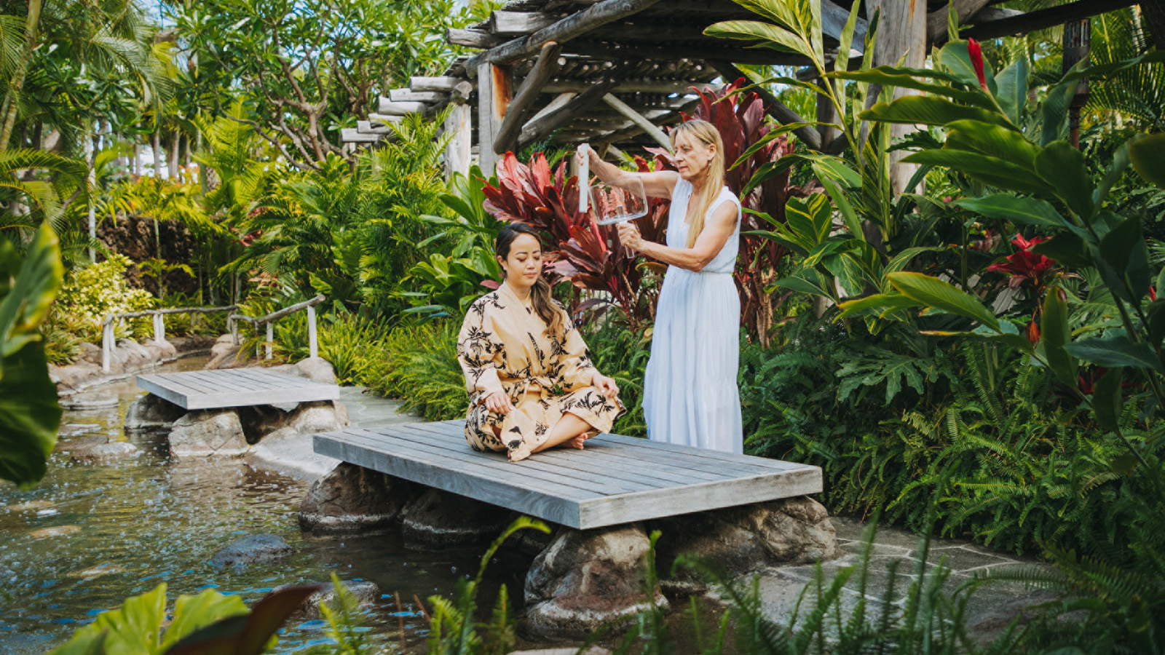
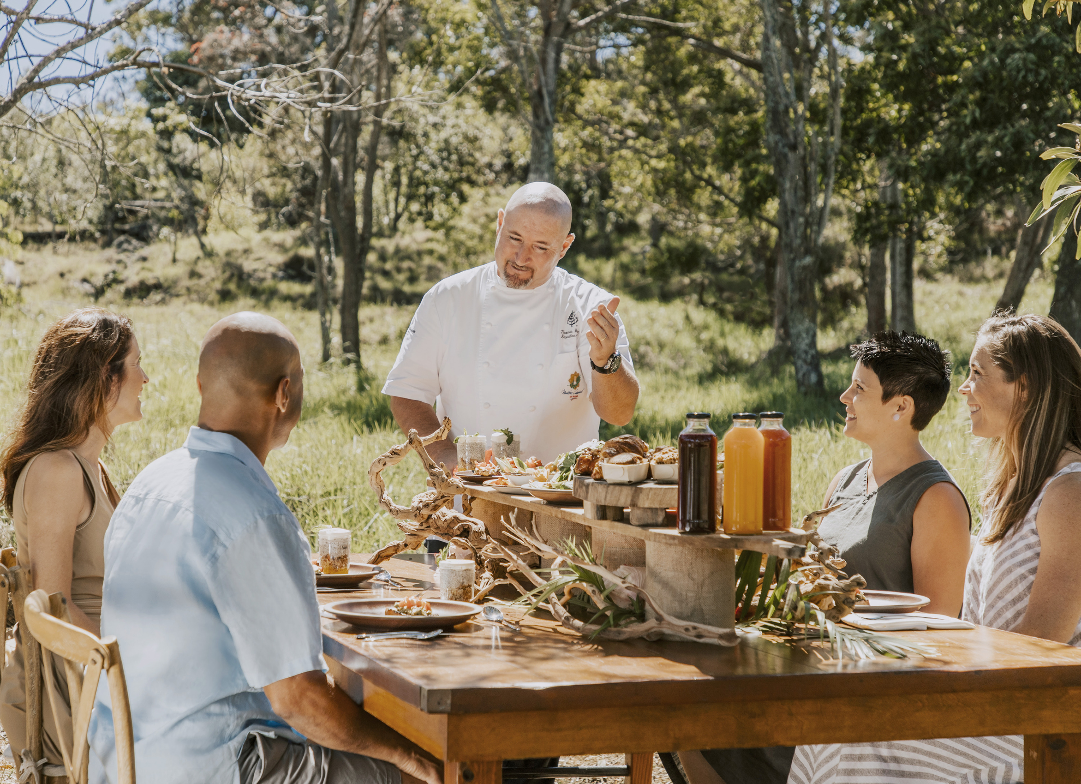 | 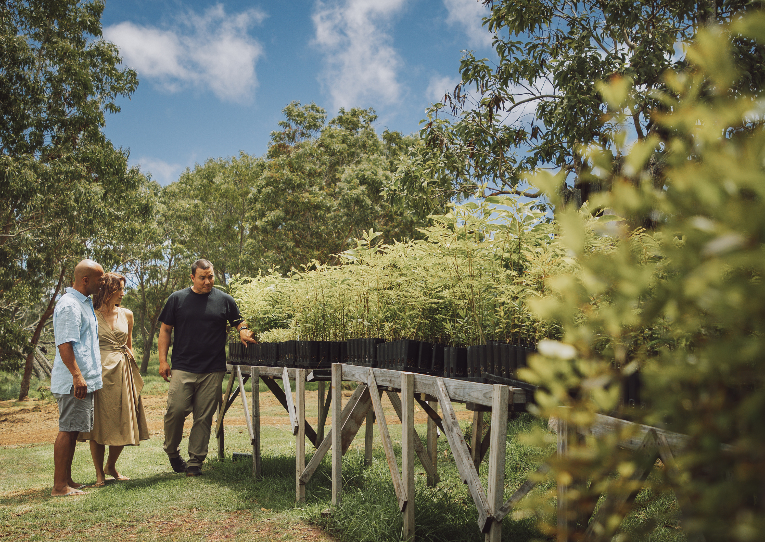 | 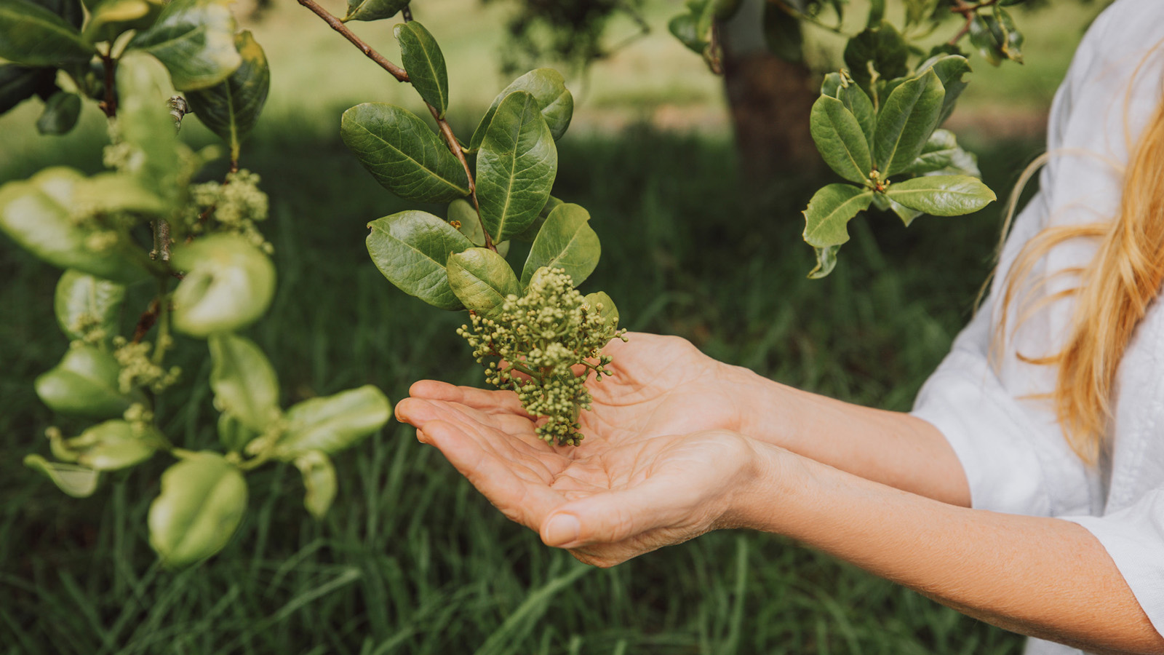
The Iliahi (Sandalwood) Farm and Spa Experience is the newest in a series of exclusive "Only at Hualalai" experiences curated specifically for guests and club members at Four Seasons Resort Hualalai. This experience allows guests to further explore the natural healing properties of the native plants and flowers Hawaiians used as medicine decades ago.
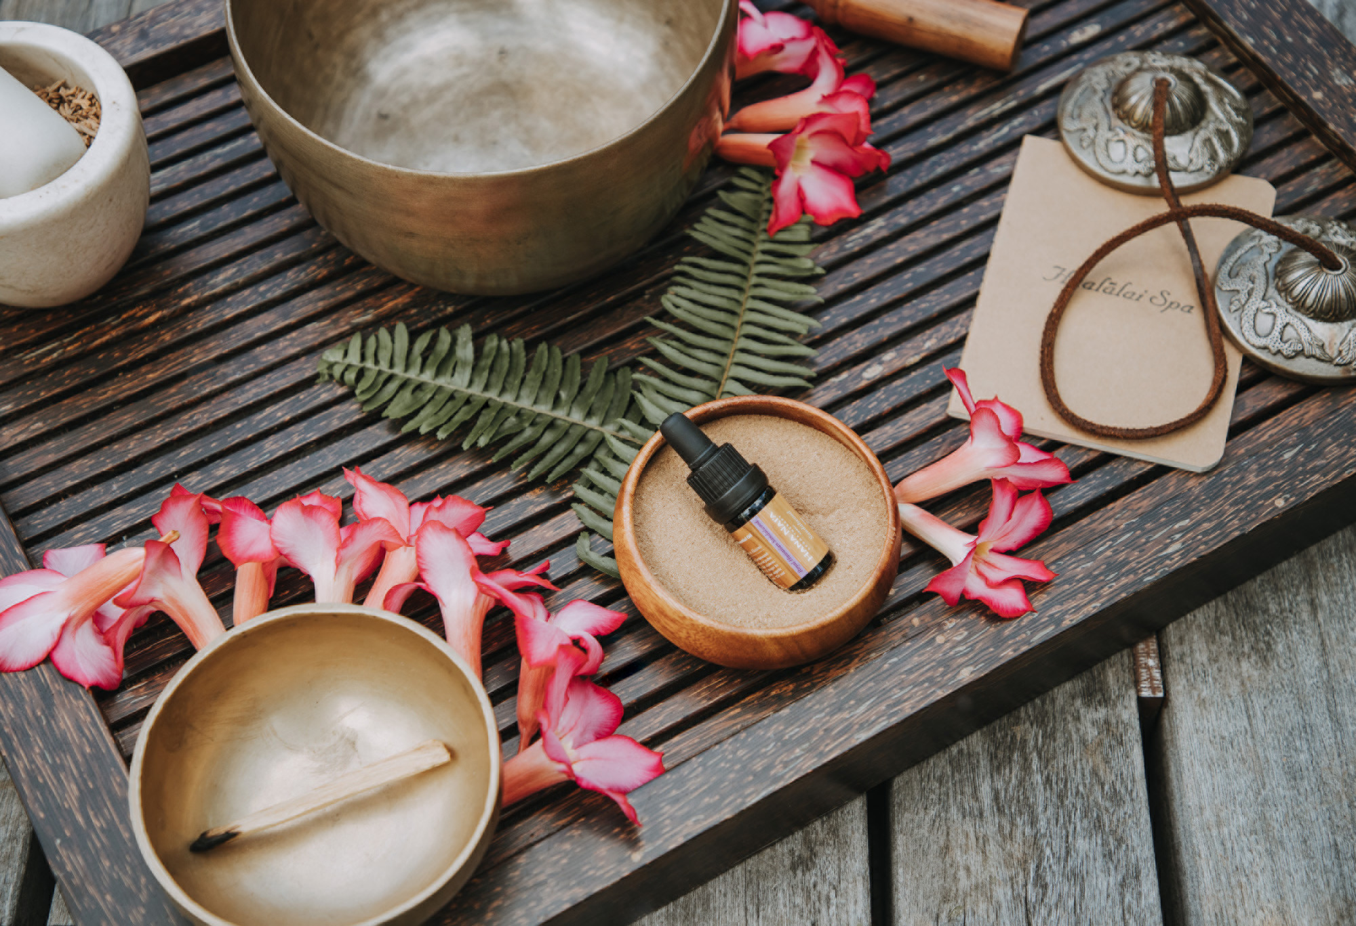 | 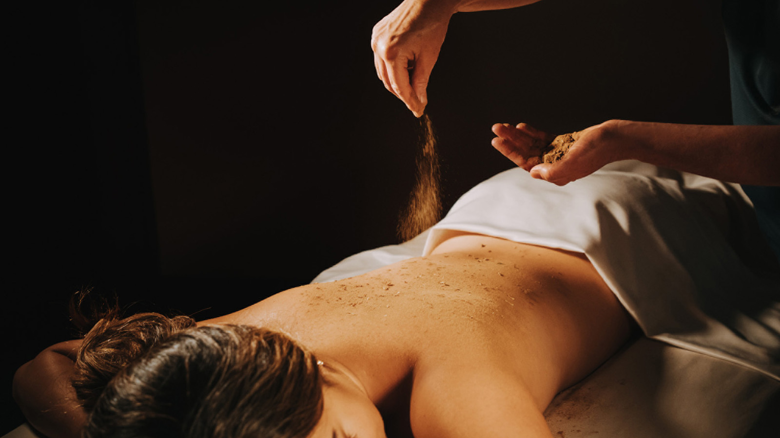

RELATED

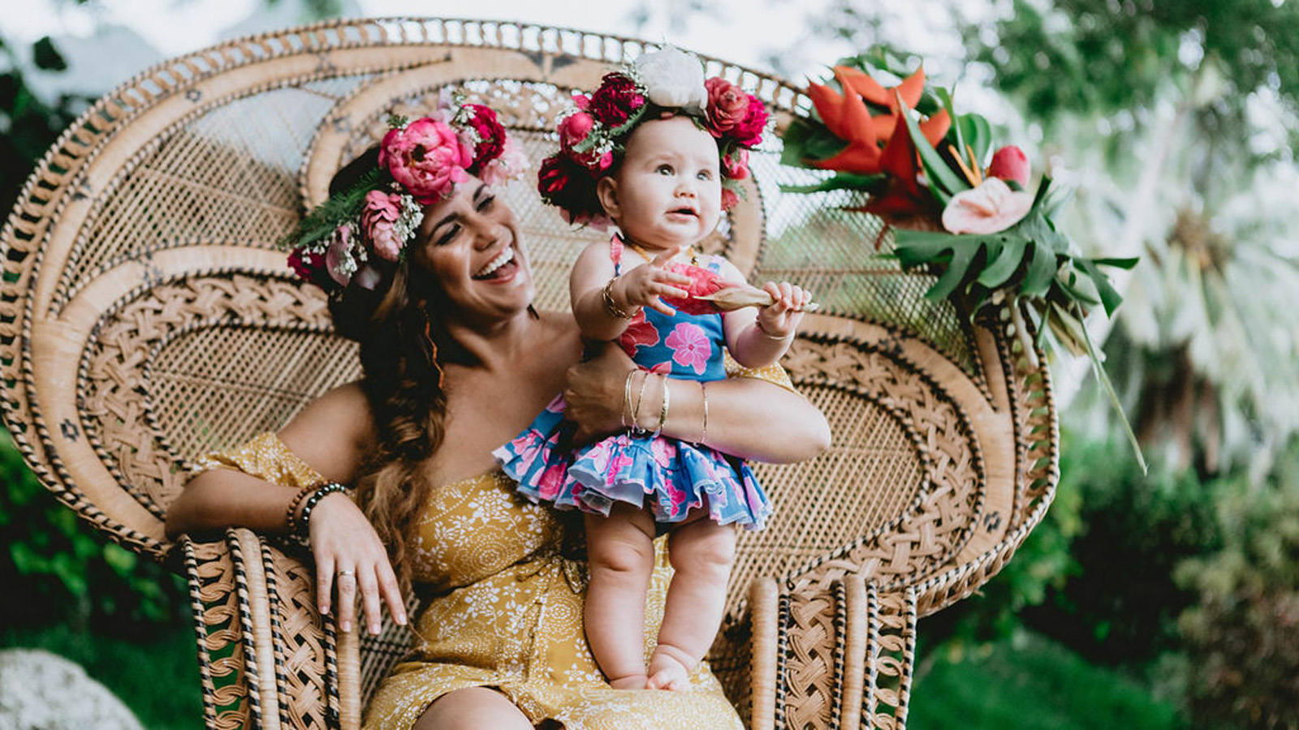 | November 29, 2019, Hawaii, Oahu, U.S.A.  Sip, Shop and Dine Under the Stars: Grammy Nominated Singer Songwriter Kimie Miner Joins More than 30 Hawaii Artists and Artisans at Moonlight Market at Four Seasons Resort Oahu at Ko Olina  https://publish.url/oahu/hotel-news/2019/festive-moonlight-market.html
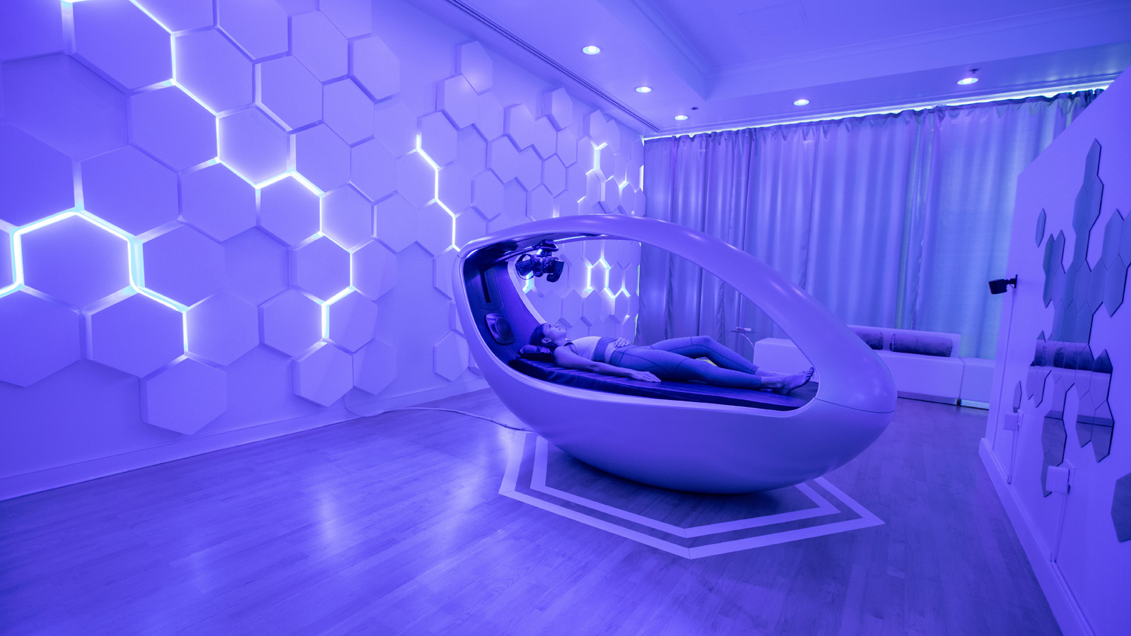 | November 28, 2019, Hawaii, Oahu, U.S.A.  Four Seasons Resort Oahu at Ko Olina and Sensync Partner to Introduce the World’s First Multi-Sensory Virtual Reality Wellness Experience: The Vessel, Featuring Deep Brain Massage  https://publish.url/oahu/hotel-news/2019/the-vessel-immersive-sensory-experience.html

PRESS CONTACTS

Morgan Suzuki
Director of Public Relations and Communications
72-100 Ka'upulehu Drive
Kailua Kona
U.S.A.
morgan.suzuki@fourseasons.com

1 (808) 557-5909

