Signature Deep-Soaking Baths at Four Seasons Hotel Seattle Elevate Rest and Relaxation with a New Salt & Scrub Experience

March 1, 2019, Seattle, U.S.A.

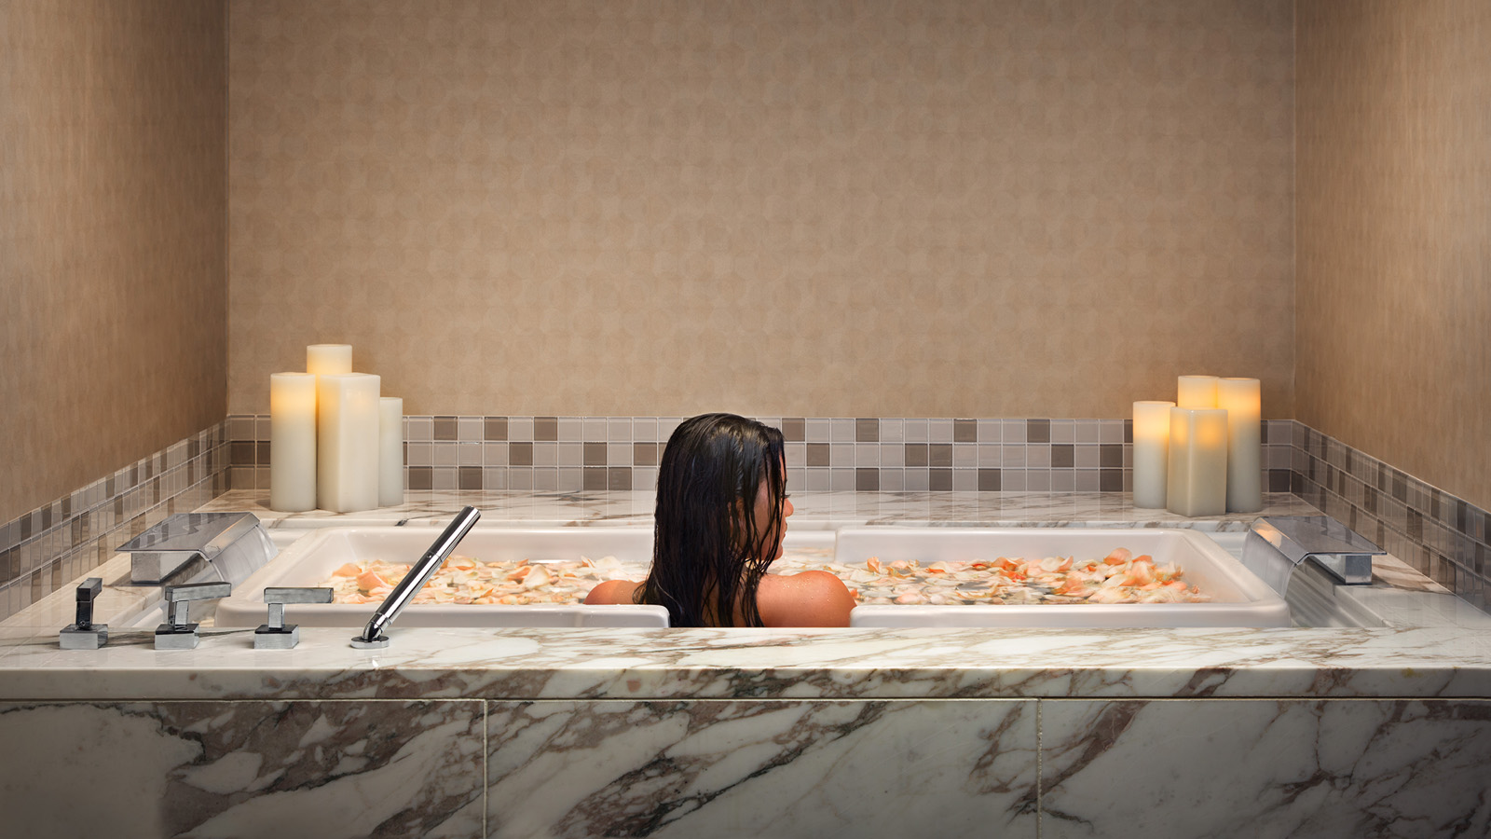
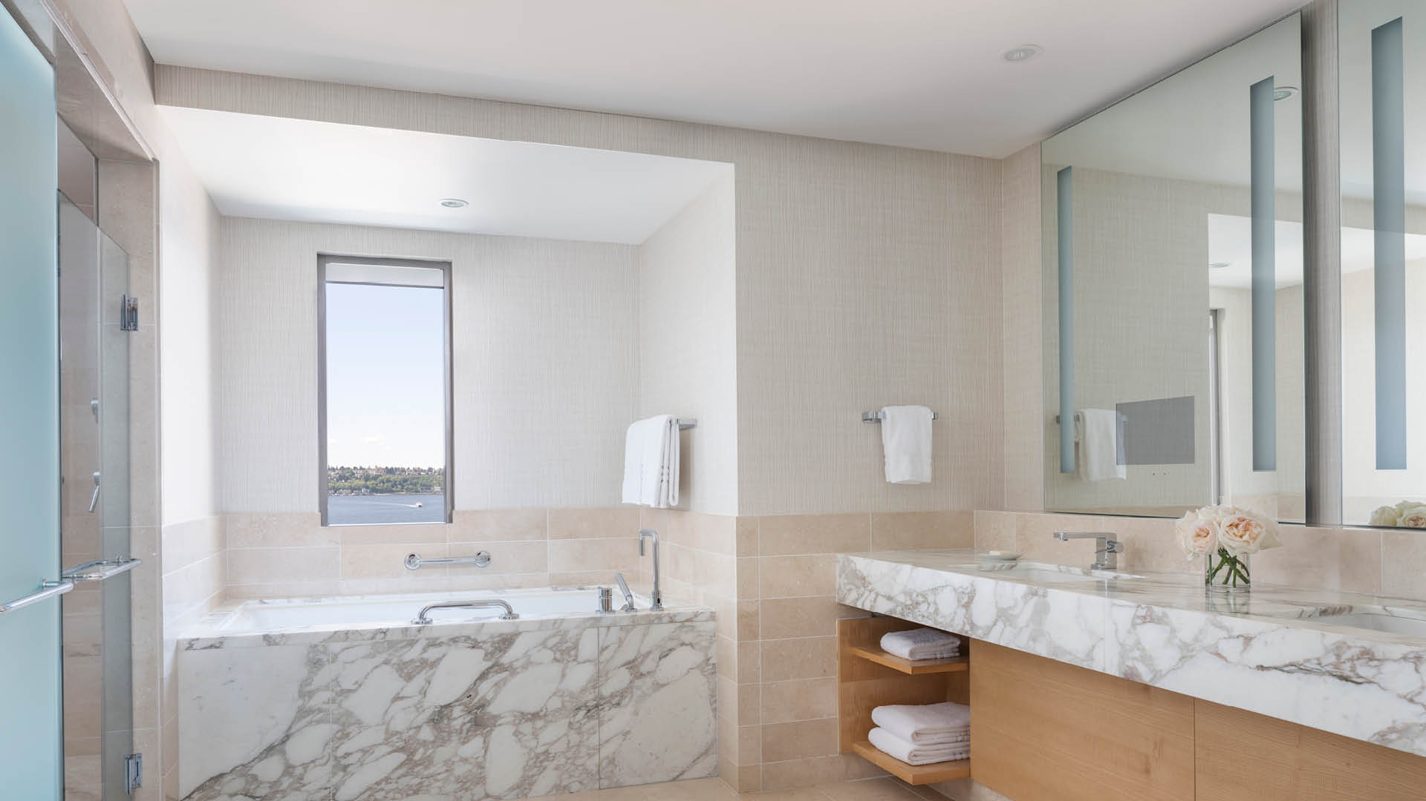 | 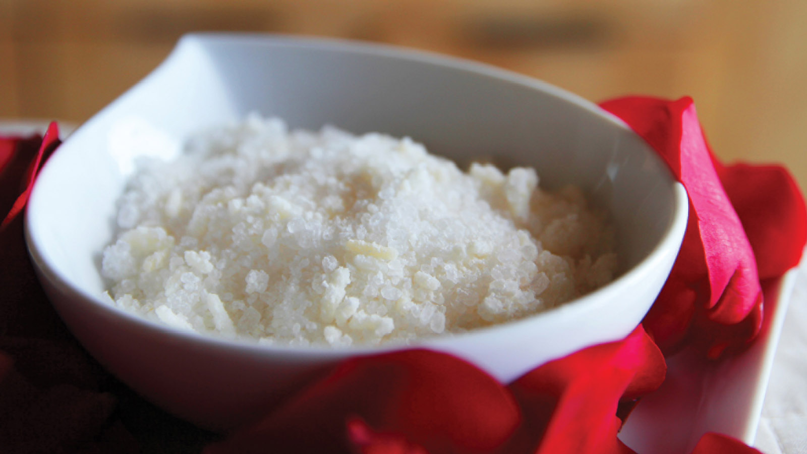
Seattle’s only hotel with deep soaking tubs and separate rain showers in every guest room and suite, Four Seasons Hotel Seattle further elevates its bath experience with a new menu of signature salts and scrubs for guests to enjoy.
Four Seasons bath experiences are a luxurious opportunity to enhance a daily ritual. Available to order via the Four Seasons App, text, Facebook messenger, or in-room phone, the Bath Experience includes two kits to select from: Seattle Signature, and Romance. Each kit contains bath salts, a body scrub, and body shea butter.
“The team personalised the scents in the bath experiences with the guest and location in mind,” says Trina Wood, Director of Spa at The Spa at Four Seasons Hotel Seattle. “Combined with the invigorating and healing qualities of the scrub and the smoothing and moisturising benefits of the shea butter, the overall result is a feeling of rejuvenation and relaxation in our amazing deep soaking tubs.”
Evoking the scents of the Pacific Northwest, the Seattle Signature Bath Experience features a cedar and saffron salt with woodsy, spicy and vanilla notes; LaNatura Green Tea Sugar Exfoliator; and LaNatura Sea Water Therapy Shea Butter.
Perfect for an evening of indulgence, the Romance Bath Experience includes amber-scented therapeutic bath salts for a warm, rich, honey-like, and earthy scent. It is paired with LaNatura Green Tea Sugar Exfoliator and LaNatura Jasmine Shea Butter.
“Rich in antioxidants, organic sugar cane and coffee come together to polish skin with alpha-hydroxy acid. As a coffee-centric city, it was a natural fit to include coffee grounds, as it also stimulates the skin, giving it an all-over glow,” continues Wood. “The green tea aids in slowing the signs of ageing with its high antioxidant content. The finishing touch, the shea butter provides deep moisture and heals dry skin.”
The marble guest bathrooms include a deep-soaking tub, glass-enclosed rain shower and vanity mirror with an integrated television. A favourite among guests, the Corner Elliott Bay Suite deep-soaking bath faces Elliott Bay and has views of Puget Sound and the Seattle Great Wheel.

RELATED

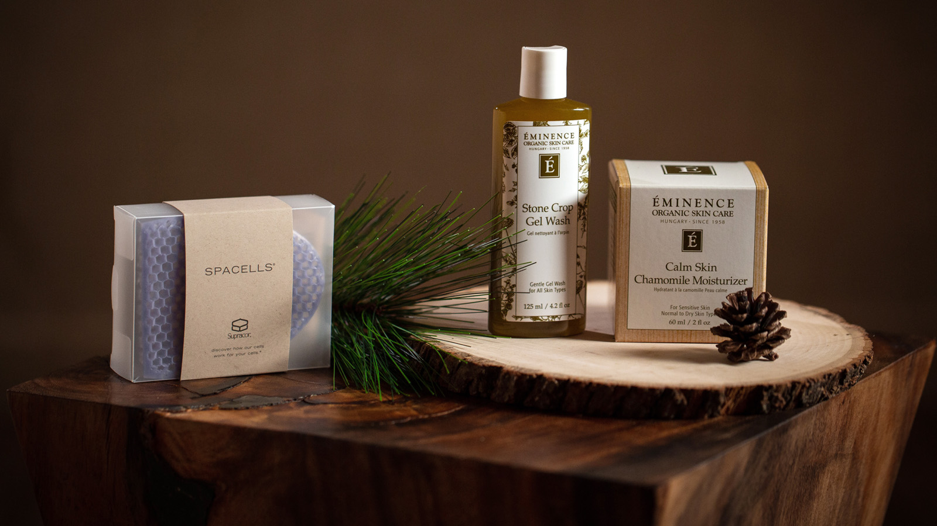 | December 10, 2019, Seattle, U.S.A.  Favourite Wellness and Beauty-Themed Gift Ideas from The Spa Experts at Four Seasons Hotel Seattle  https://publish.url/seattle/hotel-news/2019/spa-gift-recommendations.html
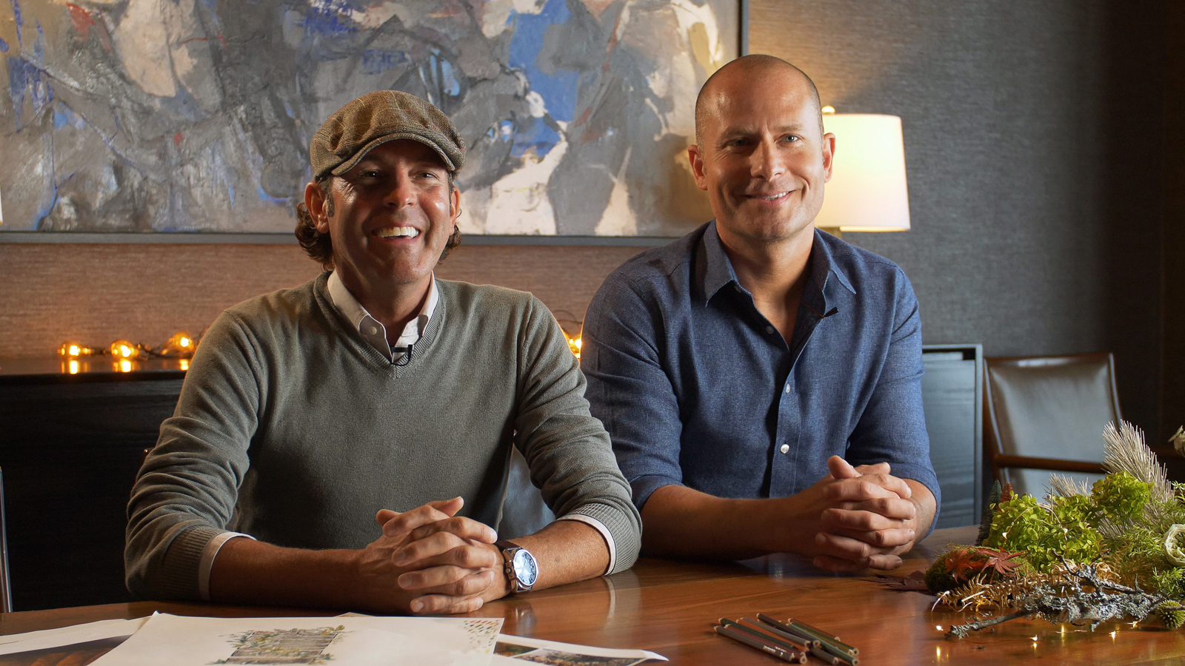 | December 3, 2019, Seattle, U.S.A.  Floral Architects Delinger + Radovich Create Pacific Northwest Holiday Display at Four Seasons Hotel Seattle  https://publish.url/seattle/hotel-news/2019/festive-decor.html

PRESS CONTACTS

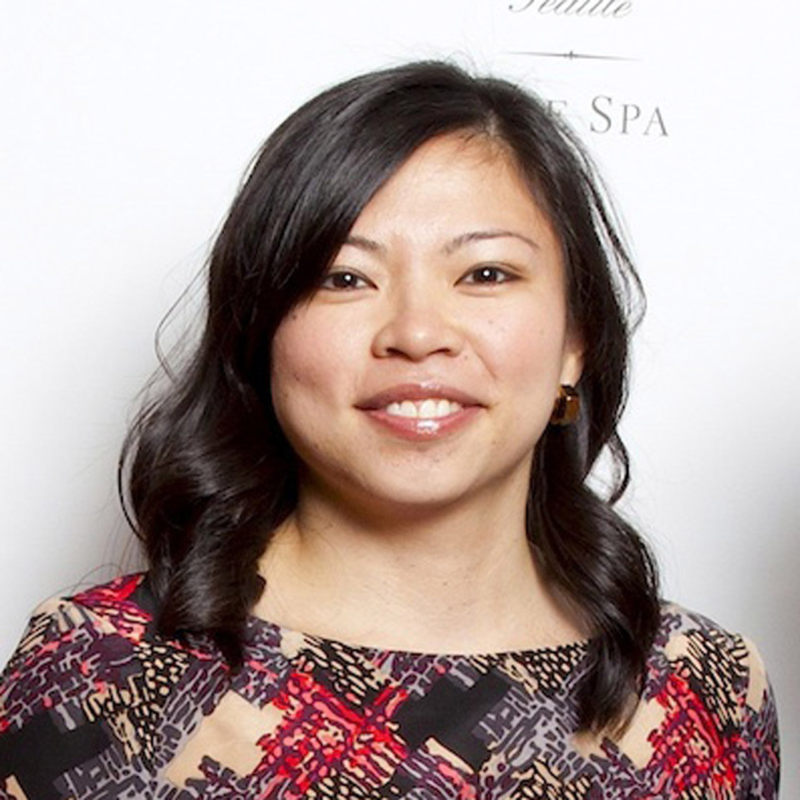 | Meg Paynor  PR Consultant  99 Union Street  Seattle  U.S.A.  meg@paynorpr.com  1 (206) 913-3848
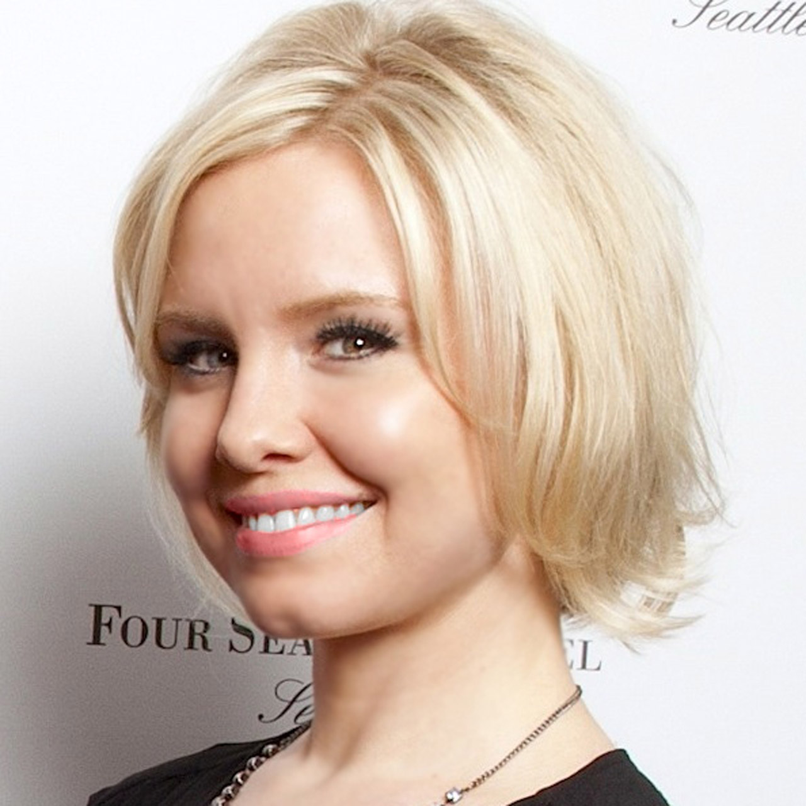 | Crystal Southcote  Digital Media Manager  99 Union Street  Seattle  U.S.A.  crystal.southcote@fourseasons.com  +1 (206) 749-3909

