Four Seasons Resort Oahu at Ko Olina and Sensync Partner to Introduce the World’s First Multi-Sensory Virtual Reality Wellness Experience: The Vessel, Featuring Deep Brain Massage

November 28, 2019, Hawaii, Oahu, U.S.A.

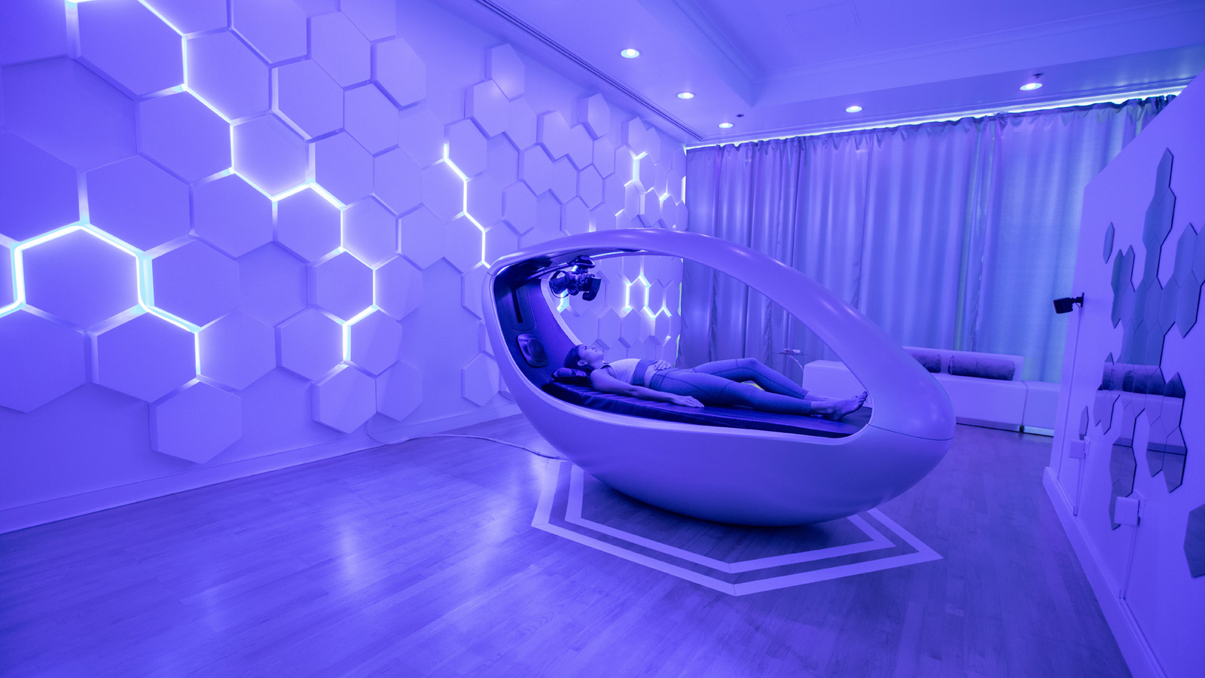
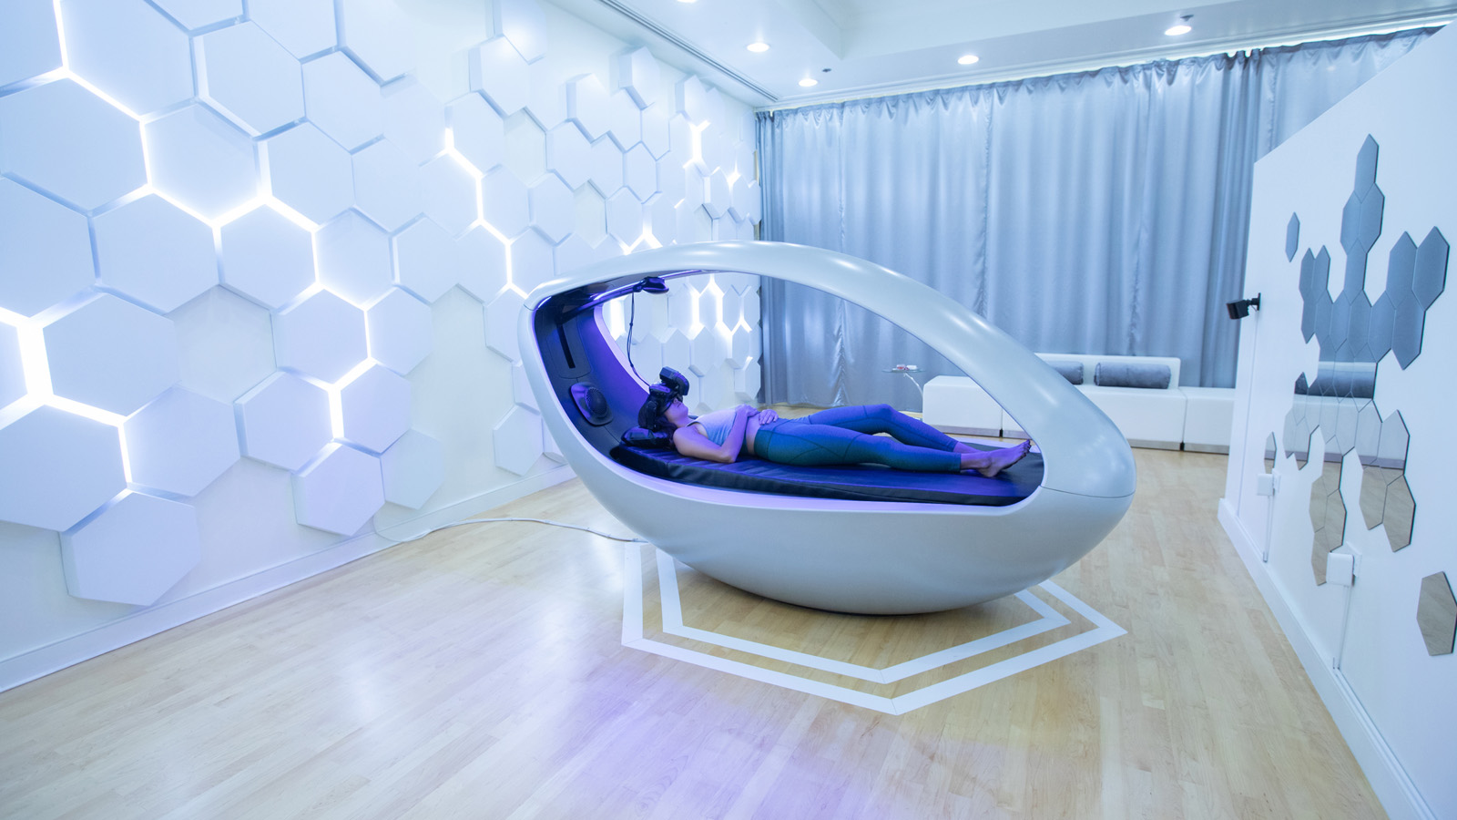 | 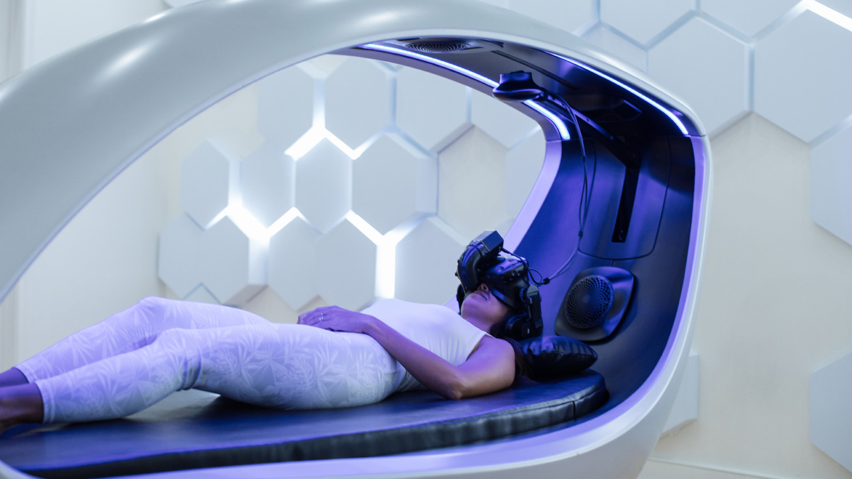 | 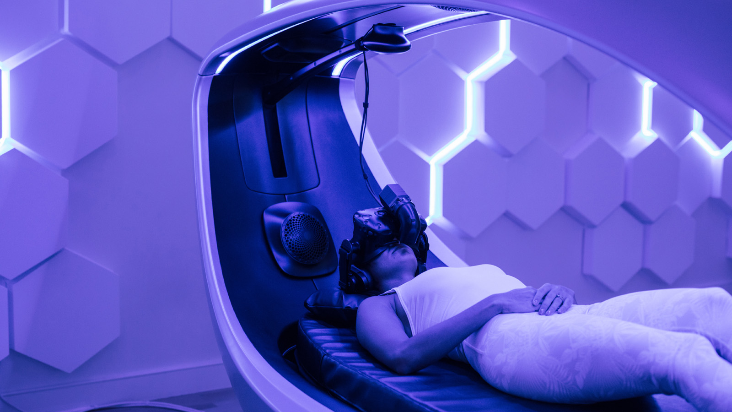
Four Seasons Resort Oahu at Ko Olina and Sensync, the immersive wellness company founded by Dr. Adam Gazzaley and Dr. Alex Theory, have partnered to introduce The Vessel - a luxury virtual experience that combines mixed reality innovation with advanced therapeutic technology to create a revolutionary, immersive sensory experience.
All around the world people are facing higher rates of stress, fatigue, anxiety, depression, insomnia, and other mental health issues. Concurrent with the upswing in mental health issues, there is an increased demand for solutions and new technology that can facilitate wellness in our daily lives.
The vision of the Sensync Vessel, a multi-sensory virtual reality wellness experience, is to displace guests from the burdens of their mind and unlock new approaches for relaxation and restoration.
The Vessel offers guests of Naupaka Spa & Wellness Centre at Four Seasons Resort Oahu at Ko Olina a series of customised journeys that help “reset” their brains to achieve a more tranquil state of mind. Journeys such as Deep Space, Kairos, Ocean Cove, Zen Garden, Quantum Oneness, Crystal Cave, Lost Jungle, Floating Clouds and Deep Space range from 20 to 80 minutes based on guest preference. Limited appointments are now available.
The Sensync Vessel’s experiential treatments are designed to relax and restore the fatigued mind by taking guests on a virtual journey into nature so that their focus is pulled away from goal-directed thoughts, allowing a much-needed restoration from cognitive fatigue to take place.
In the Vessel guests see, hear, smell, feel, and touch sensations of nature, presented in unison, leveraging the power of sensory synchronisation to create immersive nature experiences personalised in real-time by recordings of the guest’s physiology, yielding a first-of-its-kind, closed-loop experience.
The Science of The Vessel
Sensync’s Sensory Immersion Vessel is the world’s first premium-level technology that integrates the presentation of comprehensive sensory environments (state-of-the-art devices delivering stereoscopic visuals, spatial audio, scent, vibroacoustics, proprioception, wind and temperature) with real-time, physiological data collection (onboard sensors recording respiration, heart rate, electrodermal activity and electroencephalography) to enable the generation of deeply-engaging, dynamic, closed-loop experiences.
Another important and unique aspect of the Vessel is its ability to present all the rich sensory elements of these closed-loop experiences in unison, a process known as sensory synchronization (Sensync’s name origin).
Sensory synchronisation and multi-sensory integration serve as the neurophysiological basis for how our perception generates the human construct of reality. This phenomenon is precisely what has been engineered by Sensync to create the next level of virtual reality: travellers in the Vessel are taken on a journey with a greater sense of presence and immersion than has ever been achieved, integrating:
- Visual virtual reality treatments
- Aromatherapy
- Sound and music therapy
- Vibroacoustic stimulation
- Relaxation and nature therapy, meditation/mindfulness practices, biofeedback, and neurofeedback
Fully integrated, these protocols comprise what founders Alex Theory and Adam Gazzaley call the Deep Brain Massage. This novel treatment invented by Sensync is based upon decades of research showing the brain health benefits of nature exposure: improved attention, stress reduction, and mood enhancement.
About the Founders
Adam Gazzaley, M, Ph.D is The David Dolby Distinguished Professor of Neurology, Physiology and Psychiatry at the UC San Francisco, and the Founder and Executive Director of Neuroscape, a translational neuroscience centre engaged in technology development and scientific research of novel brain assessments and optimization tools. Dr. Gazzaley is co-founder and Chief Science Advisor of Akili Interactive and JAZZ Venture Partners. He has been a scientific advisor for more than a dozen technology companies including Apple, GE, Nielsen, Deloitte, Magic Leap and the VOID, and filed multiple patents, authored more than 130 scientific articles, and delivered more than 650 invited presentations around the world. He wrote and hosted the nationally televised PBS special The Distracted Mind with Dr. Adam Gazzaley, and co-authored The Distracted Mind: Ancient Brains in a High- Tech World, winner of the 2017 PROSE Award. Dr. Gazzaley has received many awards and honours, including the 2015 Society for Neuroscience – Science Educator Award.
Alex Theory PhD is a CEO and Futurist specialising in large scale immersive experiences, interactive content, augmented reality, virtual reality, and transmedia storytelling. He has produced a variety of top rated television shows, music videos, films, brand activations, live events, and experiential marketing campaigns. During his career he has worked with clients such as Google, Facebook, iTunes, Cirque du Soleil, MGM, NBC, ABC, PBS, Sting, Black Eyed Peas, Elton John, Alanis Morissette, and many others.

RELATED

October 15, 2019, Hawaii, Oahu, U.S.A.
This Festive Season, Celebrate the Rich Culture of O’ahu at Four Seasons Resort Oahu at Ko Olina
https://publish.url/oahu/hotel-news/2019/festive-season.html

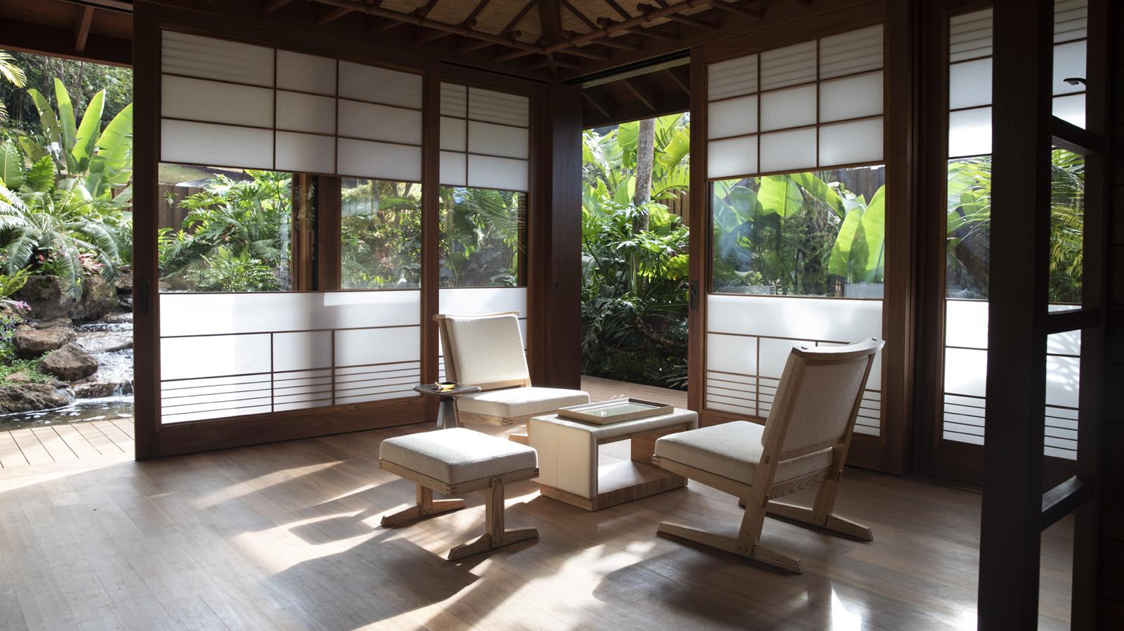 | October 10, 2019, Hawaii, Lanai, U.S.A.  フォーシーズンズとセンセイによるオールインクルーシブの ウェルネスリゾートがラナイ島に登場  https://publish.url/jp/koele/hotel-news/2019/new-all-inclusive-sensei-wellness-retreat-2.html

PRESS CONTACTS

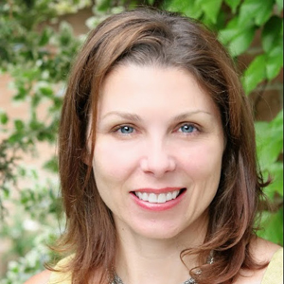 | Yvonne Hunter  Director of Public Relations  92-1001 Olani Street  Kapolei  U.S.A.  yvonne.hunter@fourseasons.com  +1 (808) 377-0746

