Four Seasons Hotel Istanbul at the Bosphorus Offers Fun Activities at Winter City for Young Guests During School Winter Break in January

The Hotel invites children and their families for enjoyable moments at its Winter City, which features an ice rink by the Bosphorus, a band of mascots, saxophone show, bubble and juggler shows and also delicious flavours prepared by the culinary team throughout the winter break
January 13, 2020, Istanbul at the Bosphorus, Turkey

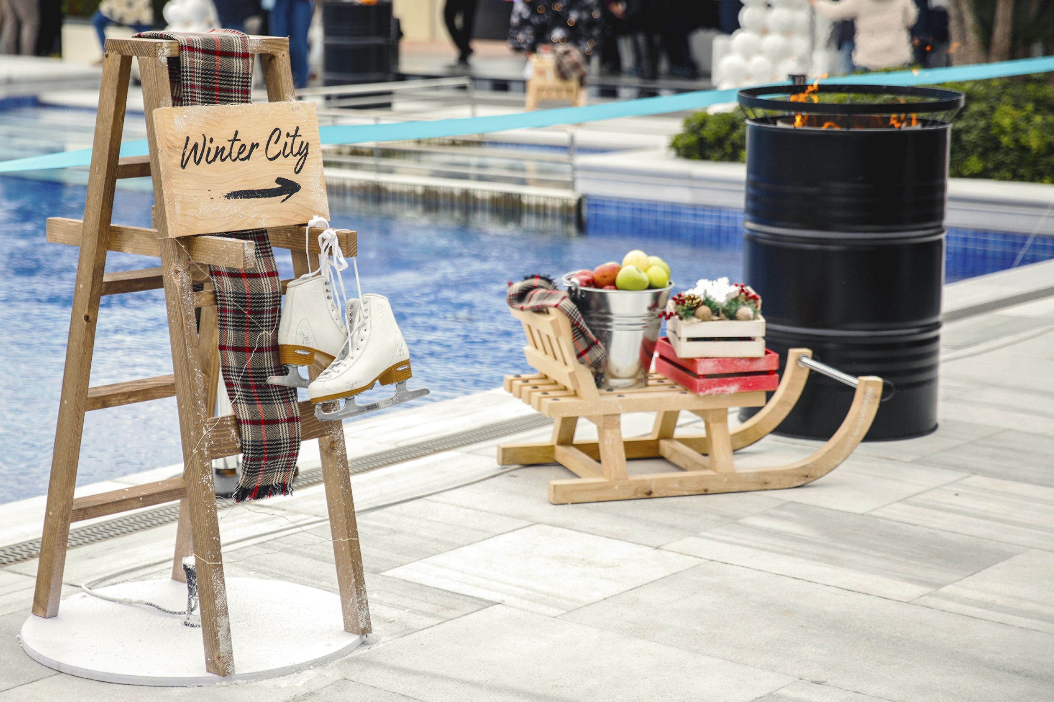
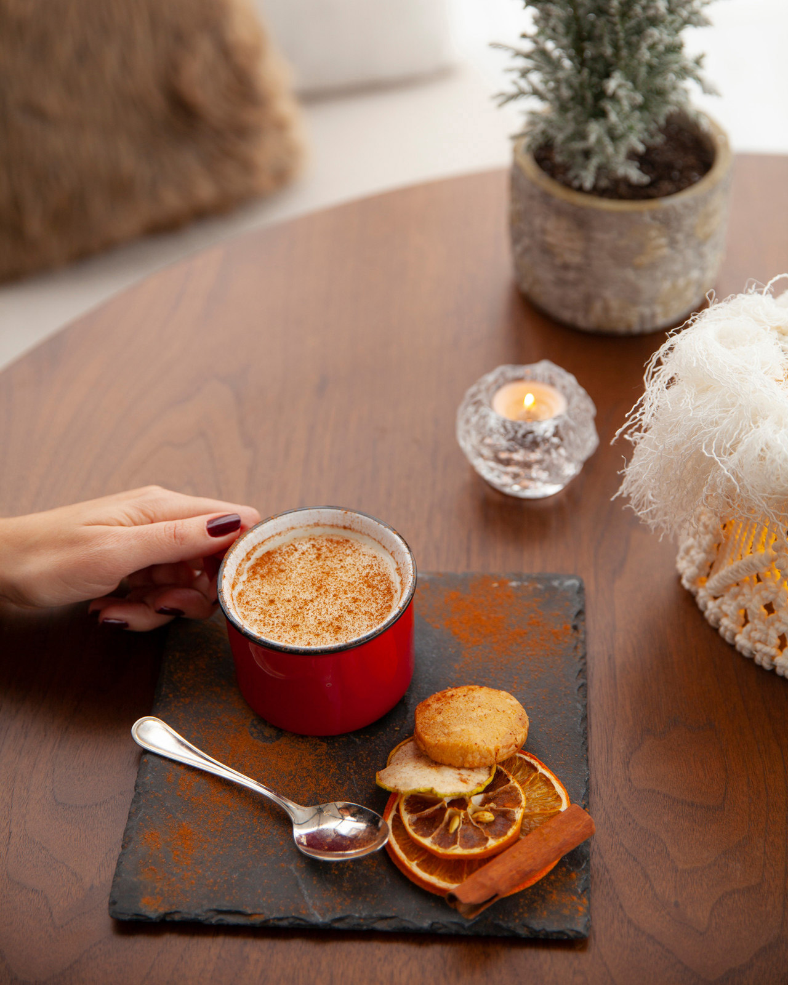 | 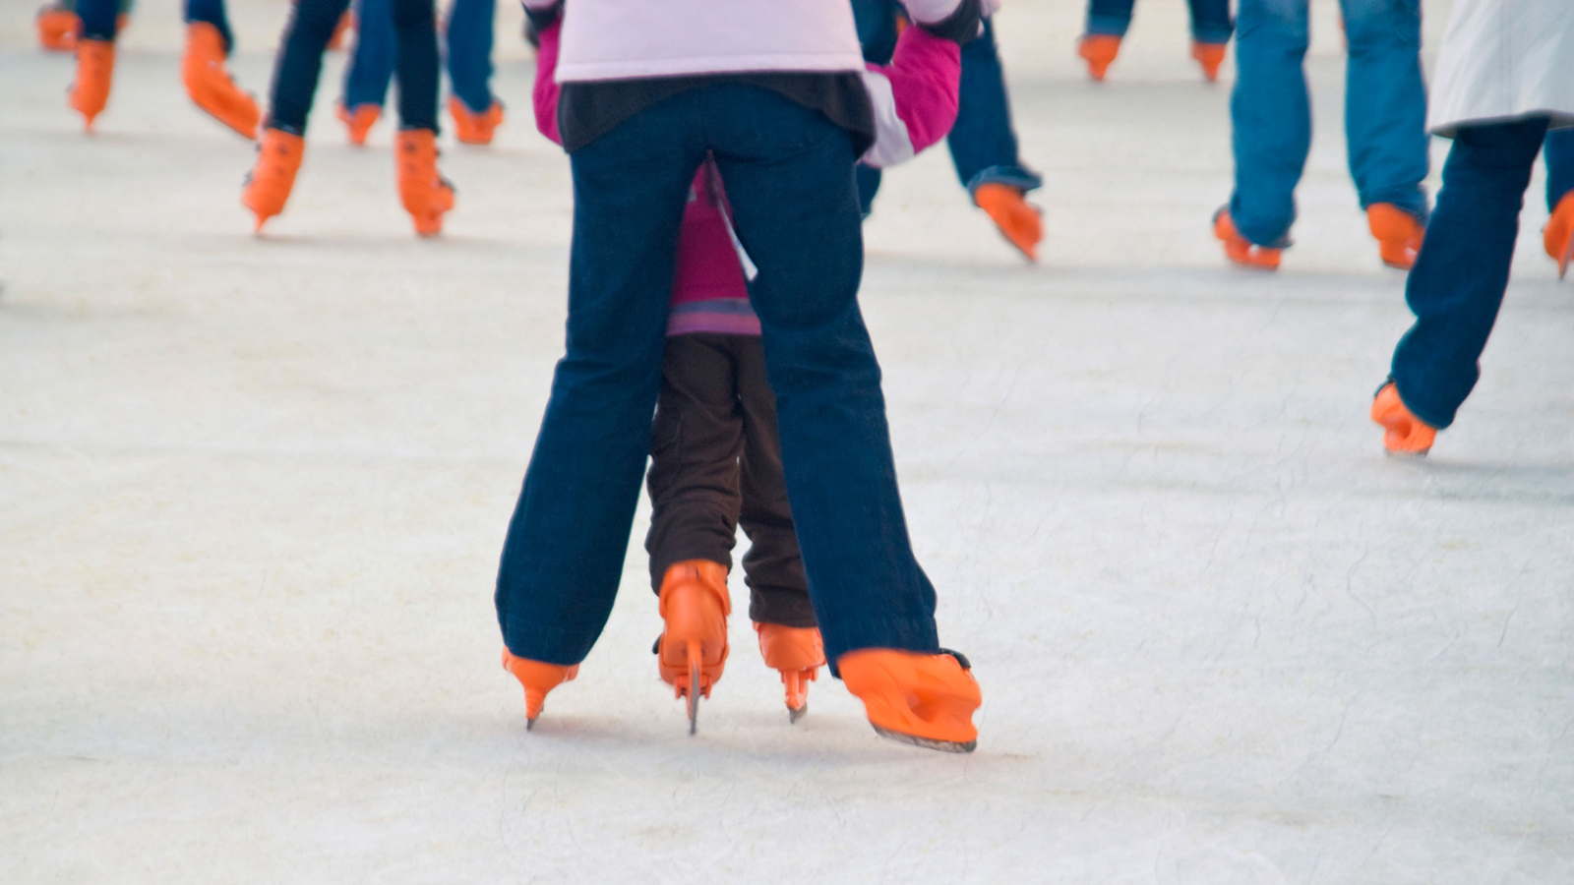
Four Seasons Hotel Istanbul at the Bosphorus promises children unforgettable hours during their winter break with Winter City, which features an ice rink, musical shows and delicious street-style food on its outdoor terrace by the Bosphorus. Winter City attracts families who are looking for outdoor activities with their young children during winter season.
For those who wish to spend the winter break in Istanbul, the activities in the Winter City will be available every day from 12:00 noon to 8:00 pm. Ice skating, with the option to take private lessons, and a variety of fun activities as well as entertaining shows will be accompanied with warming flavours.
Street-style food will include meatball and spicy sausage sandwiches, baked potatoes, hamburgers, hot dogs, lahmacun (a local flat bread with meat, fresh out of the wood-burning oven) and sweets. Irresistible winter delicacies such as roasted chestnuts, cotton candy, wafers and candy apples will be accompanied by salep (a local winter drink with milk), and hot chocolate to keep warm. DJ performances will energise visitors in cold weather.
Entrance fee for city guests will include a sandwich, a soft drink and a hot drink. Guests in residence will enjoy free entrance.
For those who would like to have private ice skating lessons:
- 45-minute ice skating session - TRY 75 per person
- 45-minute private lesson - TRY 150 person
For more information, call: 0090 552 381 11 11.

RELATED

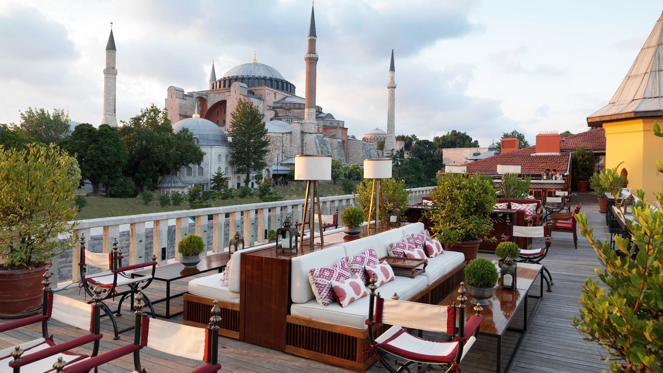 | November 26, 2019, Istanbul, Turkey  Four Seasons Hotel Istanbul at the Bosphorus and Four Seasons Hotel Istanbul at Sultanahmet Take Home Seven Haute Grandeur Global Awards  https://publish.url/istanbul/hotel-news/2019/haute-grandeur-global-awards.html
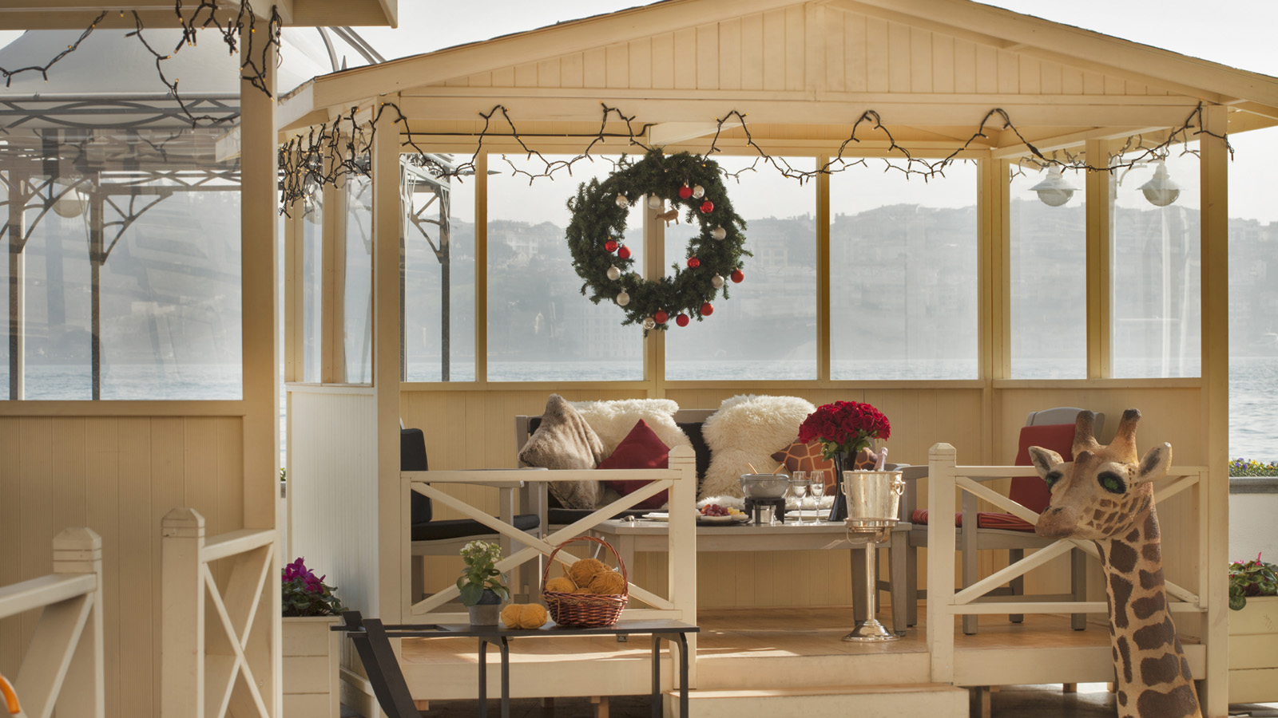 | November 20, 2019, Istanbul at the Bosphorus, Turkey  Four Seasons Hotel Istanbul at the Bosphorus Welcomes 2020 in a Festive Spirit Full of Entertainment, Fun and Dynamism, Just Like the Pulse of Istanbul  https://publish.url/bosphorus/hotel-news/2019/festive-season.html

PRESS CONTACTS

Sibel Benli
Senior Director of Public Relations and Communications
Çırağan Cad. No. 28
Istanbul
Turkey
sibel.benli@fourseasons.com

90 (212) 381 41 35

