Celebrate A Season of Sapphire at Four Seasons Resort Seychelles this Christmas and New Year

Petite Anse bay prepares to welcome guests for a glistening festive season
September 21, 2017, Seychelles

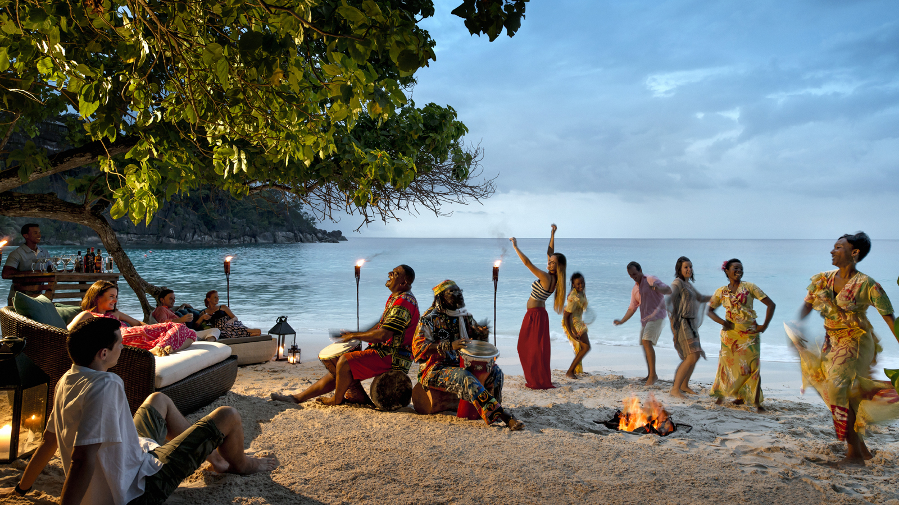
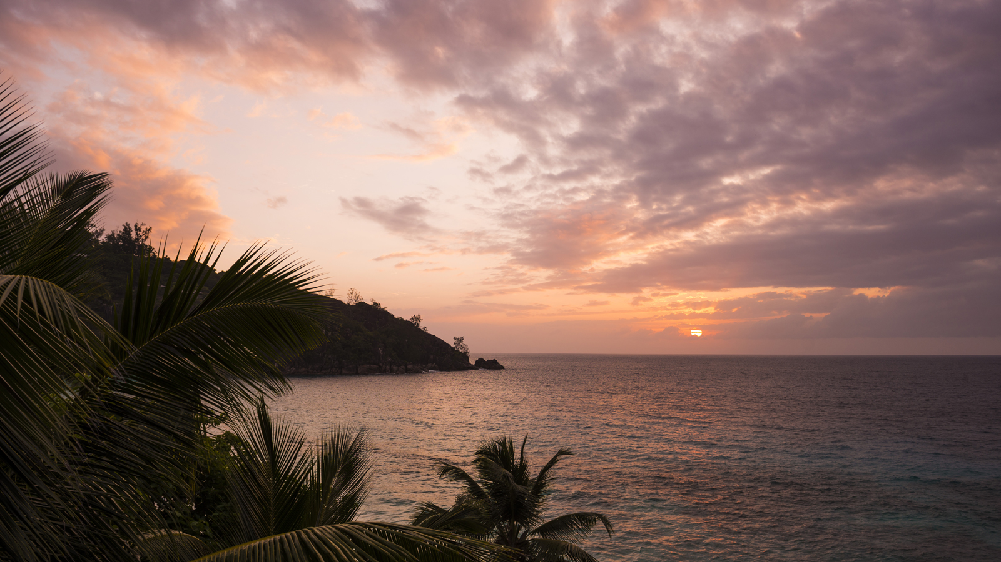 |  | 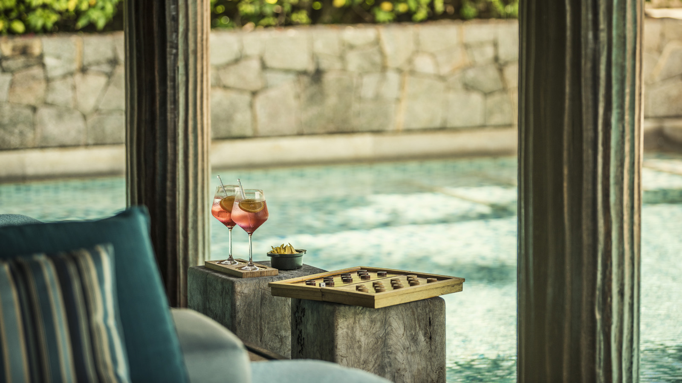
With the Christmas and New Year holidays fast approaching,
Four Seasons
Resort Seychelles has revealed details of exclusive events and exotic celebrations that are set to take place in its A Season of Sapphire festive program.
Running as from December 23, 2017 to January 8, 2018, A Season of Sapphire will allow guests to disconnect from their day-to-day and immerse themselves in the nature and tranquility of Seychelles. With a full program of culinary highlights and recreational activities prepared by the Resort's expert team, all ages will be kept entertained throughout the festive period.
Reflecting the seasonal theme, the Resort's decoration will echo the shades of the Indian Ocean seen in the horse shoe-shaped bay of Petite Anse. Glistening festivities will be displayed from the hilltop Spa down to the poolside restaurant of Kannel, with the official Christmas tree lighting ceremony taking place on December 24, where children will be invited to prepare and place the final ornaments on the Resort's Christmas tree. Further highlights from the festive program include:
- Sapphire Sensation - Celebrate the arrival of 2018 with an evening of poolside entertainment, a choice of cuisine from around the globe and a barefoot countdown to the new year.
- The Candy Shop of Petite Anse - Those with a sweet tooth will be spoiled for choice in this new pop-up experience. Crafted by the Resort's pastry chefs, desserts, pastries and cakes will be available for seasonal treats on several evenings during the festive period.
- A Coral for Christmas - The decorations continue beneath the surface with the marine education team from WiseOceans, who will be assisting guests to select and sponsor a coral fragment that will be attached to an underwater Christmas tree from where it can find new life in the Coral Nursery.
- Eclectic Cuisines - Ranging from seafood to Italian, Lebanese to Latino, the Resort's culinary team will be serving up a gourmet selection of international dishes to suit every taste in a dedicated festive dining program.
Families staying at the Resort over the Christmas and New Year period will also be treated to a number of activity options, including Family Zoo Yoga, surfing and stand up paddle boarding lessons, and a dedicated Kids for All Seasons program at Pti Torti Kids' Club.
Four Seasons
Resort Seychelles is located on the south west coast of Mahé, where its 67 treetop Villas and Suites, plus eight Three to Six Bedroom Residences provide seclusion and relaxation to both couples and families. Rates during the festive season start from EUR 2,070 per night plus 26.5 percent tax and service charge per night, including breakfast.

RELATED

August 3, 2017, Seychelles
From A "Cravings Hotline" to Personalised Welcome Amenities: Parents-to-Be are Pampered in Paradise with a New Babymoon Experience from Four Seasons Resort Seychelles
http://publish.url/seychelles/hotel-news/2017/babymoon-experience.html

August 3, 2017, Seychelles
Four Seasons Resort Seychelles подготовили приятные сюрпризы для пар, ожидающих пополнение в семье
http://publish.url/ru/seychelles/hotel-news/2017/babymoon-experience-2.html

PRESS CONTACTS

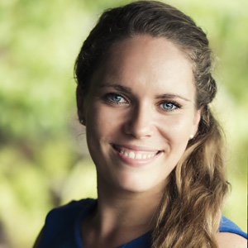 | Amy Sefton  Public Relations Coordinator  Petite Anse, Baie Lazare, P.O. Box 1397  Victoria, Mahe  Seychelles  amy.sefton@fourseasons.com  +248 439 3016
Debbie Duval
Director of Public Relations and Communications

Beau Champ
Mauritius
debbie.duval@fourseasons.com

(230) 402 3100

