Four Seasons Resort Maldives Hospitality Apprenticeships Exceed Milestone 500 Graduates

May 10, 2018, Maldives at Landaa Giraavaru, Republic of Maldives

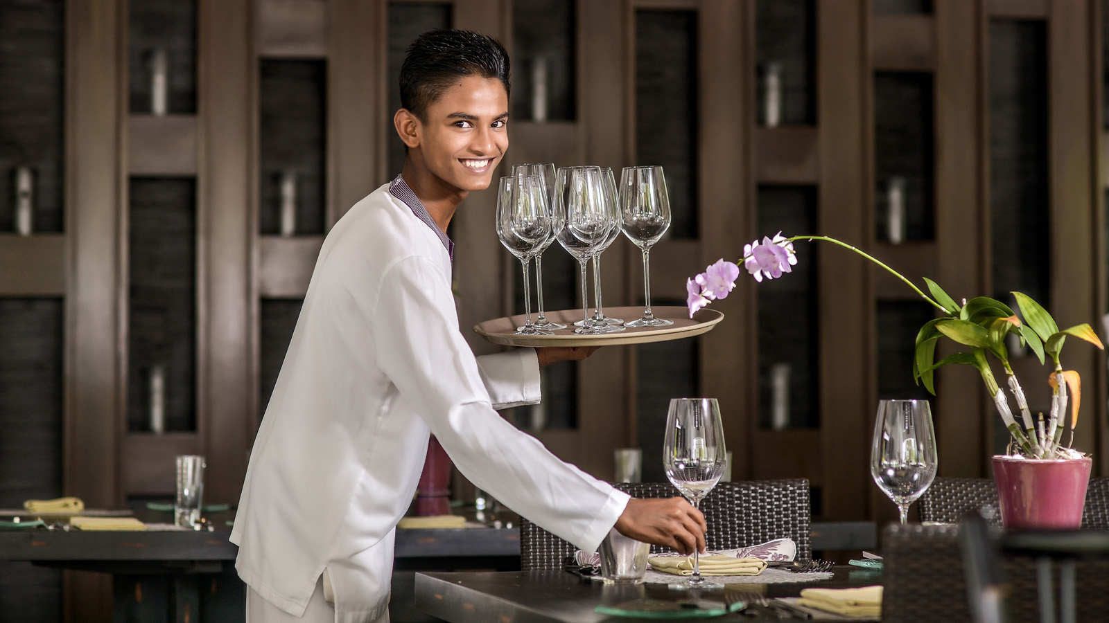
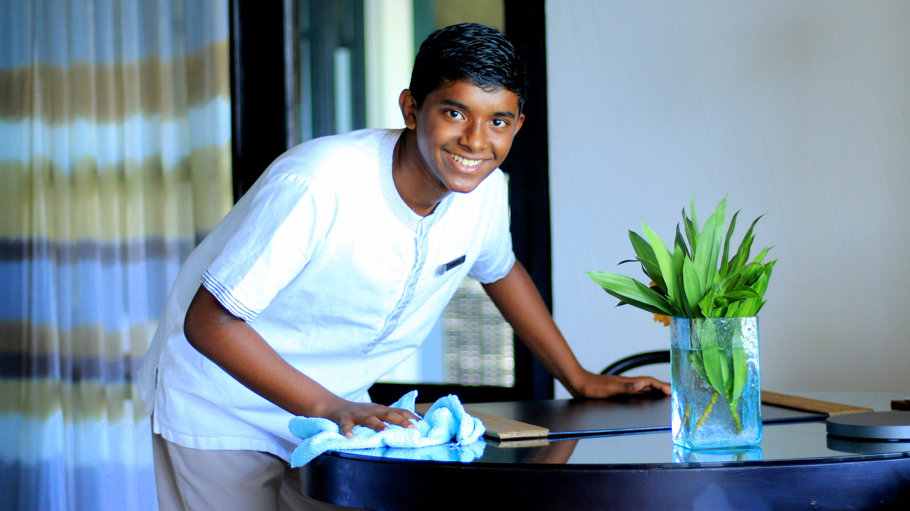
May 8, 2018 marked the graduation ceremony of 48 apprentices from
Four Seasons
Resorts Maldives Apprenticeship Class of 2018 – taking the total number of graduates to date over the magic 500 milestone, to 536.
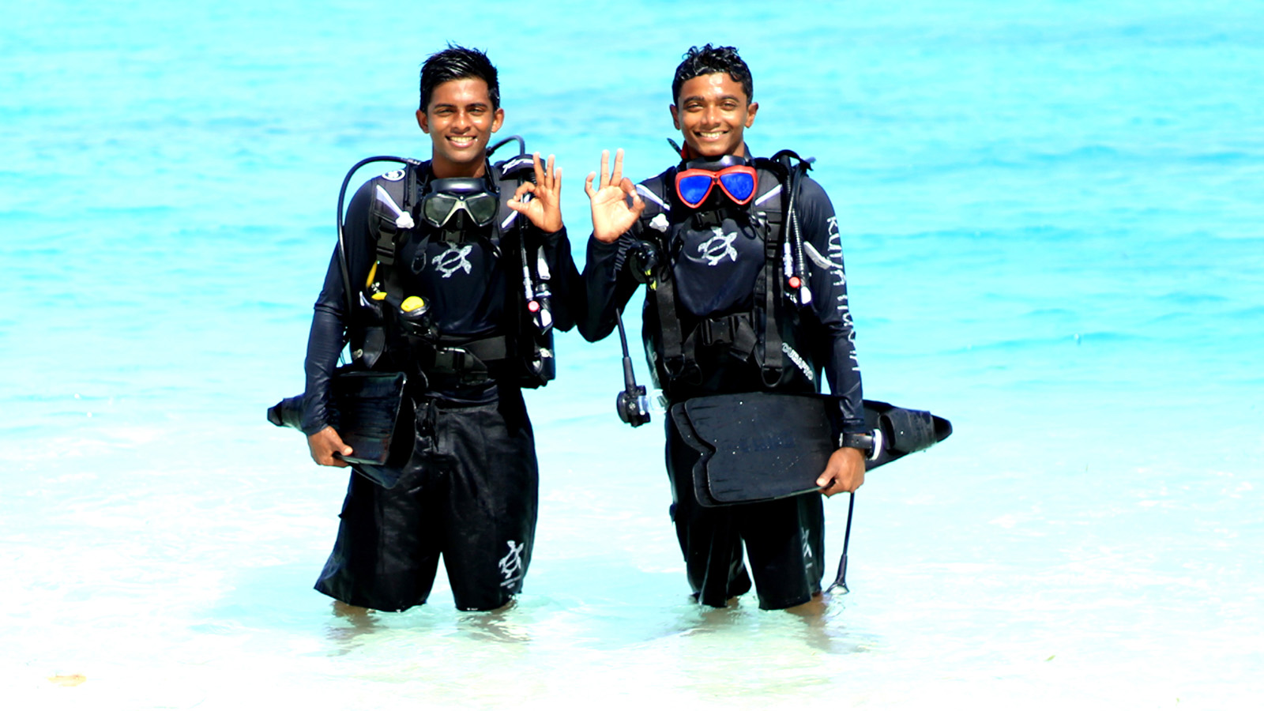
The graduation took place at 10:00 am (Mal&eacute; time) at the National Art Gallery, Mal&eacute; in the presence of Minister of Environment and Energy, Mr. Thoriq Ibrahim.
In addition to celebrating the achievements of the Class of 2018 – which comprises 24 first year apprentices and 2 second year apprentices from
Four Seasons
Resort Maldives at Landaa Giraavaru; and 22 first year graduates from
Four Seasons
Resort Maldives at Kuda Huraa – the event also marked the inauguration of 70 new apprentices into the Class of 2019 (64 first year apprentices and 6 second year apprentices), marking yet another record-breaking intake for the program.
Commenting on the enduring success of the apprenticeship,
Four Seasons
Resorts Maldives Regional Vice President Armando Kraenzlin said: “Year on year we are exceeding the intake numbers, which is not only testament to the success of the program but also to the increasing desire of local Maldivians to enter into the hospitality industry. This program is now such an ingrained part of our Resorts’ culture that it’s easy to take it for granted, but reaching – and exceeding – a total of 500 graduates is a huge achievement for the whole team and for everyone who is committed to developing the future of Maldivian hospitality.”
Aimed at 17-20 year olds, the Technical and Vocational Education and Training (TVET) Apprenticeship Programme equips enthusiastic youngsters from all over the country with the skills required to excel in the hospitality industry. Applicants interested in applying for the Apprenticeship Class of 2020 should contact Apprenticeship.Maldives@fourseasons.com for details of future recruitment procedures.

RELATED

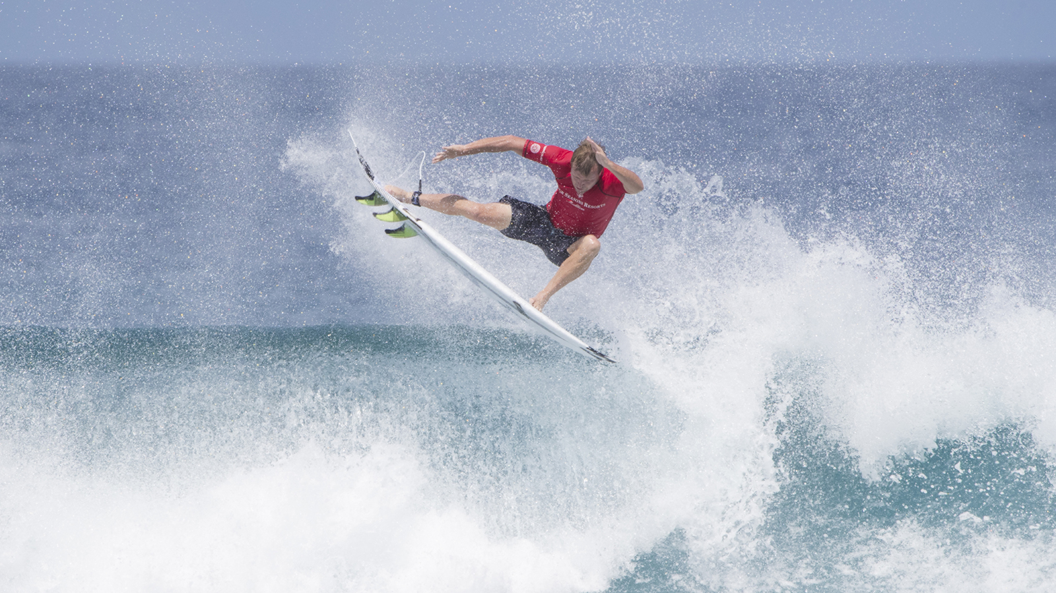 | May 9, 2018, Maldives at Kuda Huraa, Republic of Maldives  Surf Legend Taj Burrow Confirms Return to Four Seasons Maldives Surfing Champions Trophy 2018  https://publish.url/maldiveskh/hotel-news/2018/surfing-champions-trophy.html
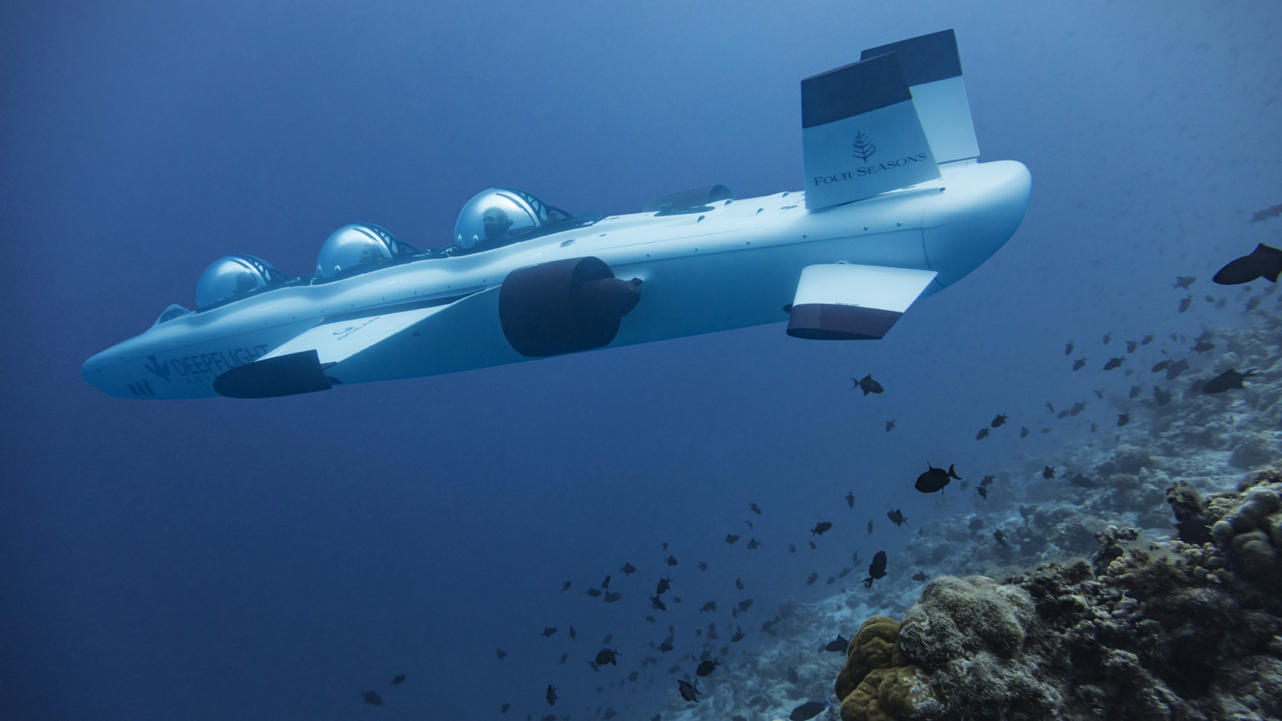 | May 3, 2018, Maldives at Landaa Giraavaru, Republic of Maldives  Four Seasons Resort Maldives at Landaa Giraavaru Premieres World Exclusive DeepFlight Adventures  https://publish.url/maldiveslg/hotel-news/2018/submarine-experience.html

PRESS CONTACTS

Juliana Ang
Director of Public Relations
Tourism Court, #04-00, 1 Orchard Spring Lane
Singapore
247729
juliana.ang@fourseasons.com

(65) 6514 82 81

