Jin House at Four Seasons Hotel Tianjin Has Been Awarded 2021 Black Pearl One Diamond

April 8, 2021, Tianjin, China

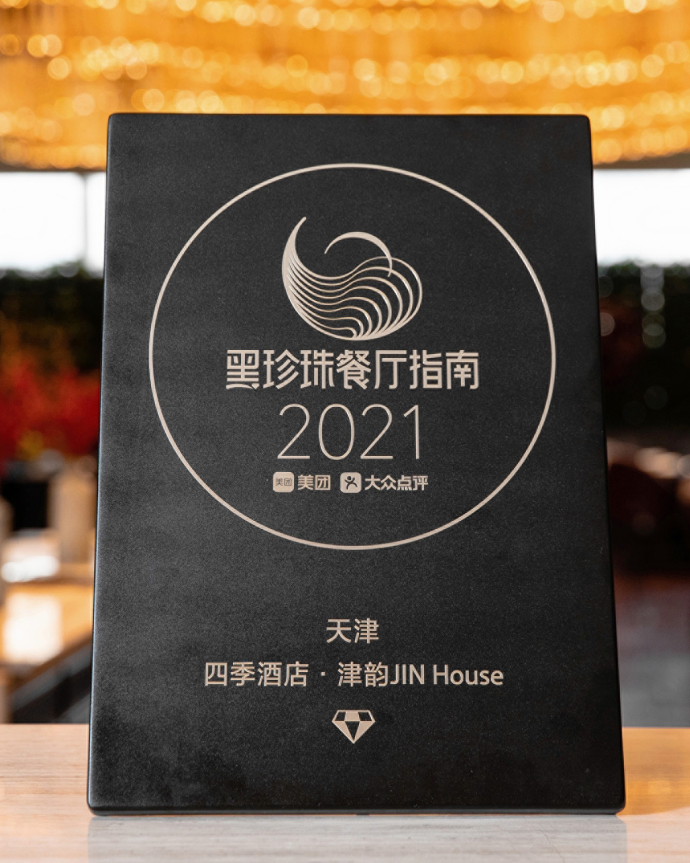
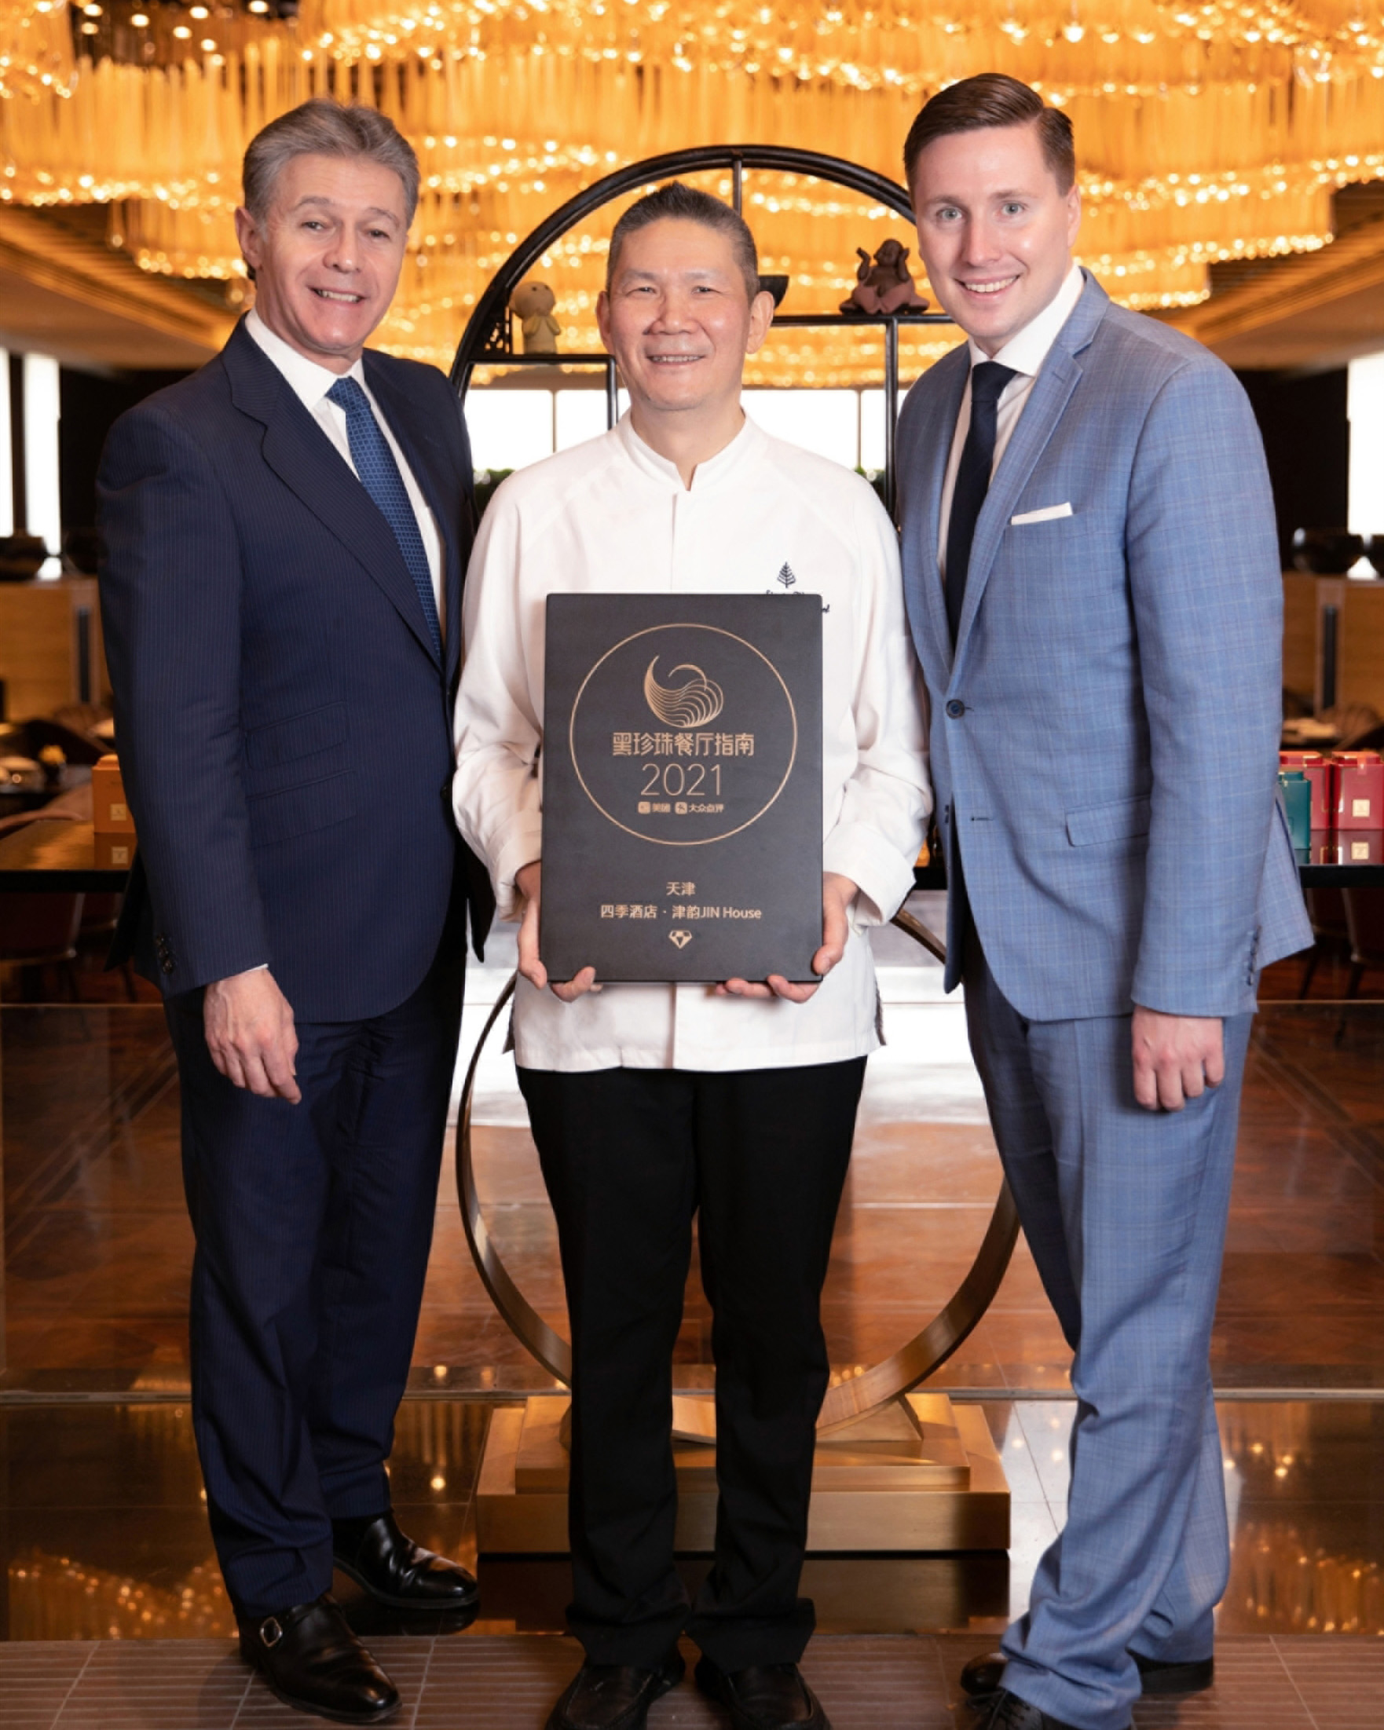 | 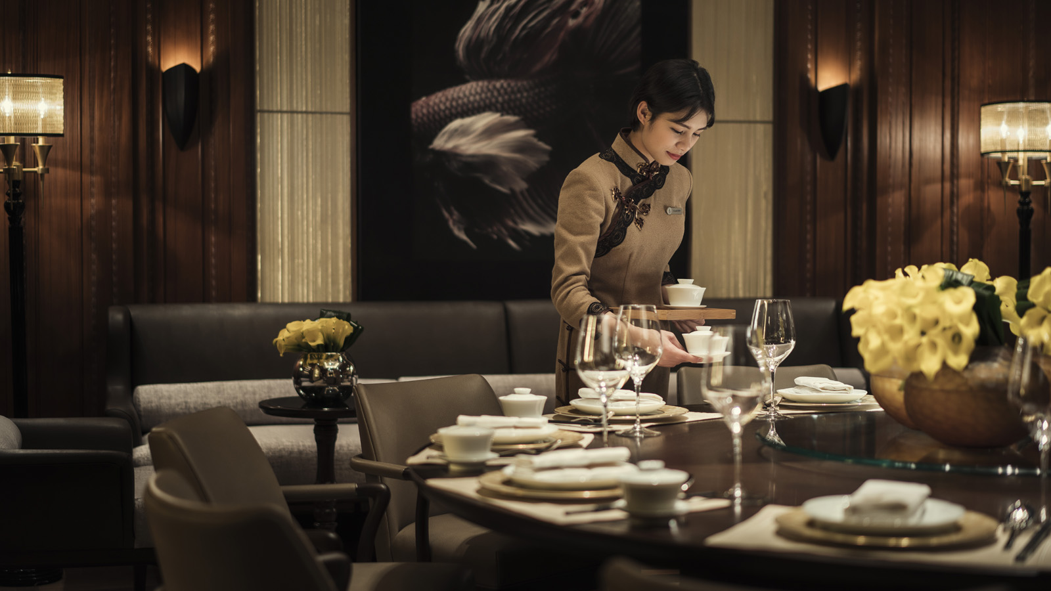 | 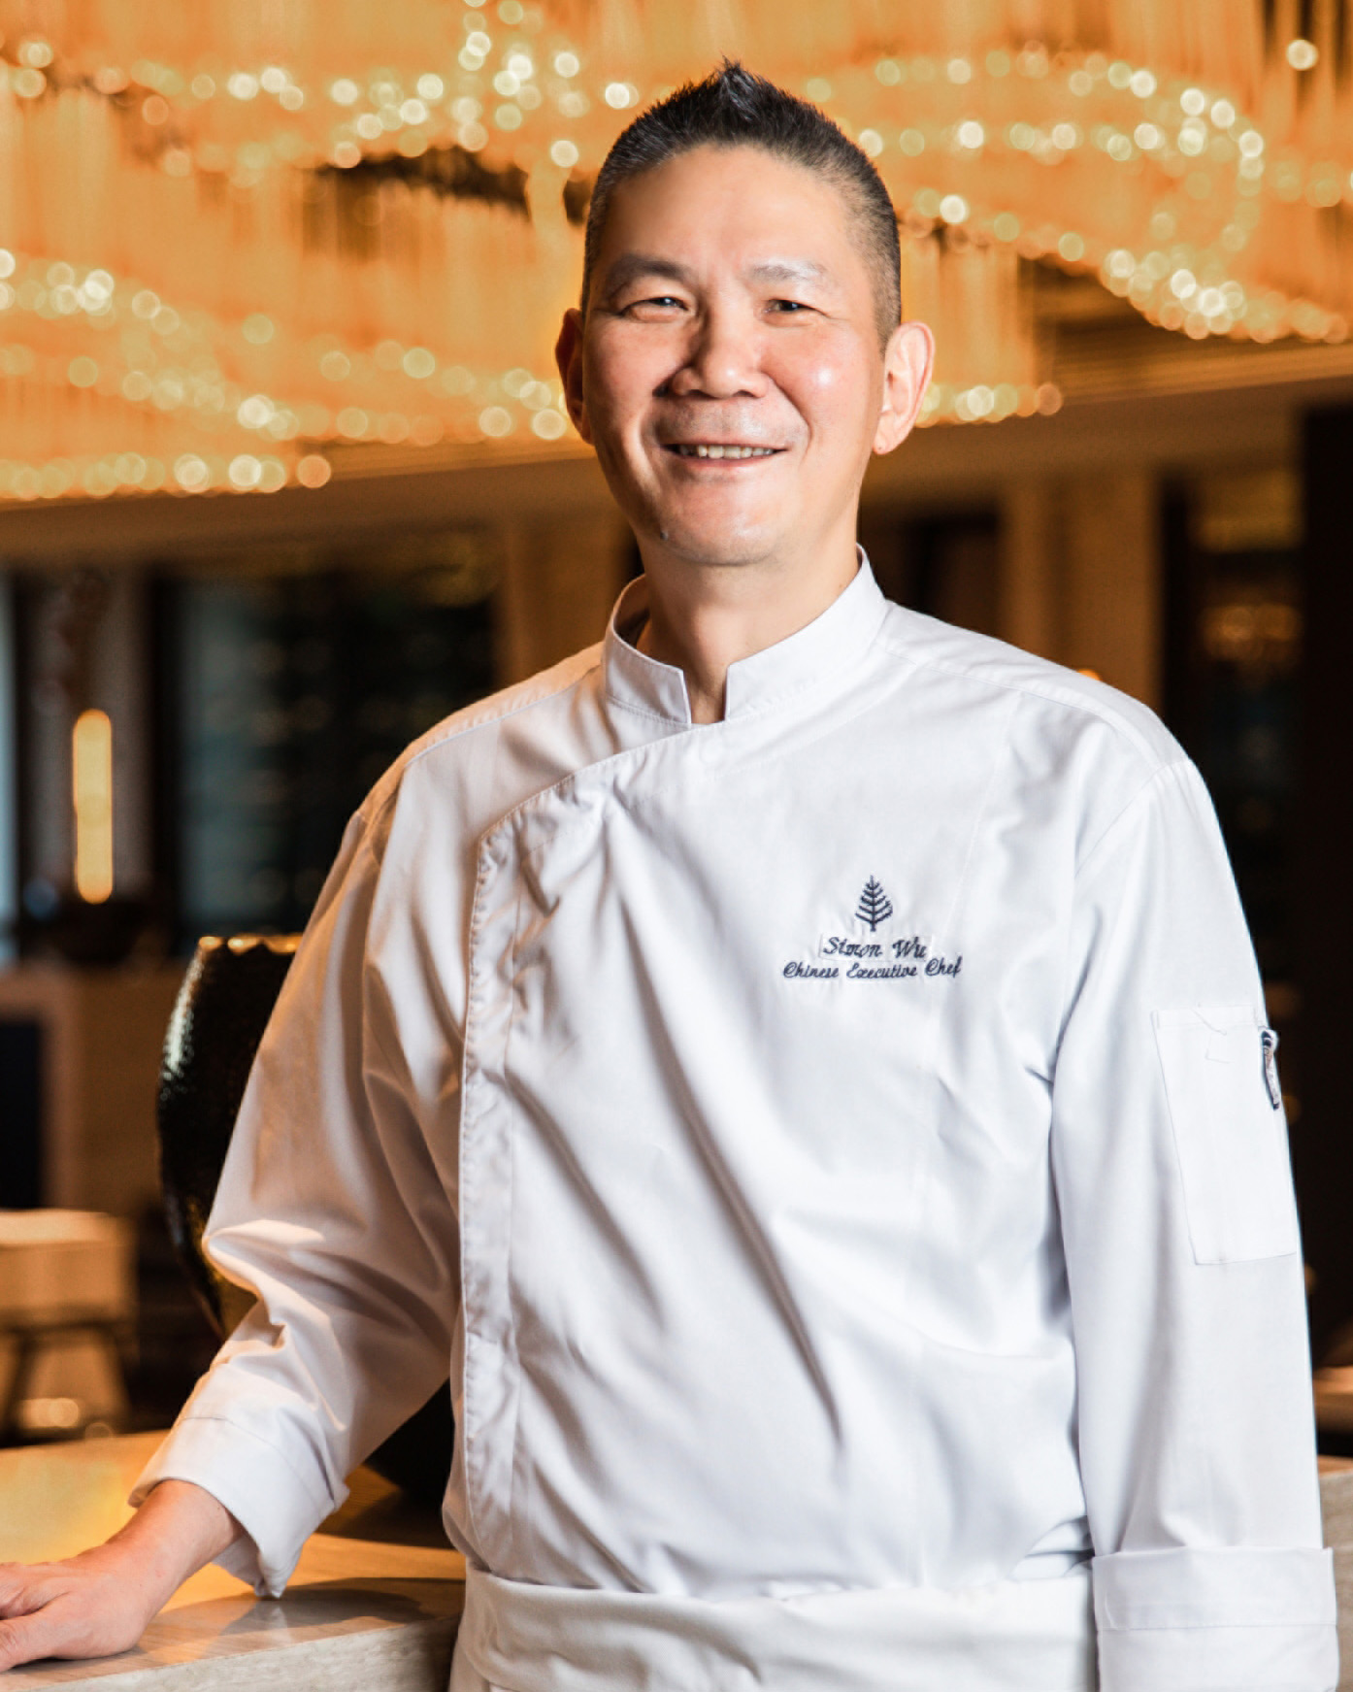
On March 26, 2021, Meituan-Dianping unveiled the 2021 edition of the Black Pearl Restaurant Guide in Yangzhou. Jin House Chinese restaurant at Four Seasons Hotel Tianjin has retained its listing on the Black Pearl Guide for the 4th consecutive year and received one diamond. As the only hotel and Cantonese restaurant in Tianjin to earn this recognition in 2021, the Hotel has once again established itself as a regional leader in culinary excellence.
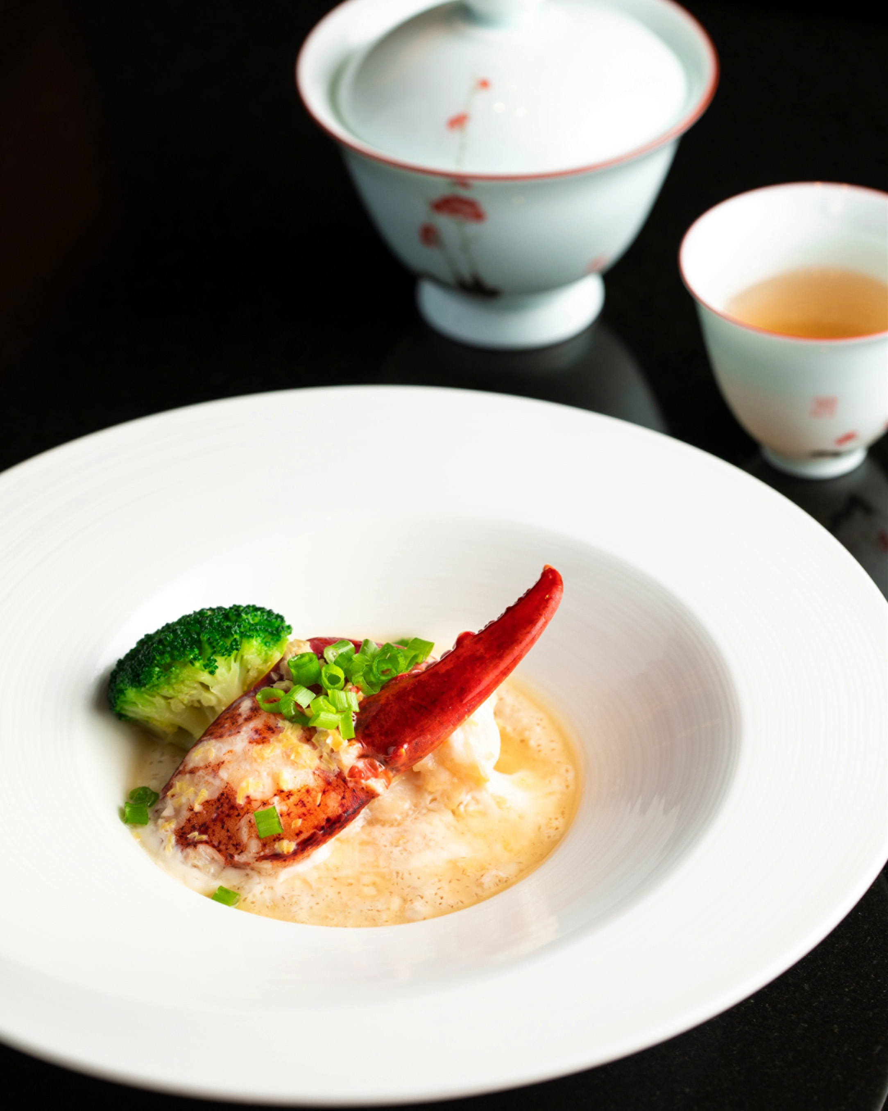 | 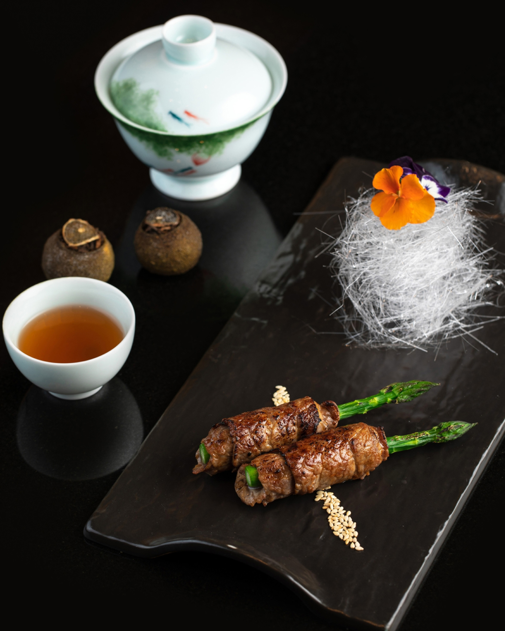 | 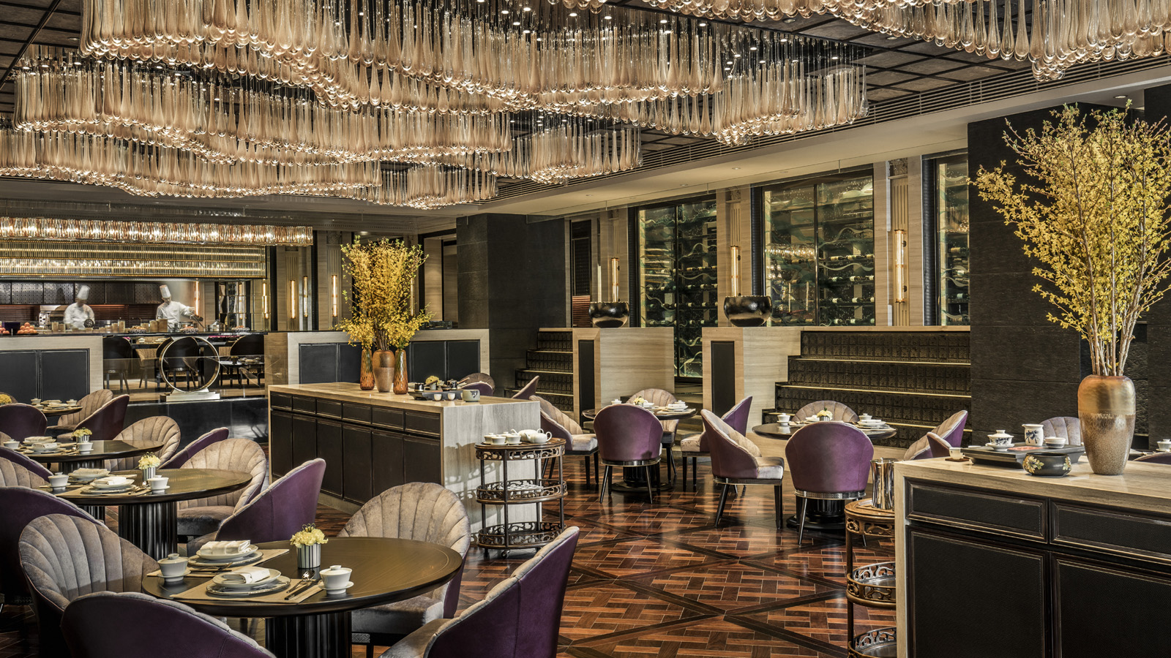
General Manager Julien Carralero comments, “We are thrilled that the Black Pearl Guide judges have once again awarded us the distinction. Despite the extremely challenging situation facing hoteliers and restaurateurs since the beginning of the COVID crisis, our chefs and their teams have continued to be passionate and creative, sharing with guests their culinary craftsmanship. We look forward to welcoming guests again to enjoy extraordinary gastronomic experiences in Jin House.”
Building on Meituan-Dianping’s incredibly popular restaurant review and rating platform, the Black Pearl Restaurant Guide focuses on the high-end dining scene for foodie visitors looking to explore the city's best dining spots. The restaurants are selected based on anonymous voting by a panel of judges with expertise in China's dining sector, combined with big data analysis and the opinions of the Meituan-Dianping Board of Directors.
Offering sophisticated Cantonese cuisine, Four Seasons Chinese Executive Chef Simon Wu is driven by the relentless desire to constantly refine his culinary creations. Influenced by his Hong Kong roots, Chef Simon is focused on keeping dishes authentic and infusing the classics with a modern twist.
Selected to participate in the Black Pearl Chef’s Week event initiated by Meituan-Dianping from March 27 to April 18, 2021, Chef Wu has created two celebratory 8-course set menus with signature and seasonal delicacies at Jin House. Featuring food and tea pairing and a personal greeting from Chef Simon, the set menus also include a secret dish as a special surprise for guests.
To find out more about the above new offering, contact Jin House at Four Seasons Hotel Tianjin at 022-2716 6187 / 6688.

RELATED

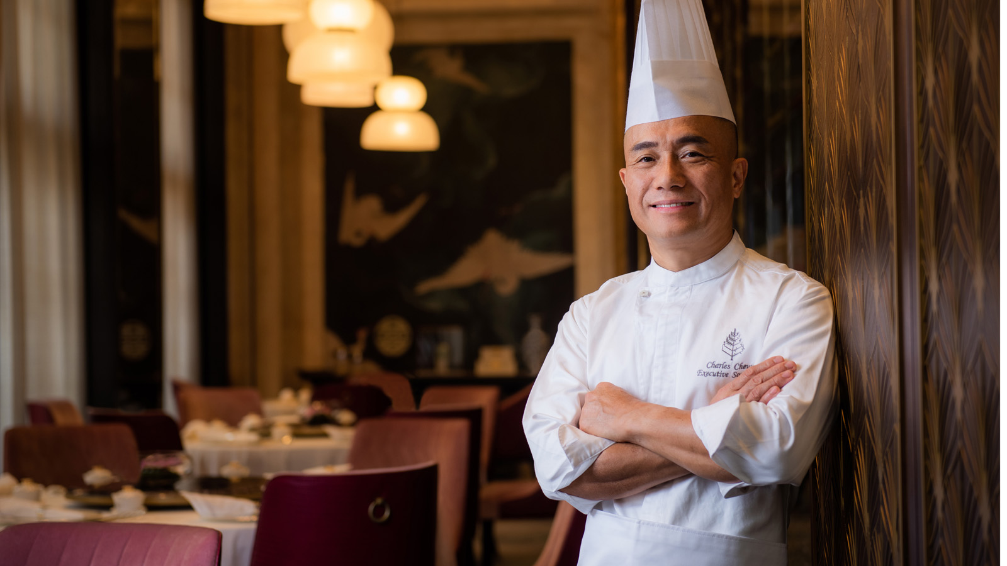 | March 29, 2021, Macau, China  Zi Yat Heen at Four Seasons Hotel Macao Recognised at 2021 Black Pearl Restaurant Guide Awards  https://publish.url/macau/hotel-news/2021/zi-yat-heen-black-pearl-award.html
March 29, 2021, Macau, China
澳门四季酒店紫逸轩 荣获「2021年黑珍珠餐厅指南」殊荣
https://publish.url/zh/macau/hotel-news/2021/zi-yat-heen-black-pearl-award-2.html

PRESS CONTACTS

Lucy Zhang
Director of Public Affairs
138 Chifeng Road
Tianjin
China
lucy.zhanglx@fourseasons.com

+86 22 2716 6187

