Sip, Savour and Groom with Whiskey Wednesdays at the Nail Bar

February 19, 2016, Hong Kong, China

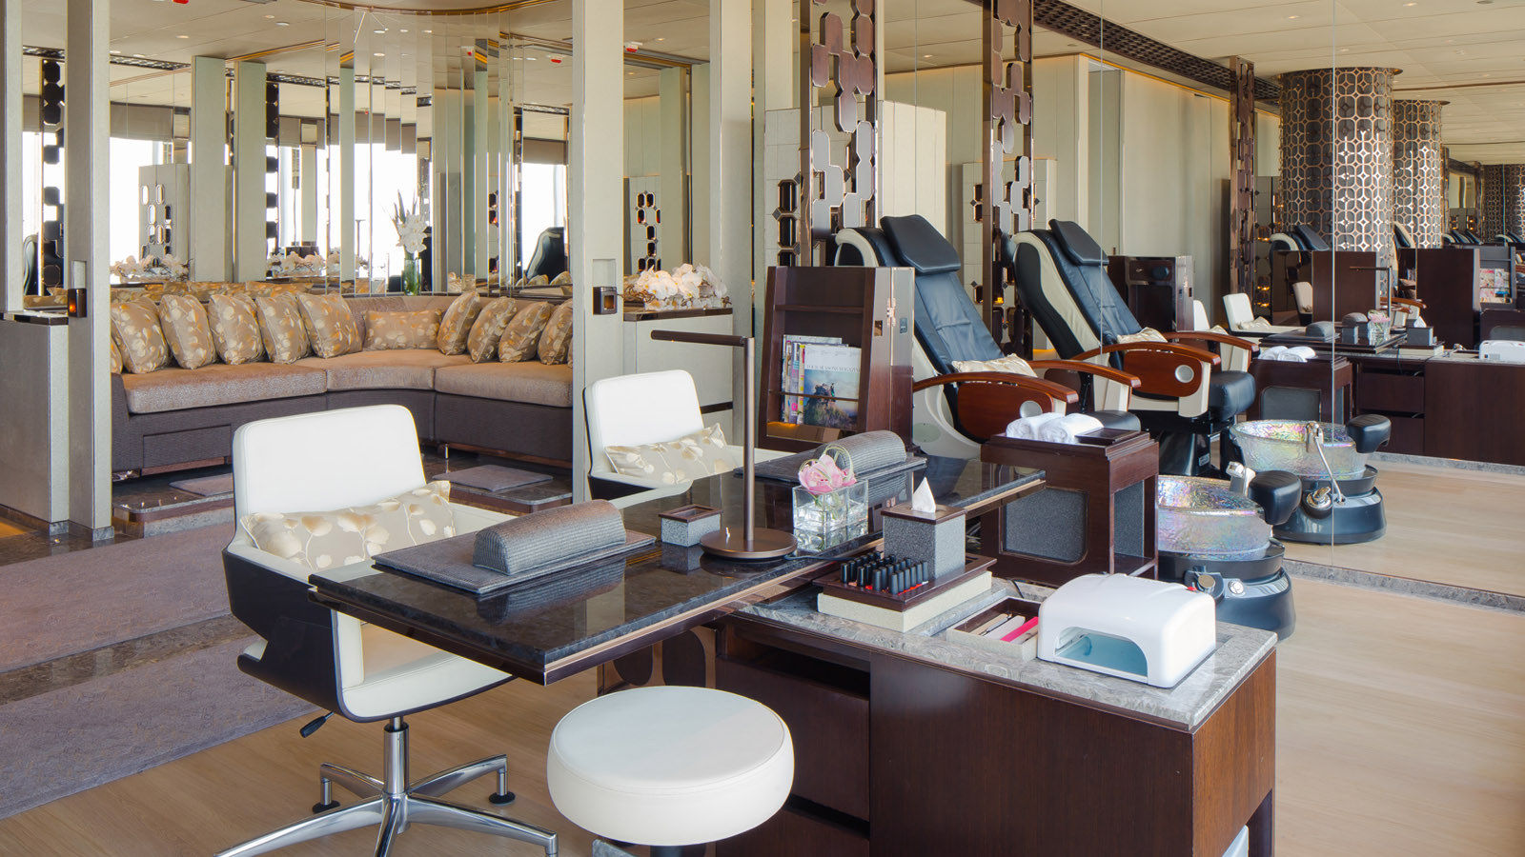
 | 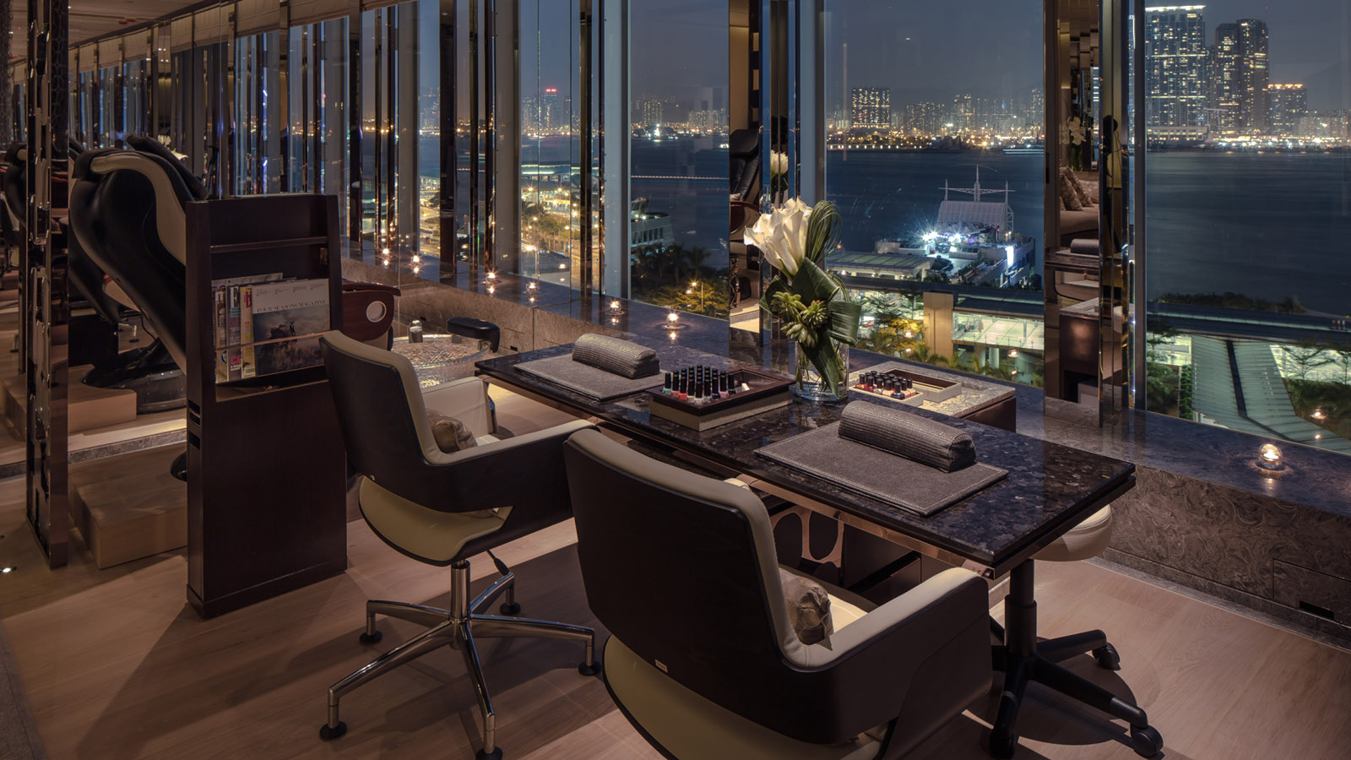 | 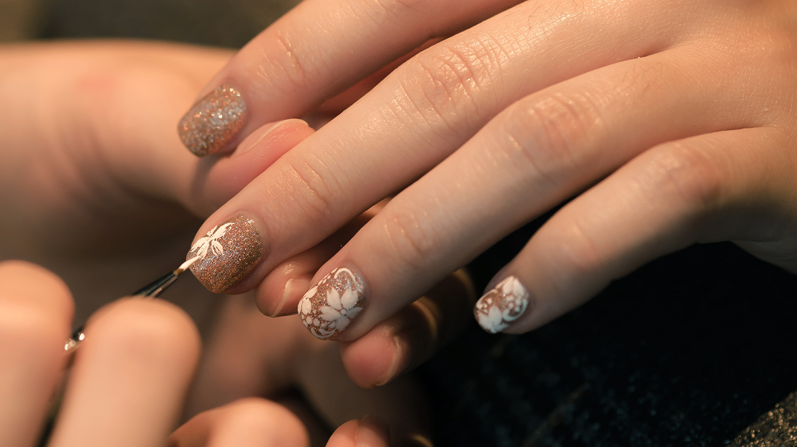
After surviving Monday’s blue and Tuesday’s grey, you might find yourself in need of a mid-week pick-me-up. Enter the Nail Bar at
Four Seasons
Hotel Hong Kong, where relaxation and luxury now meet the world’s finest spirits with Whiskey Wednesdays. Watch the tension melt away sipping your favourite tipple while our therapists breathe new life into your hands and feet.
Every Wednesday, with the purchase any hand and foot treatment, you will get a complimentary whiskey tasting. Catering up to only five guests at a time, you will be treated with your own personal window overseeing the sparkling view of Victoria Harbour. Sink into a leather massage chair to unwind solo or bring along your friends for an indulgent new twist on after-work drinks.
The Nail Bar debuts the first theme, 18 & Single, on February 24, 2016, featuring a flight of 18 year old single malt whiskies handpicked by Tommy Kong, Beverage Manager of the Hotel. Accompanied by a digital step-by-step tasting guide, Kong makes sure every guest knows how to fully appreciate the “water of life.” The theme changes every three weeks, allowing you to swirl and enjoy a different line up of whiskey just in time for your next manicure.
Get perfectly manicured hands or feet at the Nail Bar on Wednesdays and wind up the day with a glass of whiskey. If polish is not your taste, opt for the deeply restorative Pure Therapy for Your Hands or Feet, or Reflexology Remedy. Wednesdays just got a lot more fun.
Whiskey Wednesday at The Nail Bar at
Four Seasons
Hotel Hong Kong runs from 5:00 to 9:00 pm every Wednesday. Treatments are priced from HKD 700 on Wednesdays.
For reservations, contact the Spa team at 3196 8900 or email spa.hkg@fourseasons.com.

RELATED

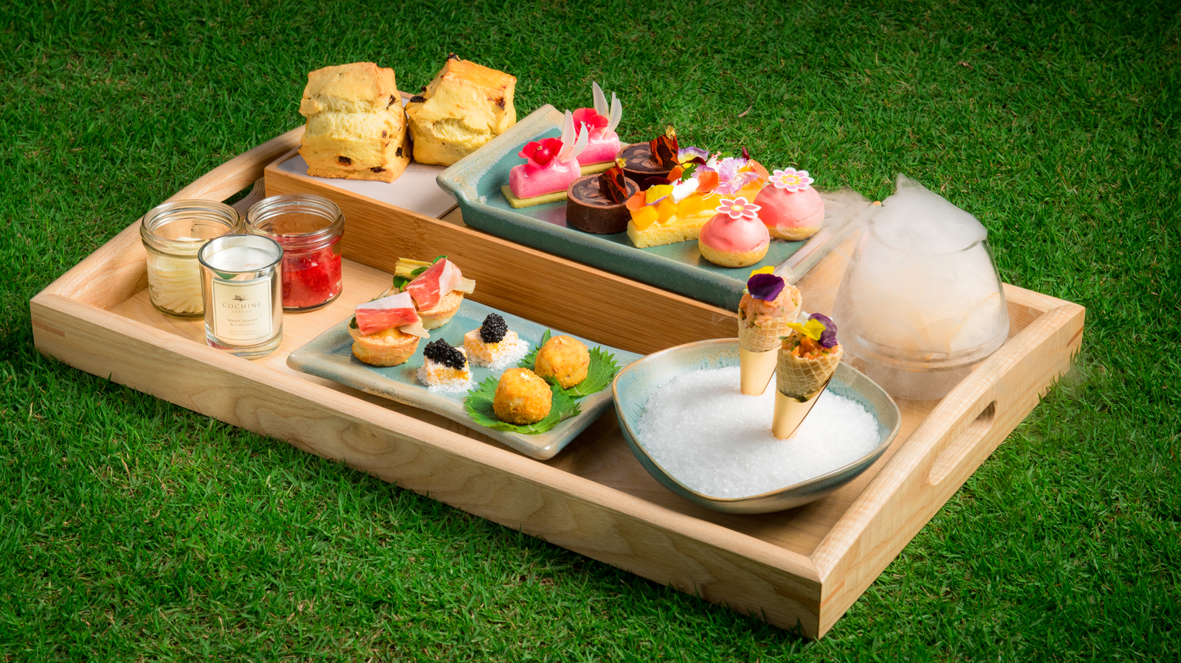 | April 12, 2017, Macau, China  Four Seasons Hotel Macao Launches Exclusive Mother’s Day Afternoon Tea Set  http://publish.url/macau/hotel-news/2017/mothers-day-tea.html
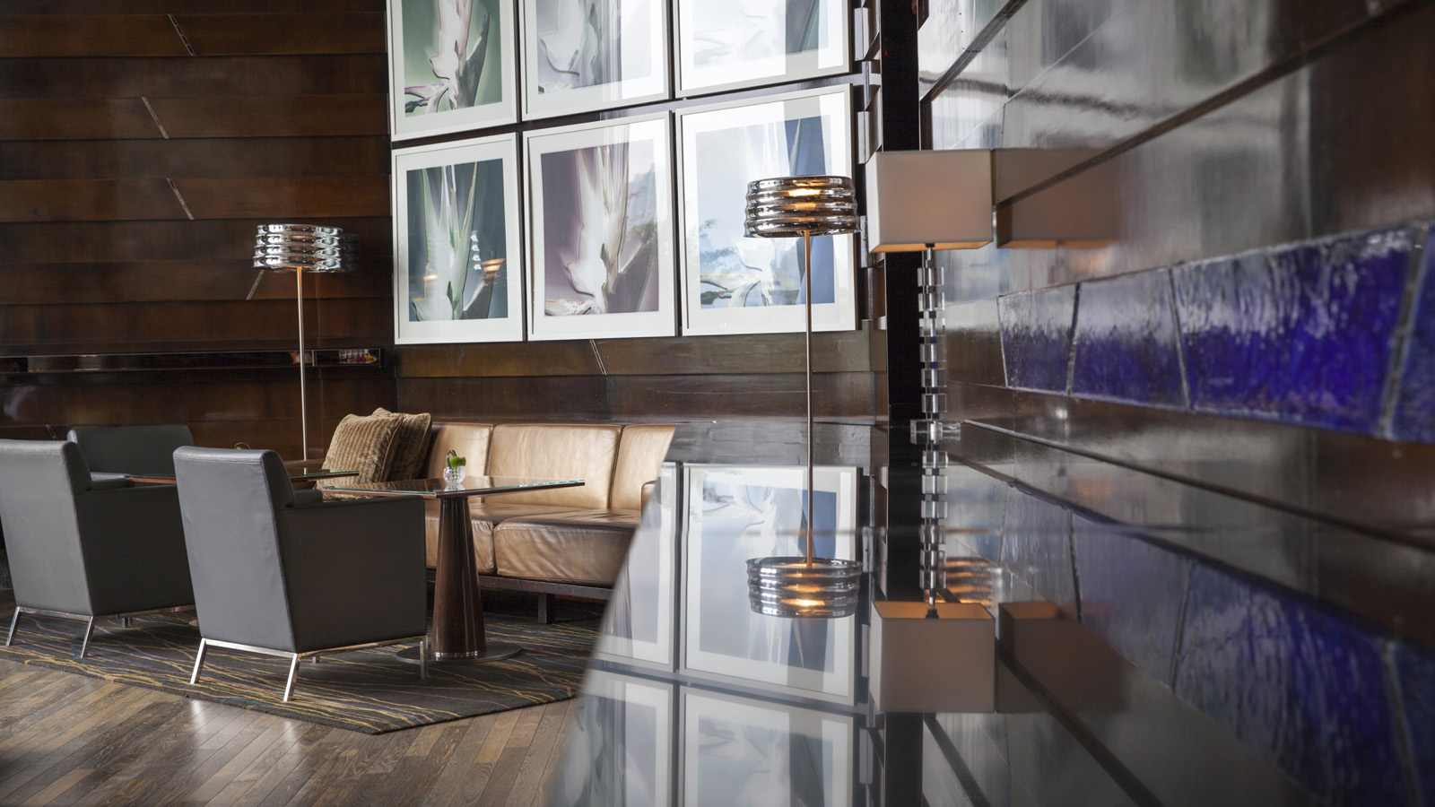 | April 11, 2017, Hong Kong, China  全球最佳酒吧 The Dead Rabbit 登陆香港四季酒店  http://publish.url/zh/hongkong/hotel-news/2017/the-dead-rabbit-bar-event-3.html

PRESS CONTACTS

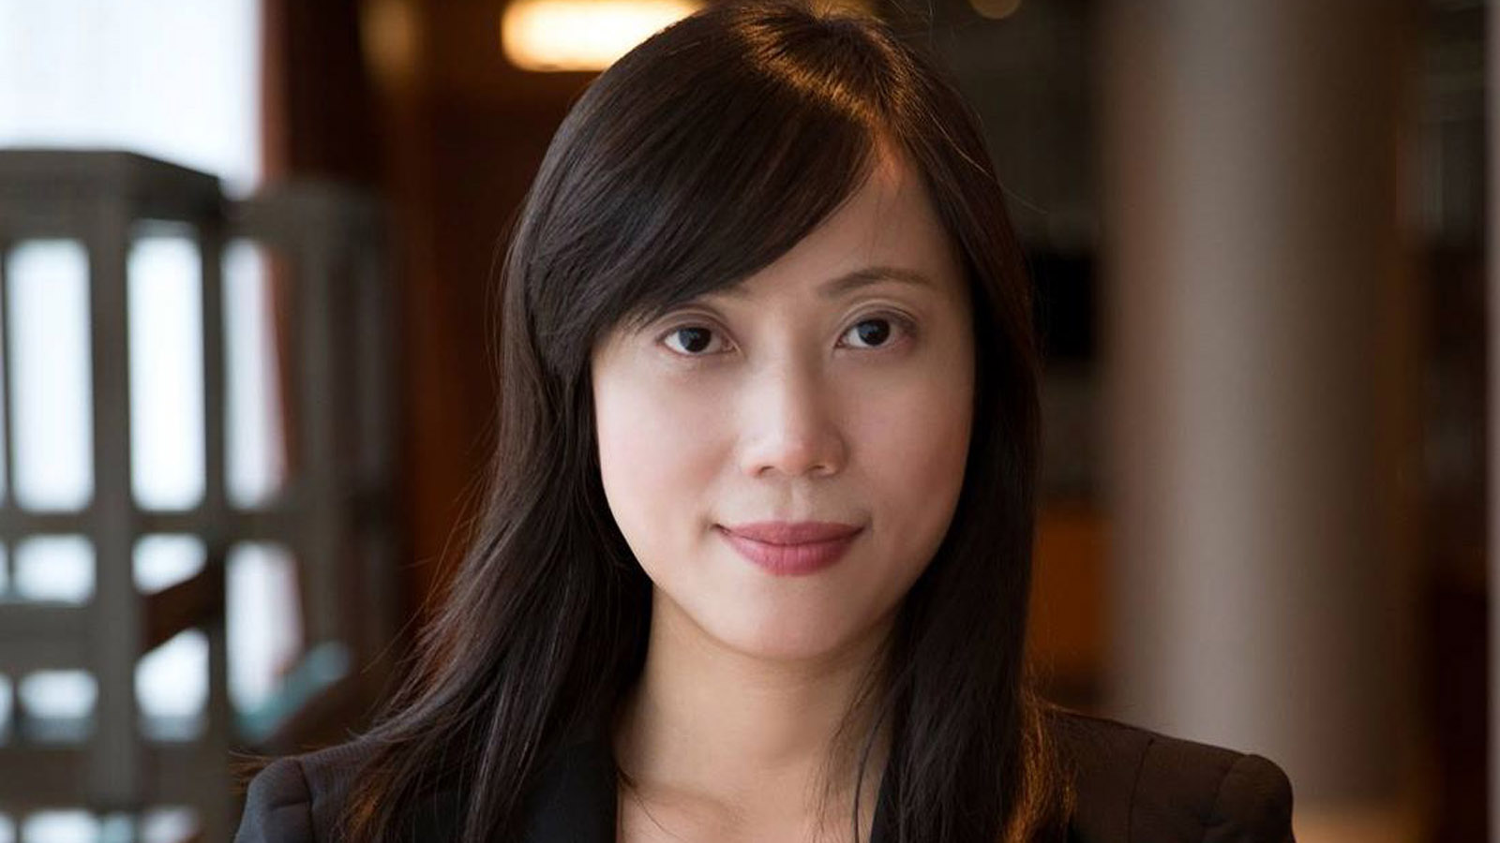 | Mimi Cheung  Digital Marketing Manager  8 Finance Street, Central  Hong Kong  China  mimi.cheung@fourseasons.com  852 3196 8317
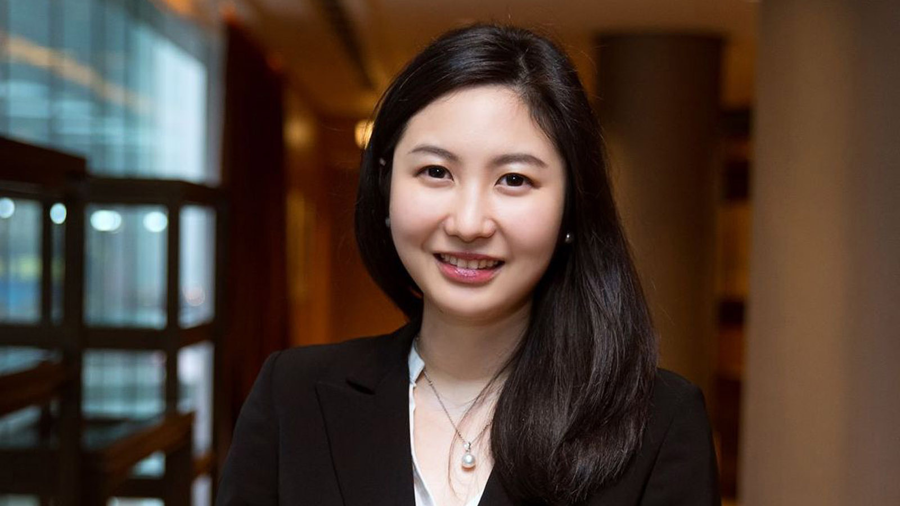 | Priscilla Chan  Public Relations Manager  8 Finance Street, Central,  Hong Kong  China  priscilla.chan@fourseasons.com  (852) 3196 8307
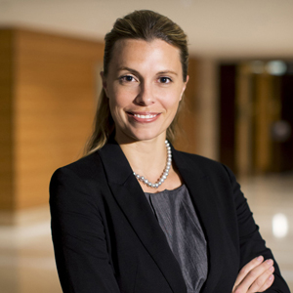 | Amy Powell  Director of Public Relations and Communications  8 Finance Street, Central  Hong Kong  China  amy.powell@fourseasons.com  +852 3196 8306
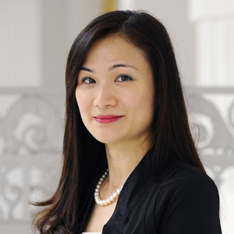 | Vivian Koh  Director, Public Relations and Content, Asia-Pacific  Tourism Court, 1 Orchard Spring Lane #04-01  Singapore  Singapore  vivian.koh@fourseasons.com  +65 6739 5806

