Four Seasons Hotel Seoul Retains Forbes Five Star Rating for Fourth Consecutive Year
- Forbes Travel Guide 2023 recognizes Four Seasons Hotel Seoul as a luxurious hotel for its exceptional services and sensuous interior, among other standout features
- The Spa also earns a seven-year run with its four-star rating, making it the only spa in Korea to achieve such a feat

February 15, 2023, Seoul, Korea

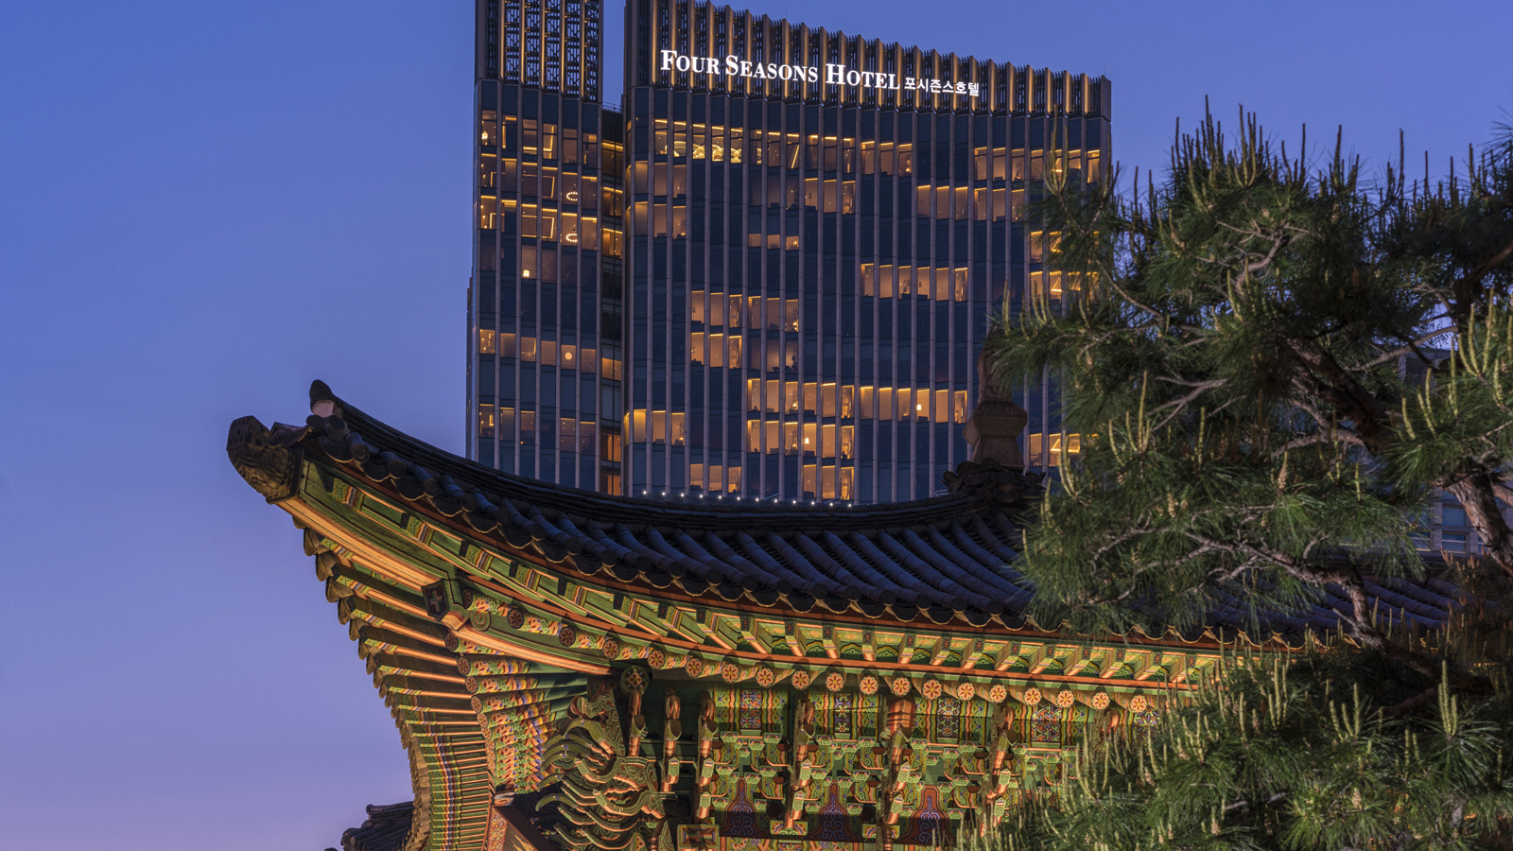
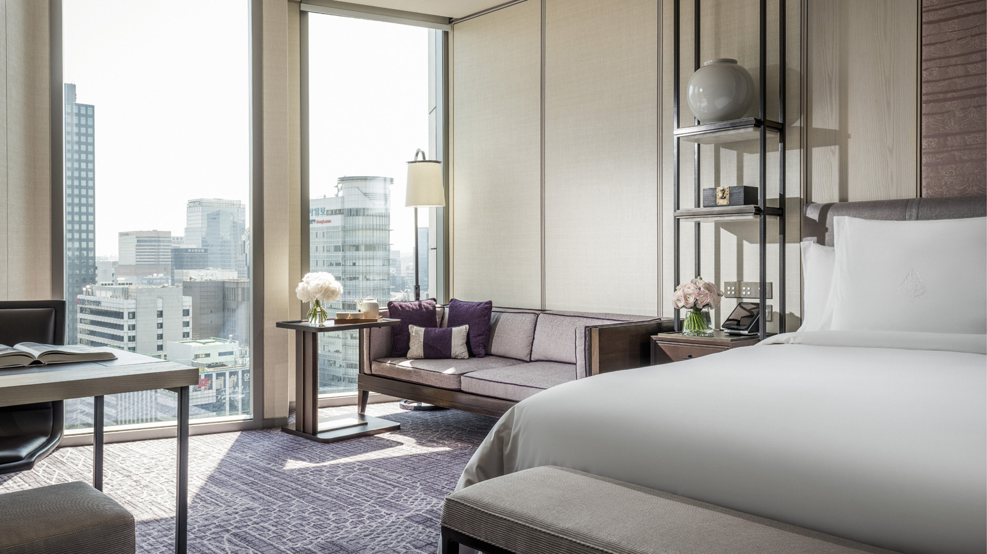 | 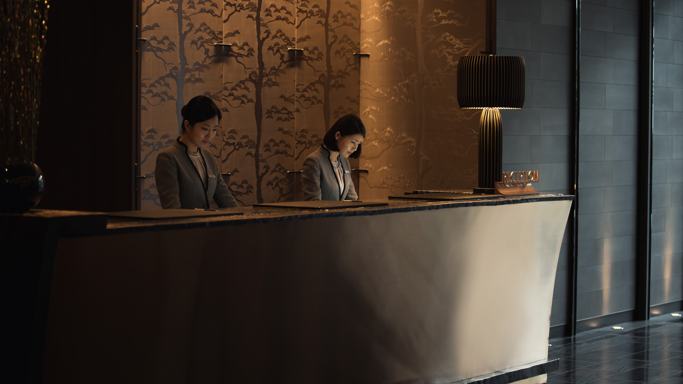
Four Seasons Hotel Seoul has maintained its Forbes Five Star status for the fourth consecutive year, as announced by Forbes Travel Guide 2023 on February 15, 2023. The Hotel, which stands tall with 29 glittering stories in the heart of Seoul, was recognized for its exceptional services, sophisticated features, and “sensuous interior” by anonymous professional inspectors. The Spa also maintained its status with a Four Star rating, making it the only spa in Korea with a seven-year run of Forbes-rated spas.
Forbes Travel Guide has been assisting discerning travellers in choosing the best experiences worldwide for more than 60 years, making it the only independent, global rating system for luxury hotels, restaurants, and spas. Inspectors assess properties based on 900 objective standards and define Five Star properties as “outstanding, often iconic properties with virtually flawless service and amazing facilities."
Since opening in 2015, Four Seasons Hotel Seoul has become Korea's leading luxury escape, providing world-class services, high-tech conveniences, and a heartfelt connection to Asia's bustling metropolis. Classic Korean nature motifs and modern aesthetics adorn the décor, reflecting the surrounding mountain backdrop and views of Gyeongbokgung and Changdeokgung Palaces. The Spa offers a decadent Korean sauna with cold, warm, and hot baths, all decorated with 18-carat gold tiles, signature treatments, and a picturesque sunlit pool with a juice bar.
The Hotel features eight distinct restaurants and bars, including award-winning Yu Yuan and the secret speakeasy Charles H., ranked as the Best Bar in Korea and one of the Asia's 50 Best Bars. The Hotel’s 196 square metres (23,638 square feet) of light-filled function space includes five ballrooms for up to 800 guests, two executive boardrooms, and a stunning 15th-floor Garden Terrace. Additionally, the Hotel offers the latest virtual technology for cutting-edge hybrid events.
Forbes Travel Guide first visited Korea in 2017 and awarded Four Seasons Hotel Seoul with its first Four Star rating. The Hotel has held the coveted Five Star accolade since 2020, establishing it as one of the premier luxury destinations in the city.
For reservations, call 02-6388-5000 or book online.

RELATED

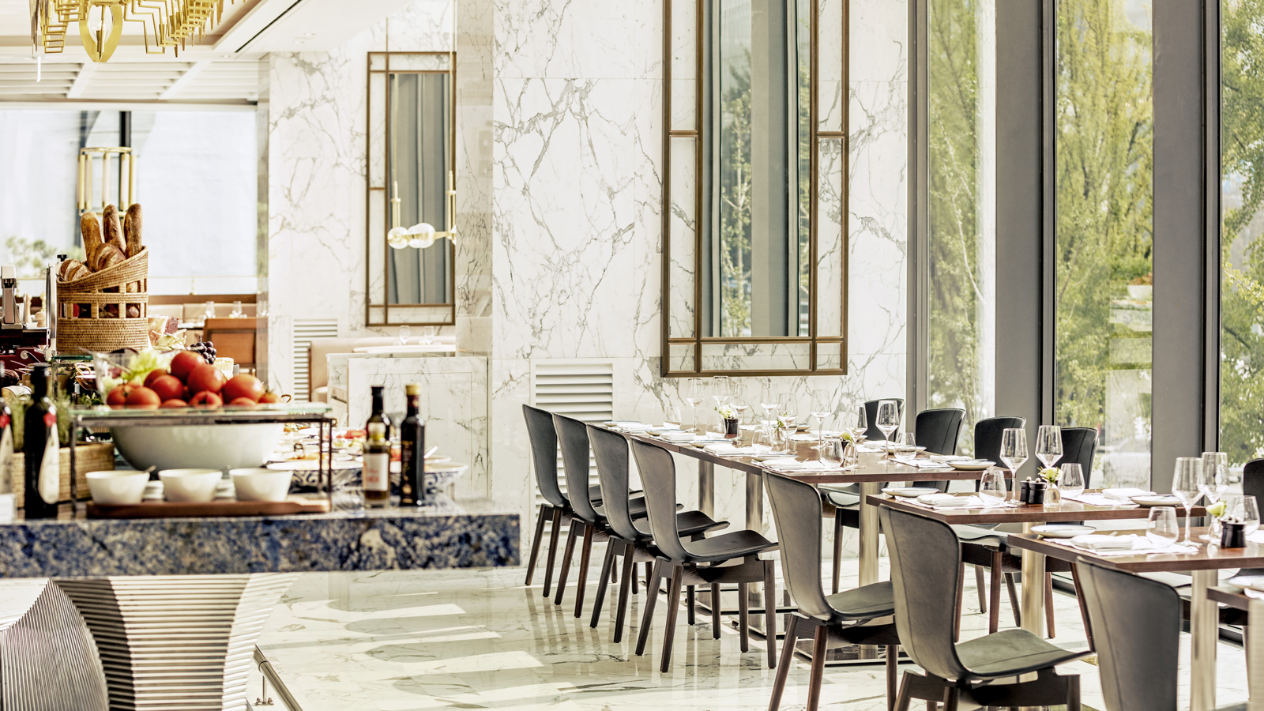 | March 3, 2023, Seoul, Korea  Four Seasons Hotel Seoul Brings a Vibrant Taste of La Dolce Vita with New Italian Lunch Delight Set Menu at Boccalino  https://publish.url/seoul/hotel-news/2023/set-lunch-at-boccalino.html
March 3, 2023, Seoul, Korea
‘가성비&가심비 갑’ 고품격 이탈리안 다이닝 즐기기
https://publish.url/kr/seoul/hotel-news/2023/set-lunch-at-boccalino-2.html

PRESS CONTACTS

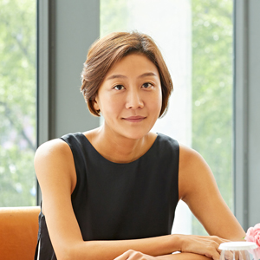 | Inyoung Moon  Director of Public Relations and Communications  97 Saemunan-ro, Jongno-gu  Seoul  Korea  inyoung.moon@fourseasons.com  82 2 6388 5044
Kelly Wong
Director of Marketing
97 Saemunan-ro, Jongno-gu
Seoul
Korea
kelly.wong@fourseasons.com

82 2 6388 5001

