Hit the Decks this Festive Season at Four Seasons Resort Mauritius at Anahita

Resort set to host a DJ competition for younger guests this Christmas and New Year with resident DJ Ashley Gai
December 18, 2017, Mauritius

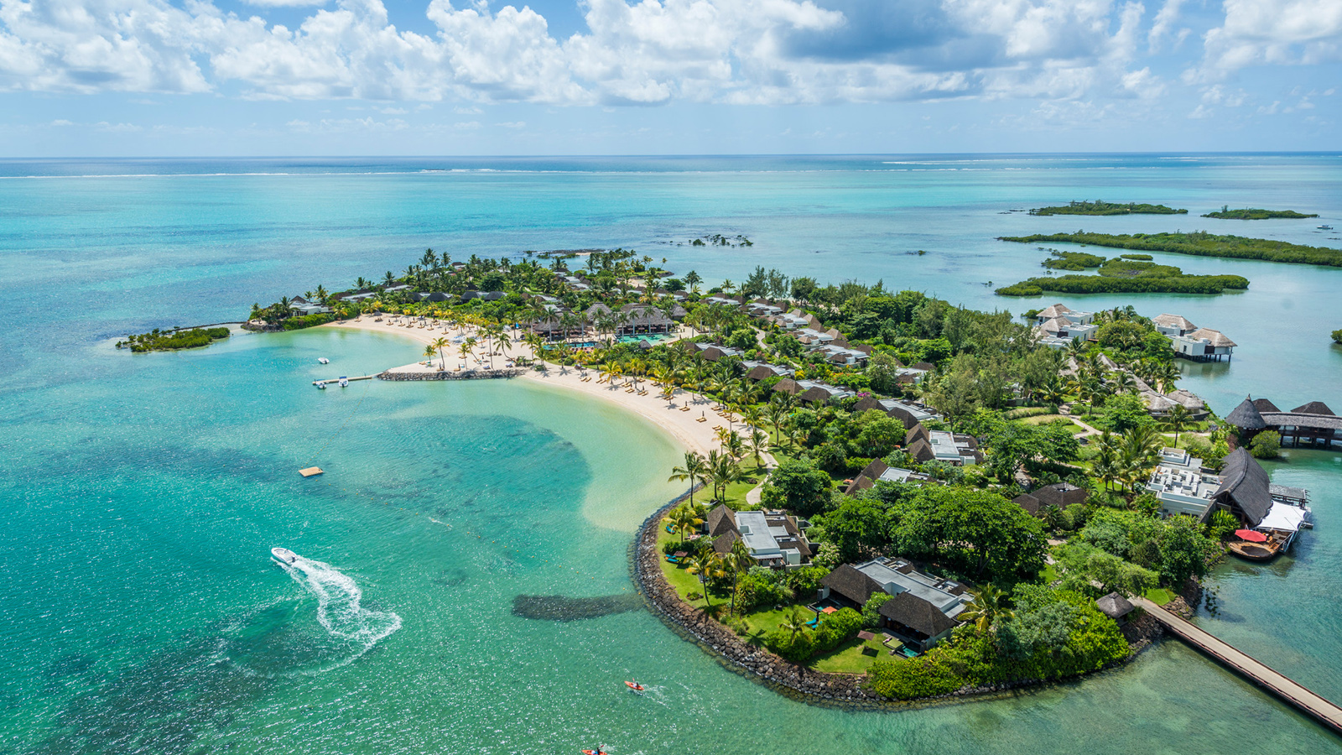
 | 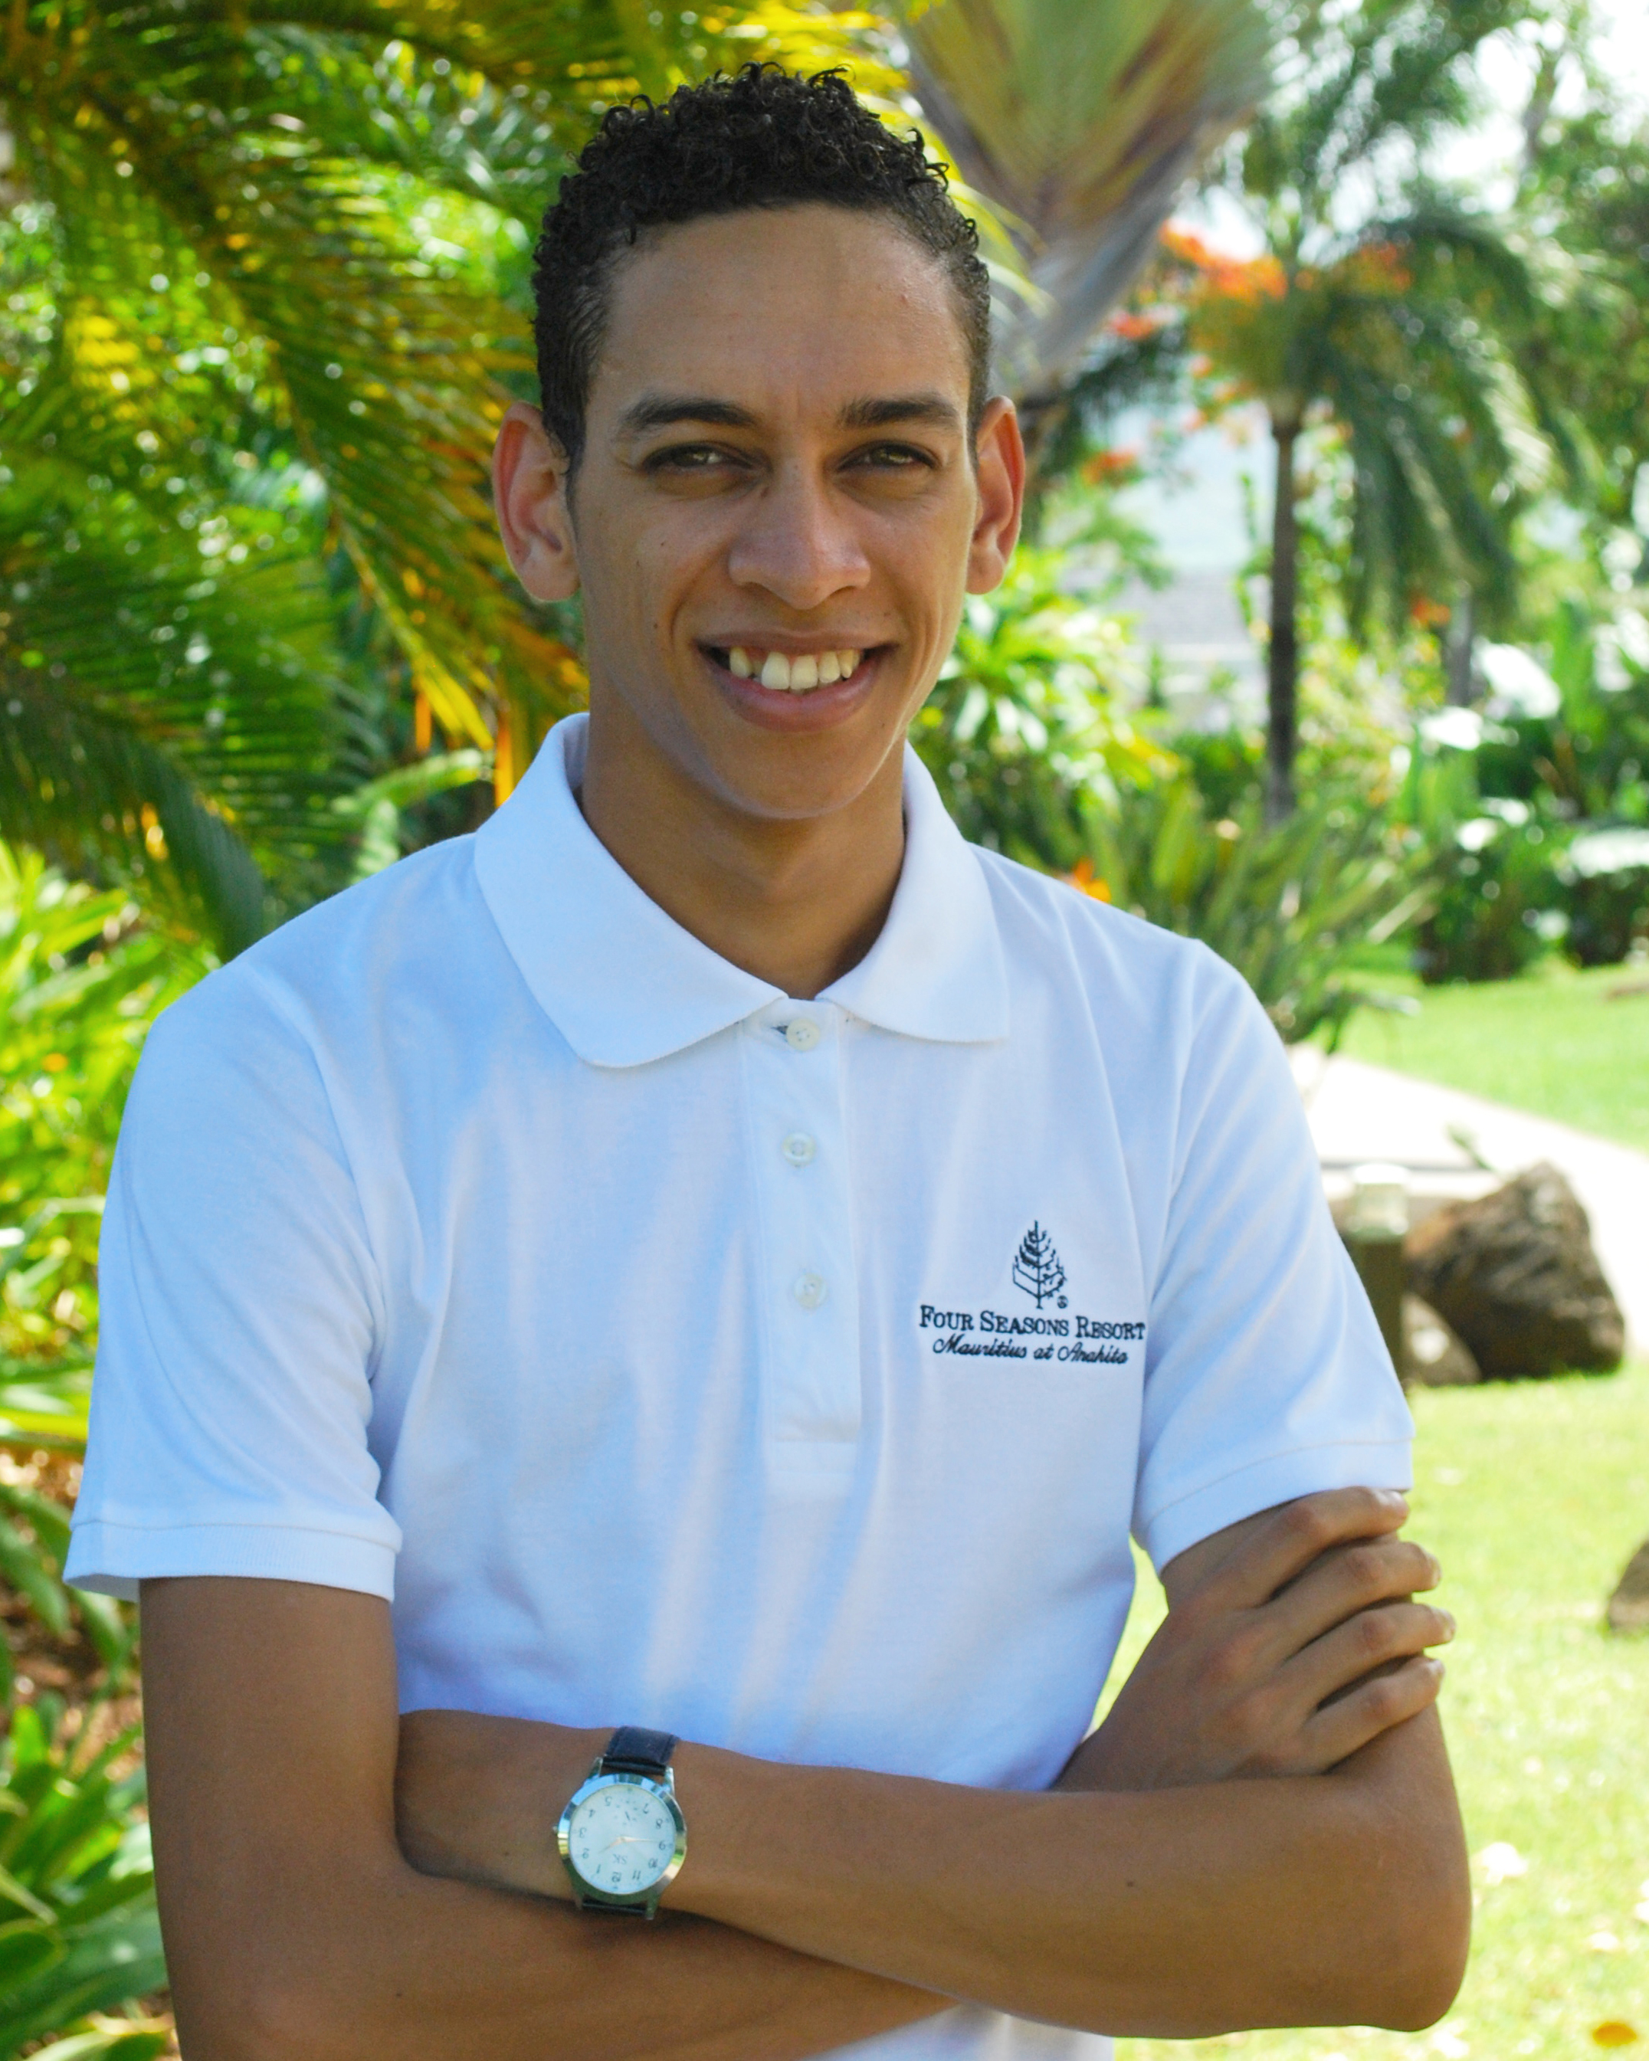 | 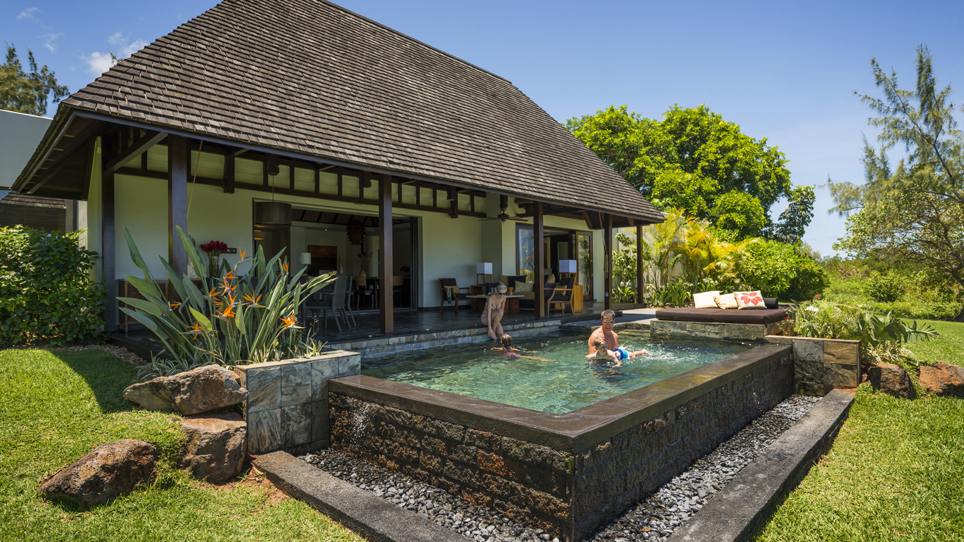
With the countdown to New Year underway, younger guests staying at
Four Seasons
Resort Mauritius at Anahita this festive season can prepare to be among the top performers for the New Year celebrations thanks to the launch of a new young DJ competition at Karokan Young Adults' Centre.
Open to children and teenagers as from age 10 staying at the Resort, Karokan provides a place to play and hang out under the supervision of a dedicated Four Seasons team. Activities on offer range from table tennis to beach football, sailing, golf initiations and now, DJ lessons and an exclusive DJ competition. The competition is being launched for the festive season, where the grand prize* is a one night complimentary stay at the Resort for their family, where all meals and beverages are included for the young winning DJ.
Commenting on the competition, resident DJ Ashley Gai says: "I began deejaying at the age of 15 and it quickly became a passion for me; I love to see how I can incorporate different music styles into my sets. The decks in Karokan are my favourite place in the Resort and I am excited to have the chance to teach and guide new aspiring DJs during this special time of year, for what is sure to be a fantastic competition."
Ashley Gai will run four 30-minute DJ sessions between December 26 and 29, 2017, which will be open to all children and teenagers as from age 10 staying in the Resort. During these sessions, each young DJ will have the chance to learn mixing steps and to master new tricks under Ashley's guidance, with every participant receiving a recording of their mix to take home.
For the final on December 30, 2017, the young DJ contenders will perform to Ashley and the Resort's management team during a "spin off" at Karokan, where the star prize of a one night family stay awaits.
"The atmosphere in the Resort during the festive season is extremely special. The energy and excitement from children is felt around the property and our team are always looking for ways to make their stay even more memorable," comments Michel Volk, General Manager of
Four Seasons
Resort Mauritius at Anahita. "With us being fortunate to have the talents of Ashley among our team and a DJ booth in Karokan itself, I am sure there will be some fierce and fun-filled competition at the finale on December 30 to add even more sparkle to the festive celebrations!"
All year round, Karokan is open daily from 10:00 am to 11:00 pm. Further family amenities include a Hobbit Village Kids' Club, a choice of watersports in the Resort's protected lagoon waters, children's menus in all three restaurants and spacious pool villas that range from one to five bedrooms. Rates during the festive season start as from EUR 1,910 er night, inclusive of daily breakfast and complimentary golf on the Ernie Els Design course.

*The prize is a one night stay for a future reservation for up to a family of four (two adults and two children) in a Two Bedroom Garden Residence Villa, inclusive of breakfast for the whole family and all meals and beverages for the young, winning DJ. Prize excludes alcoholic beverages. Blackout dates may apply.

RELATED

February 12, 2018, Mauritius
Introducing the New Sleep Improvement Ritual at Four Seasons Resort Mauritius at Anahita
https://publish.url/mauritius/hotel-news/2018/sleep-improvement-ritual.html

December 18, 2017, Mauritius
Mettons-nous aux platines pour les fêtes de fin d’année au Four Seasons Resort Mauritius at Anahita
https://publish.url/fr/mauritius/hotel-news/2017/young-adult-dj-competition-2.html

PRESS CONTACTS

Debbie Duval
Director of Public Relations and Communications

Beau Champ
Mauritius
debbie.duval@fourseasons.com

(230) 402 3100

