Celebrate the Fourth of July with Unforgettable Experiences at Four Seasons Hotel Boston

June 10, 2019, Boston, U.S.A.

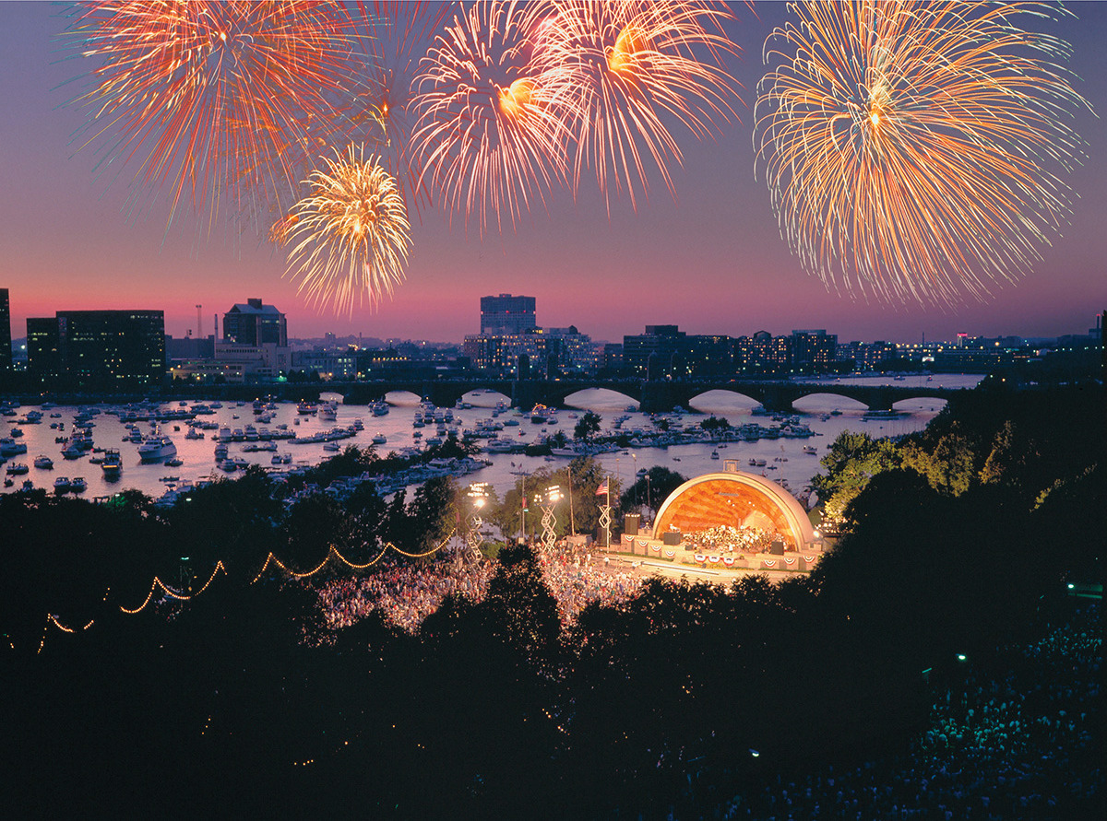
There is no better place than Boston for families to enjoy the ultimate Fourth of July experience. Guests of Four Seasons Hotel Boston have the very best of the city at their fingertips, and New England’s capital enchants visitors and locals alike with unforgettable offerings that pay tribute to the birth of a nation.
City-Wide Celebrations
Within walking distance from Four Seasons Hotel Boston guests can delight in Freedom Trail tours, sight-seeing cruises along the Charles River, and even a public reading of the Declaration of Independence at City Hall Plaza as it was read to the citizens of Boston in 1776.
On July 3, the Boston Pops Fireworks Spectacular will kick off at 8:00 pm, and on July 4 an unforgettable fireworks display will begin at 8:00 pm at the Hatch Memorial Shell on the Charles River Esplanade.
Throughout the week, from July 1 through 7, Harborfest, a Boston tradition, takes place with hundreds of activities to celebrate Independence Day weekend at Boston’s best landmarks.
Four Seasons Hotel Boston Family Activities
There is plenty to explore over the holiday weekend within the walls of Four Seasons Hotel Boston, too.
From Wednesday, July 3 through Saturday, July 6, 2019, the Hotel's indoor pool overlooking the Boston Public Garden will host a special "Stars and Stripes Swim" for kids daily from 2:00 to 4:00 pm. Children can enjoy the large indoor pool, complete with festive pool toys, music and refreshing snacks specially created just for kids.
On July 3 at 5:00 pm, families can gather in the lobby for a special telling of the story of the Midnight Ride of Paul Revere, read by a local historian donned in colonial attire. Following the reading, guests can proceed to a kids’ movie night at 6:00 pm with treats from the Four Seasons pastry team for families to enjoy.
And certainly not to be missed, on the Fourth of July from 4:00 to 5:00 pm families can head to the lobby where the Hotel will offer a special "Fireworks Preparation Station." Guests can enjoy crafts and festive giveaways before making their way to the fireworks.
To round out the Fourth of July getaway, on July 6 at 4:00 pm, the Hotel's littlest guests are also welcome to sign up for a special workshop with the esteemed pastry team at Four Seasons. Children can learn how to bake and decorate treats in the Pastry Kitchen, perfectly themed for the holiday.
Finally, to enhance their experience, guests can always book the Kid’s Adventure Package where little ones are treated to in-room tents and a luxury "glamping" experience.
Call 617 338 4400 at least two days prior to make a reservation.

RELATED

April 18, 2019, Boston, U.S.A.
Four Seasons Hotel Boston Welcomes New General Manager Michael Pedder
https://publish.url/boston/hotel-news/2019/new-general-manager-michael-pedder.html

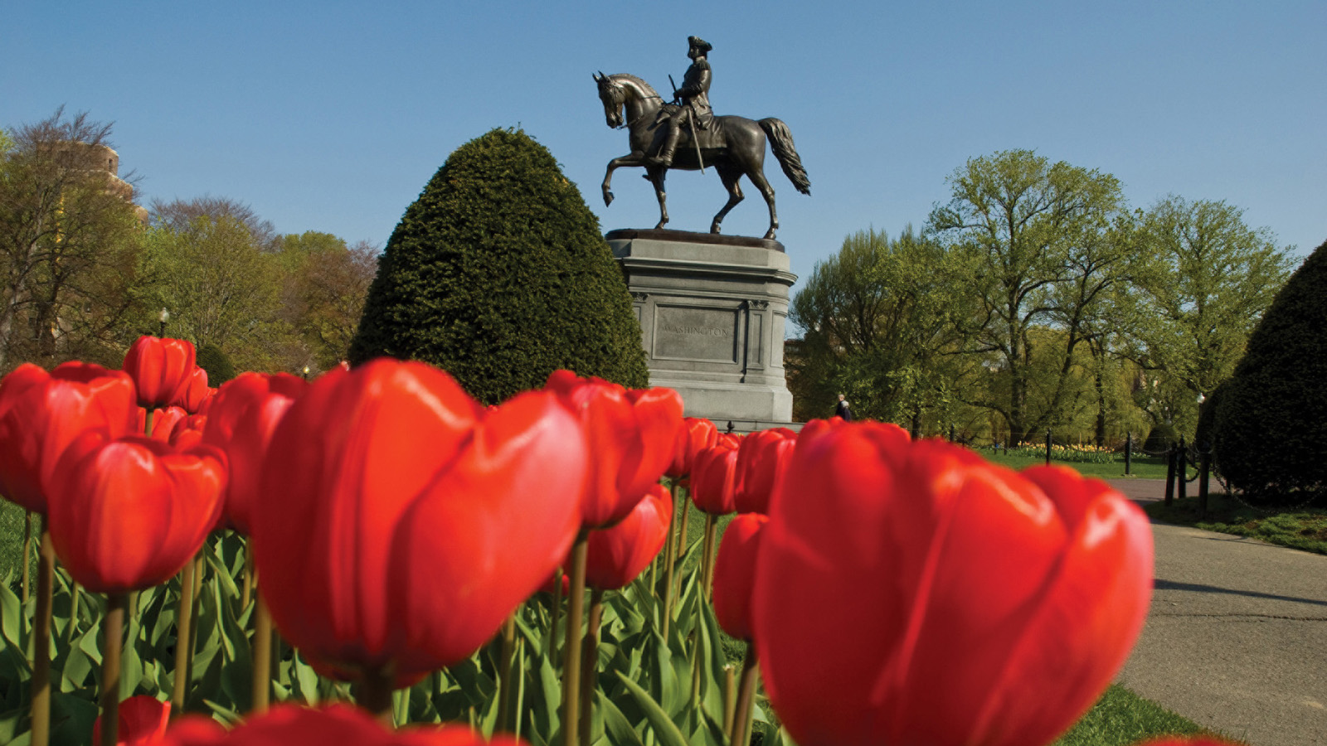 | April 12, 2019, Boston, U.S.A.  Four Seasons Hotel Boston is in Full Bloom, Featuring a Seasonal Pop-Up Bar, Fresh Spring Menus and Unforgettable Offerings for Easter and Mother’s Day  https://publish.url/boston/hotel-news/2019/spring-promotions-and-events.html

PRESS CONTACTS

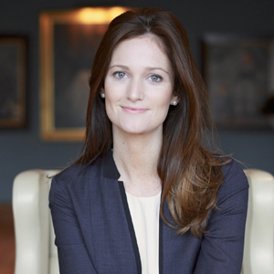 | Maggie Lawler  Director of Public Relations and Communications  200 Boylston Street  Boston  USA  maggie.lawler@fourseasons.com  +1 617 351 2161
Bridget Kearney
Digital Marketing Manager
200 Boylston Street
Boston
USA
bridget.kearney@fourseasons.com

+1 617 351 2205

