Usher in Grilling Season with the Ultimate Backyard Barbecue at Four Seasons Hotel St. Louis

Hotel partners with Gerard Craft, Jack Arnold, Big Green Egg, KOW Steaks and Side Project Brewing
March 5, 2021, St. Louis, U.S.A.

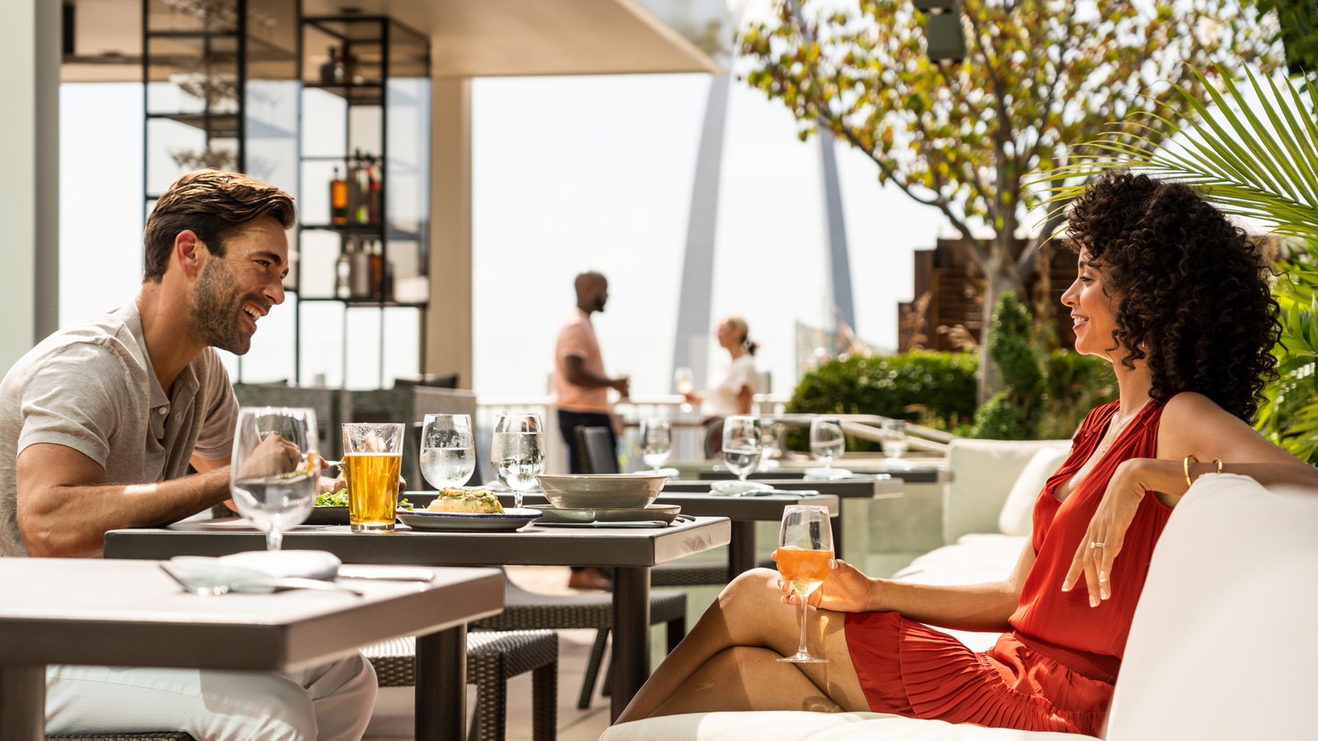
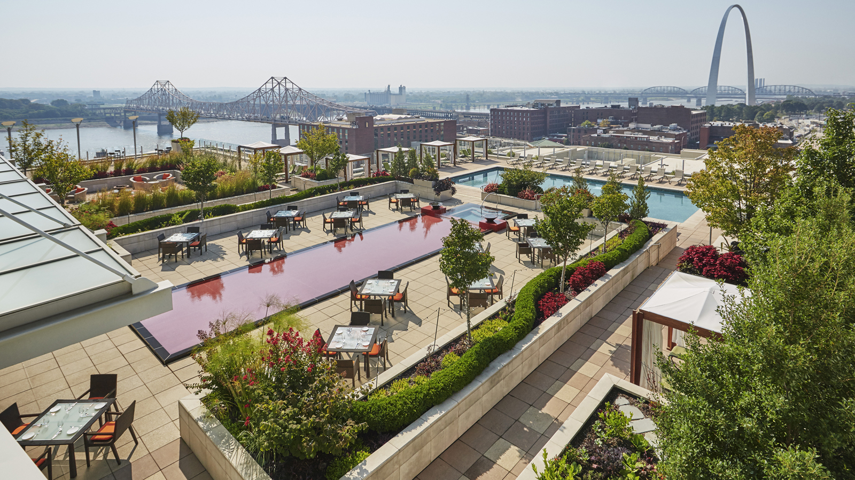
This April, Cinder House at Four Seasons Hotel St. Louis invites guests and locals alike to kick-off grilling season as the industry’s finest come together for a gourmet barbecue on the Hotel’s expansive rooftop patio. Two evenings of cooking demos, entertainment, traditional and South American-inspired barbecue can only be found in the heart of the one of the city’s most vibrant dining scenes.
On April 23 and 24, 2021, James Beard Award-winning Chef Gerard Craft and the Cinder House team will collaborate with Big Green Egg’s official pitmaster and guest chef Jack Arnold as they serve up American wagyu ribeye loin and New York strip loin from KOW Steaks. Sit back, relax and sip on cold beer from local favourite Side Project Brewing while sampling choice cuts of meat, sides that feature the season’s freshest local vegetables, and house made dipping sauces that include aji verde, piri piri and more.
Parlaying the ease of a backyard barbecue, steaks from 125-year-old family run farm KOW will be grilled to perfection by Arnold and Craft as these pros demonstrate the art of seasoning and roasting wagyu in a variety of ways. “I’m honoured to partner with Four Seasons Hotel St. Louis, Cory King of Side Project Brewing and KOW steaks for a terrific event in one of the best barbecue cities in America. Being on the rooftop overlooking the St. Louis skyline and Gateway Arch, while working alongside Chef Craft is a dream come true. Expect awesome demos, delicious food, terrific cold brews and a lot of energy at this backyard barbecue,” says Arnold.
Space is limited to 50 guests per night with socially distanced tables staggered on the outdoor terrace of Cinder House restaurant, located on the 8th floor of Four Seasons Hotel St. Louis. The two-night event starts at 6:00 pm on April 23 and 24, tickets are USD 95 per person, excluding tax and gratuity. Each ticket includes one beer courtesy of Side Project Brewing or a frozen Caipirinha from Cinder House. Purchase a ticket today by calling 314 881 5759 or emailing Cinder House at cinderhouse.stlouis@fourseasons.com.
As the safety of guests and employees continues to be top priority, Four Seasons Hotel St. Louis remains dedicated to its enhanced global health and safety program, Lead With Care, with ongoing, real-time guidance on the evolving COVID-19 situation. Enhanced cleanliness and safety measures are present within each available offer and experience on-property.

RELATED

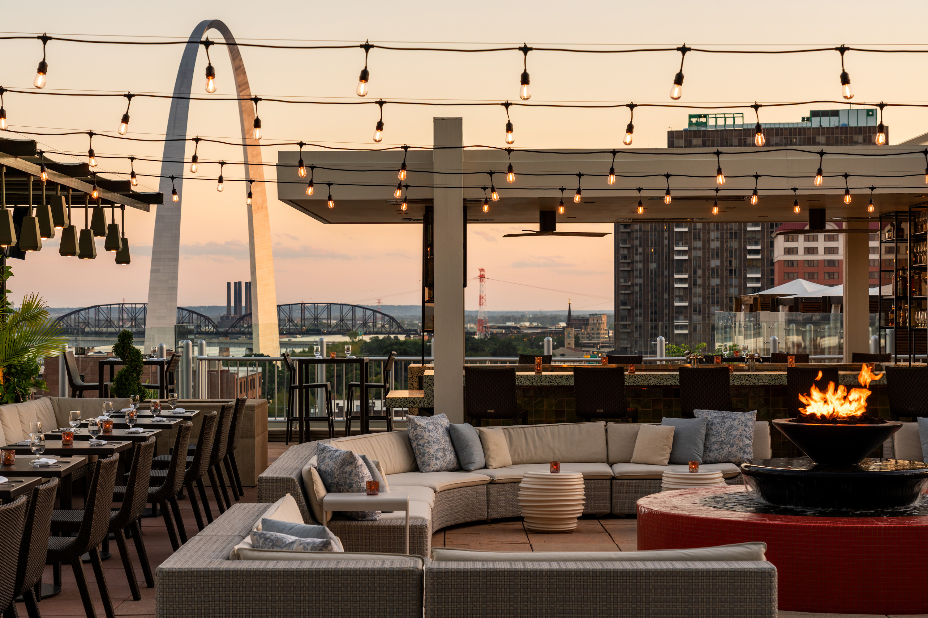 | February 9, 2021, St. Louis, U.S.A.  Four Seasons Hotel St. Louis Named the #1 Hotel in St. Louis  https://publish.url/stlouis/hotel-news/2021/best-hotel-in-st-louis.html
January 26, 2021, St. Louis, U.S.A.
Celebrate Galentine’s Day with a Girlfriend’s Getaway at Four Seasons Hotel St. Louis
https://publish.url/stlouis/hotel-news/2021/galentines-day.html

PRESS CONTACTS

Chloe Caylor
Director of Public Relations and Communications
999 North 2nd Street
St Louis
USA
Chloe.Caylor@fourseasons.com

+1 (314) 881-2021

