Four Seasons Hotels and Resorts Celebrates Global Meetings Industry Day

Four Seasons joins its clients around the world in recognising the importance of meetings, business events, and incentive travel
April 12, 2018, Toronto, Canada

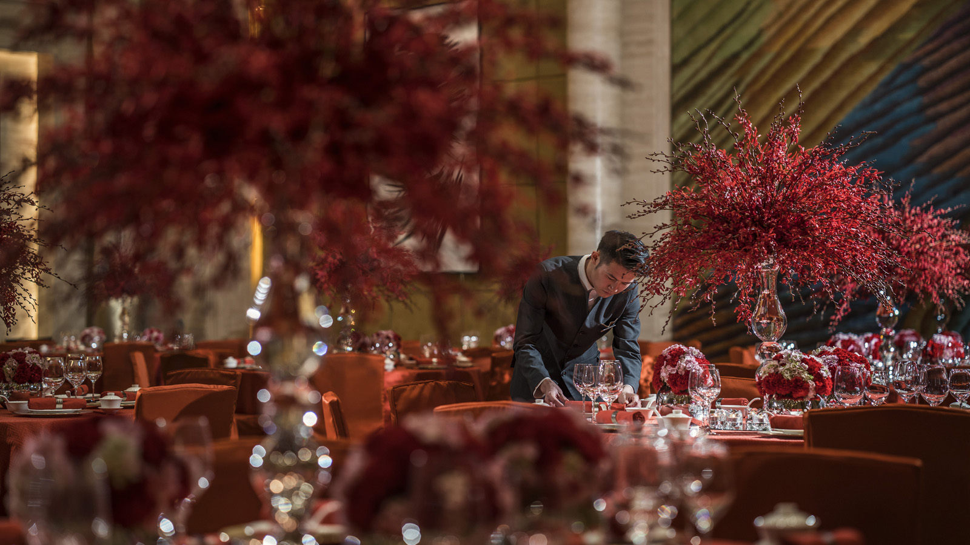 | 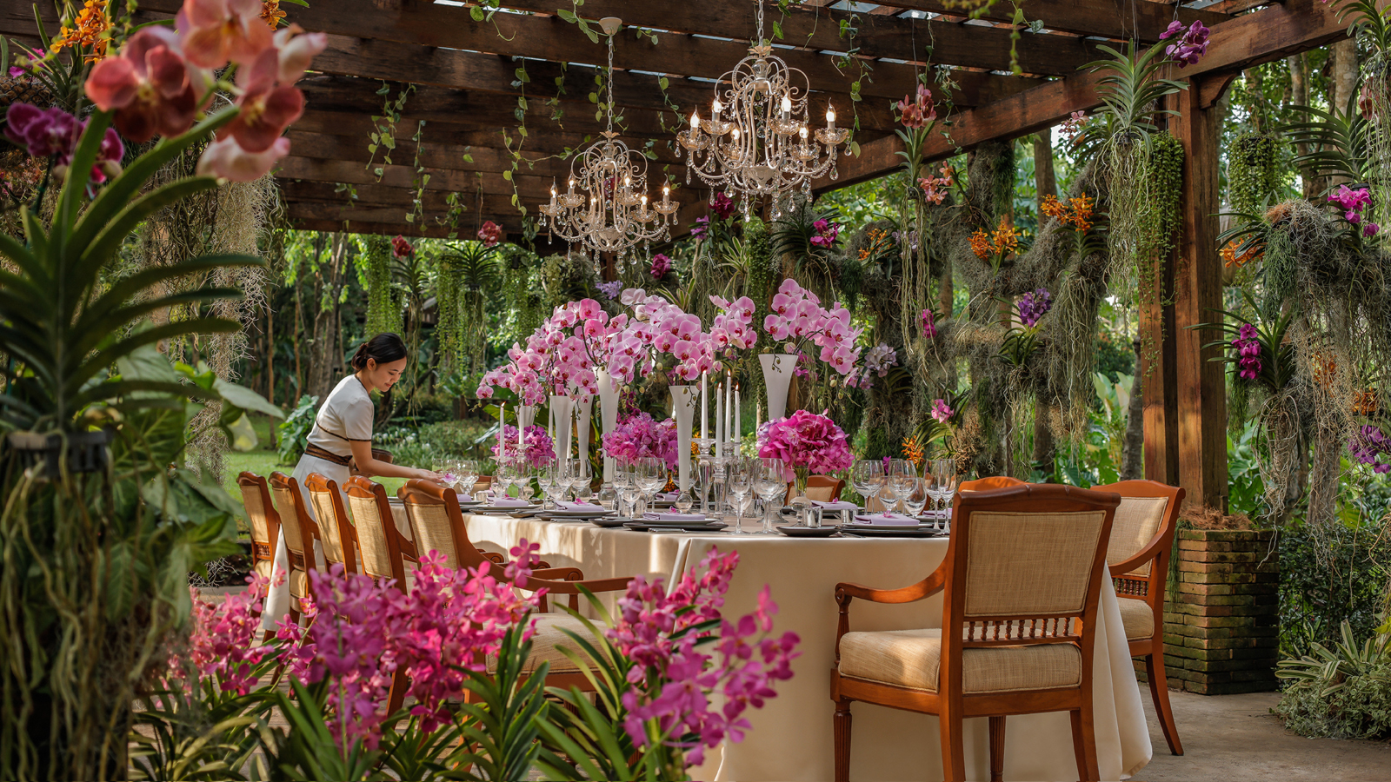 | 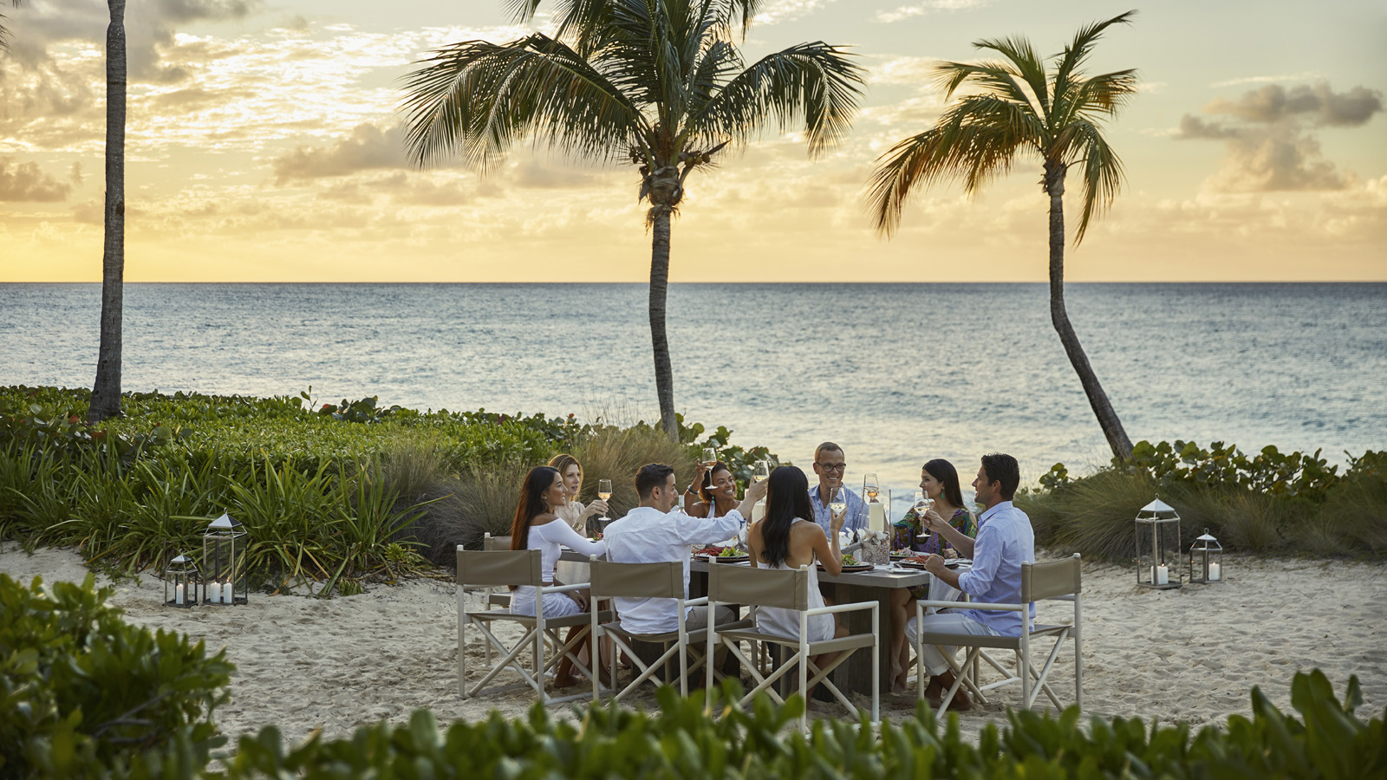
Four Seasons
Hotels and Resorts, the world’s leading luxury hospitality company, today celebrates Global Meetings Industry Day (GMID), an annual celebration bringing together leaders from the meetings and events industry and showcasing the importance of business meetings and incentive travel to individuals, businesses and communities around the world.
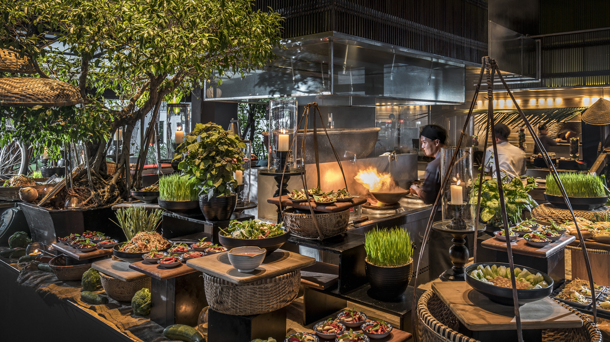
From private wine tastings in the renowned La Cave, the underground cellar of
Four Seasons
Hotel George V, Paris, to a traditional tea ceremony at the Shakusui-tei tea house at
Four Seasons
Hotel Kyoto, planners know that when they host at
Four Seasons
the results will be exceptional. Groups have access to the unforgettable backdrops, caring and passionate people, and extraordinary experiences that only Four Seasons can offer.
“On the occasion of Global Meetings Industry Day, we would like to recognise the importance of meetings, events and incentive travel to our business, and thank our partners for choosing
Four Seasons
,” says Peter Nowlan, Executive Vice President and Chief Marketing Officer,
Four Seasons
Hotels and Resorts. “Meeting and events are not only an important part of business growth, they are also an opportunity for us to showcase the passion, creativity and excellence that happens every day at
Four Seasons
hotels and resorts around the world.”
Meetings and events are an important business for
Four Seasons
and a key consideration when designing a new hotel or resort.
Four Seasons
function spaces are strategically designed to act as the perfect backdrop for any occasion, allowing for flexibility and customisation of every event, as well as creating seamless integration with hotel amenities such as world-class dining and spa facilities.
General Managers and entire property teams, alongside conference service professionals, are all dedicated to providing the highest levels of personalised service, and going above and beyond to make every event a success. Planners can even leverage the full extent of
Four Seasons
experiences, services, amenities and people when choosing to book an exclusive or buyout.
Here’s what industry experts around the world are saying about meetings and events at
Four Seasons
:
“We see great success when booking with
Four Seasons
because our guests are excited about the brand. What’s more is that
Four Seasons
employees care as much as we do about both the small and large things and how we create event impact together. It’s a brilliant formula for us and for our customers.” – Deb Parsons, EVP Sales and Marketing, The Performance Group, Inc., a Creative Group Company, USA
“There is nothing more memorable than personal experiences, which is why we and our clients choose to partner with
Four Seasons
. They continuously deliver caring personal touch, memorable experiences, and always exceed expectations for all of their guests and visitors. It is wonderful working with the exceptional people at
Four Seasons
!” – Mark Riches, Non-Executive Director, FIRST London, UK
“It is an absolute pleasure for us to partner with
Four Seasons
on a conference or incentive program. Our strong relationships with their incredible people, complemented by consistent service excellence globally, ensure programs with Four Seasons are always a huge success for us and our clients. We have many
Four Seasons
highlights; most recently the privilege to do a full buyout of the magnificent
Four Seasons
Hotel Prague.” – Leon Burman, Managing Director, TRIBE Travel & Events, Australia
To see how
Four Seasons
goes above and beyond to create unforgettable meetings and events experiences, click here.
To plan your next
Four Seasons
meeting or event, visit our website.

RELATED

March 13, 2018, Dubai, U.A.E.
Fun Family Activities to Entice Guests to Hop Over to Four Seasons Hotels and Resorts in Europe and the Middle East This Easter
https://publish.url/news-releases/2018/emea-easter.html

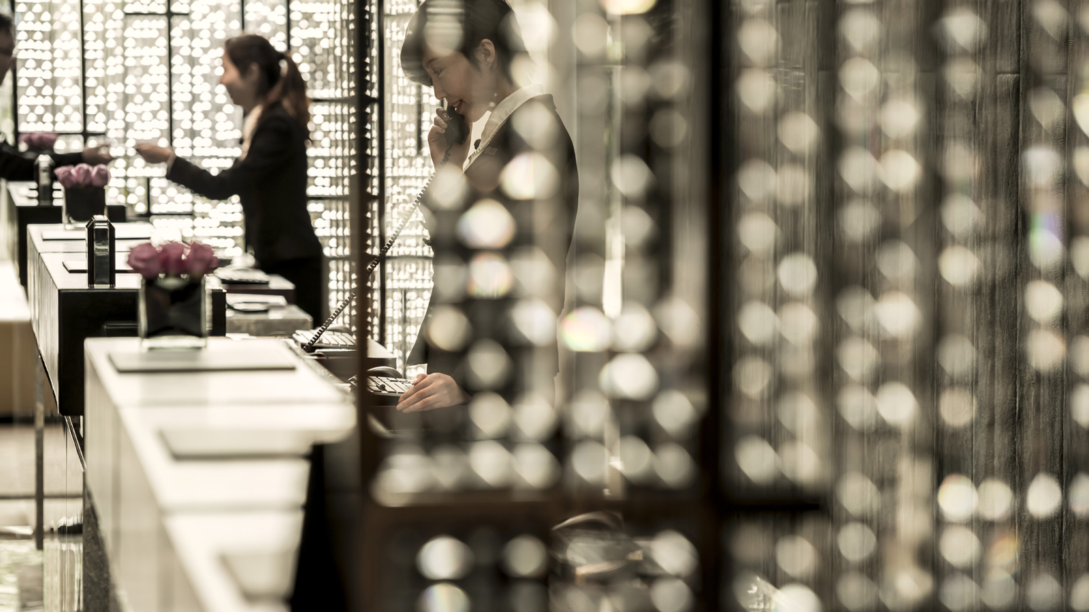 | March 1, 2018, Toronto, Canada  Four Seasons Awards and Accolades  https://publish.url/news-releases/awards-and-accolades-for-four-seasons-hotels-and-resorts.html

PRESS CONTACTS

Sarah Tuite
Senior Director, Corporate Public Relations
1165 Leslie Street
Toronto
Canada
prsm@fourseasons.com

+1 (416) 441-4350

