Four Seasons Hotel Gresham Palace Budapest Ranks #1 in Hungary in Condé Nast Traveler Readers' Choice Awards 2021

The Art Nouveau masterpiece on the Danube has been featured on the coveted list for five consecutive years
October 22, 2021, Budapest, Hungary

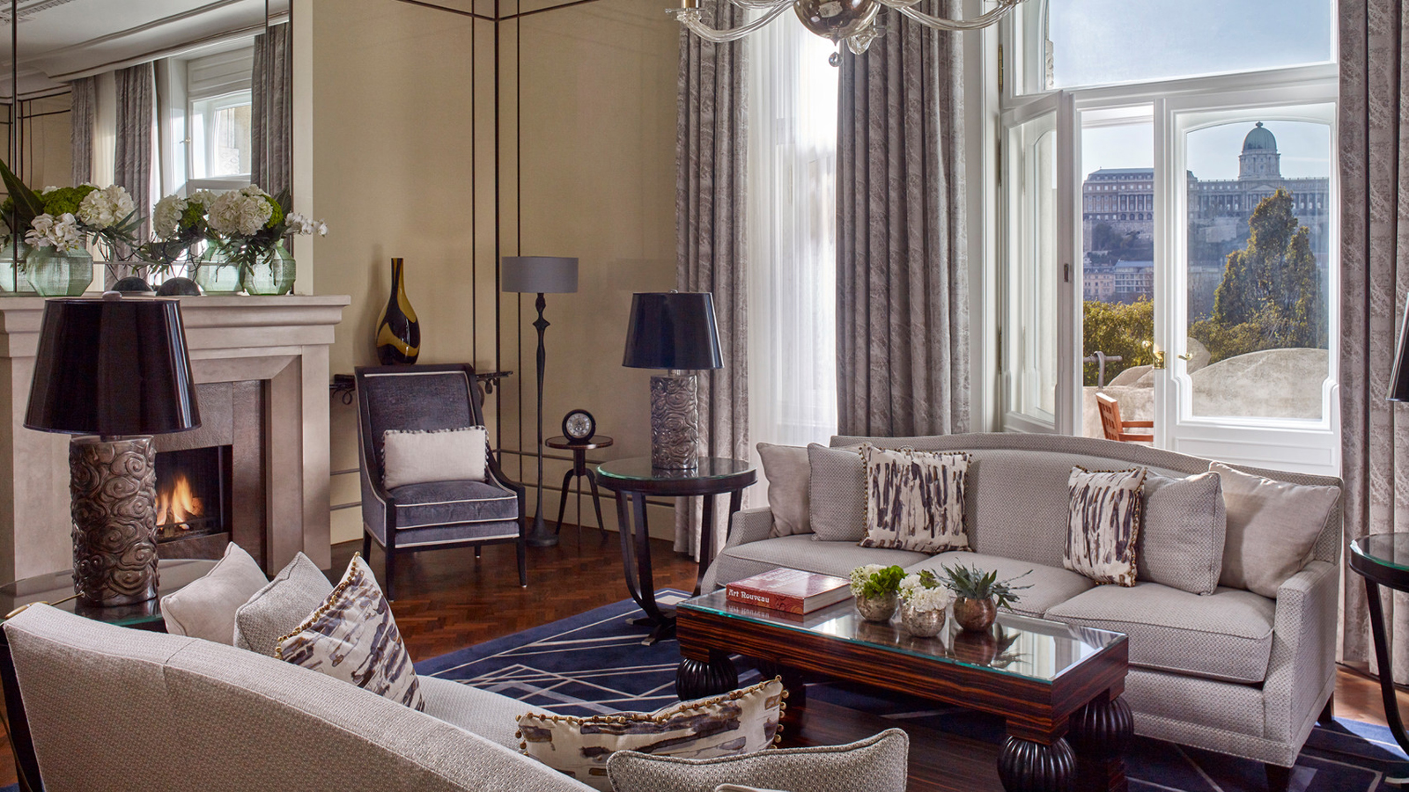
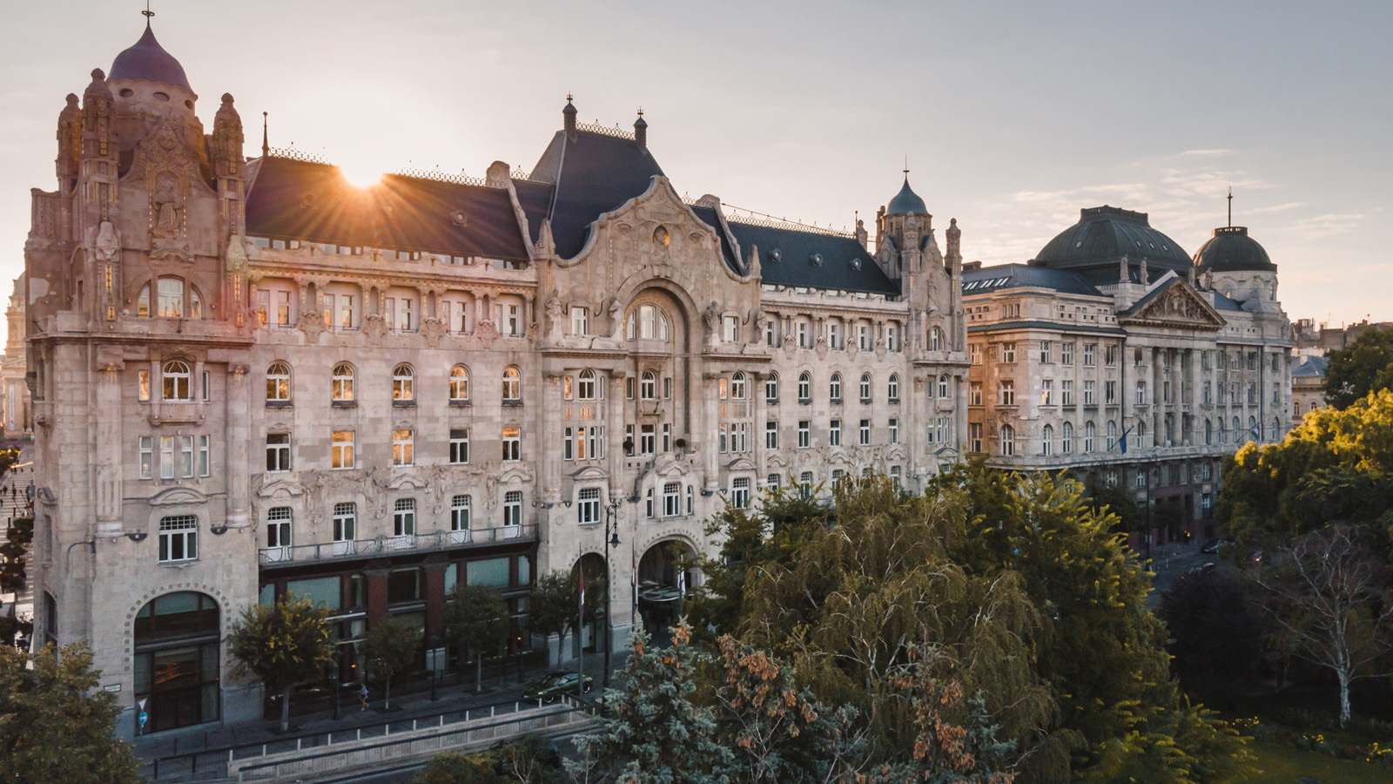 | 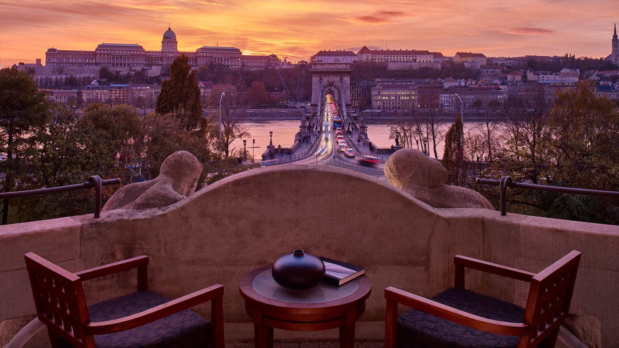 | 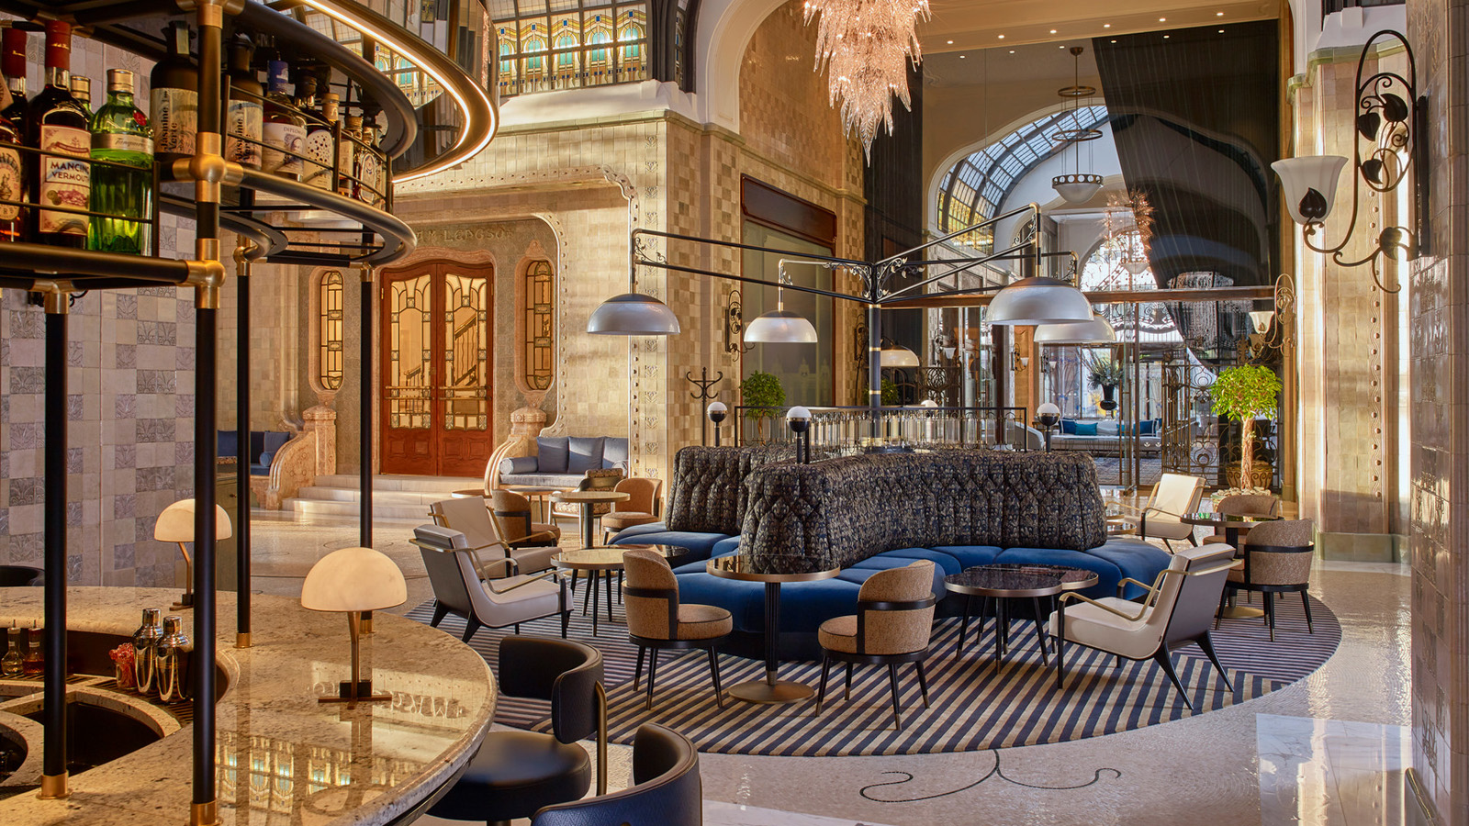
Condé Nast Traveler US recently announced the results of its annual Readers’ Choice Awards, with Four Seasons Hotel Gresham Palace Budapest being recognised as the #1 Hotel in Hungary and among the top 15 in Central Europe. Based on the same reader survey, Condé Nast Traveller UK listed Four Seasons as the #1 Hotel in Hungary and among the Best Hotels in Europe (a list that does not include hotels in France or Italy). This marks the fifth consecutive year that the Hotel has been featured on the elite lists.
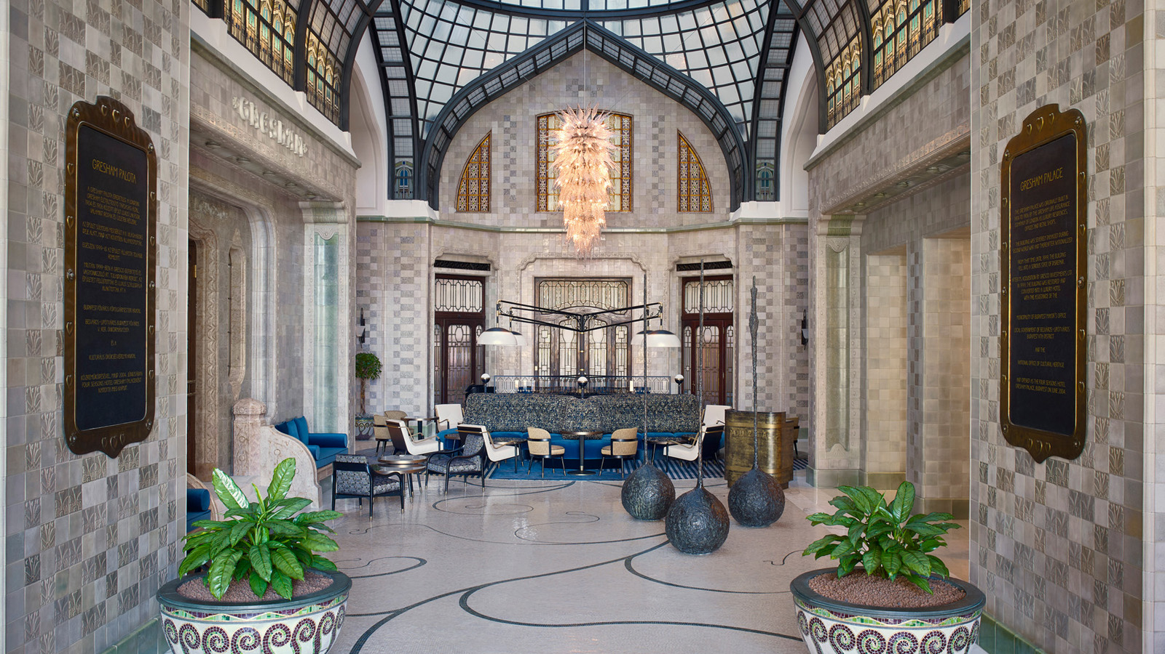 | 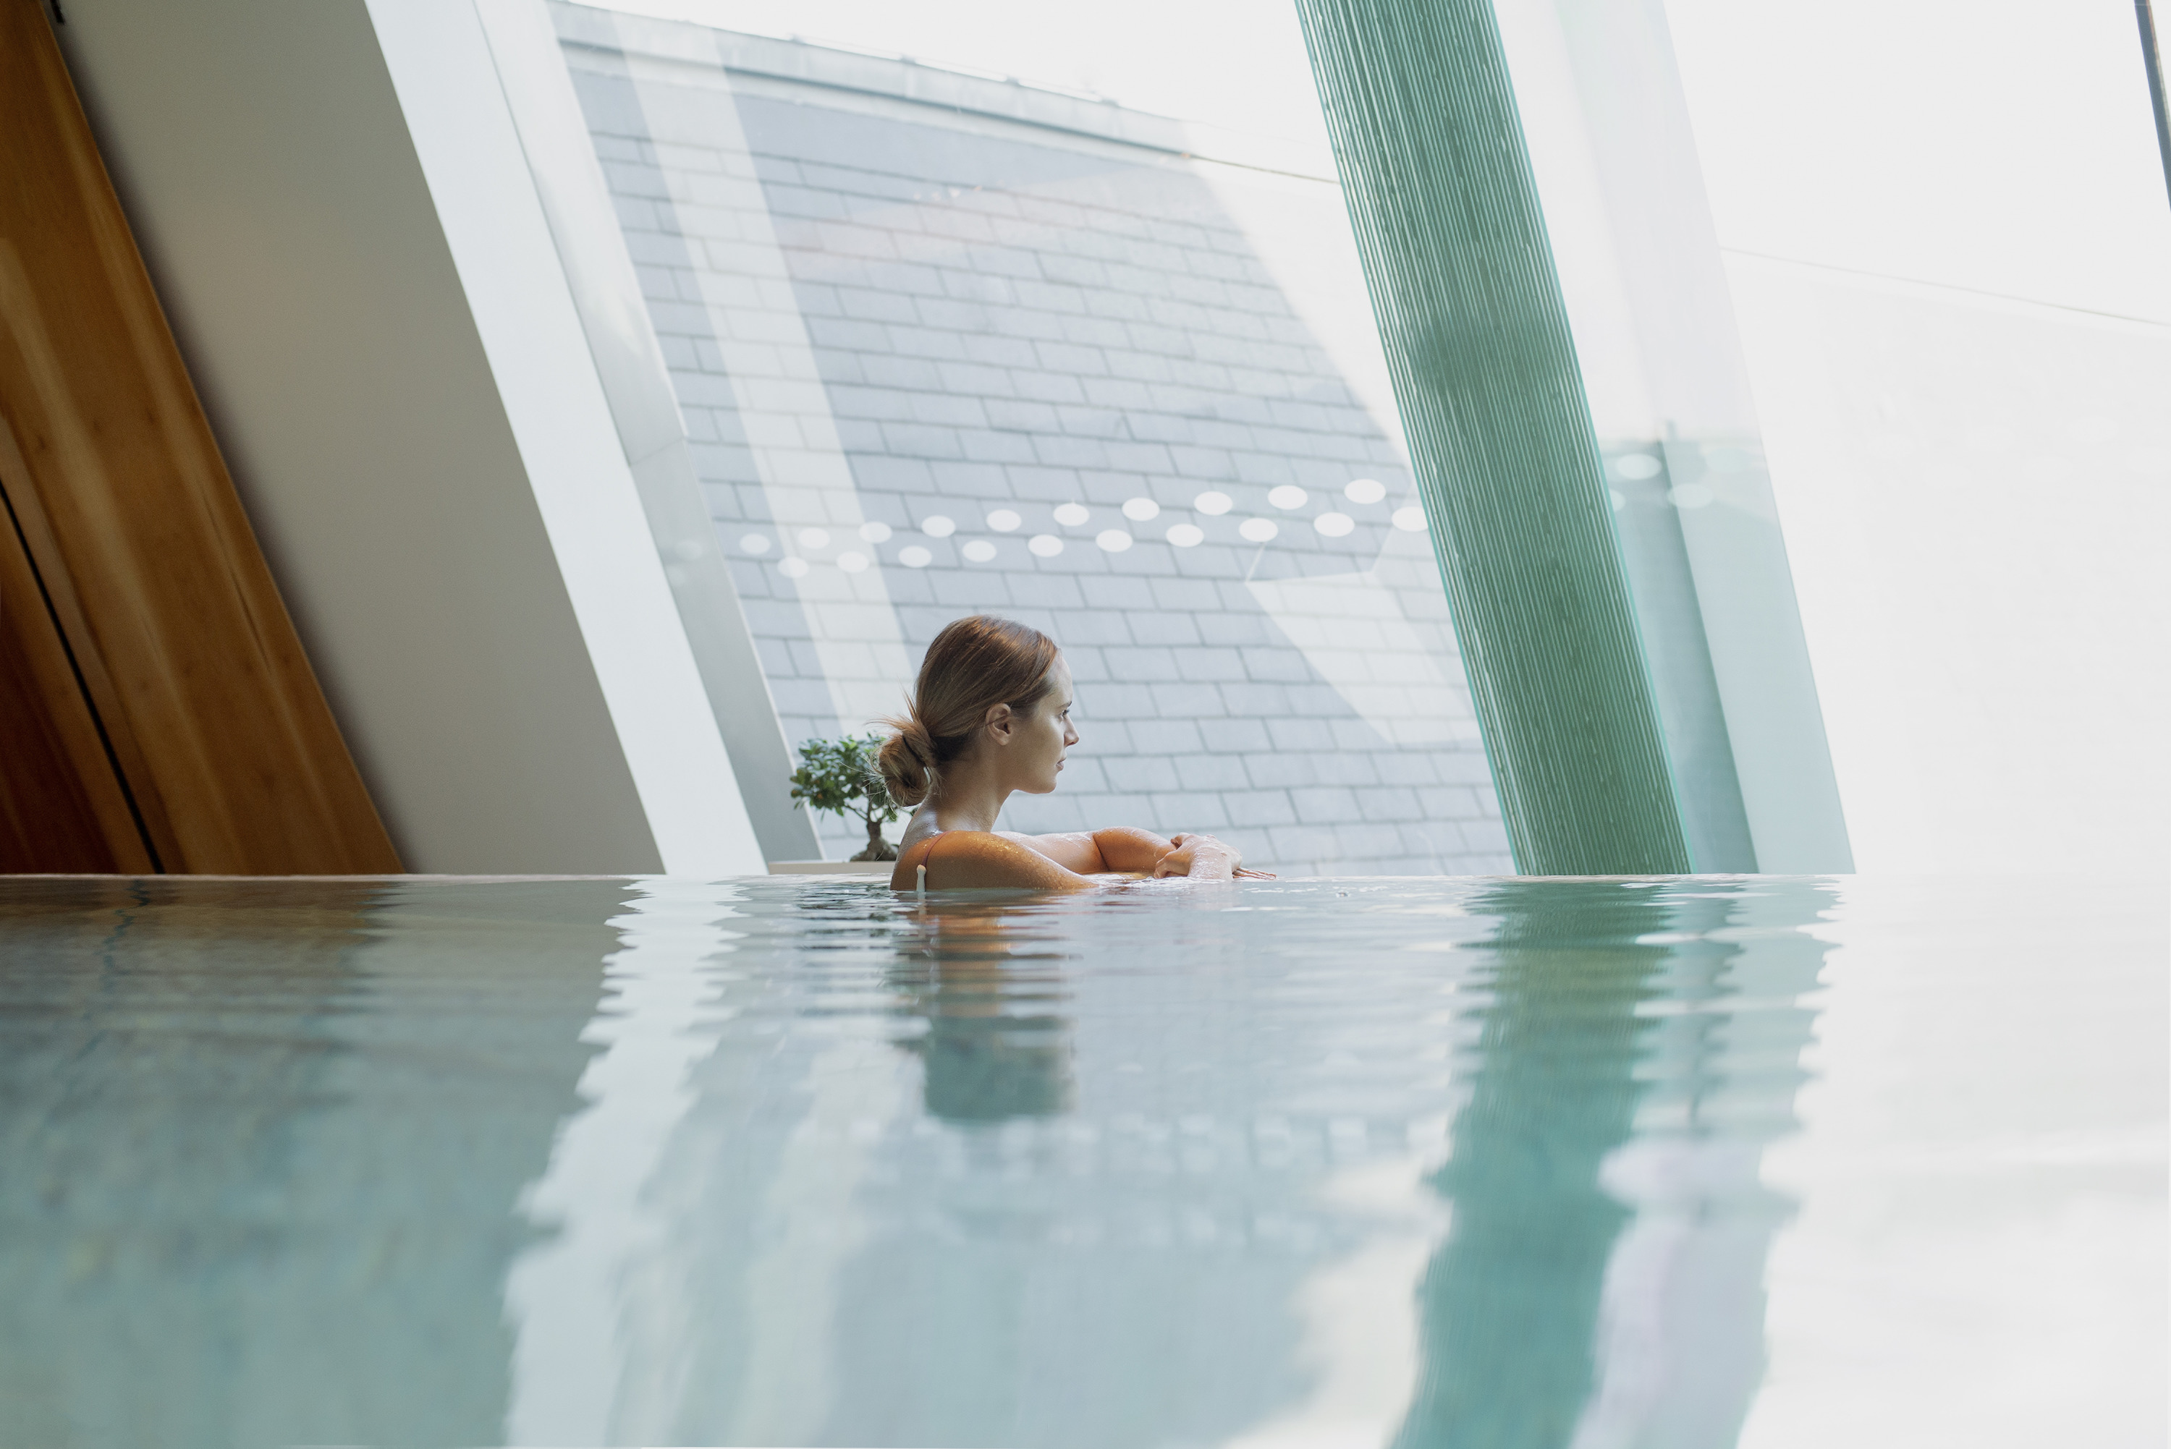
This year, more than 800,000 readers submitted responses, rating their travel experiences across the globe and highlighting places that they longed to experience once more. The Readers’ Choice Awards are one of the longest-running and most prestigious recognition of excellence in the travel industry.
“It is an incredible achievement and testament to our entire team,” says Yves Giacometti, General Manager. “This has been a difficult year for all of us, so receiving such overwhelming support from our guests and patrons is even more meaningful. We thank you all for your support, and we look forward to continuing to offer the highest standards of hospitality and care our brand is known for. More than ever, we want guests to feel comfortable and confident that their wellbeing is of utmost importance when they are staying with us.”
An Art Nouveau Masterpiece on the Danube
Offering 160 luxurious guest rooms, 19 expansive suites and spectacular, light-filled, grandiose event spaces, Four Seasons Gresham Palace is an Art Nouveau landmark on the Danube with views to the picturesque Buda skyline, situated in the city's vibrant restaurant and bar scene, steps from historic attractions.
The Gresham Palace embodies the spirit of Budapest’s Golden Era glam with its striking Art Nouveau interiors, stunning craft cocktail bar Muzsa and Art Deco Kollazs restaurant offering glamorous dining and drinking experiences accompanied by live musical performances. With a Spa that harnesses the city’s rich heritage in wellness, Four Seasons Gresham Palace is the ideal choice for romantic getaways, family staycations, business trips and weekend celebrations.
Experience the Gresham Palace with a Special Offer
Infusing Eastern mystique and Old-World elegance, Budapest is a one-of-a-kind city that long inspired artists and travellers alike, with its unique beauty, architecture and vibrant cultural life. Let the magic of Budapest inspire while experiencing legendary Four Seasons service at the Gresham Palace. With the Budapest Escape promotion, guests can enjoy 20 percent savings on the Best Available Rate when they are staying for two nights.
To make a reservation, call +361 268 6000 or book online.
World-Class Health and Safety Standards
The award-winning Hotel is a proud adopter of Lead With Care, an enhanced global health and safety program focusing on providing care, confidence and comfort to all Four Seasons guests, employees and visitors within the new COVID-19 environment.

RELATED

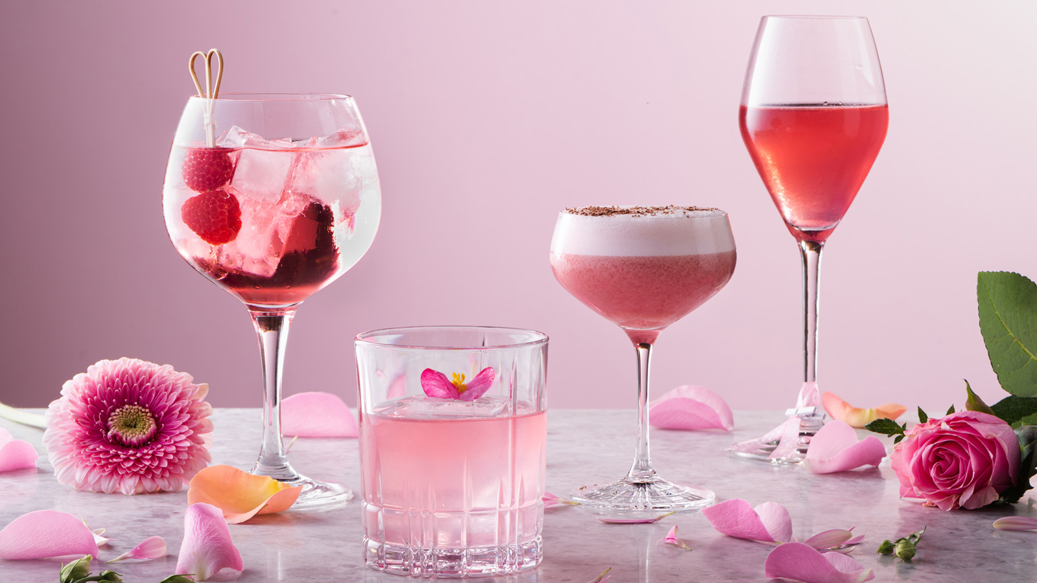 | October 1, 2021, Budapest, Hungary  Four Seasons Hotel Gresham Palace Budapest Joins the Spirit of Pink to Support Breast Cancer Awareness Month  https://publish.url/budapest/hotel-news/2021/pink-october.html
October 1, 2021, Budapest, Hungary
Együtt a Mellrák Ellen - a Four Seasons Hotel Gresham Palace és a Mellrákinfó Egyesület Közös Kampánya Októberben
https://publish.url/hu/budapest/hotel-news/2021/pink-october-2.html

PRESS CONTACTS

Krisztina Ilosfai
Director of Public Relations
Széchenyi István tér 5-6.
Budapest
Hungary
krisztina.ilosfai@fourseasons.com

+36 1 268 5452

Fruzsina Otto
Public Relations and Marketing Communications Coordinator
Széchenyi István tér 5-6.
Budapest
Hungary
fruzsina.otto@fourseasons.com

+36 1 268 5419

