From the Mountain Straight to the Glass: Fifty Mils Takes Part in Cubo, an Extraordinary Gastronomic Experience

October 12, 2021, Mexico City, Mexico

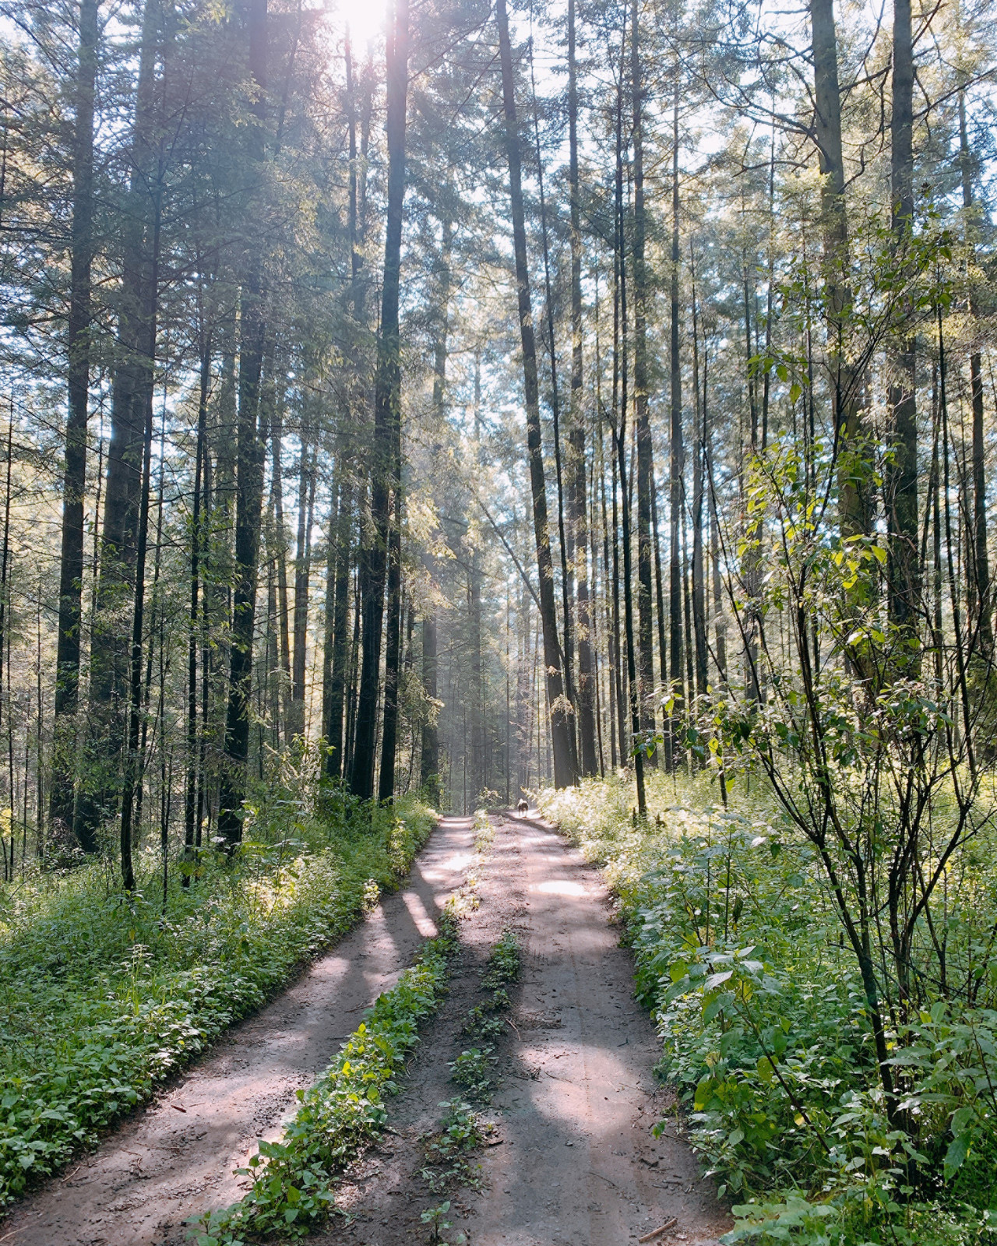
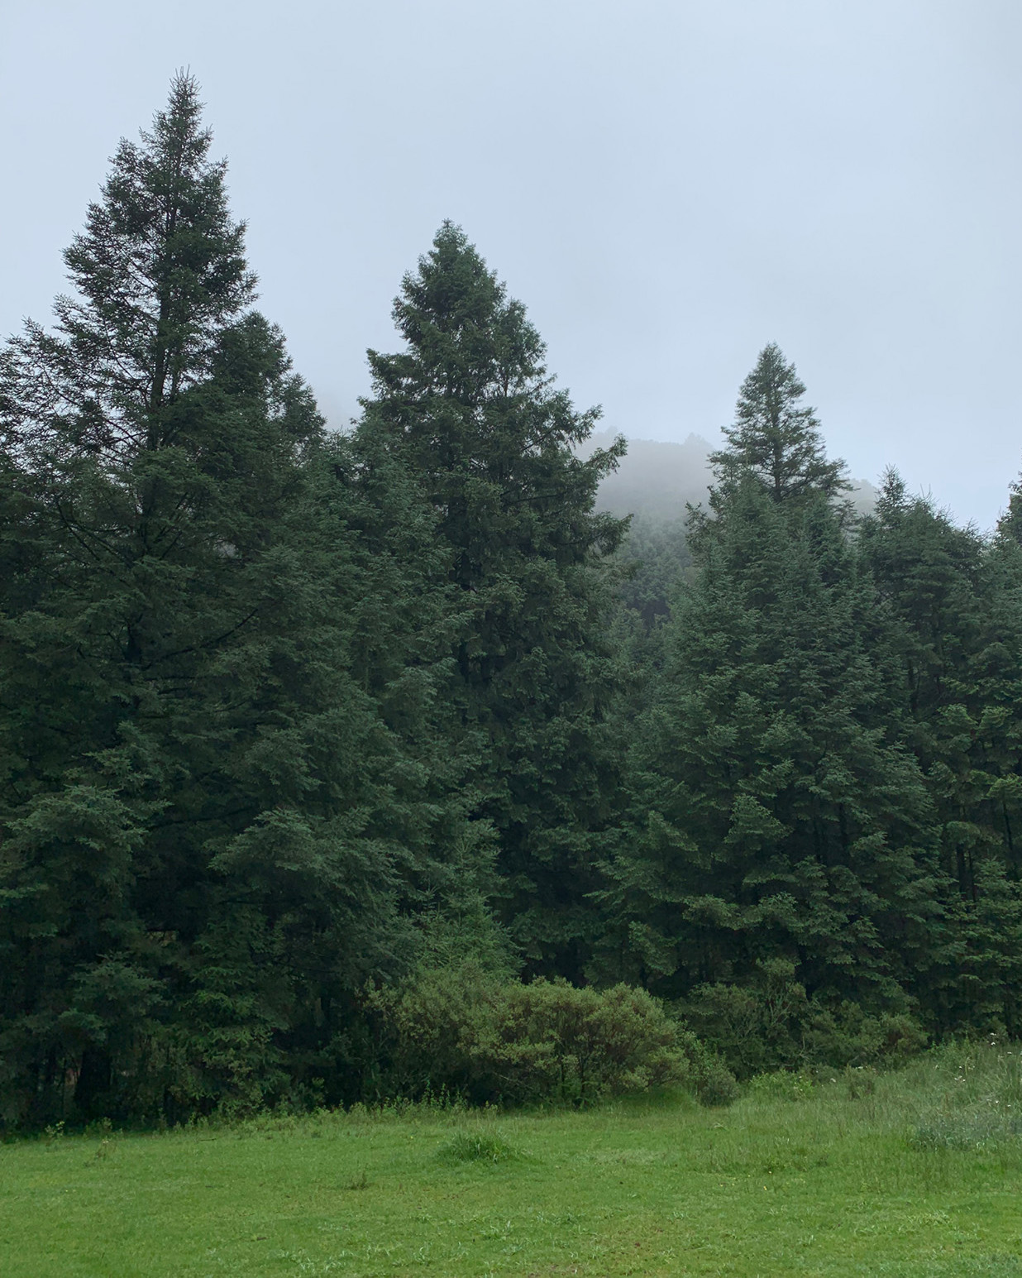 | 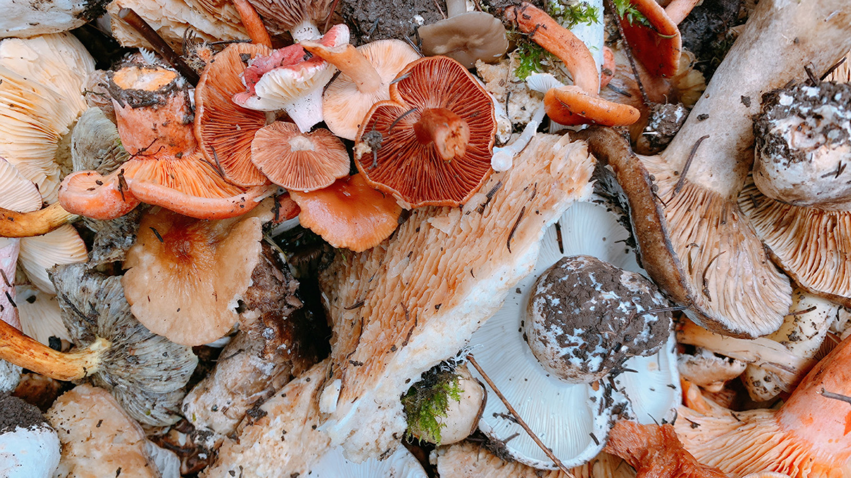 | 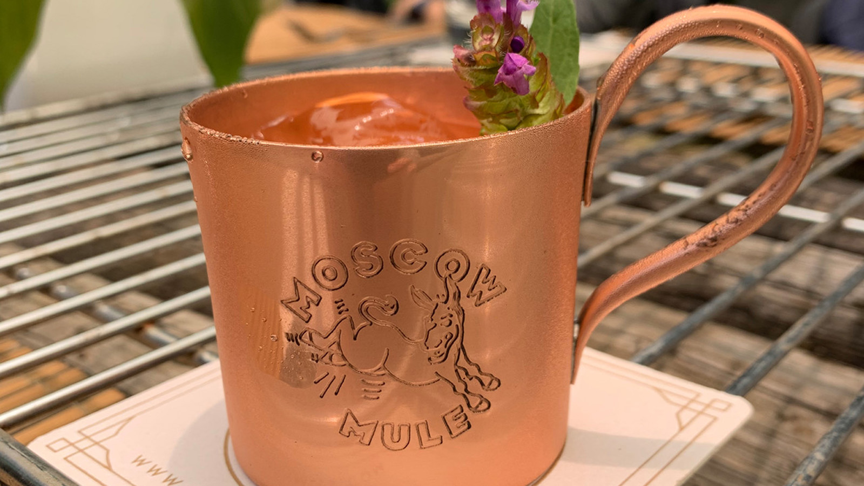
As it expands the portfolio of activities that guests and locals can participate in, Four Seasons Hotel Mexico City takes part in Cubo, a culinary experience designed and led by Roberto Lingard, who invites up-and-coming local chefs and Fifty Mils bartenders to join in the experience.
“It is both a challenge and an honour for us to participate in this venture, since we are collaborating with some of the most experimental chefs in Mexico. We are also showing visitors a new face of Fifty Mils, taking it from the city to the mountain – so they can enjoy the best cocktails amid scenery that’s totally different,” says Francisco Calvo, Head Bartender at Fifty Mils.
At a mere 50-minute ride out of the capital, Four Seasons guests enjoy an extraordinary culinary experience in an inhospitable, yet captivating, landscape surrounded by sky-scraping trees, mountain fresh air, and exuberant flora that fully enthral their every visitor. Devised to deliver a completely different gastronomic affair, Cubo offers dishes and cocktails concocted from ingredients that participants collect along this Otomi reserve, which also inspires some of the activities for this day of cuisine, culture, and, of course, Mother Nature.
During the rainy season – June to September – a group of guests led by the Hotel’s expert chefs travels from Four Seasons to the Santa Ana Jilotzingo township, located at the fringe of the capital, to hand pick several types of mushrooms directly from the earth.
These mushrooms are part of the delicacies that partakers can enjoy upon harvesting. To complement the gastronomic experience, Fifty Mils bartenders design special cocktails to pair these dishes that involve not only the chefs, but also participants.
In addition to getting to savour these mushrooms, attendants learn about the variants that can be found in the area and the purposes to which each is destined.
For reservations at Four Seasons and to book experiences such as Cubo, contact the concierge team at 55 5230-1818.

RELATED

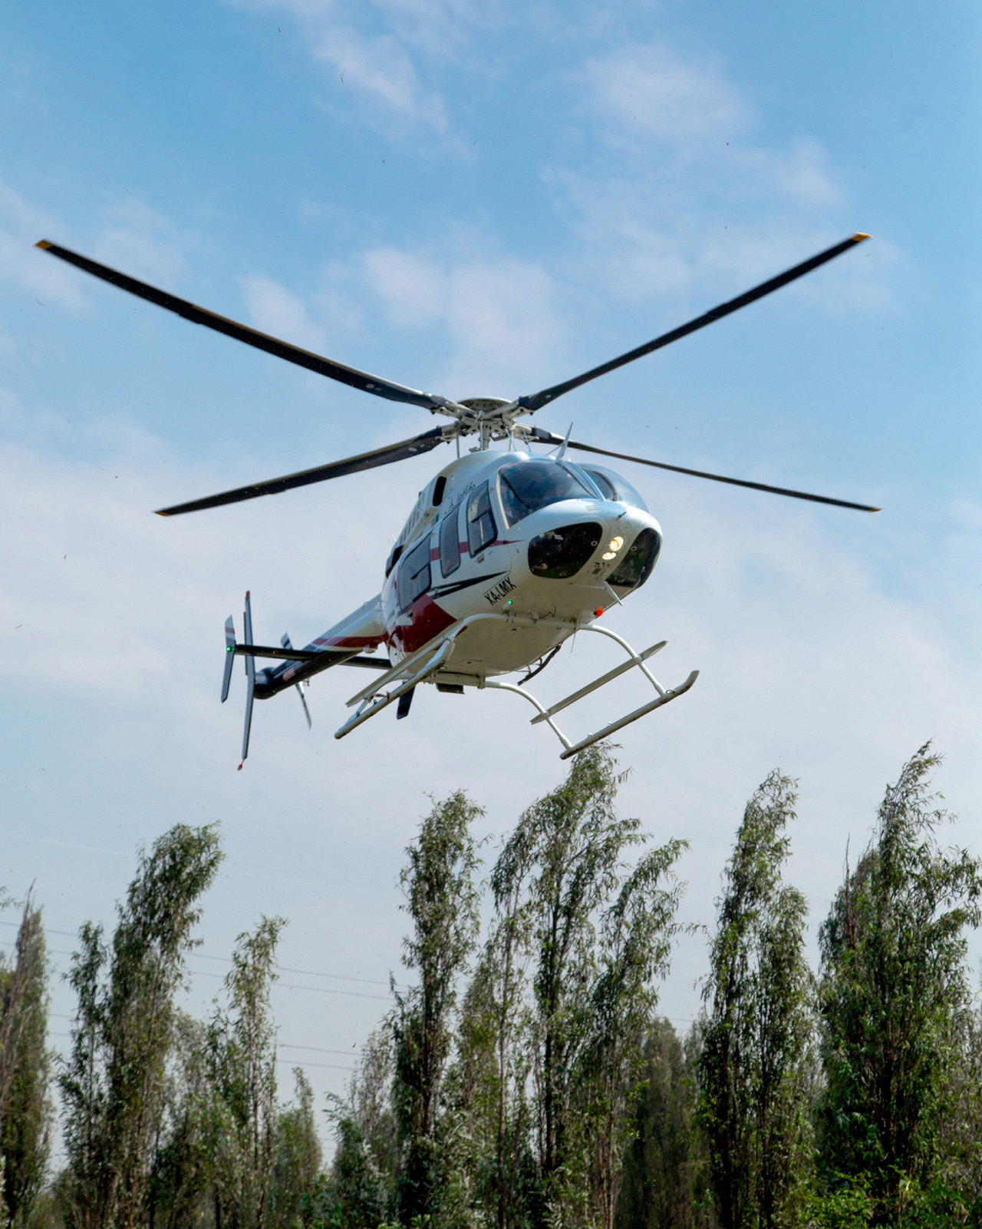 | October 12, 2021, Mexico City, Mexico  Four Seasons Mexico City Invites Guests to Experience UNESCO World Heritage Site Xochimilco Through the Hotel’s Stamp of Unparalleled Exclusivity  https://publish.url/mexico/hotel-news/2021/xochimilco-experience.html
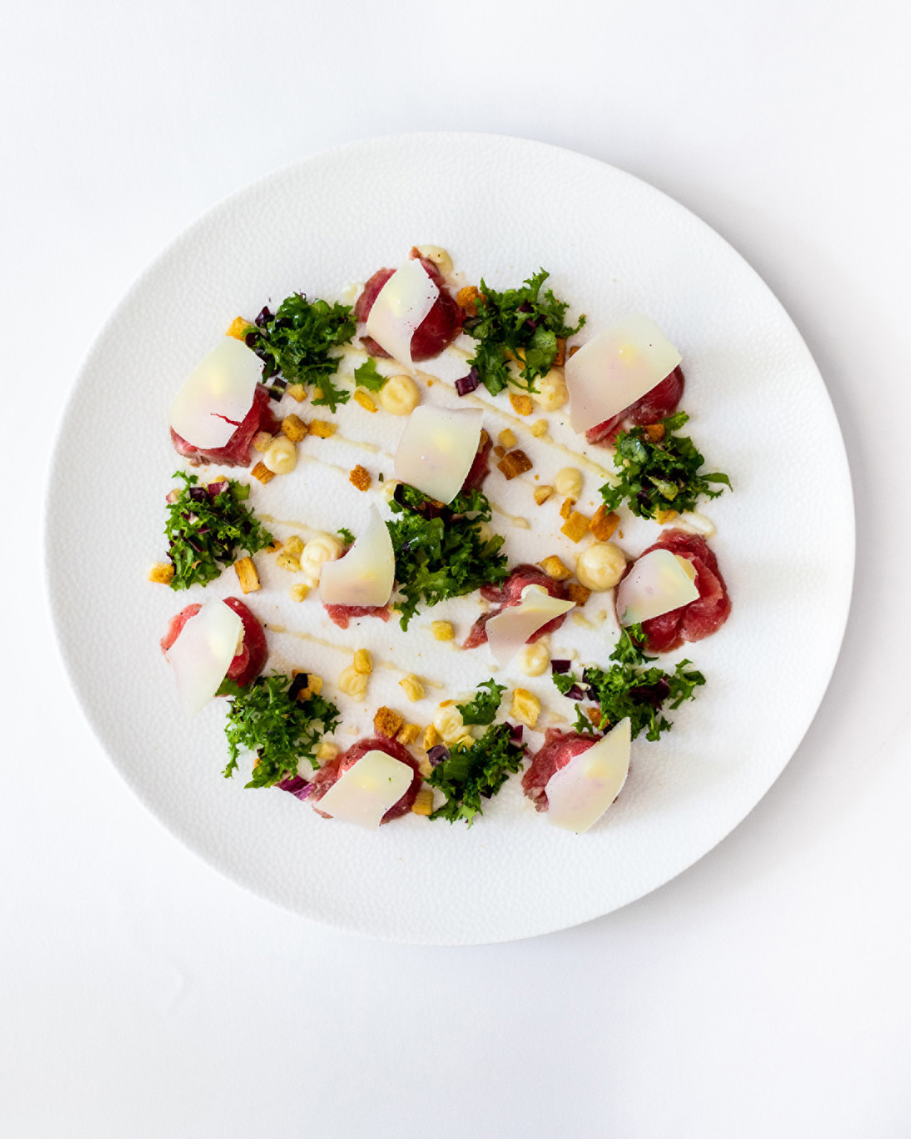 | July 15, 2021, Mexico City, Mexico  Vuelve lo mejor de la alta cocina italiana en la CDMX con Il Becco en Four Seasons  https://publish.url/es/mexico/hotel-news/2021/il-becco-reopening.html

PRESS CONTACTS

Adriana Linares
Director of Public Relations and Marketing Communications
Paseo de la Reforma Ave. 500,
Mexico City
Mexico
adriana.linares@fourseasons.com

+52 5525607198

