An Island Graduation Tribute at Four Seasons Resort Lanai

June 5, 2020, Hawaii, Lanai, U.S.A.

Missed graduation this year? The oceanfront five-diamond Four Seasons Resort Lanai is a popular setting for celebrating many of life’s milestones, from proposals to weddings, birthdays and anniversaries. Graduates who unfortunately can’t walk across the stage to accept their diploma this year due to social distancing can commemorate the ceremony with their families at the Resort. Families can take part in a special "Graduation Ceremony" during their visit. A reception service will present the graduate with an opportunity to receive their diploma on the Luau Grounds or Lanai Gardens. A podium set up will allow parents to deliver the certificate of graduation and have a presentation of leis. The presentation is a Hawaiian tradition, as graduates receive a lei to signify their journey from school to the next stage of life, and bestow luck. Grads can learn to make their own leis with the Love Lanai team during Hooluana, or a dedicated Hawaiian crafts class. The leis, crafted from paper so graduates can save as a keepsake, can showcase school colours, elegant greenery (males often choose this) or favourite flowers. Guests can enjoy a private dinner in one of our outdoor areas, complete with a complimentary graduation cake.

RELATED

June 3, 2020, Toronto, Canada
Four Seasons Resorts Hawaii and Four Seasons Resort Bora Bora Bring Global Wellness Day, June 13, 2020 into Homes of Guests Across the World
https://publish.url/news-releases/2020/global-wellness-day-pacific-islands.html

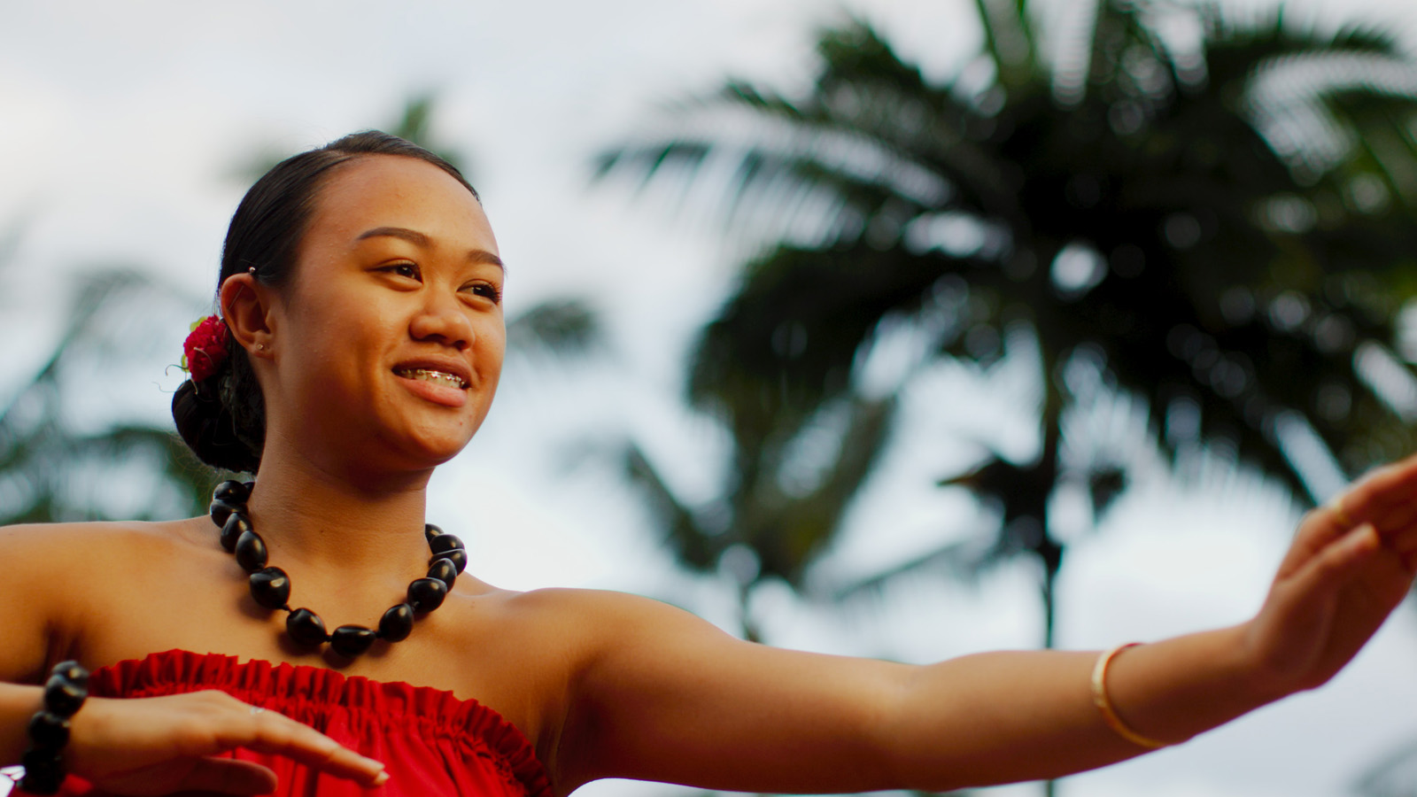 | June 2, 2020, Hawaii, Lanai, U.S.A.  Experience Hawaiian Culture with “Lanai At Home” from Four Seasons Resort Lanai  https://publish.url/lanai/hotel-news/2020/lanai-at-home-social-media-series-continued.html

PRESS CONTACTS

Lori Holland
Director of Public Relations
6100 Center Drive, Suite 1250
Los Angeles
U.S.A.
lori.holland@fourseasons.com

+1 (201) 294-7810

Olivia Kragen
Digital Marketing Manager
6100 Center Drive, Suite 1250
Los Angeles
U.S.A.
olivia.kragen@fourseasons.com

+1 (310) 695-3385

