Begin a New Season of Traditions with the Endless Summer Experience at Four Seasons Resort Palm Beach

Unlimited pool and beach access, fitness classes and kids club offer something for all along Palm Beach Island’s best beachfront
June 22, 2022, Palm Beach, U.S.A.

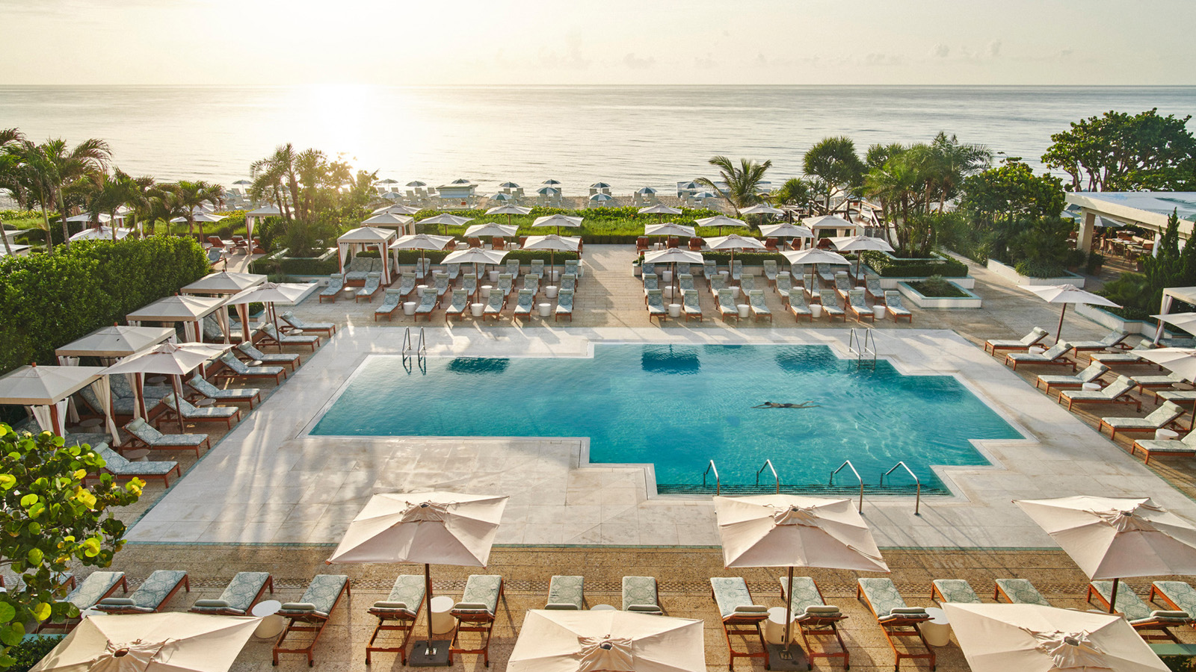
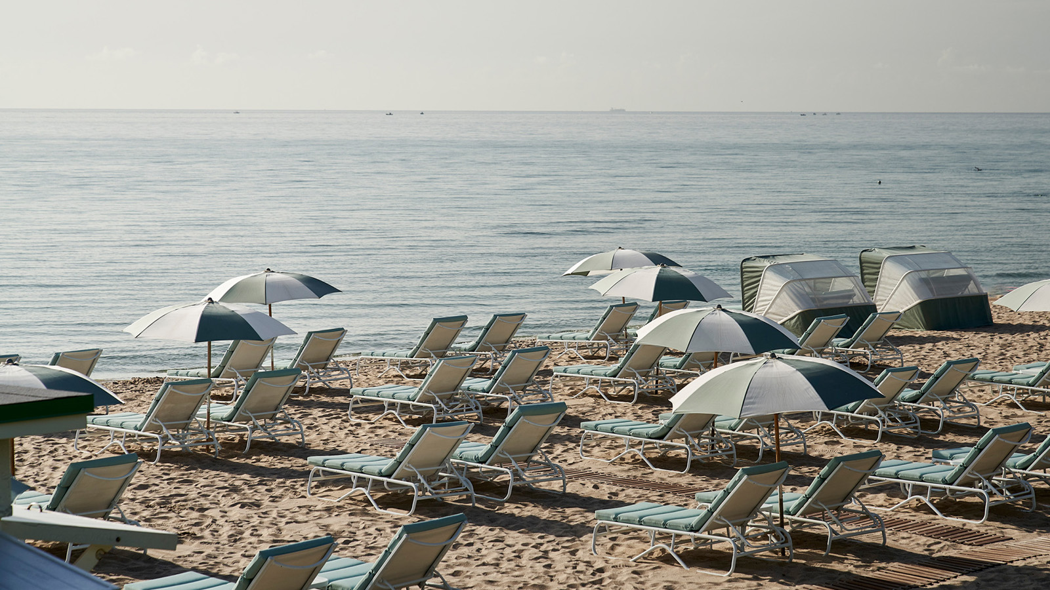 |  | 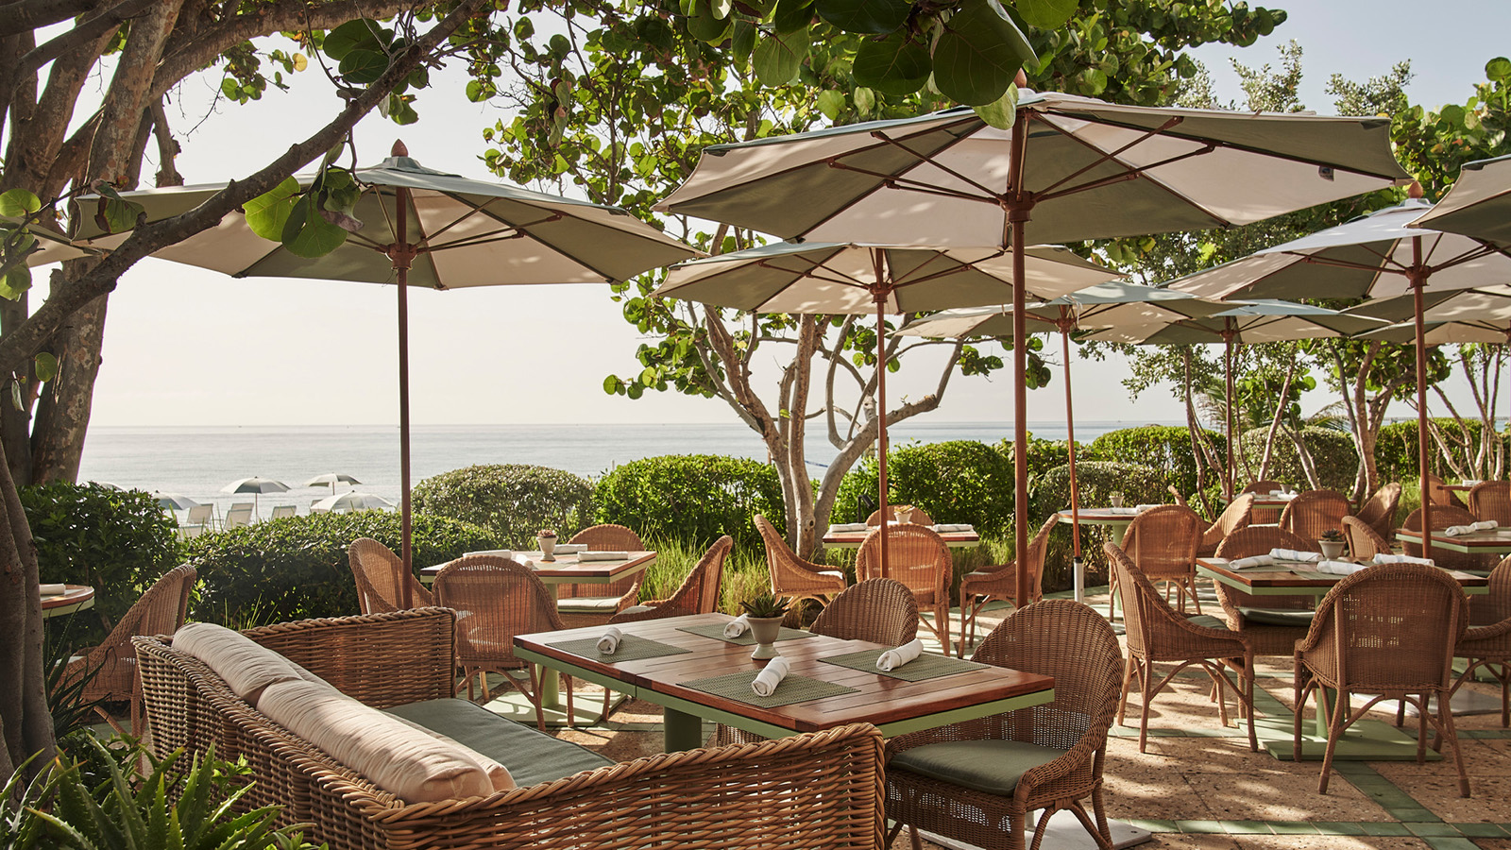
Every summer has a story. Create new traditions for years to come at the Five-Star, Five-Diamond Four Seasons Resort Palm Beach with the Endless Summer experience. Enjoy unlimited Resort access including the adults-only and family pools, private beachfront, Resort amenities and personalised touches, making this summer with Four Seasons one for the books.
Sun, Sand and Sea
An inviting pool terrace opens out to acres of pristine coastline, beckoning carefree days lounging under the sun on plush beach beds or indulging the adventurous spirit through an array of beach and watersports, with an area just for children to enjoy, from building sandcastles to beach volleyball with new friends.
Poolside, where ocean views continue, guests discover the true meaning of relaxed sophistication with the option to call a lounger or cabana home for the day while cooling off with summertime treats such as gelato, tropical smoothies, or botanical-inspired mocktails.
A Season of Self-care
Those seeking an escape through exercise can enjoy access to the Resort’s fitness centre, tennis courts and classes such as Sunrise Beach Yoga, Pre-Brunch Crunch, Beach Bootcamp and more. For a break from the sun, a vacation state-of-mind awaits at the Five-Star Spa with treatments inspired by the natural wonders of the land and sea, from the Oceanique Renewal Scrub to the Beach Body Perfect Wrap. Retail therapy can also be found at the Resort’s Swell boutique, featuring a captivating collection of designer resort-wear, jewellery, and gifts in Palm Beach style.
Summer of Flavour
Satiate appetites with culinary bravado in inspiring spaces. Seafood takes centre stage with a hint of Latin flair at Seaway, the oceanfront restaurant, or indulge in a coast-to-coast collaboration at Florie’s by Mauro Colagreco. Take advantage of the seasonal offerings such as the Mediterranean Summer Tasting Menu or Florie’s Sunday Brunch overlooking the pristine coastline.
Kids in Paradise
Summertime and living is easy. While parents unwind, a world of wonder awaits at Kids For All Seasons for the youngest members of the family with activities from shell-finding to arts and crafts. At the end of the day, kids can share the day’s favourite moments while enjoying poolside s’mores as a family.
Here, couples, friends and families can truly embrace the South Florida lifestyle, with each experience providing as much relaxation and summertime frolicking as one could wish.
Endless Summer Inclusions
- Valid for dates between June 13, 2022 - October 31, 2022*
- Access includes up to two adults and children under 18 years old
- Unlimited Resort, pool and beach access
- Access to the fitness centre, fitness classes and tennis courts
- 20 percent savings for dining, retail and spa
- Kids For All Seasons daily program included when at the Resort
- Complimentary valet parking
To reserve the Endless Summer experiences, call Four Seasons Resort Palm Beach at 561 582 2800.

*Restricted dates and terms apply

RELATED

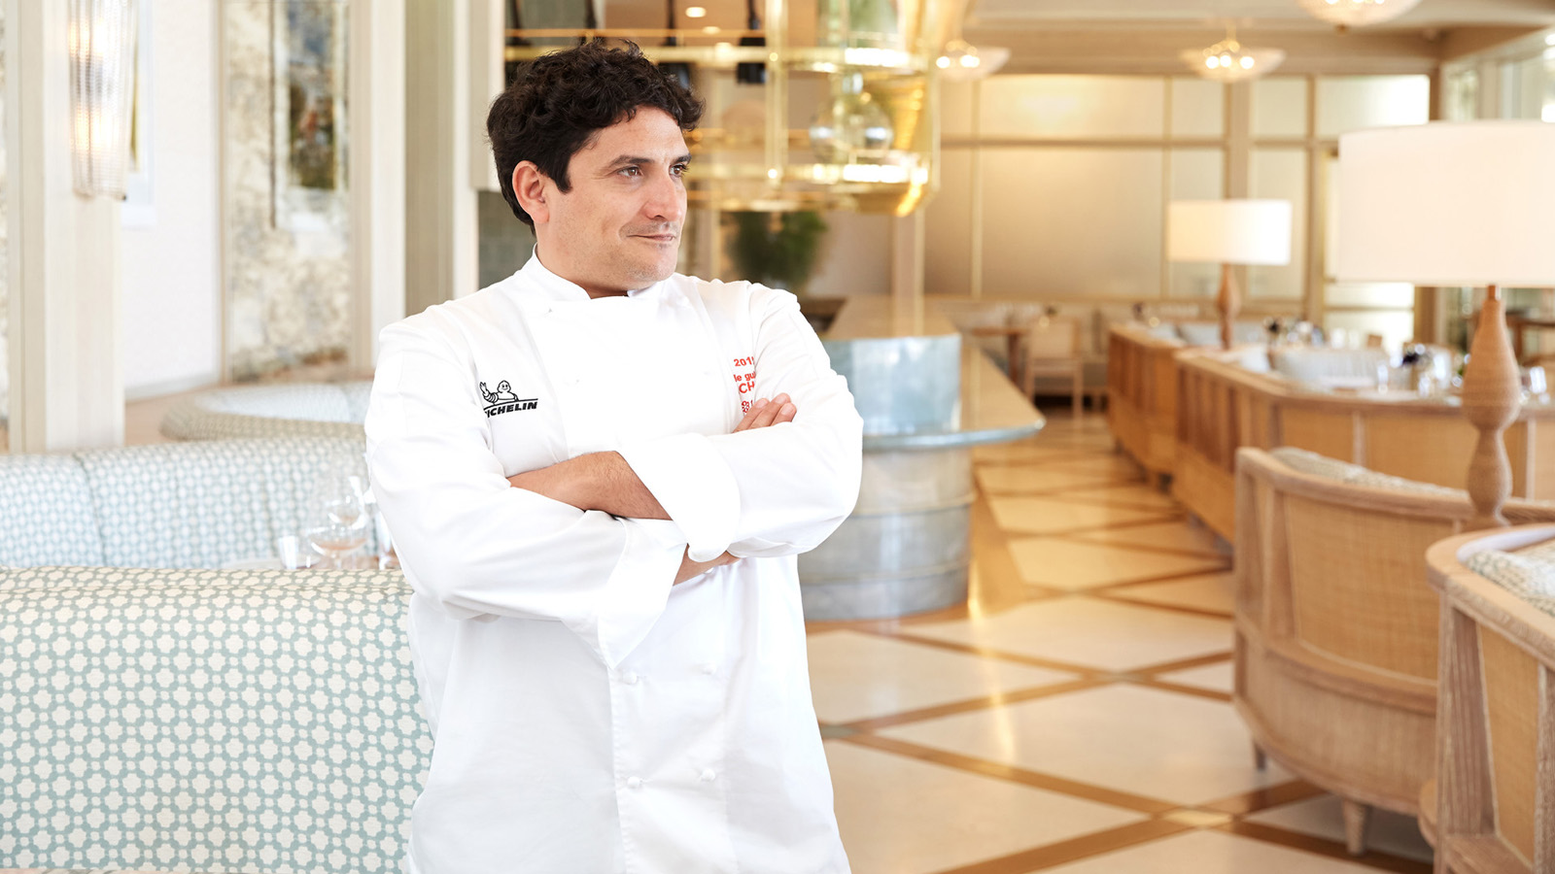 | May 9, 2022, Palm Beach, U.S.A.  Michelin-Starred Chef Mauro Colagreco Returns to Florie’s at Four Seasons Resort Palm Beach, His Only Restaurant in the USA, with a Host of Immersive Experiences  https://publish.url/palmbeach/hotel-news/2022/dining-events-with-mauro-colagreco.html
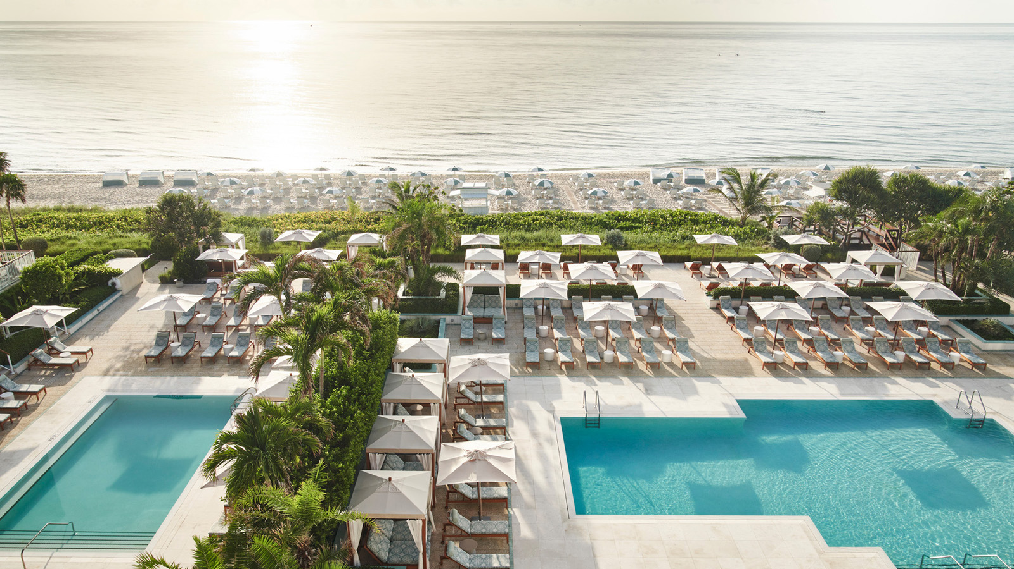 | April 27, 2022, Palm Beach, U.S.A.  Four Seasons Resort Palm Beach Celebrates Continued Honour as Island’s Only Forbes Travel Guide Five Star Destination  https://publish.url/palmbeach/hotel-news/2022/forbes-five-star-hotel-and-spa.html

PRESS CONTACTS

Eileen Sturgis
Public Relations and Communications Manager
2800 South Ocean Boulevard
Palm Beach
USA
eileen.sturgis@fourseasons.com

+1 561 493 5549

Laurie Herrick
Regional Director of Public Relations and Communications
2800 South Ocean Boulevard
Palm Beach
USA
laurie.herrick@fourseasons.com

