Celebrate Mom This Mother’s Day at Four Seasons Hotel One Dalton Street, Boston

Pamper the most important woman in life with a selection of offerings including Laurent-Perrier Mother’s Day Tea, an overnight stay, and wellness offerings
April 21, 2021, Boston One Dalton, U.S.A.

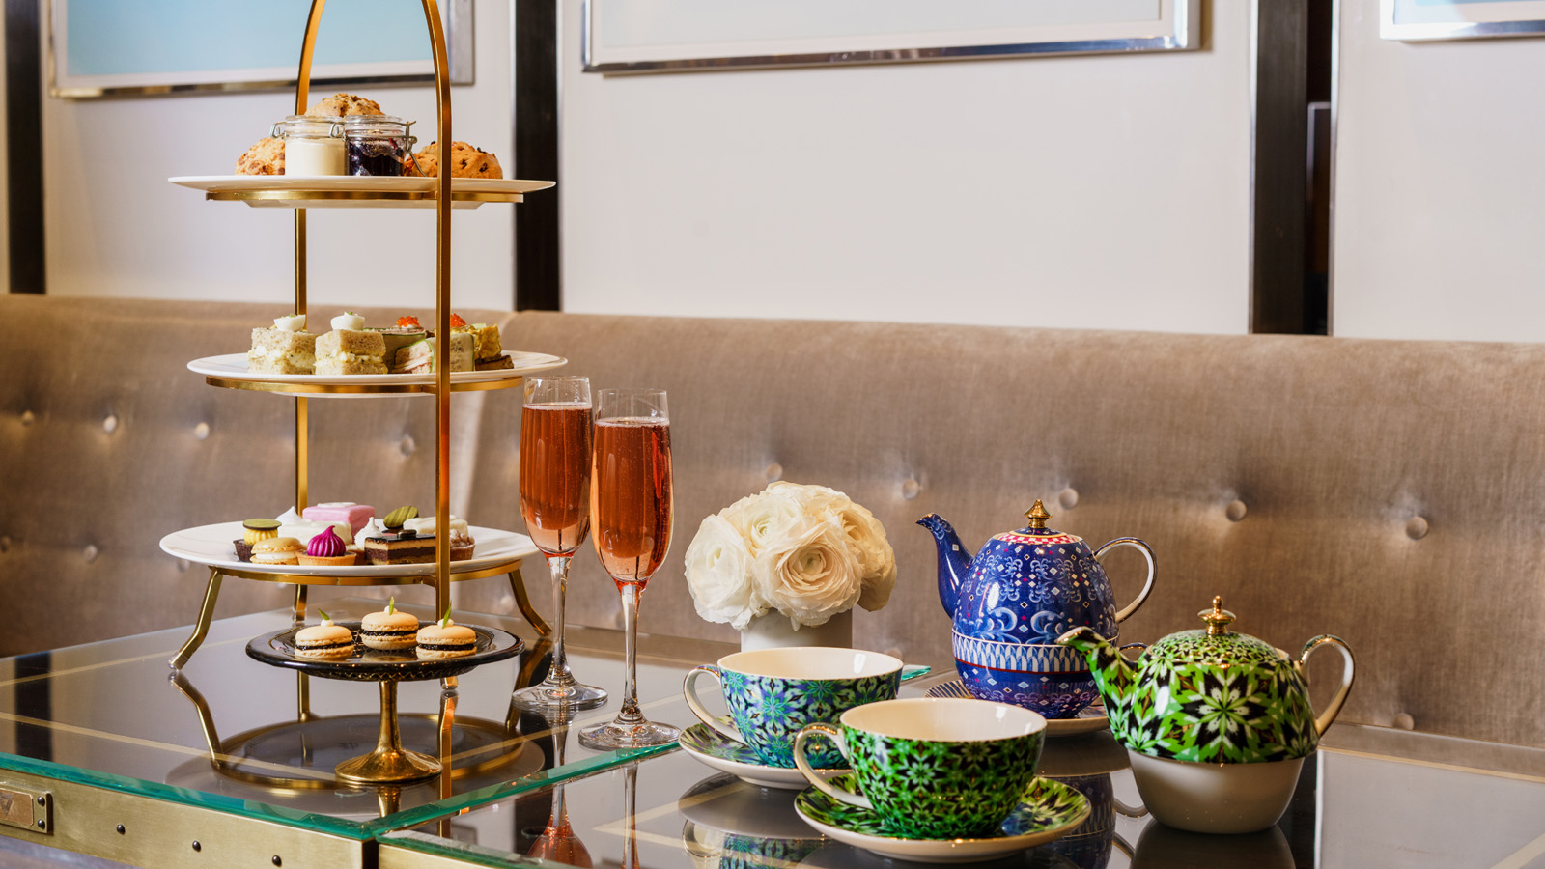
Mother’s Day is the one day a year that we can celebrate and give back to the woman who takes care of us every other day of the year. At Four Seasons Hotel One Dalton Street, Boston, the gifting options are endless. The world-class hotel located in the heart of Back Bay is home to a very special Laurent-Perrier Mother’s Day Tea; a celebratory overnight package entitled Moments That Matter; and a selection of wellness offerings from The Wellness Floor at One Dalton.
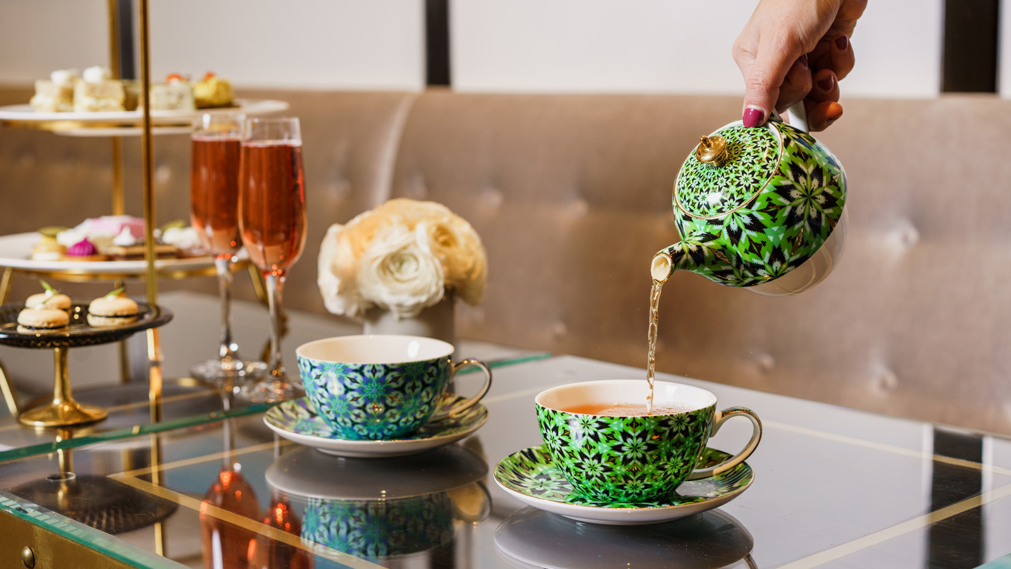 | 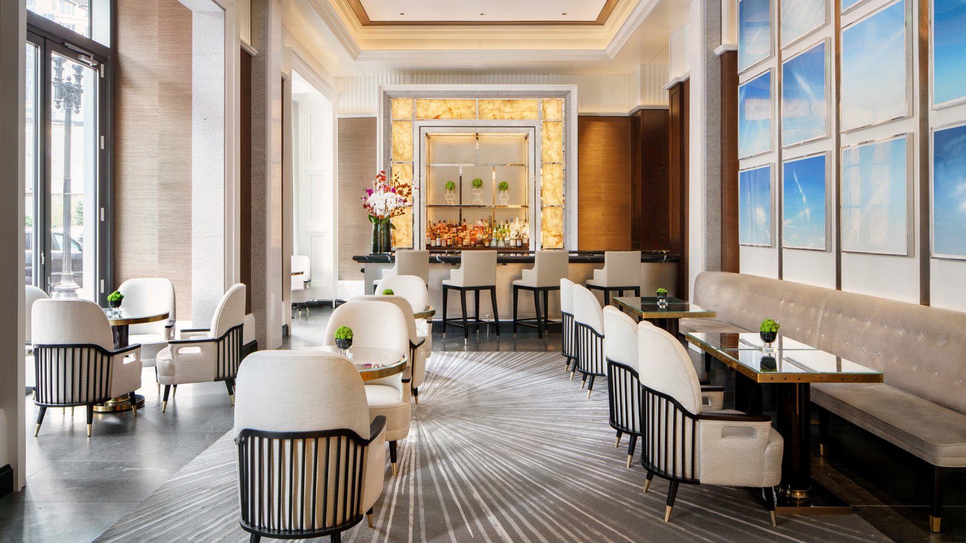 | 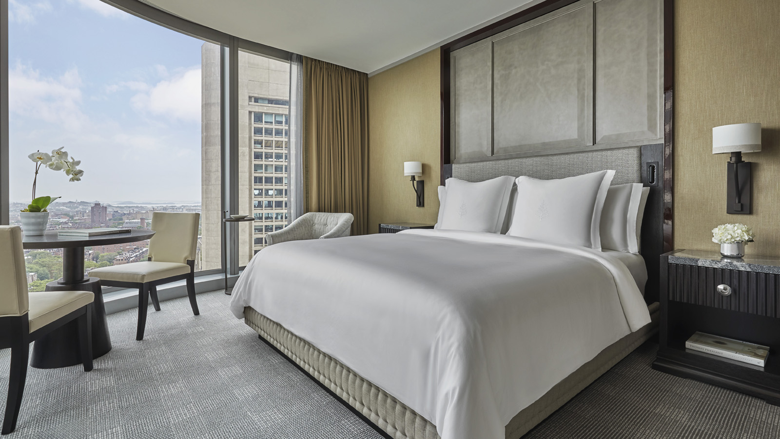
Laurent-Perrier Mother’s Day Tea
In partnership with Champagne Laurent-Perrier, Trifecta will play host to a very special Mother’s Day Tea this year. The Laurent-Perrier Mother’s Day Tea will offer an enhanced experience designed to celebrate mothers with a complimentary glass of Laurent-Perrier champagne on arrival. Established in 1812, Champagne Laurent-Perrier is now the largest female and family-owned Champagne house, with a long-standing tradition of celebrating women and all that they do.
Offering a contemporary take on the classic afternoon tea, this special Mother’s Day Tea will feature eclectic tea sandwiches, freshly baked scones, an assortment of desserts and bespoke blends of local favourite J’enway Tea Co.
Continue the celebration with a complimentary liquor pairing with two special tea selections. Available exclusively for Mother’s Day weekend, Trifecta will offer a raspberry white lemonade tea spiked with limoncello, and a cinnamon almond biscotti tea spiked with Disaronno.
The special Mother’s Day Afternoon Tea in Trifecta is available from 11:00 am to 3:00 pm on Saturday, May 8 and Sunday, May 9, 2021 at USD 65 per person. Reservations are highly recommended.
Moments That Matter
Designed to recognise a special someone or celebratory moment, there is no better opportunity to pamper Mom than with One Dalton’s Moments That Matter package. The ultimate in-room experience includes a celebratory Champagne amenity from Champagne Laurent-Perrier and includes a sweet treat on arrival, a special bath amenity for full relaxation in the room's deep soaking tub, Soveral body oil and two take-home spa robes to enjoy in-room and at-home.
Reservations are essential and can be made by calling 617 530 1388 or by emailing reservations.onedalton@fourseasons.com.
The Wellness Floor
The Wellness Floor at One Dalton will be re-opening for Mother’s Day weekend and on weekends thereafter. Known as an urban sanctuary within the city of Boston, The Wellness Floor offers the ultimate in pampering and relaxation and is available to locals and Hotel guests. Pamper Mom with one of the four exceptional treatments available in the Spa including:
- One Dalton Bespoke Experience: An expert therapist creates a customised essential oil blend for this massage experience. Using Alexandra Soveral’s aromatherapy collection of the purest organic essential oils, this journey will create harmony between body and mind. 100 minutes / USD 380-390
- Coastal Intentions: Let the healing hands of a skilled massage therapist pamper. With this custom massage, deep relaxation and a sense of calm will be given. Fatigue and stress will drift away as the therapist works to achieve guest goals. 50–80 minutes / USD 180–250
- Deep Focus: This therapeutic massage is designed to improve mobility and reduce the chronic restrictions the body endures. Steamed towel packs and natural cooling muscle balm complement this journey, targeting specific concerns and enabling healing from within. 50–80 minutes / USD 190–260
- Reflexology: Reflexology stimulates energy flow and encourages optimal body function through applied pressure to specific areas of the hands and feet. This therapy can help improve circulation and will leave guests feeling balanced and relaxed. 50 minutes / USD 180–190
The Wellness Floor will be open for private appointments from 1:00 to 7:00 pm on Friday, May 7 and 10:00 am to 7:00 pm on Saturday, May 8 and Sunday, May 9, 2021.
Reservations are essential and can be made by calling 617 530 1388 or by emailing reservations.onedalton@fourseasons.com.
About Champagne Laurent-Perrier

RELATED

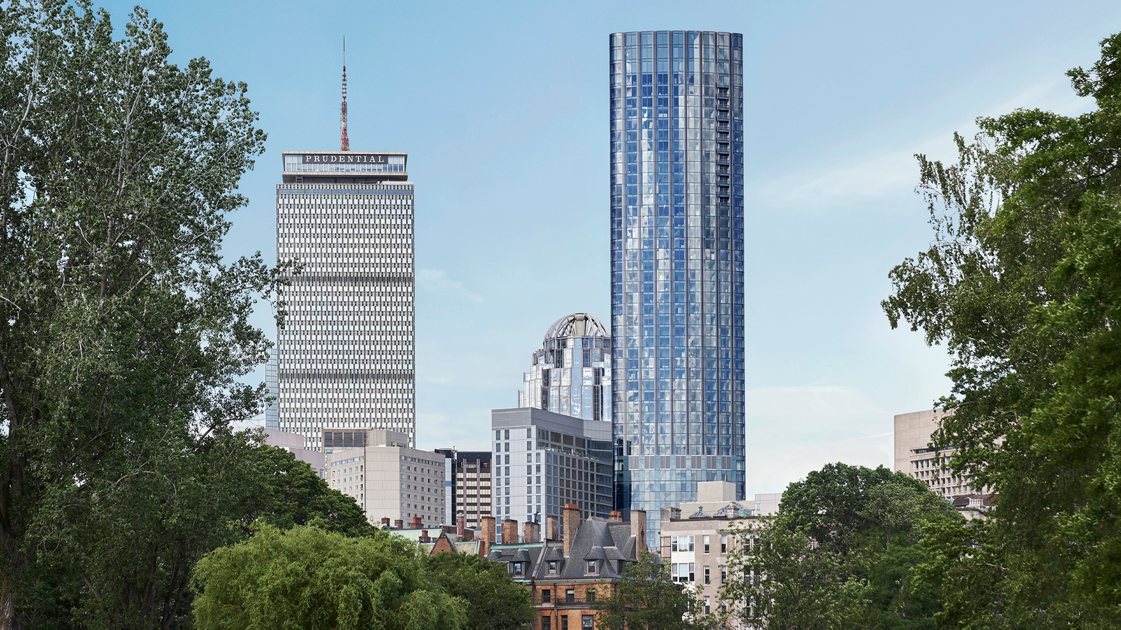 | July 28, 2021, Boston One Dalton, U.S.A.  Four Seasons Hotel One Dalton Street, Boston Launches Unforgettable Summer Experiences  https://publish.url/onedalton/hotel-news/2021/summer-experiences.html
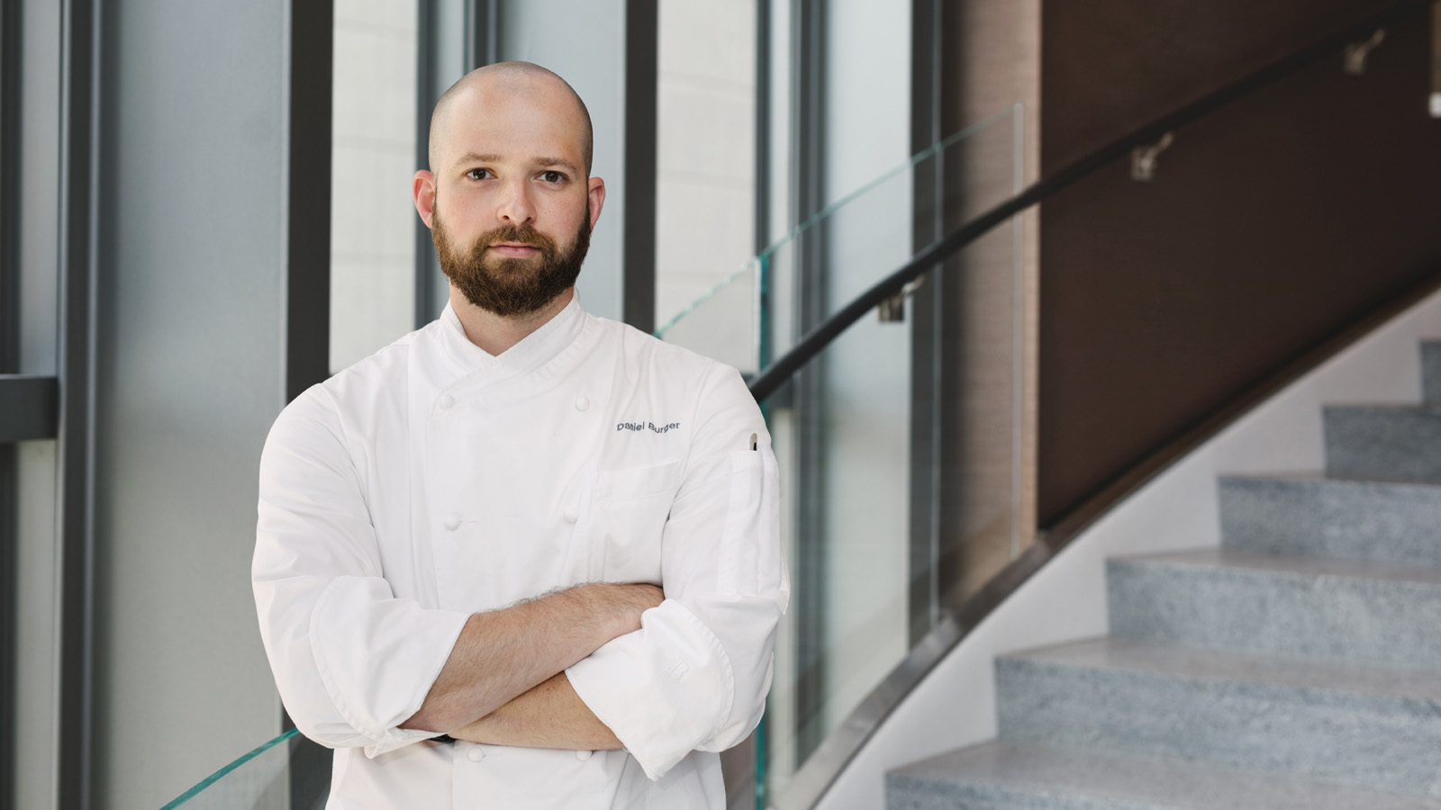 | July 9, 2021, Boston One Dalton, U.S.A.  Four Seasons Hotel One Dalton Street, Boston Appoints New Culinary Leadership Team  https://publish.url/onedalton/hotel-news/2021/new-culinary-team-members.html

PRESS CONTACTS

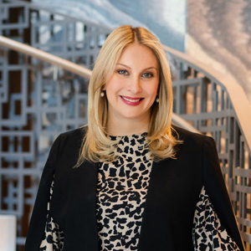 | Kristi Blake  Senior Public Relations Director  1 Dalton Street  Boston  USA  kristi.blake@fourseasons.com  +1 646 757 0115
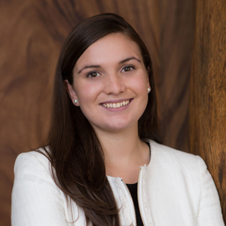 | Katie Eldemery  Digital Marketing Coordinator  1 Dalton Street  Boston  USA  katie.eldemery@fourseasons.com  +1 617 530 1850

