Sourdough Rising

May 29, 2018, Hong Kong, China

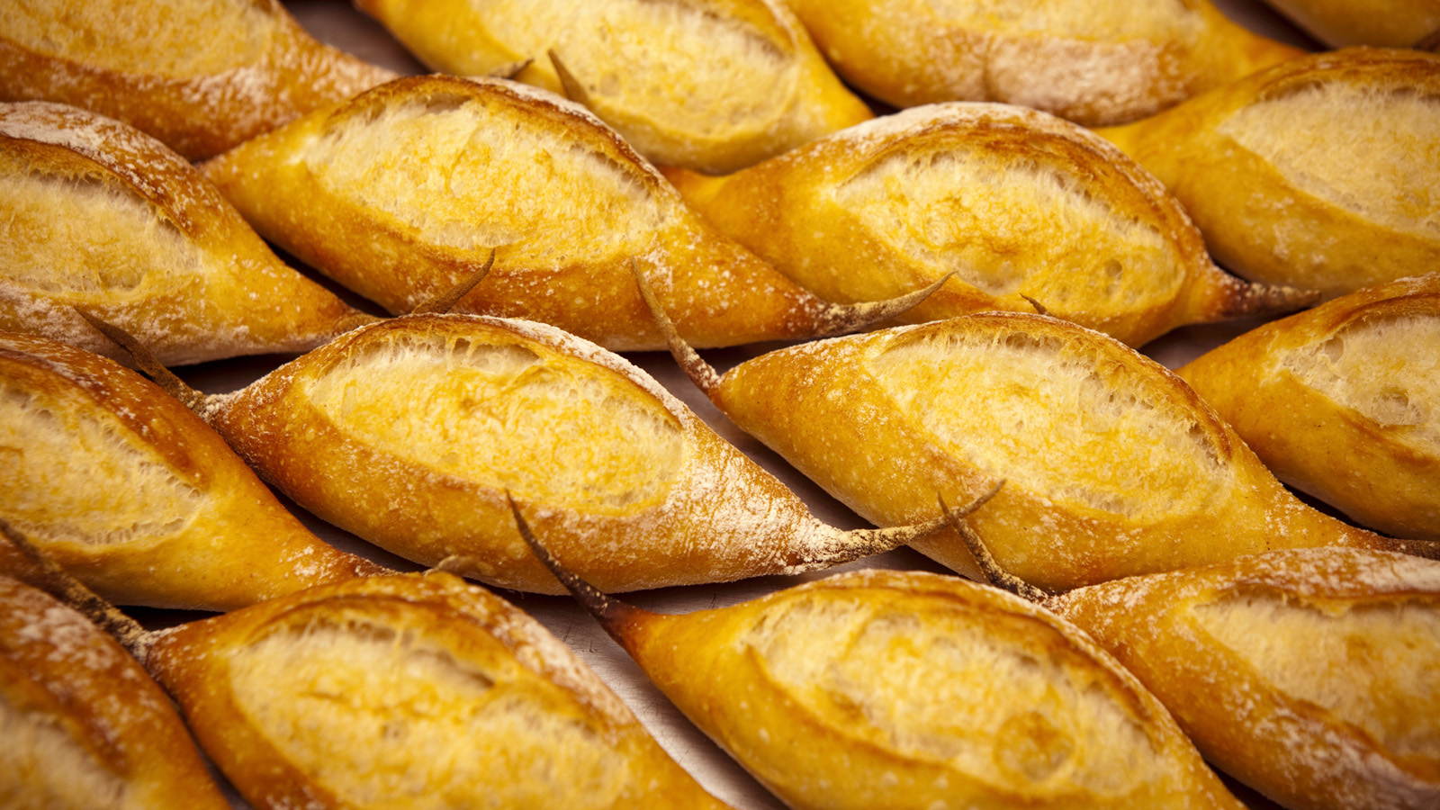
With a history that dates back more than five thousand years, sourdough bread is hardly new to the modern baker. The demand for artisan bread was significantly lower in Asia back in 2005 when
Four Seasons
Hotel Hong Kong opened. Today, the increasing demand for healthier and quality breads in recent years means it is not uncommon nowadays for a baker to have a sourdough starter living in their kitchen.
The sourdough starter at
Four Seasons
Hotel Hong Kong was created at the same time as the Hotel’s opening using three ingredients – raisins, water and honey - fermented to capture the wild yeast used to leaven bread. This process took about a week and when bubbles became clearly visible, a sign that the yeast was active, it was ready for endless bread making.
Similar to nursing an infant, a starter grows with care and nurturing. Since the Hotel's opening, the starter has been on a strict feeding schedule of every eight hours where a member of the pastry team feeds it with water and flour to "keep it alive" – or happy. The flavour of the bread in its early years was milder, but intensified as the starter matured after four to five years.
"When you have to nurture the starter regularly and for so many years, you develop feelings for it and it becomes a part of the family. The starter is older than my son," says Executive Pastry Chef Ringo Chan.
The benefits of replacing commercial yeast with natural yeast are the taste it breeds - a more natural yeasty flavour that is often favoured by bread artisans and more importantly, it promotes digestive health.
Temperature and humidity play an equally important role as the quality of the ingredients and skills of the baker before, during and after baking. Cooler temperatures and lower humidity levels enable the ingredients to perform at its best with a longer fermentation, making the bread easier to digest, while warmer temperatures expedite the proofing process and often results in over-proofing the dough. Bread making at home without the use of a professional proofing oven could be a different experience every day.
Chef Ringo has taken this sourdough practice to other
Four Seasons
properties where he was a member of the pre-opening task force team. The sourdough tradition lives on, literally.
Today, the starter resides in the warmth of the Hotel’s pastry kitchen, used every day to make bread for diners at Caprice, Blue Bar and The Lounge where bread is very much a part of the overall dining experience. Leaving guests to ask, “What should I eat with the bread?”

RELATED

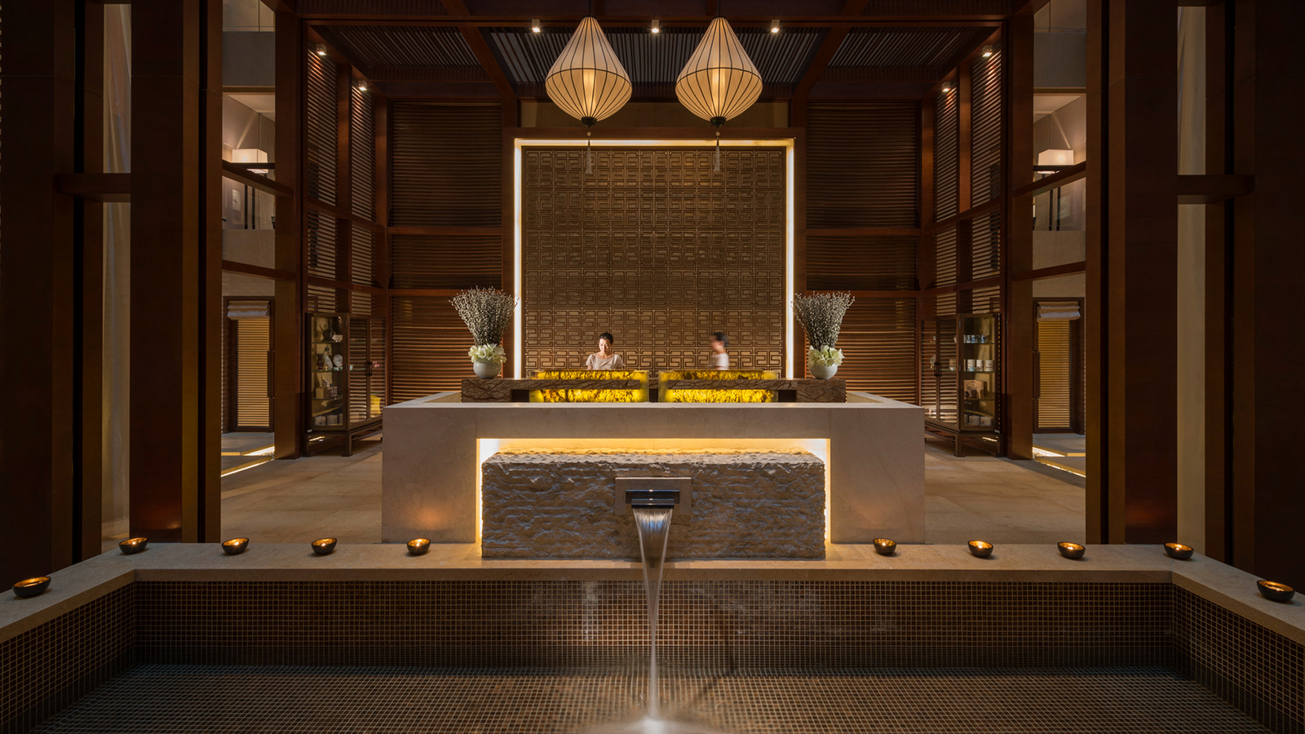 | May 29, 2018, Beijing, China  肌密之光：法国高端护肤品牌“原液之谜”全新增氧系列产品进驻北京四季酒店水疗中心  https://publish.url/zh/beijing/hotel-news/2018/new-biologique-recherche-spa-treatment-2.html
May 29, 2018, Beijing, China
肌密之光：法國高端護膚品牌「原液之謎」全新增氧系列產品進駐 北京四季酒店水療中心
https://publish.url/zh_hant/beijing/hotel-news/2018/new-biologique-recherche-spa-treatment-3.html

PRESS CONTACTS

Mimi Cheung
Digital Media and Content Manager
8 Finance Street, Central
Hong Kong
China
mimi.cheung@fourseasons.com

852 3196 8317

Priscilla Chan
Public Relations Manager
8 Finance Street, Central,
Hong Kong
China
priscilla.chan@fourseasons.com

(852) 3196 8307

Amy Powell
Director of Public Relations and Communications
8 Finance Street, Central
Hong Kong
China
amy.powell@fourseasons.com

+852 3196 8306

Vivian Koh
Director, Public Relations and Content, Asia-Pacific
Tourism Court, 1 Orchard Spring Lane #04-01
Singapore
Singapore
vivian.koh@fourseasons.com

+65 6739 5806

