Love is Easy to Celebrate at Four Seasons Resort Anguilla with the Anguilla Love Package

February 6, 2019, Anguilla, West Indies

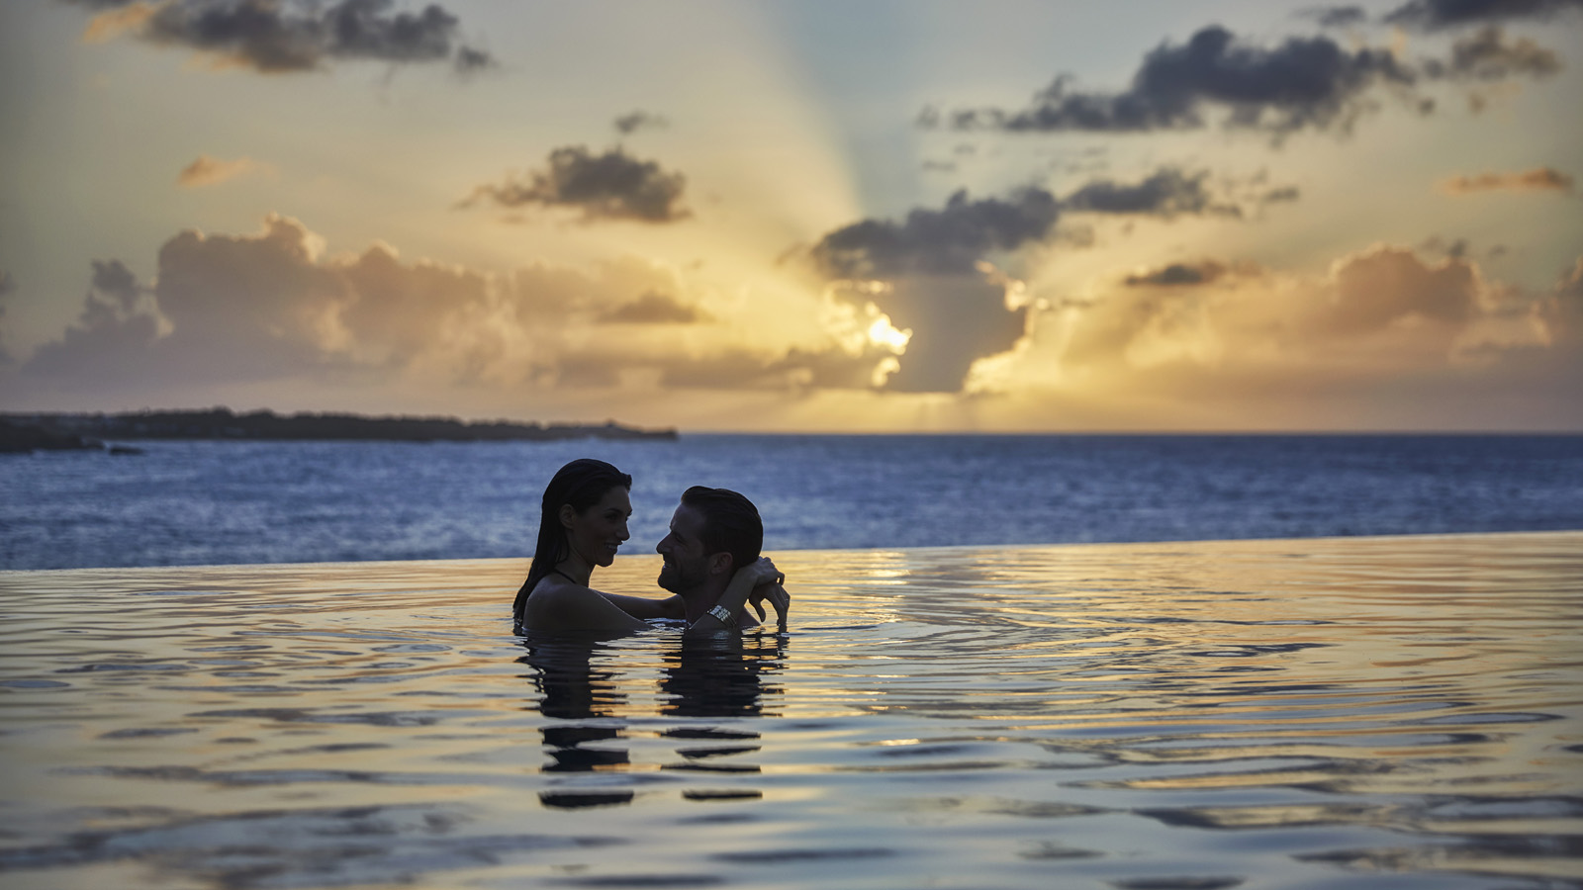
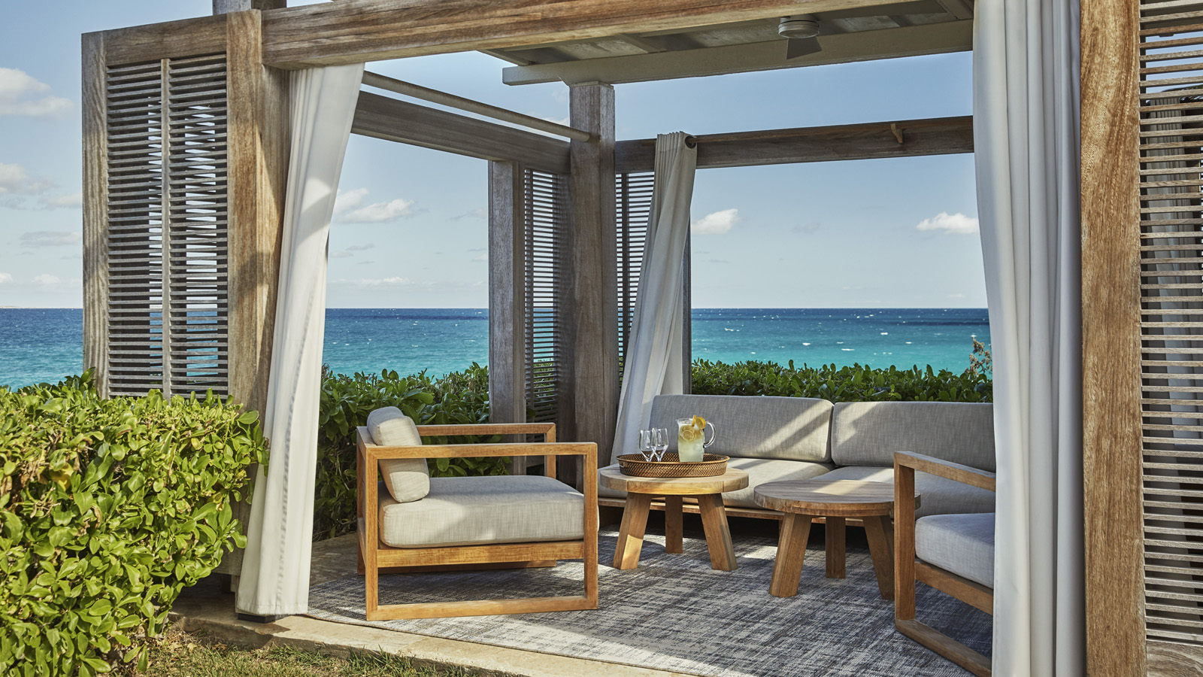 | 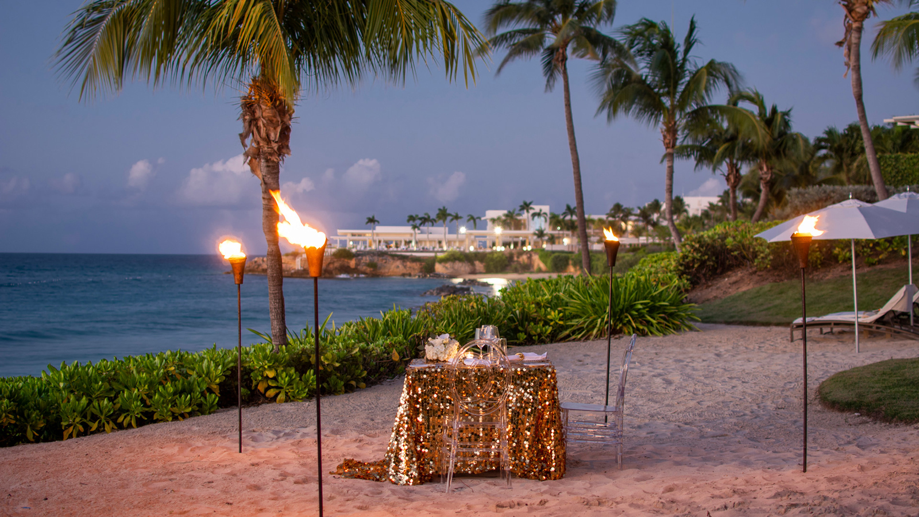 | 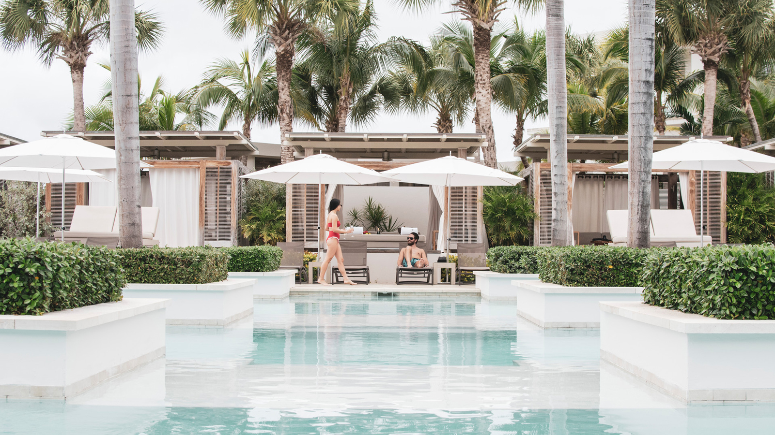
“Live in the sunshine. Swim the sea. Drink the wild air.” Ralph Waldo Emerson
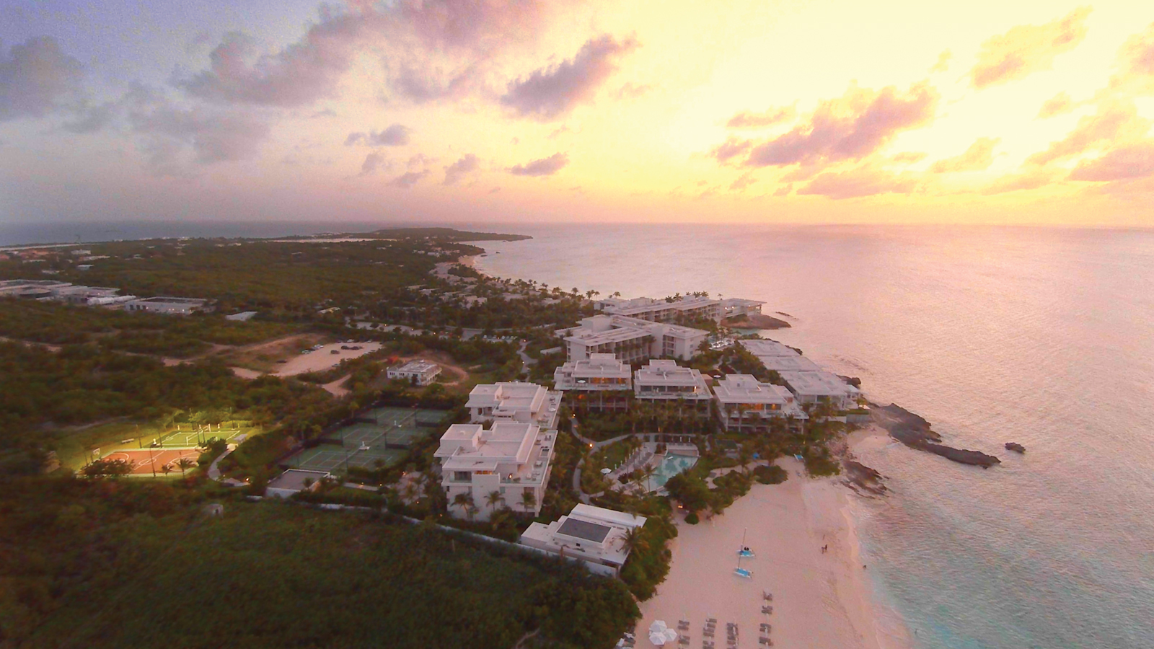
The shorelines of Anguilla entice travellers to follow Emerson’s words. Couples enjoy the tropical ambiance together with the new Anguilla Love package at Four Seasons Resort and Residences Anguilla. Whether celebrating a honeymoon, an anniversary or just another day at the beach, couples will relish their time together with this new package including:
- Two welcome drinks upon arrival
- Spa credit of USD 200
- Daily breakfast for two in Cob&agrave; restaurant
- Luxury poolside cabana for one day at the Aleta pool
Guests may choose to kick off their romantic rendezvous at the adults-only pool with their welcome drink. The Sunset Lounge & Pool is considered one of the sexiest bars in the Caribbean. Delicious Rum Punches, Mojitos, and other poolside favourites are brought to guests in the pool or served on a floating bar. Other options for a drink on the beach include Half Shell Beach Bar (on Barnes Bay) or Bamboo Bar & Grill (Meads Bay). Both beaches are considered two of Anguilla’s finest.
At The Spa, the couple may relax with a Deep Sea massage or Blue Tranquility. The couples’ room and waterfront outdoor cabanas are perfect for reconnecting in the luxury of spa pampering.
The Aleta pool is the place to be for ultimate poolside relaxation. The Cabanas provide a place in the shade plus the added bonus of a queen-size day bed in the sun. This package includes a one-day cabana rental.
Romantic Resort
Anguilla provides the perfect backdrop for romance and this package sets the stage for unforgettable days of rum-punch filled adventures and nights of endless possibilities under a star-lit sky. The Anguilla Love package starts at USD 1,175 per night (three-night minimum) and is based upon availability.
To reserve the Anguilla Love package, see your travel professional, call 800 201 9580 or book online.

RELATED

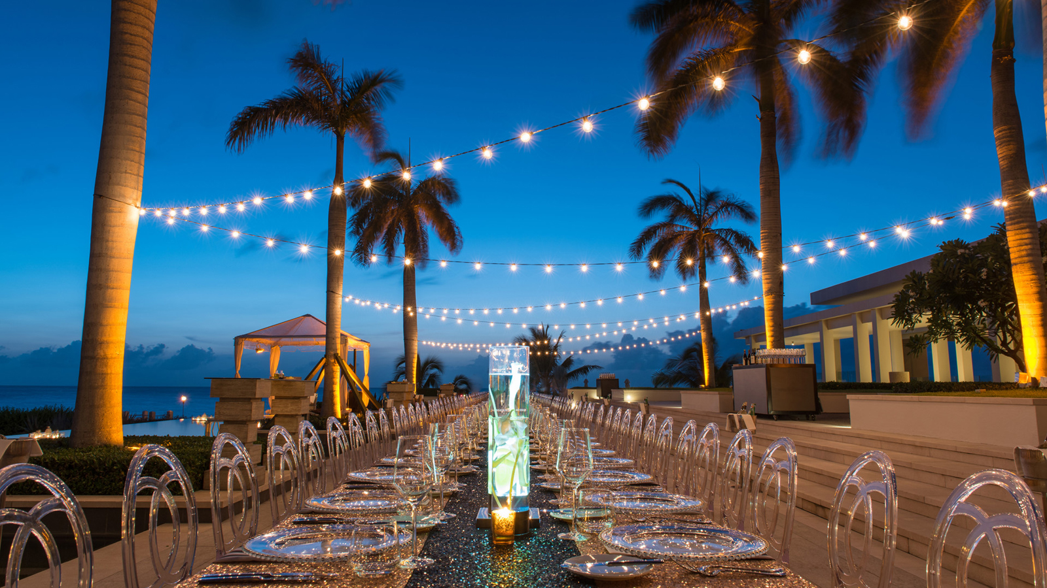 | December 5, 2018, Anguilla, West Indies  Ring in the New Year with Friends and Family on the #1 Island in the Caribbean at Four Seasons Resort and Residences Anguilla  https://publish.url/anguilla/hotel-news/2018/new-year.html
September 4, 2018, San Juan, Puerto Rico
Travel to the Caribbean in Style This Winter with Four Seasons and Tradewind Aviation
https://publish.url/nevis/hotel-news/2018/tradewind-aviation-partnership.html

PRESS CONTACTS

Suzanne Willis
Director of Public Relations and Communications
Barnes Bay, P.O. Box 8028
West End
Anguilla
suzanne.willis@fourseasons.com

+1 (239) 287-7070

