A Pure Approach to Reducing Plastic Waste at Four Seasons Resort The Nam Hai, Hoi An

Vietnam’s only Forbes 5-Star resort leads the way with water bottling facility
September 11, 2019, Hoi An, Vietnam

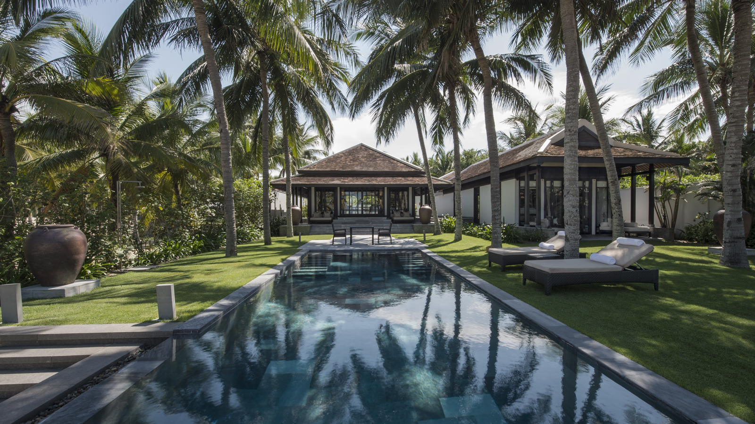 | 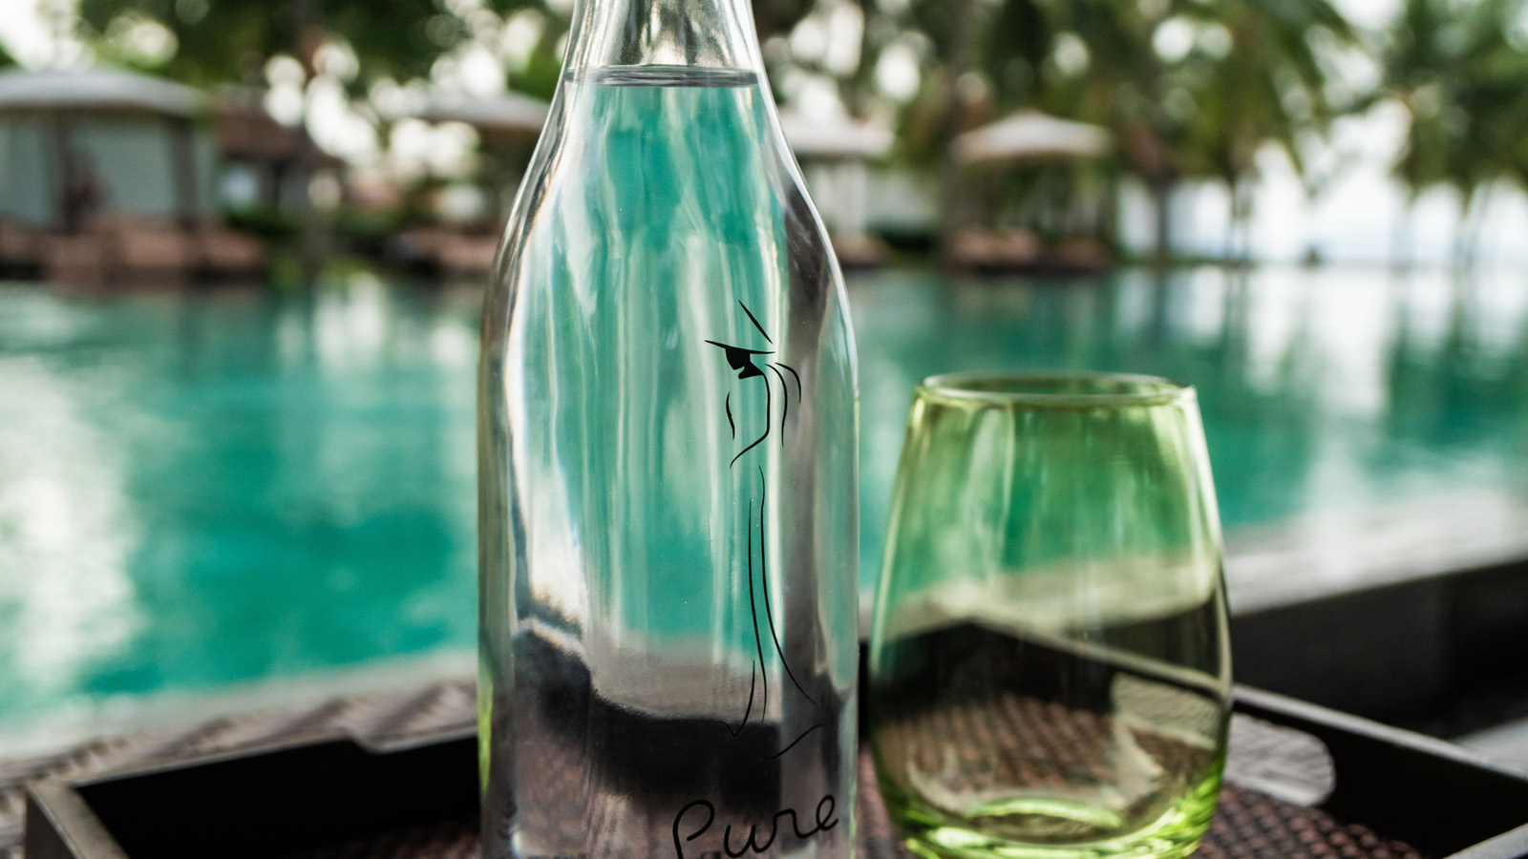 | 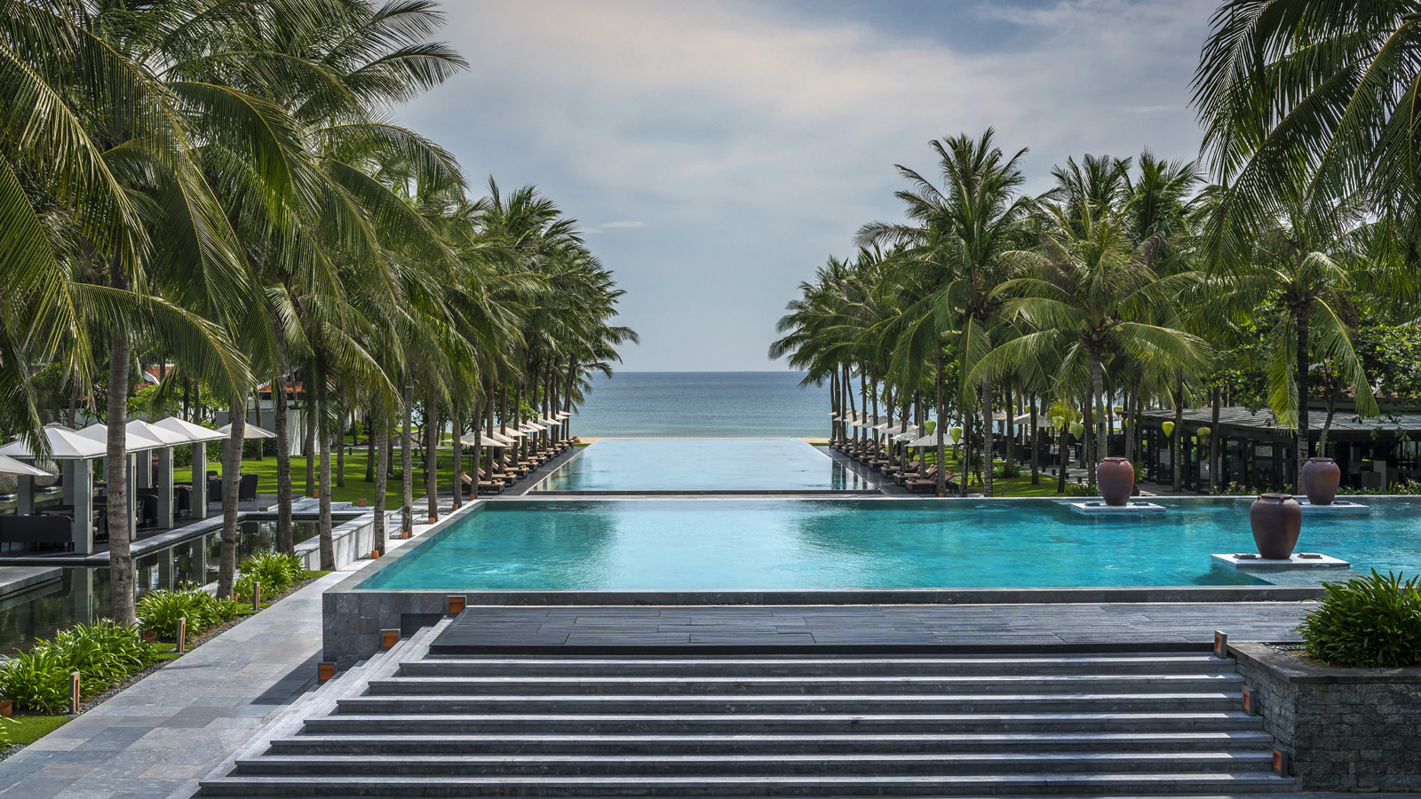
With environmental concerns over plastic consumables at an all-time high, Four Seasons Resort The Nam Hai, Hoi An is aiming to be part of the solution this December by launching Project Aqua: an on-site water-bottling facility that will cut an estimated 5.8 tons of plastic waste annually.
Named by Forbes as Vietnam’s only 5-star resort in 2019, the Resort takes its responsibility as a hospitality leader seriously and is committed to driving industry change.
Project Aqua’s facility is subtly hidden within the property’s lush beachfront grounds, beneath the shade of 4,500 palm trees. It uses state-of-the-art filtration systems such as UV and reverse osmosis filtration to ensure guests enjoy the freshest, cleanest water – without any plastic waste.
Known as "Pure," the brand not only symbolises the quality of the water but also expresses The Nam Hai’s ethos as a place to retain the simplicity of nature. In addition, the Pure logo features the image of a lady in ao dai, the simple but elegant “long shirt” dress traditionally worn by Vietnamese women. Uniquely branded glass bottles feature in every room, while aluminum bottles are available for purchase in the Resort’s Boutique, The Heart of the Earth Spa, through in-villa private bars and during Resort-arranged tours.
It is estimated that these reusable bottles will eradicate the use of more than 420,000 plastic bottles across the Resort annually. With Phase 1 a pioneering success, plans for Phase 2 of Project Aqua are already in place, including refilling stations through the Resort and the installation of water stations in the gym area.
For Bryan Ruch, The Nam Hai’s people-driven Resort Manager, sustainability is very much a part of The Nam Hai vision. “With our strong global and local reputation, it’s essential that The Nam Hai not only sets the standard in terms of hospitality but also leads by example with sustainability initiatives,” he shares. “Project Aqua represents one step in a long and ongoing sustainability journey that all hotels, businesses and households need to commit to if we are to turn the tide on environmental destruction. By showing what’s possible in terms of sustainable hospitality, we hope to encourage others to do what they can to be a part of the solution.”
Project Aqua is part of The Nam Hai’s ongoing commitment to driving economic, social and environmental sustainability in the area. In March 2019, the Resort teamed up with Hoi An Eco City Projects – a local environmental organisation striving to build a zero-waste community – to raise awareness of sustainability. Additionally, The Nam Hai’s Sympathetic Hearts charity, founded in 2009, supports some of the most impoverished residents of Quang Nam and beyond, in the areas of education, healthcare and basic needs.

RELATED

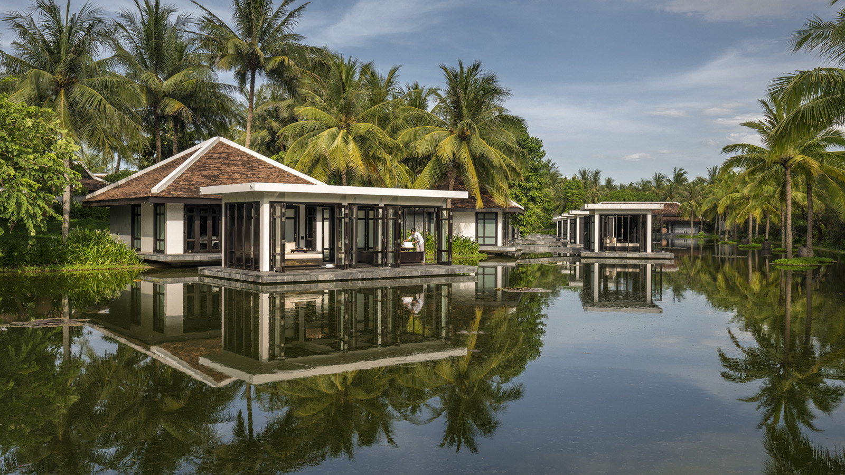 | September 17, 2019, Hoi An, Vietnam  Four Seasons Resort The Nam Hai Named SpaChina’s Global Wellness Resort of the Year for Second Consecutive Year  https://publish.url/hoian/hotel-news/2019/global-wellness-resort-of-the-year.html
September 11, 2019, Hoi An, Vietnam
플라스틱 쓰레기를 줄이기 위한 포시즌스 남하이의 '순수(PURE)' 솔루션
https://publish.url/kr/hoian/hotel-news/2019/plastic-waste-reduction-program-3.html

PRESS CONTACTS

Shingo Kido
Director of Public Relations and Communications
Block Ha My Dong B, Dien Duong Ward
Dien Ban Town
Vietnam
shingo.kido@fourseasons.com

+84 9 0570 7665

