Share the Love with Four Seasons Hotel Baku This Valentine’s Day

Indulge in a 24-karat gold massage and five courses of Azerbaijani delicacies this Valentine’s Day at Four Seasons Hotel Baku
February 7, 2019, Baku, Azerbaijan

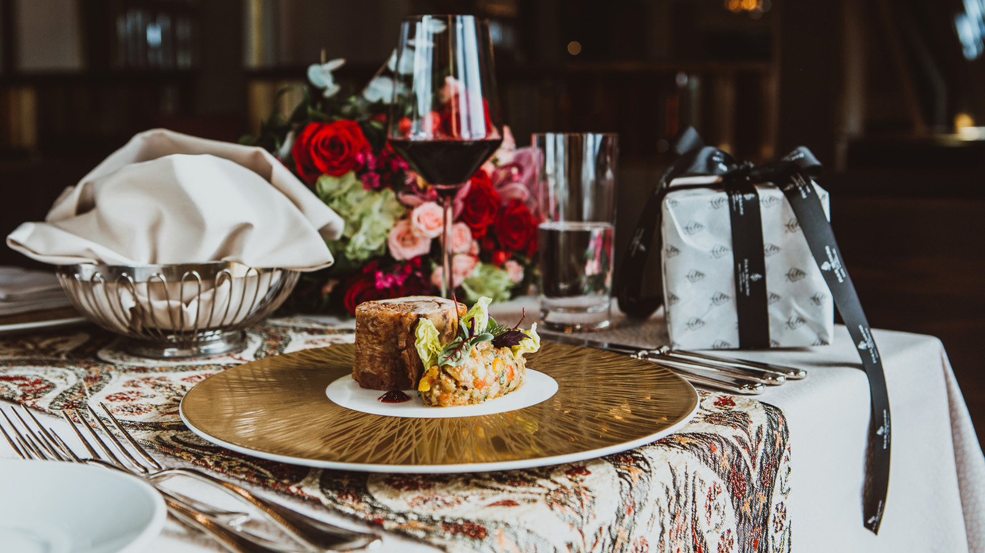
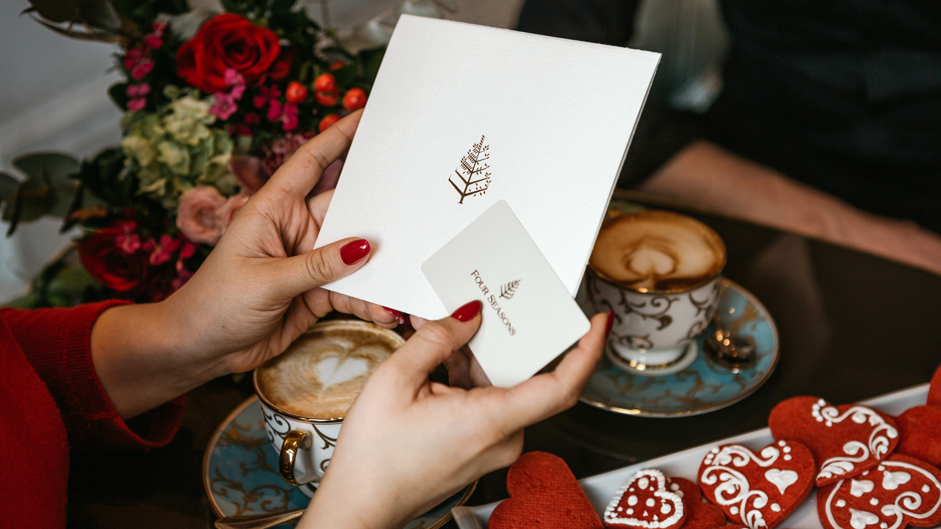 | 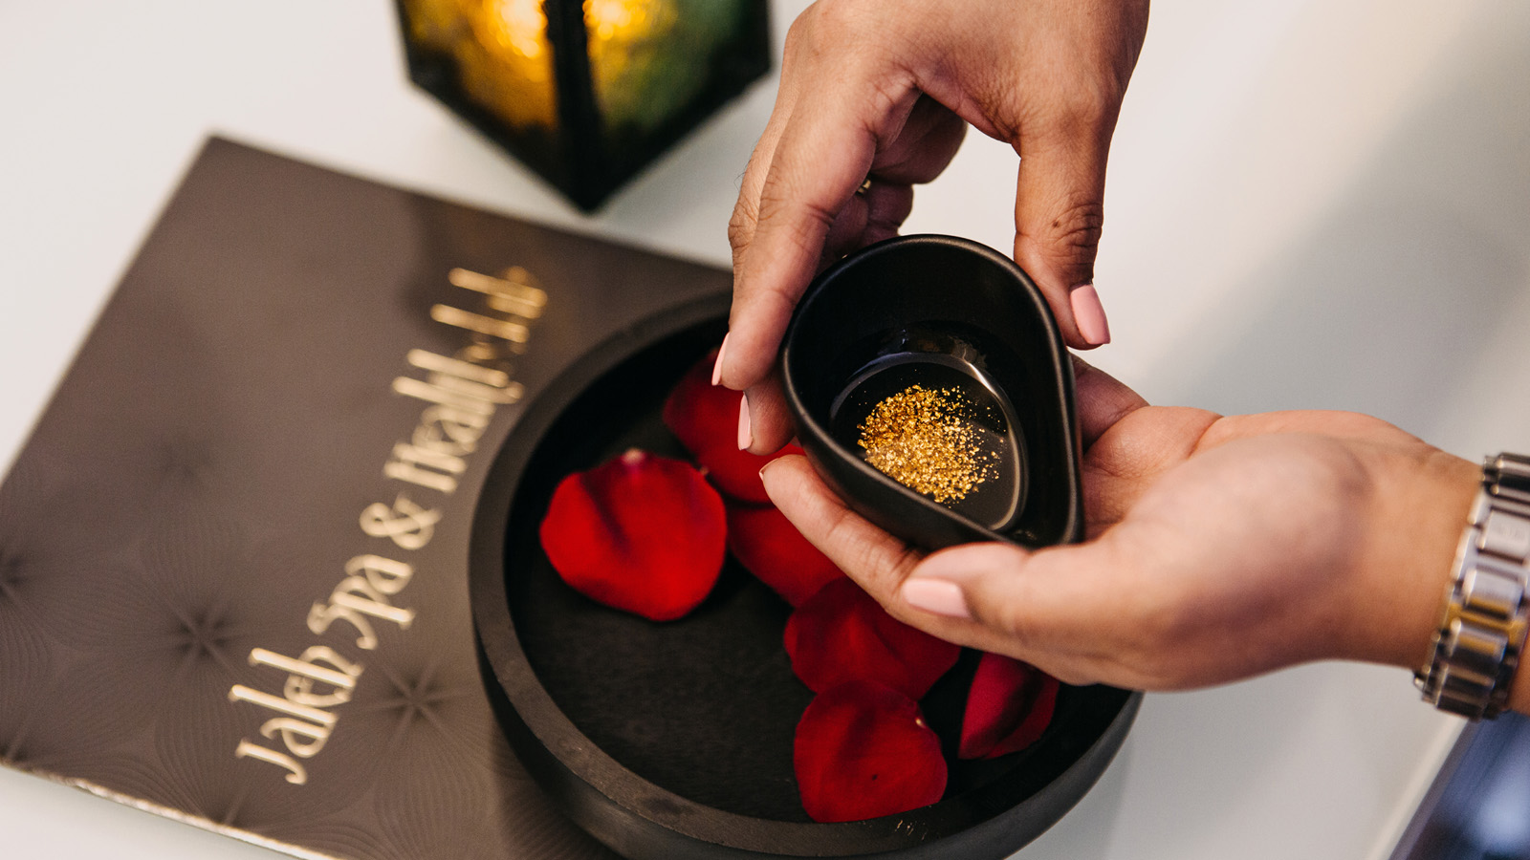 | 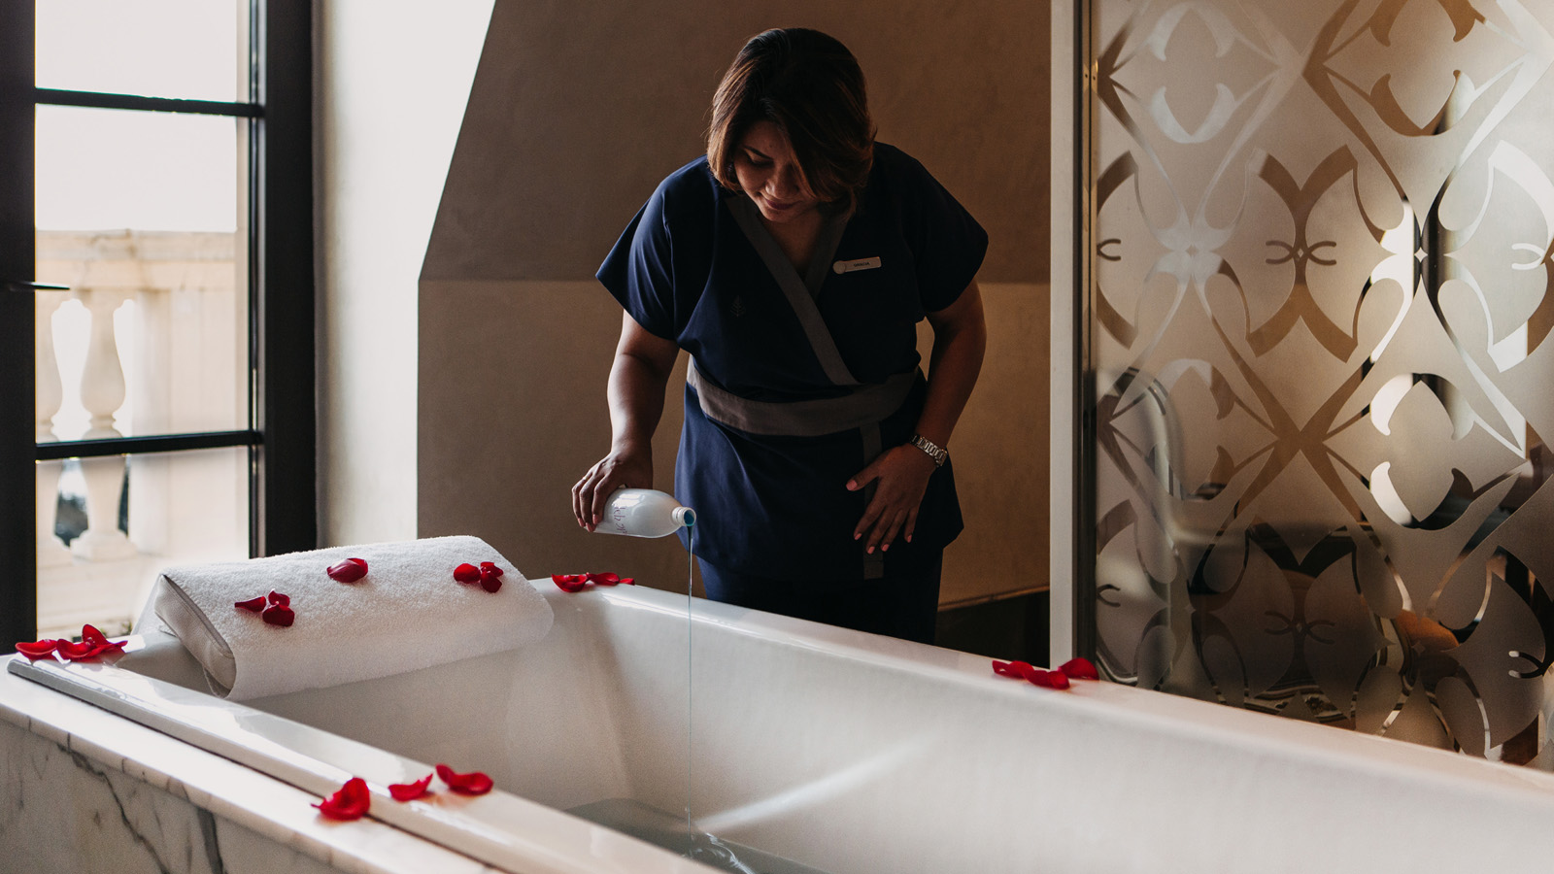
This Valentine’s Day, Four Seasons Hotel Baku is offering couples a selection of romantic activities across the Hotel, including a 24-karat gold massage, personalised flower bouquets and a romantic five-course meal at the Hotel’s picturesque rooftop restaurant, Kaspia.
Five-Course Valentine’s Tasting Menu
As Valentine’s Day approaches, guests are invited to give in to temptation with a five-course menu at the Hotel’s rooftop restaurant Kaspia. Surrounded by inspiring interiors and a magnificent view over the Caspian Sea, couples will be treated to traditional Azerbaijani music performed by a local artist alongside a romantic dinner. Courses include a delectable lamb gigot alongside roasted chestnuts, apricots and plums, and salmon "reinvented," accompanied by a white bean ragout and charred green onion. In the evening, Baku – the City of Lights - becomes a romantic destination where couples can witness the famed light display under the stars from Kaspia rooftop.
Valentine’s Dinner at Kaspia is priced at USD 174 per person and requires an advanced reservation.
Mi Amore - Cuisine From the Heart of Italy
Surrounded by tremendous vaulted ceilings and serving up artful plates of central Italian specialties, couples can enjoy a refined Italian dinner at Zafferano Restaurant, offering a diverse range of creative specialties from the heart of Italy. Guests can savour Italian Chef Luca Casini’s handmade pastas and delectable risottos, including the finest mushroom and truffle risotto in Baku. Valentine’s dinner will be accompanied by the musical stylings of local band Dervish.
24-Karat Heart of Gold
Over this romantic period, couples can also take delight in a personalised 24-karat gold massage experience at Jaleh Spa. The treatment hydrates and nourishes the skin, leaving it firmer and more youthful, featuring potent age-reversing 24-karat massage oil, a true beauty secret of Hollywood’s biggest stars.
The 24-Karat-Gold Package includes a couple's 60-minute 24-karat gold massage, a couple's 30-minute facial treatment, a selection of local teas and complimentary access to the sauna, steam room, whirlpool and swimming pool and is priced at USD 230 per couple.
Pick the Best Bouquet
Personalise Valentine’s Day at Four Seasons Hotel Baku’s Flower Shop, where for a limited time, specialist florist Anastasiya will hand-craft the perfect flower bouquet for a loved one.
The lobby flower shop will be open February 13, 2019 from 2:00 to 6:00 pm and February 14, 2019 from 8:00 am to 8:00 pm.
During the day, guests can enjoy a romantic walk along the historic waterfront of Baku Boulevard, wander through the Old City for a taste of history and culture, and explore the medieval Palace of the Shirvanshahs. Located on the highest hill in the area, the Palace is rich in history and boasts stunning views of Baku from the hilltop. Perched along the waterfront, the Beaux-Arts style Four Seasons Hotel Baku lies just steps from the medieval walls of the Inner City. The Hotel boasts a secluded Romanesque-style indoor pool housed in a stone-clad atrium beneath a vaulted glass ceiling, Turkish-style Hammams, two world-class restaurants, a casual Piazza Lounge and intimate Bentley's Whiskey Bar.
To book, call +994 124042424.

RELATED

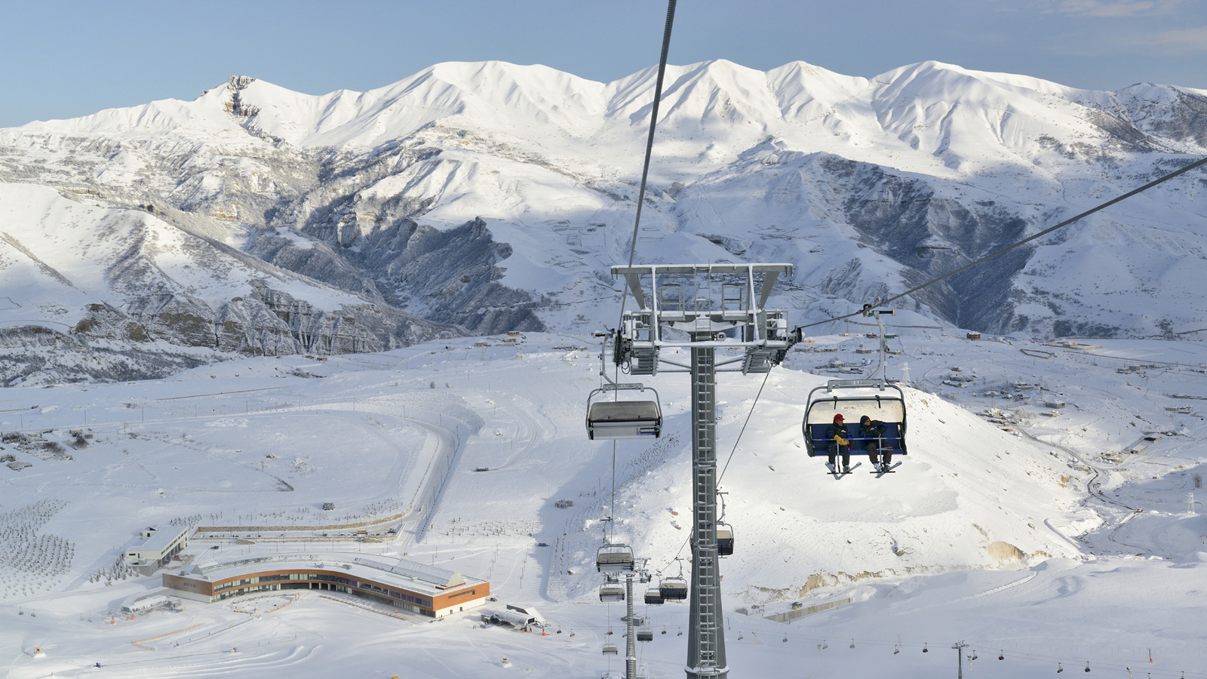 | November 21, 2018, Baku, Azerbaijan  A Winter Getaway to the Mountains of Azerbaijan with Four Seasons Hotel Baku  https://publish.url/baku/hotel-news/2018/winter-getaway-and-festive-season.html
November 21, 2018, Baku, Azerbaijan
Путешествие в зимнюю сказку: три ночи по цене двух в Four Seasons Hotel Baku и многое другое
https://publish.url/ru/baku/hotel-news/2018/winter-getaway-and-festive-season-2.html

PRESS CONTACTS

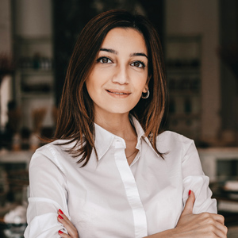 | Leila Aliyeva  Public Relations Manager  1, Neftchilar Avenue  Baku  Azerbaijan  leila.aliyeva@fourseasons.com  +994 12 404 2424

