With its Ideal Setting for a Magical Outdoor Experience, Winter City is Back at Four Seasons Hotel Istanbul at the Bosphorus

Indulge in Winter City for a joyful ice skating experience and create a winter tale by the mesmerizing Bosphorus with loved ones
November 26, 2021, Istanbul at the Bosphorus, Turkey

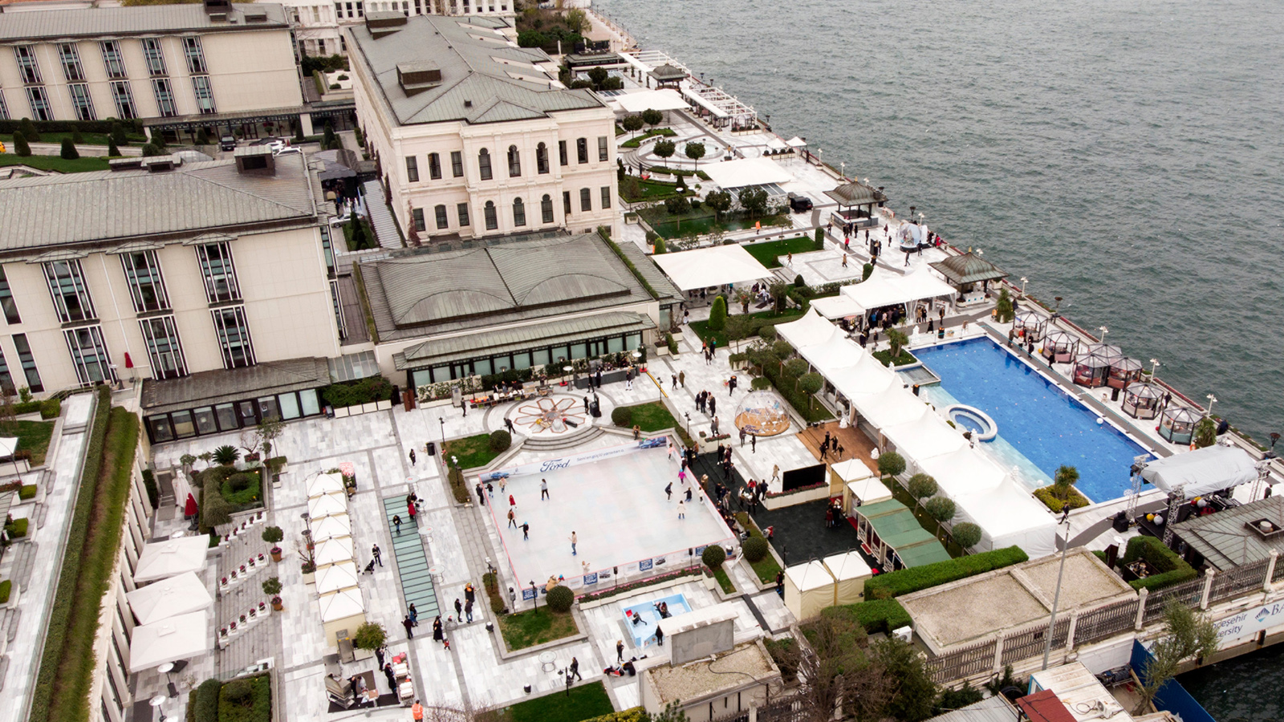
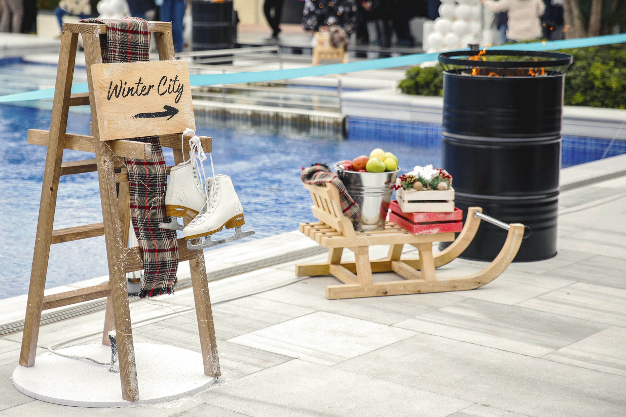 | 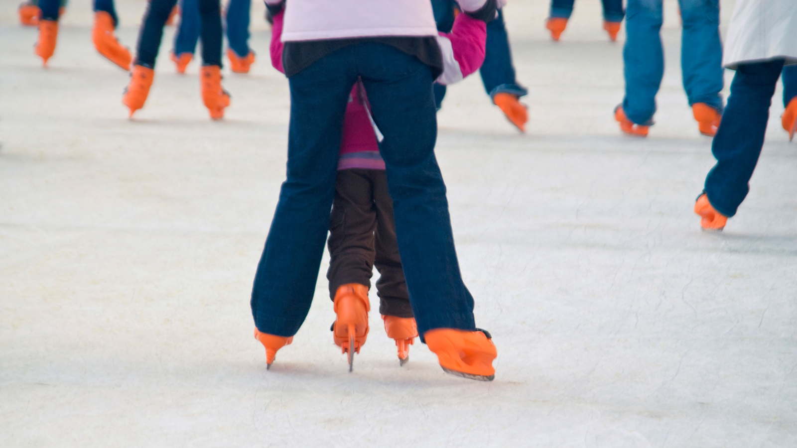
Housed in a 19th century Ottoman palace, Four Seasons Hotel Istanbul at the Bosphorus brings back Winter City with an ice skating rink on its Atik Pasha terrace by the Bosphorus. Offering a resort-style experience by the Bosphorus, the Hotel aims to be the meeting point of families with kids and youngsters with attractive winter offerings.
Available between December 15, 2021 and March 1, 2022 (weather dependant), Winter City welcomes guests every day between 12:00 noon and 8:00 pm in a leisurely setting with Bosphorus as its backdrop. Guests who would like to spice up the winter spirit may enjoy private lessons by expert ice skating instructors at the comfort of Four Seasons.
On special days and during winter school break, delicious street-style food prepared by Hotel’s culinary experts and special ice skating shows will be available at Winter City, making it even more enjoyable and attractive for its visitors.
Winter City offers a perfect opportunity for those looking for outdoor family activities in Istanbul during winter season with ice skating, which is also the very definition of festive fun.
For those who would like to have private ice skating lessons:
- 40-minute ice skating session - TRY 75 per person for adults
- 40-minute ice skating session - TRY 50 per person for kids
- 40-minute private lesson - TRY 250 person
Not only guests in residence but also daily visitors will be able to use the facility.
For more information, contact +90 212 381 40 00

RELATED

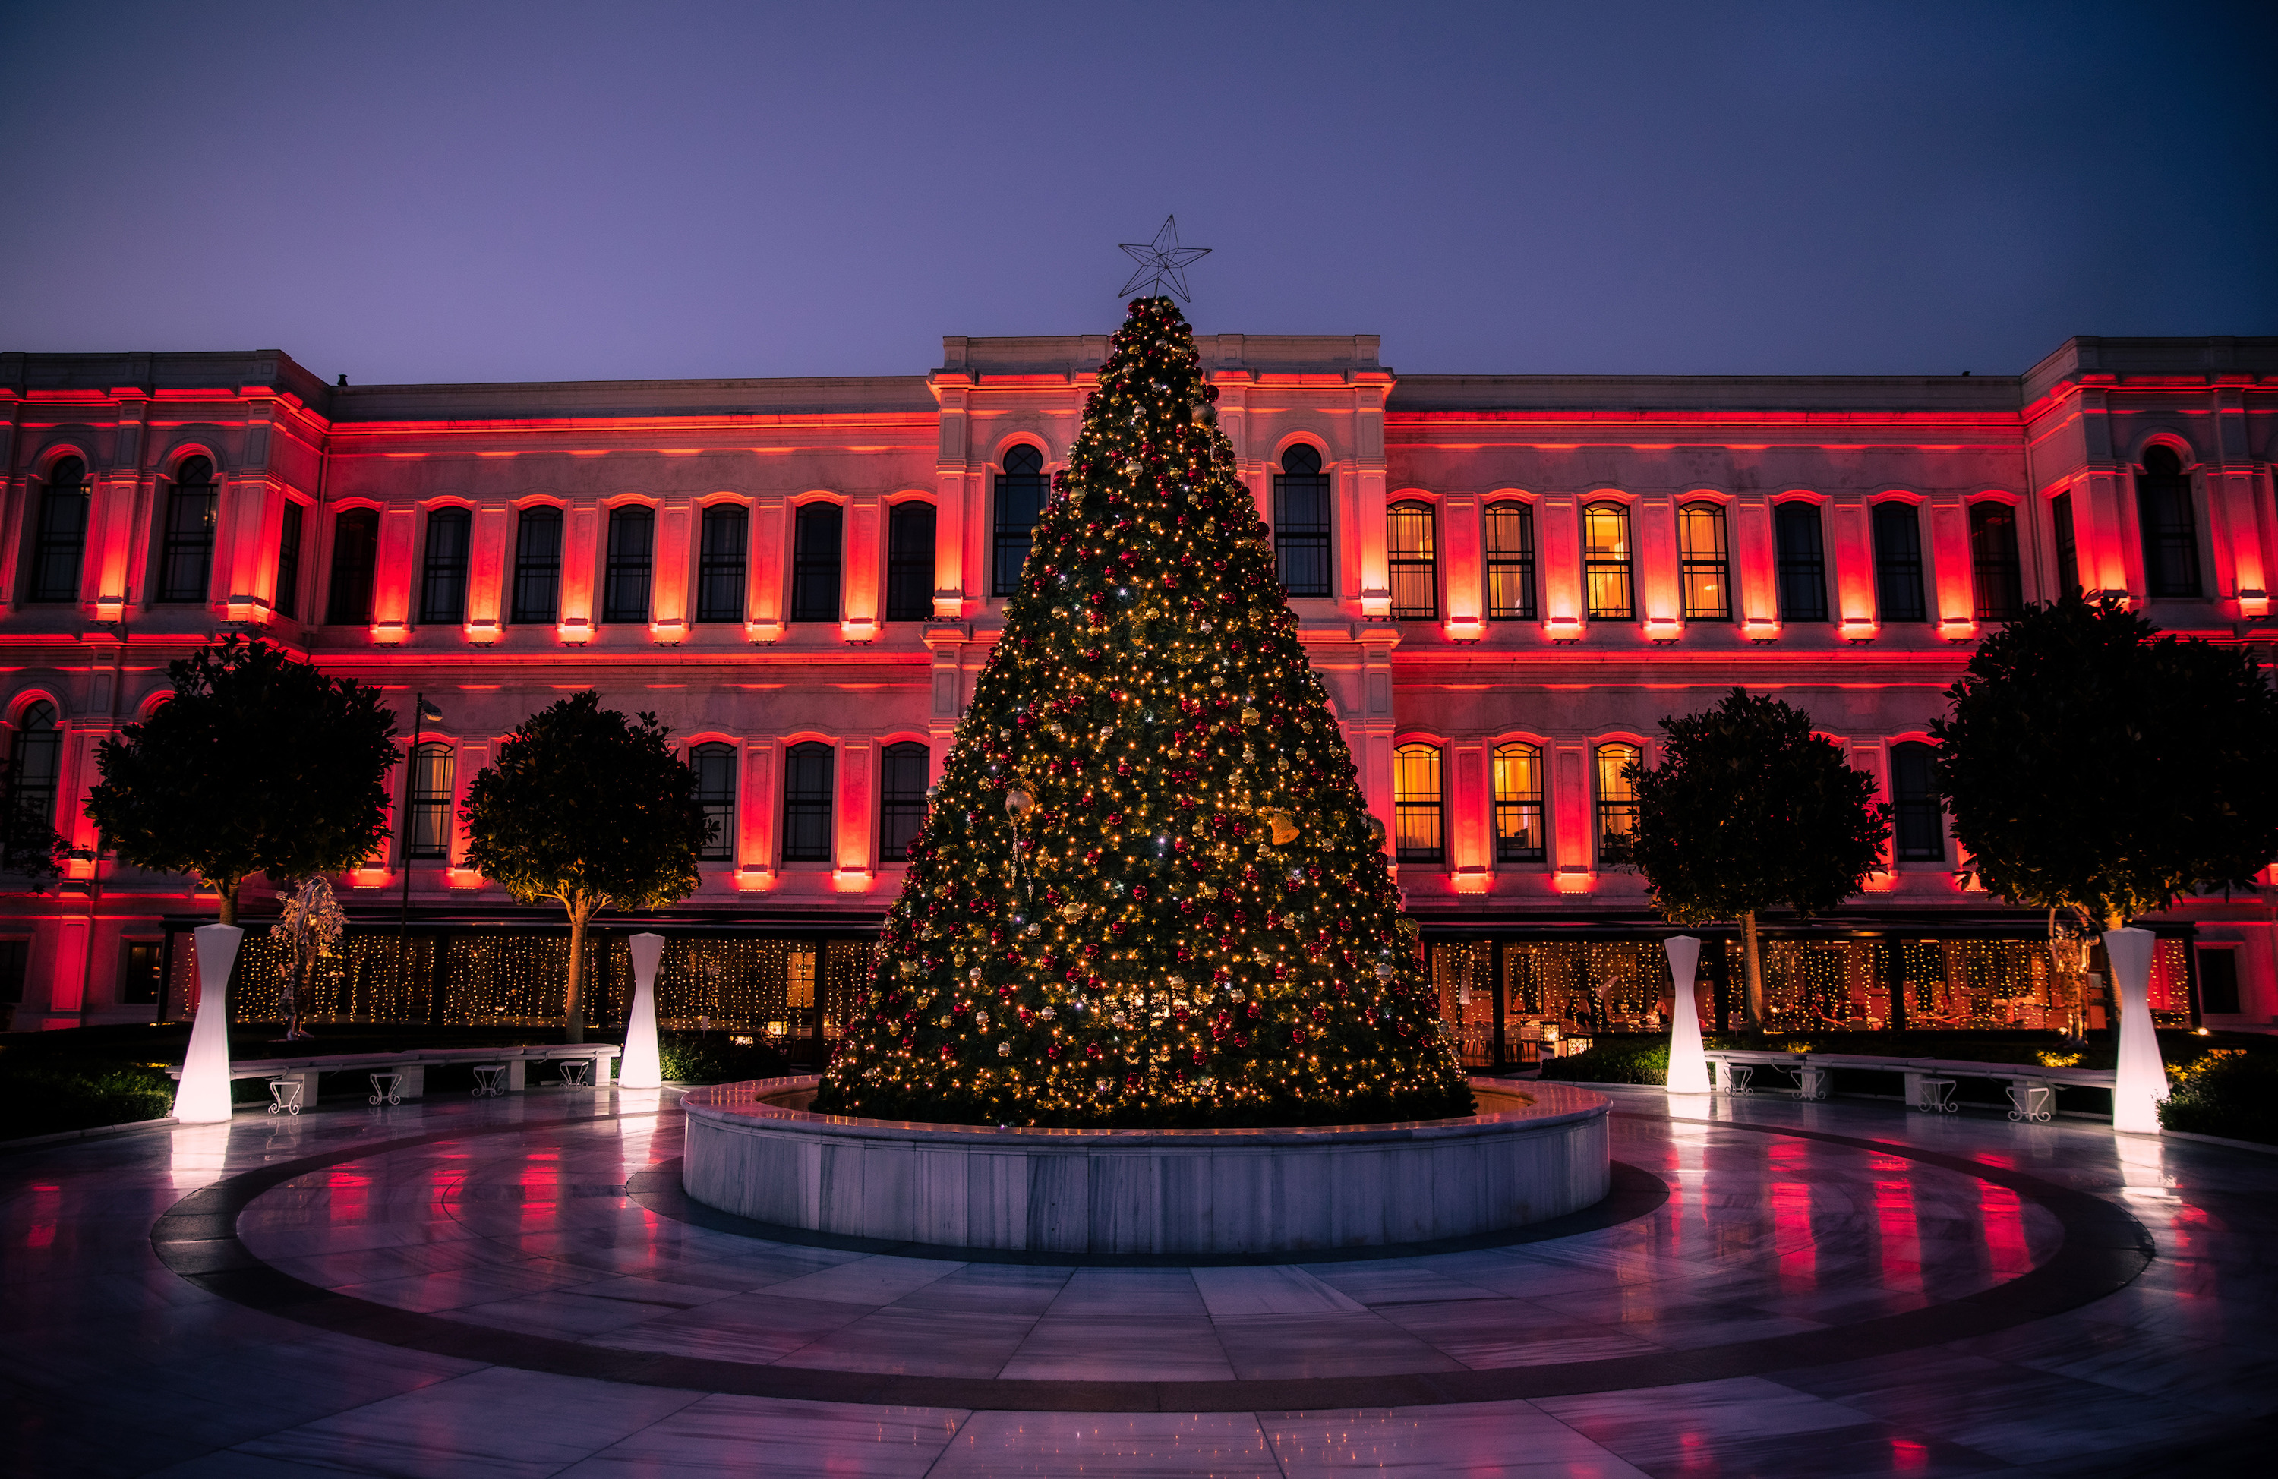 | November 24, 2021, Istanbul at the Bosphorus, Turkey  Four Seasons Hotel Istanbul at the Bosphorus Welcomes 2022 in a Celebration Full of Entertainment, Joy and Dynamism, Just Like the Pulse of Istanbul  https://publish.url/bosphorus/hotel-news/2021/festive-season-two.html
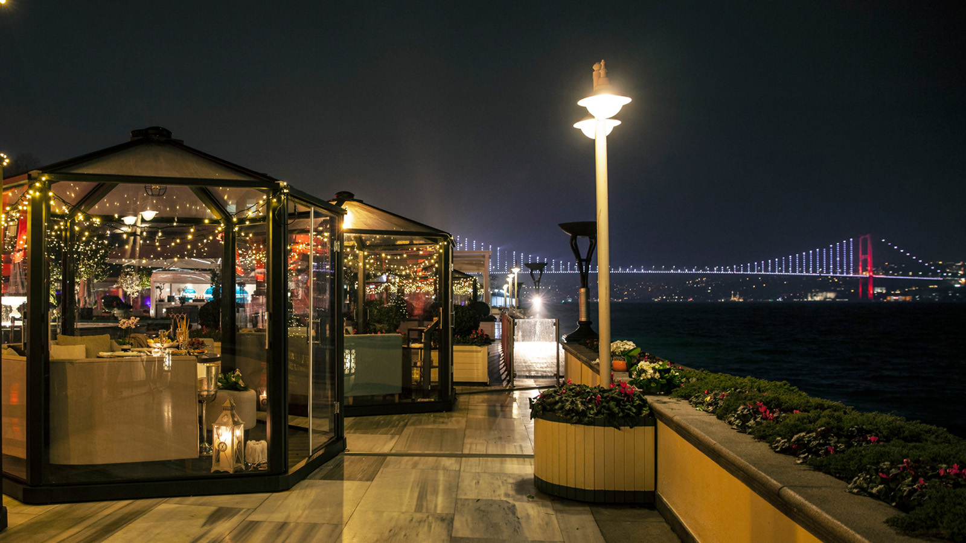 | November 22, 2021, Istanbul at the Bosphorus, Turkey  We Have Winter Covered: Winter Magic is at Four Seasons Hotel Istanbul at the Bosphorus with Custom Made Domes  https://publish.url/bosphorus/hotel-news/2021/domes-on-the-terrace.html

PRESS CONTACTS

Sibel Benli
Senior Director of Public Relations and Communications
Çırağan Cad. No. 28
Istanbul
Turkey
sibel.benli@fourseasons.com

90 (212) 381 41 35

