How You Can Support Hurricane Dorian Relief Efforts with The Ocean Club, A Four Seasons Resort, Bahamas

September 6, 2019, Paradise Island, Bahamas

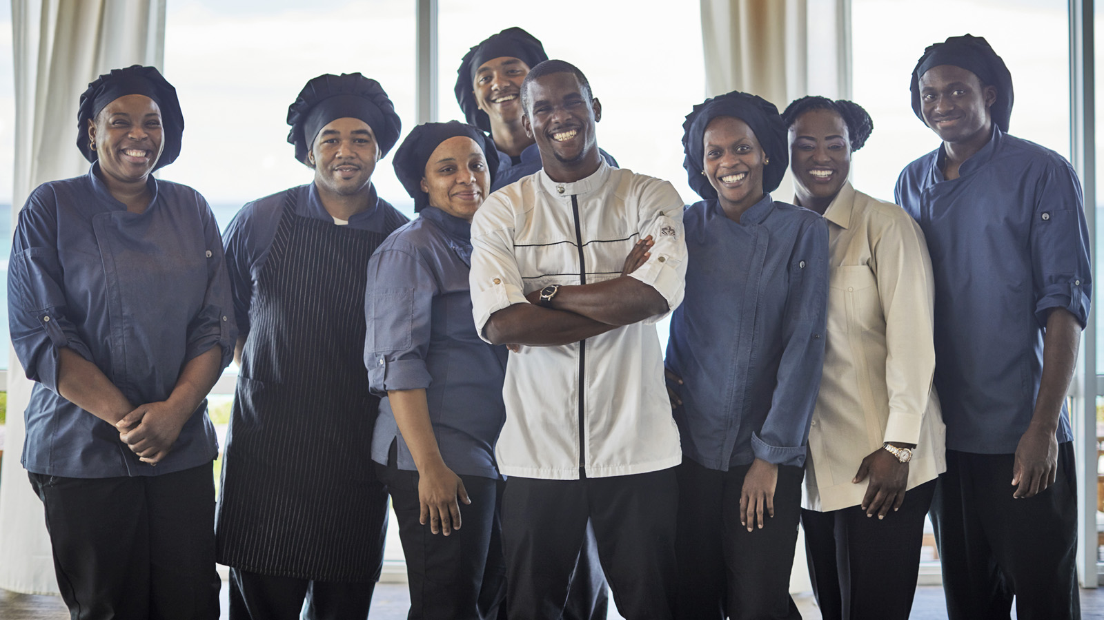
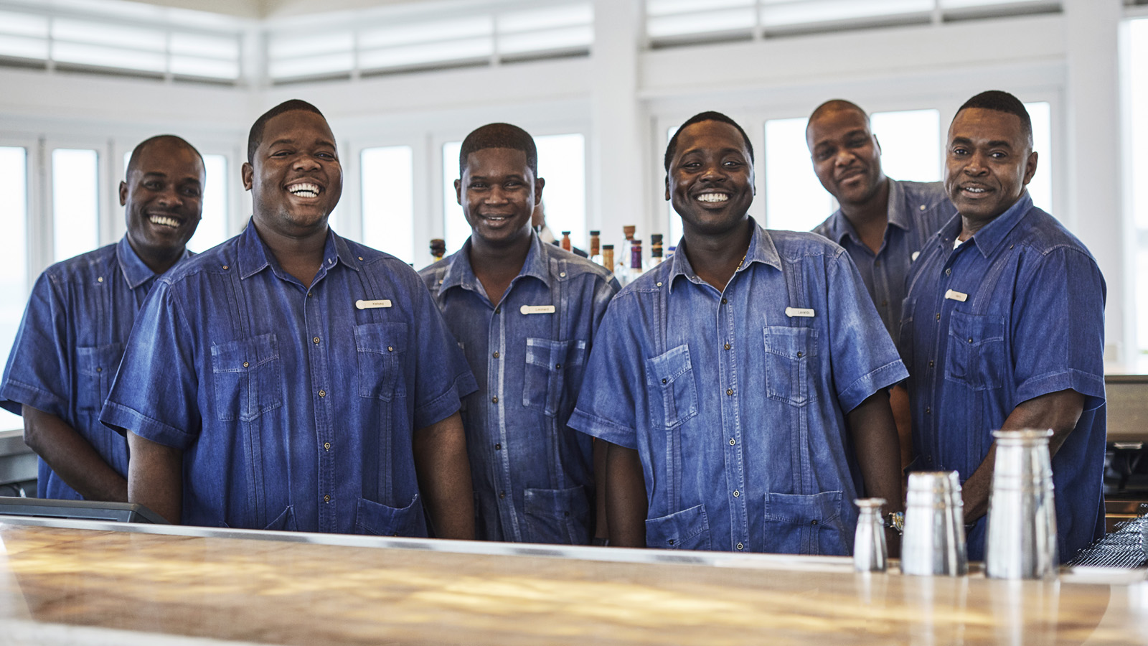 |  | 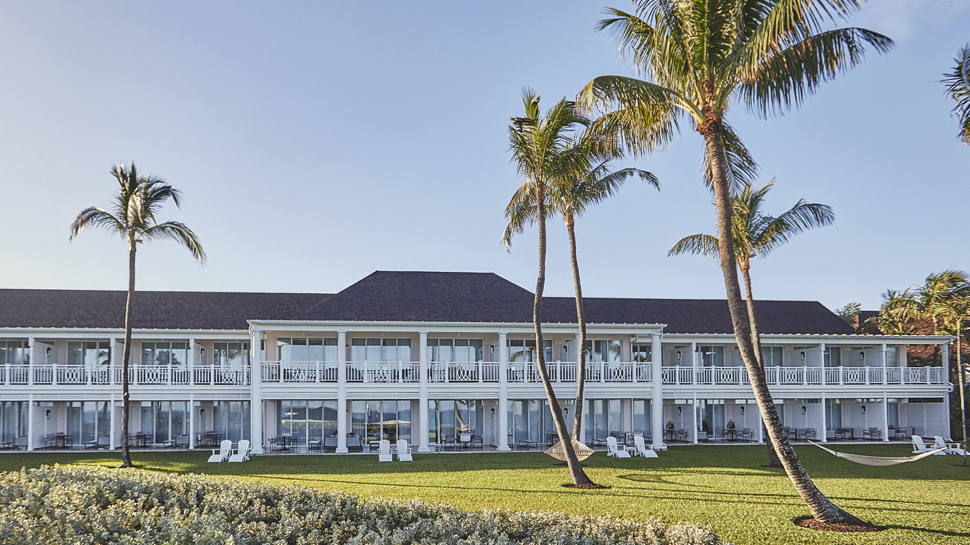
We are humbled by the amount of support you have offered in the wake of Hurricane Dorian’s destructive path over parts of The Bahamas. The initial images and information emerging from impacted islands tell a story of absolute devastation, particularly on Great Abaco and Grand Bahama Islands—where the hurricane’s eye made landfall before slowing to a crawl, destroying lives, homes, businesses, and livelihoods. The Ocean Club, A Four Seasons Resort, Bahamas is fortunate to not have been in its path.
We have had many offers of assistance and, at this time, financial contributions are the most effective way to support relief organisations in their work. With this in mind, we are raising funds for International Medical Corps, a global humanitarian non-profit organisation established by volunteer doctors and nurses, who already have teams on the ground in impacted areas. Working in support of The Government of The Bahamas and local officials, your funds will directly sponsor medical support and supplies in some of the most impacted areas.
Financial Contributions: Monetary donations are the most efficient form of assistance.
You may make monetary contributions via this link: https://www.crowdrise.com/o/en/campaign/the-ocean-club-dorian-relief
All funds after indirect costs will be put towards necessary relief efforts on impacted islands of The Bahamas. Every dollar you donate unlocks, on average, up to an additional USD 30 in grants from institutions, donated medicines and supplies. Their efficient operations have earned International Medical Corps the highest possible charity-watchdog honours.
In-Kind Contributions: According to the Government of The Bahamas’ Cabinet & Disaster Management (NEMA), the following are preferred items for donation:
- Building supplies (roofing materials, shingles, tar paper, drip caps, nails, plywood, lumber etc.)
- Tarpaulin
- Sheet rock
- Water
- Canned goods
- Meals Ready to Eat (MRE’s)
- Hygiene kits
- First aid kits
- Plastic trash bags
- Mosquito repellent
- Bleach
- Chlorine tablets
- Non-perishable dry goods
- Clean up supplies (mop, bucket, towels and towelettes)
At this time previously worn clothing cannot be accepted.
For a more comprehensive list, please consult www.bahamas.com/relief.
Supplies should be sent to:
Tropix Shipping Abaco
Attention Hurricane Dorian Relief
5610 NW 12th Avenue, Suite 203
Fort Lauderdale, FL 33309
Volunteers: We are working with World Central Kitchens on a forward plan for those who wish to offer in-person assistance. There is already an overwhelming amount of interested volunteers, and we will communicate this plan when appropriate. Members of our team are already working in Nassau with this initiative.
About International Medical Corps
International Medical Corps' approach is to be a global, first responder by providing immediate care and ensuring a sustained impact in the communities they serve. They have extensive experience building back better, providing medical care and other lifesaving relief in the aftermath of disasters and crises worldwide for over three decades. International Medical Corps provided both relief and recovery support following Hurricanes Irma, Maria, Florence, and Michael across affected areas of Caribbean.

RELATED

September 3, 2019, Paradise Island, Bahamas
Statement from The Ocean Club, A Four Seasons Resort, Bahamas
https://publish.url/oceanclub/hotel-news/2019/hurricane-dorian.html

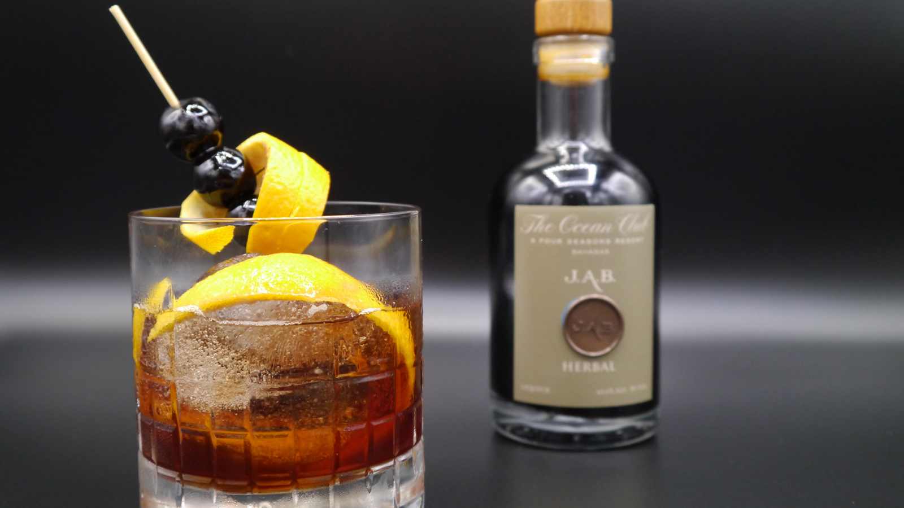 | August 26, 2019, Paradise Island, Bahamas  Passion, Provenance and Provocation: The Ocean Club, A Four Seasons Resort, Bahamas Crafts its First Artisan Cocktails  https://publish.url/oceanclub/hotel-news/2019/new-artisan-cocktails.html

PRESS CONTACTS

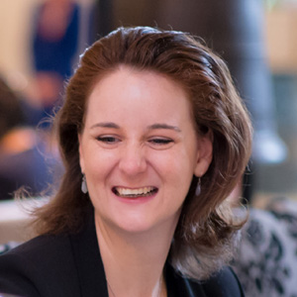 | Monica Majors  Director of Public Relations and Communications  777 Yamato Road, Suite 502  Boca Raton  USA  monica.majors@fourseasons.com  561-931-0614

