Nine Island Adventures to Experience the Best of Lanai

Four Seasons Resorts Lanai curates outdoor activities on land and sea
December 3, 2020, Hawaii, Lanai, U.S.A.

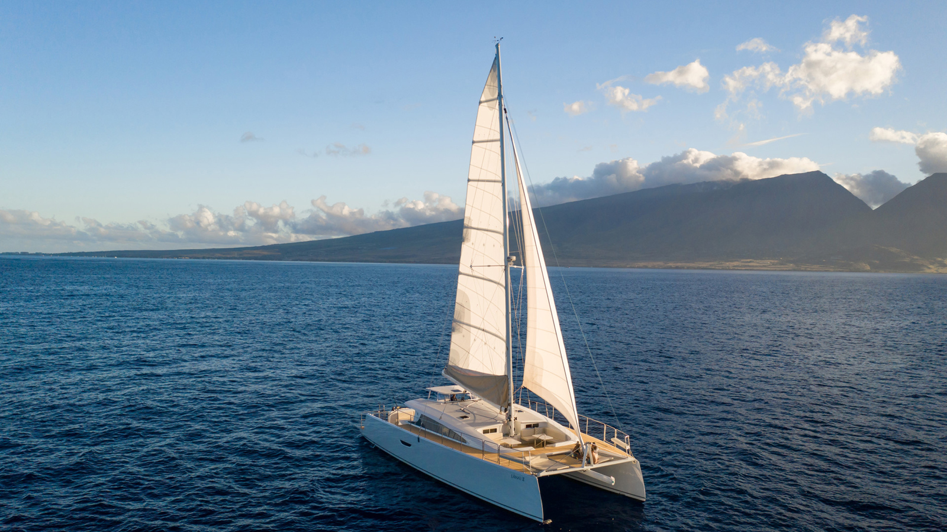
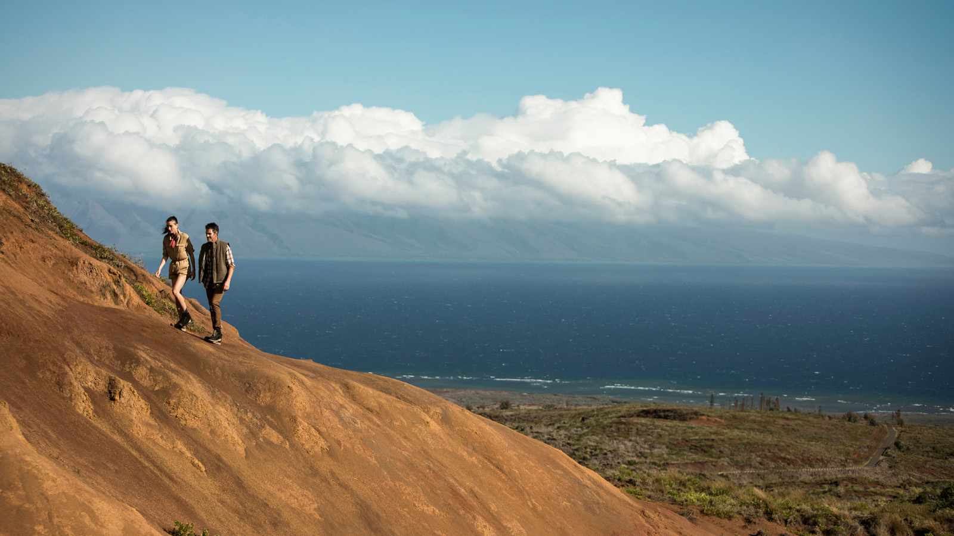
Pristine beaches, pine-tree covered hills, deep blue waters and multi-hued lava boulders provide a stunning backdrop for an array of activities, many managed by Four Seasons, on the island sanctuary of Lanai. From private excursions to small group outings, guests can explore authentic Hawaiian experiences, set sail, hike or horseback ride or discover underwater cathedrals on a dive trip. Lanai’s unspoiled island paradise comes with a healthy dose of adrenaline for adventurers of all ages. Visit the Resort’s online calendar for current schedules.
1. Sail Away - Set out on a spacious sailing catamaran for a three-hour snorkel sail. Swim along coastal reef sites teeming with brilliantly coloured fish and wildlife, perhaps even glimpsing a humpback during whale watching season from November to March. Enjoy a picnic lunch on board before heading back to shore. Or enjoy a cocktail as the sun falls below the horizon during a two-hour sunset cruise along Lanai’s stunning cliffs.
2. Private Boat Charters – On a private excursion, explore more than 13 dive sites around Lanai including Cathedrals, the unique underwater lava formations (arches and tubes), which give the appearance of stained glass as the sunlight pours through the water. Or seek out small- or big-game such as mahi mahi, wahoo, yellowfin tuna and Pacific blue marlin on a customised tour.
3. 4x4 Jeep Tours - With only 30 miles (48 kilometres) of paved roads and no traffic lights, Lanai is ideal for off-roading. Rent a four-wheel-drive vehicle and head out on your own – exploring miles of rugged terrain, taking in the scenery or stopping to visit Lanai City. Be sure to download the free Lanai Guide App and enjoy interactive hiking and driving maps, photos and more. Take along a Four Seasons picnic to enjoy at the location of your choice.
4. Horseback Riding - Escape on horseback into the hills surrounding Koele, once the centre of ranching operations on the island and enjoy an alternative way to explore the wooded valleys and trails of the extraordinary upland terrain. Custom tours, carriage rides and private lessons also available.
5. Lanai Adventure Park - Nestled among Cook pines, the Lanai Adventure Park invites you to experience more than 70 obstacles, self-guided according to your comfort level and desired level of difficulty. For the Challenge Course, teams are led through a series of mental and physical obstacles.
6. Hiking and Biking - Fascinating hiking routes are available via guided or self-guided tours. Be sure to walk to the point of Hulopoe Bay Beach, where you can enjoy the tide pools filled with such marine life as sea cucumbers, spaghetti worms and sea stars.
7. Lanai Archery and Shooting Range – Takerex or traditional archery targets up to 25 yards away.
8. Holoholo Tour - Explore the beautiful island of Lanai on a private guided excursion, go shoreline fishing and net throwing or delve into the island’s history on a customised tour with the Love Lanai Cultural Advisors.
9. Golf and Tennis - The Jack Nicklaus-signature Manele Golf Course features ocean views on every hole. The five-tee concept challenges the best golfers – tee shots over natural gorges and ravines must be precise. The Tennis Garden, managed by Peter Burwash International, offers two outdoor Plexipave hard courts and one Har-Tru clay court for matches or lessons.

RELATED

October 12, 2022, Hawaii, Lanai, U.S.A.
Four Seasons Resort Lanai Turns Up the Heat with a Big Green Egg Cookout Celebration
https://publish.url/lanai/hotel-news/2022/big-green-egg-cookout-event.html

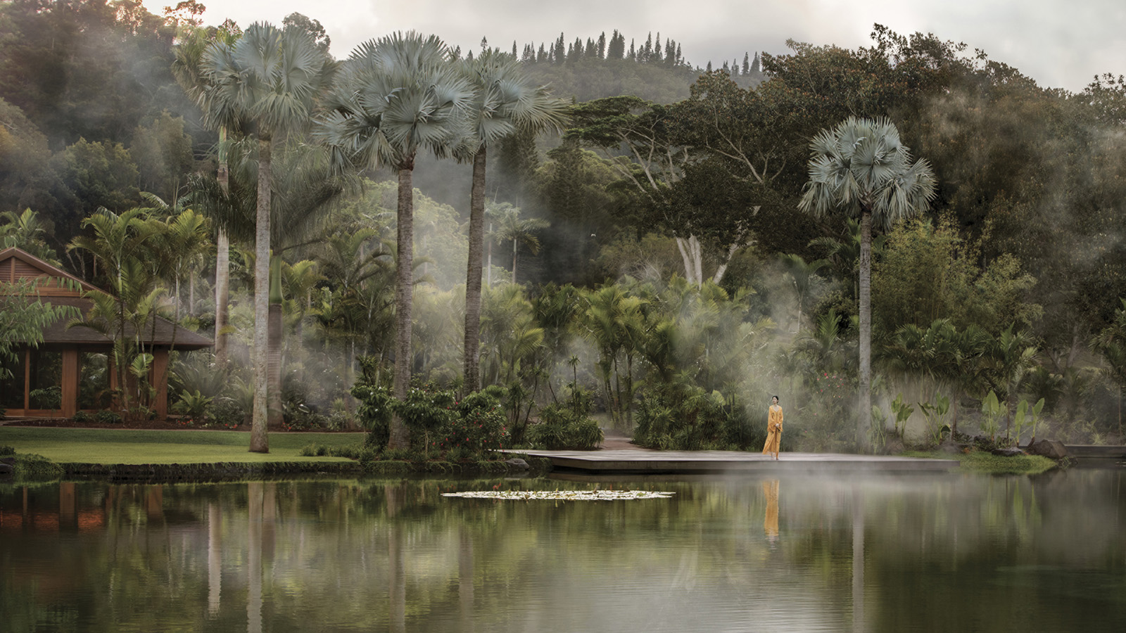 | October 4, 2022, Hawaii, Lanai, U.S.A.  Sensei Lanai, A Four Seasons Resort and Four Seasons Resort Lanai Top Condé Nast Traveler 2022 Readers’ Choice Hawaii Awards  https://publish.url/sensei/hotel-news/2022/top-resorts-in-hawaii.html

PRESS CONTACTS

Lori Holland
Senior Director of Public Relations
6100 Center Drive, Suite 1250
Los Angeles
USA
lori.holland@fourseasons.com

+1 201 294 7810

Anna Peirano
Digital Marketing Manager

Lanai
USA
anna.peirano@fourseasons.com

+1 808 649 8970

