Fill the Holiday Season with Comfort and Joy at Four Seasons Hotel Las Vegas

November 11, 2022, Las Vegas, U.S.A.

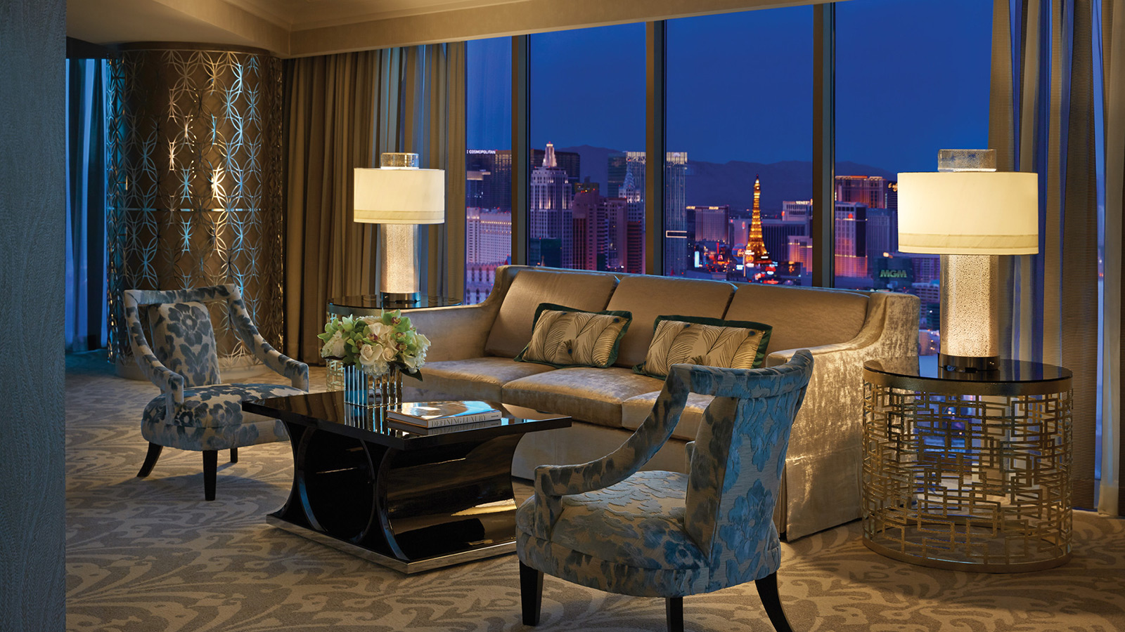
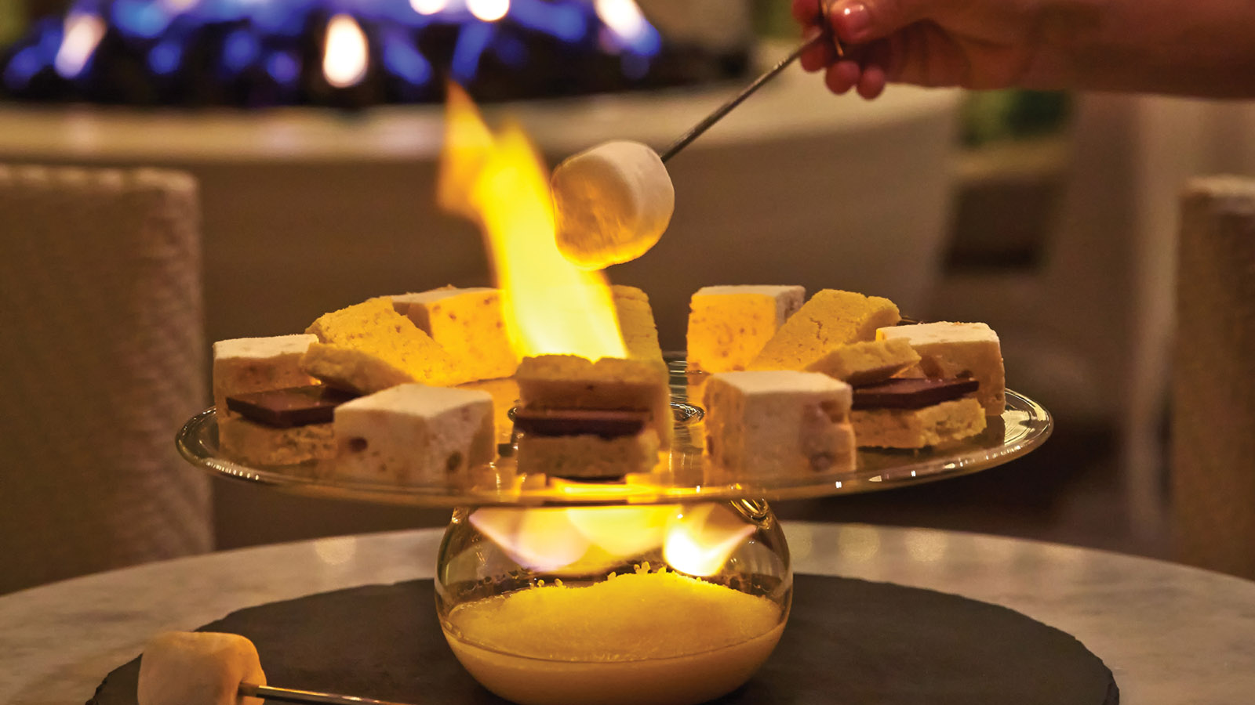 | 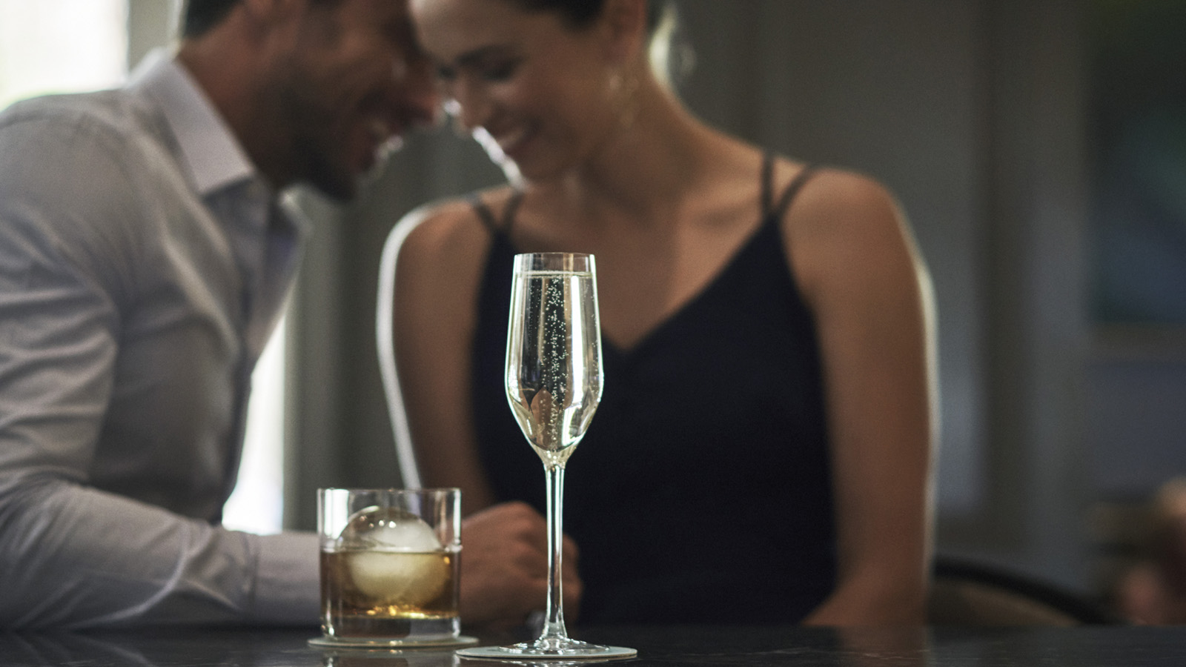
Four Seasons Hotel Las Vegas invites guests and locals to celebrate the holidays in style with festive menus, traditional décor, and Yuletide indulgences.
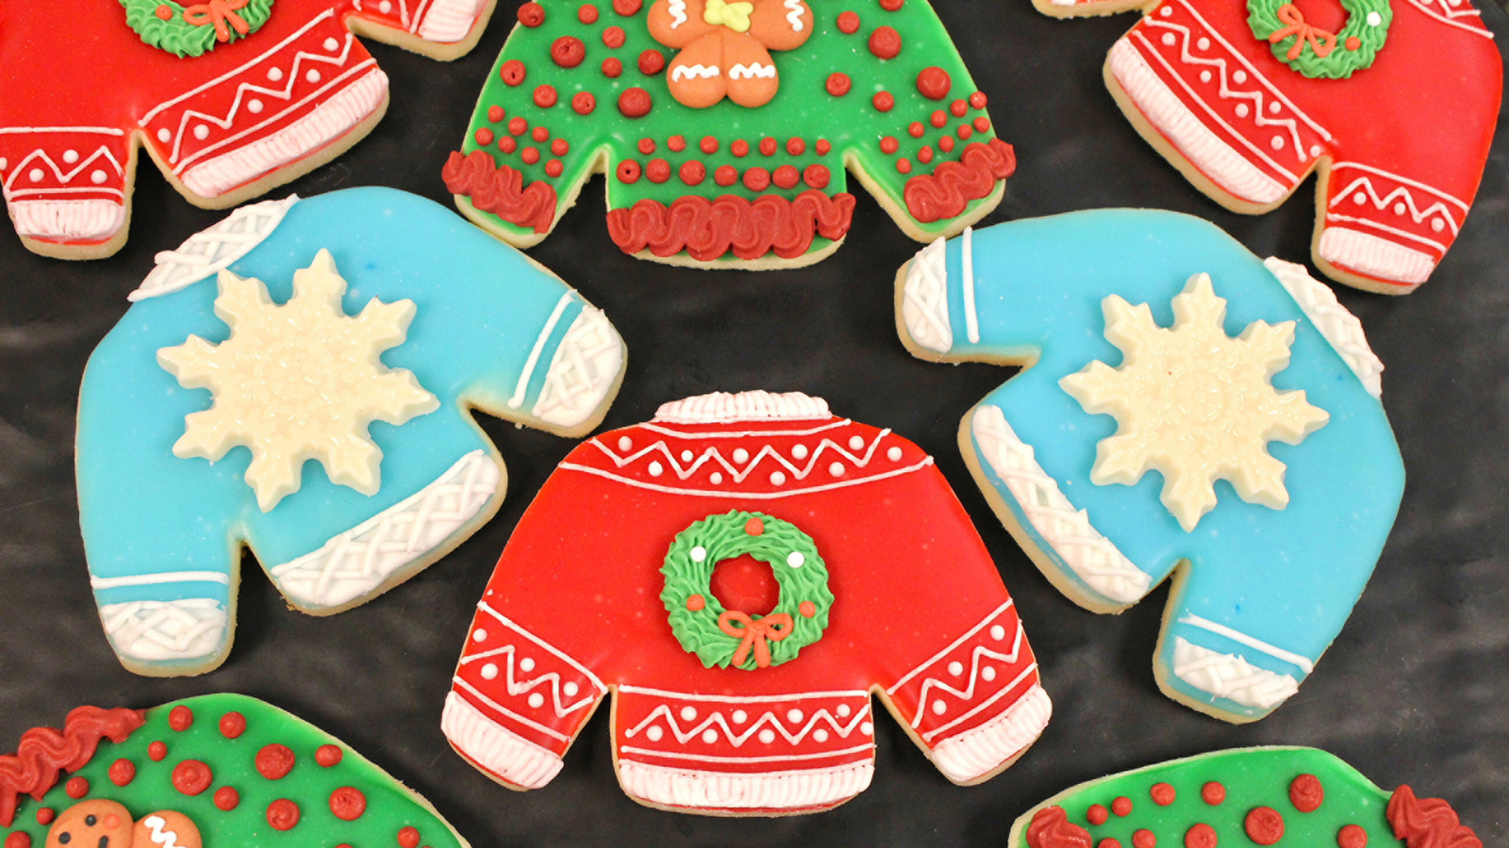 | 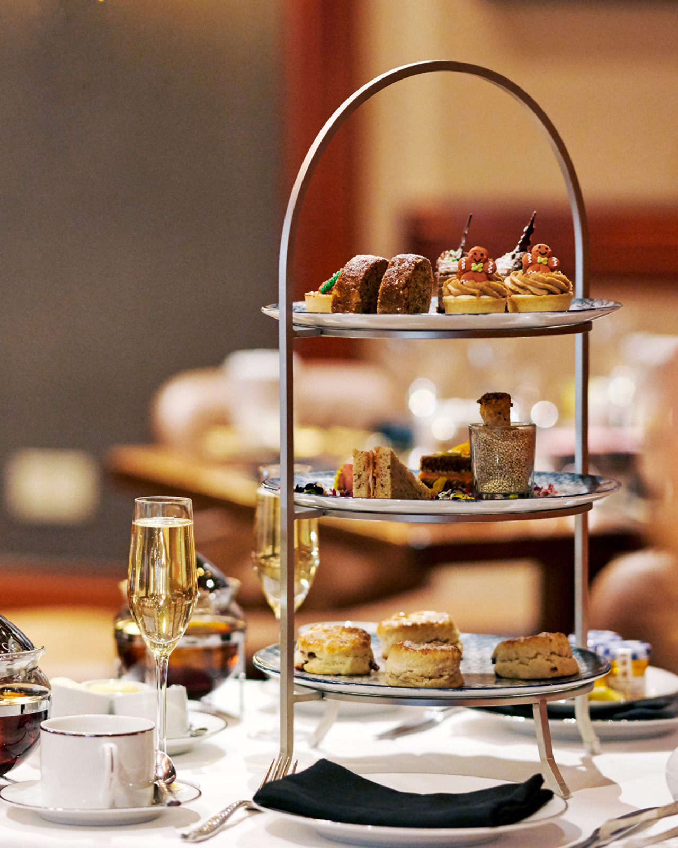 | 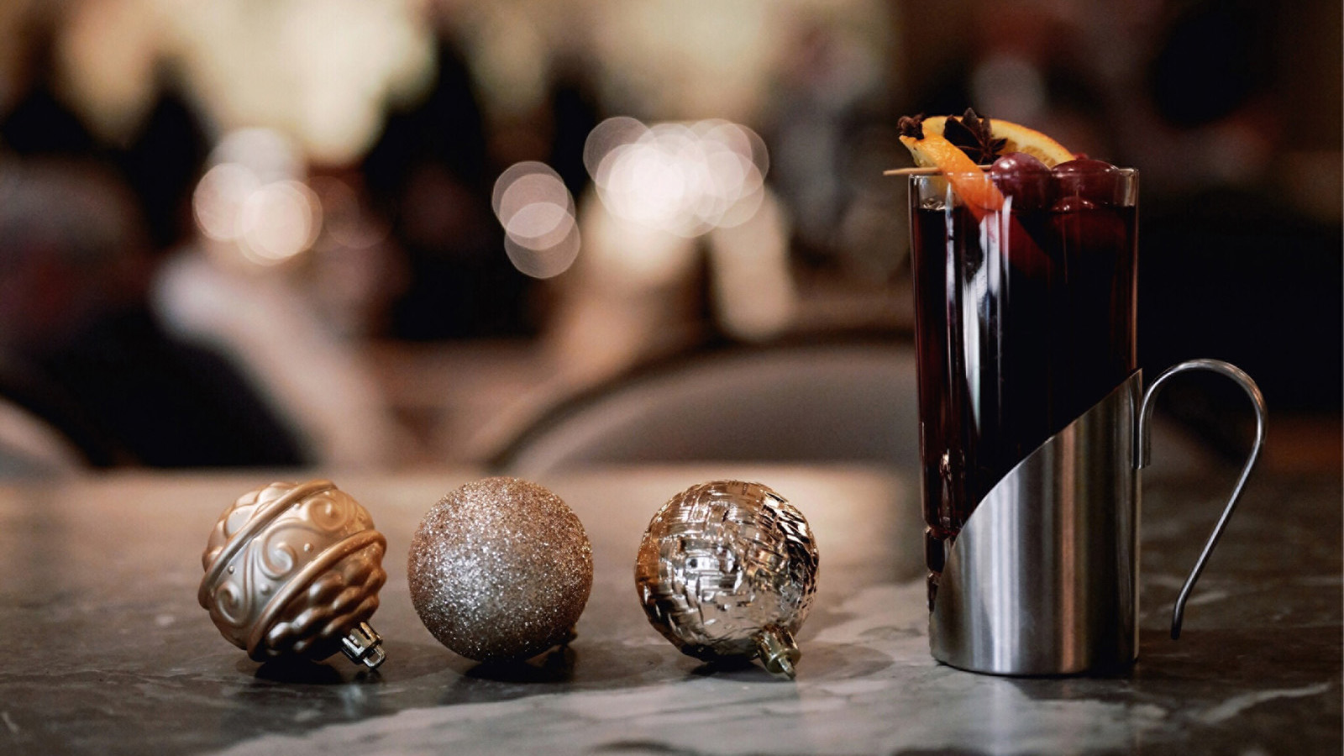
Tastes of the Season
Veranda presents the return of its celebrated Holiday Tea every Saturday from November 26 through December 17, 2022. Tea service includes a selection of organic teas and a classic menu featuring traditional scones along with a selection of sweet and savoury treats. Guests will enjoy a festive afternoon complete with elevated holiday décor and live music. Holiday Tea is available on Saturdays from 2:00 to 4:00 pm. Pricing is USD 75 per person with a complimentary glass of bubbles, and USD 39 for children 5-12. To make a reservation for the Holiday Tea, dial 702 632 5121 or reserve online here.
Let Four Seasons Hotel Las Vegas host Thanksgiving and Christmas dinners with all the trimmings. Four-course, prix-fixe feasts are available for Thanksgiving Day, Christmas Eve and Christmas Day celebrations. For guests seeking a more familial gathering, Veranda offers two private dining rooms and a lush outdoor patio for a memorable festive fête. Special holiday menus are available for USD 95 per person, and USD 45 for children 5-12. For reservations, call 702 632 5121. Visit here to view menus.
Ring in the New Year with a magnificent feast and champagne toast. Chef William Ledesma welcomes 2023 with a five-course, prix-fixe menu celebrating the finer things in life – osetra caviar, roasted scallops, homemade crab pasta, centre-cut striploin, and more. New Year’s Eve dinner is available for USD 150 per person. For reservations, call 702 632 5121.
PRESS Lounge gets into the holiday spirit with custom cocktails and small bites. Enjoy a signature Gin ‘n Tonic all dressed up for the holidays with a cranberry, pomegranate, lemon and rosemary garnish. A twist on the traditional Hot Toddy features organic chamomile tea combined with Woodinville bourbon, honey, anise, cinnamon, five-spice, and a splash of apple juice. Stay warm on PRESS Patio roasting house-made marshmallows next to the fire pit with a gourmet s’mores platter, perfect for sharing with friends or a romantic nightcap for two. PRESS Lounge opens daily at 3:00 pm.
Make a Present of Pampering
Visit the Hotel’s Forbes Five-Star Spa after a long day of shopping for holiday treatments that will transport the senses to a winter wonderland. The Spiced Apple Exfoliating Manicure and Pedicure festive manicure and pedicure includes an aromatic apple cider soak, sugar scrub, nail maintenance and a moisturizing massage to renew dry skin. The Fall Harvest Cider Sugar Scrub Body Treatment begins with an apple cider-infused sugar scrub on the back and feet, then seamlessly moves into a full body message erasing all tension and stress.
Las Vegas locals are invited to spa the day away this season with 20 percent off all spa treatments, 20 percent off lunch at Veranda, and complimentary valet parking. Local offer available Monday through Thursday. Holiday date restrictions may apply.
Make a Spa appointment online, or call 702 632 5000.
Spreading Cheer
‘Tis the season for giving and Four Seasons Hotel Las Vegas invites guests to keep an eye out for the famous mini donut bar in the Lobby for a complimentary holiday treat, Fridays from November 25 through December 30, 2022 between 2:00 and 4:00 pm.
Had a “ruff” flight? Pay a visit to the “Santa Paws” workshop and relax with Santa’s little helpers (licensed and trained Therapy Dogs) from Michael’s Angel Paws on Saturday, December 17, 2022, between 10:00 am and 12:00 noon.
On December 25, 2022, the Hotel welcomes the man in the big, red suit himself. Take photos with Santa and create custom holiday cards between 10:00 am and 5:00 pm.
Meet Me in Vegas Offer
Let Four Seasons Hotel Las Vegas be home for the holidays. Receive 15 percent off the Best Available Rate when booking multiple rooms or suites with a minimum two-night stay with the Meet Me in Vegas offer. To reserve an unforgettable holiday experience with family and friends, call 1 877 632 5000.

RELATED

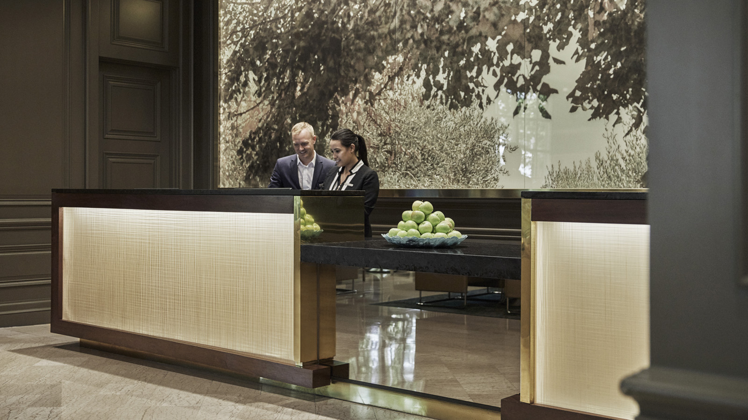 | October 19, 2022, Las Vegas, U.S.A.  Four Seasons Invites Guests to Fall in Love with Las Vegas  https://publish.url/lasvegas/hotel-news/2022/fall-activities-and-events.html
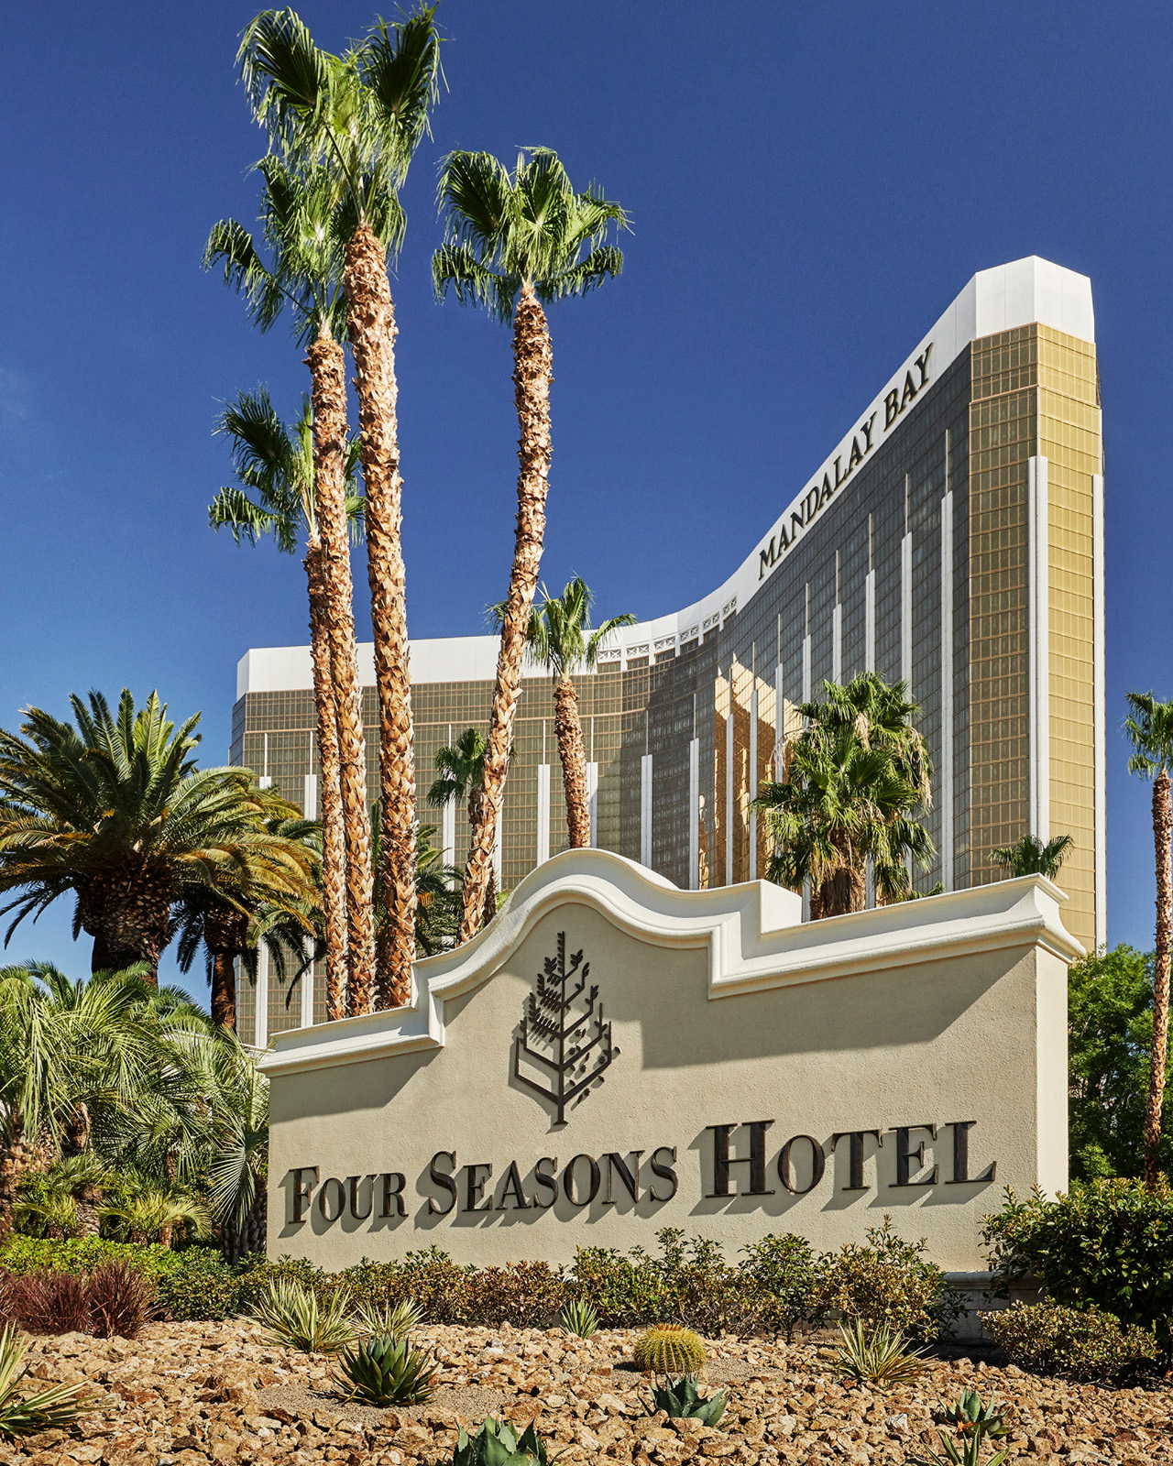 | October 12, 2022, Las Vegas, U.S.A.  Four Seasons Hotel Las Vegas Reveals Plans for 2023 Room Redesign  https://publish.url/lasvegas/hotel-news/2022/rooms-renovation.html

PRESS CONTACTS

Jeff Lovari
Director of Communications
3960 Las Vegas Boulevard South
Las Vegas
USA
jeff.lovari@fourseasons.com

+1 702 632 5103

