FOUR SEASONS Langkawi, Malaysia
Tel: 60 (4) 950 8888 Email: press@fourseasons.com

OPENING DATE: May 2005
GENERAL MANAGER: Ivan Giles

Physical Features
Total Number of Rooms: 92
- Pavilions: 68
- Villas: 24
Design Aesthetic:
- Inspired by a blend of Moorish architecture and traditional Malay "kampung" or village setting, with pavilions and villas blending Asian and Arabic influences
- Reflective of the natural surroundings, with neutral earth tones weaved within a textured setting of exotic woods, stones and fabrics
- Indoor/outdoor spaces with ceilings fans, woven wooden screens, handcrafted hanging mirrors with antique patina finishes, grey slate and burnished steel light fittings, batik pillows, oversized terrazzo bathtubs built into arched nooks
Architect:
- Lek Bunnag/Bunnag Architects
- Bill Bensley/Bensley Design Studios
Interior Designer(s):
- Bill Bensley/Bensley Design Studios
- John Underwood/Underwood Co. (guest rooms and public areas)
- Jeffrey Wilkes/Lim Teo+ Wilkes Design Works
History: "Isle of Legends" famed for native folklore tied to formation of the island's geographic features, flora and fauna
Location: Set on one of the island's best beaches on the north-eastern cape of Tanjung Rhu on the Andaman Sea

The Geo Spa
Number of Treatment Rooms: 6
Design Aesthetic:
- Sanctuary set amid forested limestone cliffs and reflecting ponds, with secluded thatched-roof pavilions with floor-to-ceiling windows and outdoor rain showers
- Walls and furnishings take on the natural hues of soothing sage green and beige to mirror the serenity of nature
- Beachfront villas have private spa suites
Interior Designer:
- Lek Bunnag/Bunnag Architects
- Bill Bensley/Bensley Design Studios
- John Underwood/Underwood Co.
Signature Treatment:
- Geo Signature Massage Urut Melayu (60 or 90 minutes)
- Shirodhara Ayurvedic Ritual (120 minutes)
- Feminine Flow Signature Experience (120 minutes)
- Masculine Vigour Signature Experience (120 minutes)
- Raja & Ratu Connect Couple's Signature Experience (120 minutes)
- Unify Family Ritual (120 minutes)
- Elements Balancing, Therapeutic and Stand Up Paddle Board Yoga Sessions
Special Features:
- Three relaxation bales perched on reflecting ponds for after-treatment siesta
- Spa Bar for health elixirs and herbal tisanes
- Steam room for each treatment pavilion
- Yoga pavilion
- Spa Boutique featuring ila's Beyond Organic body and skin care products, Malaysian aromatherapy and massage oils, crystal and semi precious stone healing jewelry, natural perfumes, yoga wear, OPI nail lacquer, candles and books
- Spa Salon

Dining

Examples of Locally Sourced Ingredients:
- Lemon grass
- Torch ginger
- Pandan leaves
- Kaffir lime leaves
- Curry leaves
- Local basil
- Green chilli
- Fresh young ginger
- Turmeric
- Ulam leaves
Restaurant: Ikan-Ikan
- Signature Dish: Ikan Jenahak Asam Katok - crispy fried red snapper fillet, tamarind honey chili sauce

Recreation
Tennis:
- Number of Tennis Courts: 1
- Tennis Lessons: For a fee
On-site Activities:
- Beach volleyball
- Fishing
- Jogging
- Library
- Sailing
- Snorkelling
- Water sports
Off-site Activities:
- Bird watching
- Golf – 30 minutes
- Jungle trekking
- Kayaking
- Mangrove excursions
- Sailing
- Scuba diving
- Motorised water sports
- Windsurfing
Pools:
- Number of Pools: 2
Fitness Facilities:
- Size: 175 sq m / 1,884 sq ft

- Special Features:
- Soaring ceilings and floor-to-ceiling windows look out to lush gardens
- Meandering jogging path through tropical foliage and 1.5-kilometre (1-mile) stretch of sugar-sand beach
- Infinity-edge lap pool overlooking the Andaman Sea with private cabanas
- Bicycles available

- Sample Fitness Activities:
- Daily yoga sessions, include sunrise and sunset, aqua yoga, asana yoga
- Private yoga sessions and personal gym training sessions available
- Mangrove and sea-kayaking

For Younger Guests
- Kids for All Seasons: Supervised program in a dedicated facility, including kids' yoga and spa treatments, sea kayaking and other sports, themed nights with dinner, games and adventures

Meeting Rooms
Total Size: 200 sq m / 2,150 sq ft
Meet and Feed Capacity: 80
Banquet Capacity: 80
Outdoor Banquet Capacity: 120
Breakout Spaces: 3
Private Dining Room Capacity: 16
Unique Meeting and Event Facilities: Intimate Malay-style pavilion with sea and garden views ideal for small meetings and executive retreats

Special Features
- Cooking classes allow guests to learn about Malaysian cuisine

PRESS CONTACTS
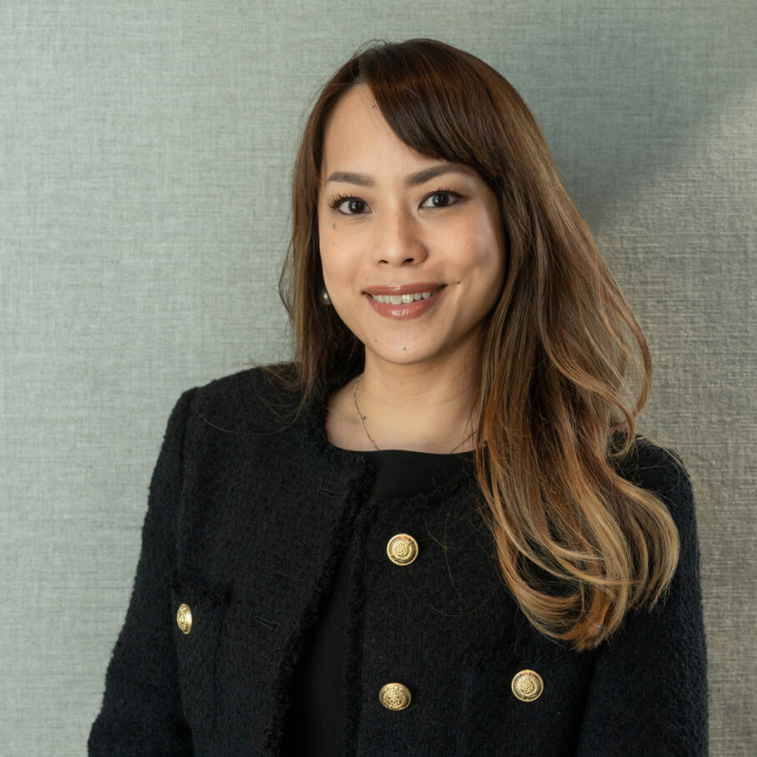 | Tracy Khee  Public Relations Director  145 Jalan Ampang  Kuala Lumpur  Malaysia  tracy.khee@fourseasons.com  +6 03 2382 8740

