Experience Complete Wellness in Paradise at Four Seasons Resort Costa Rica

The Resort celebrates Global Wellness Day with complimentary activities
June 1, 2022, Costa Rica

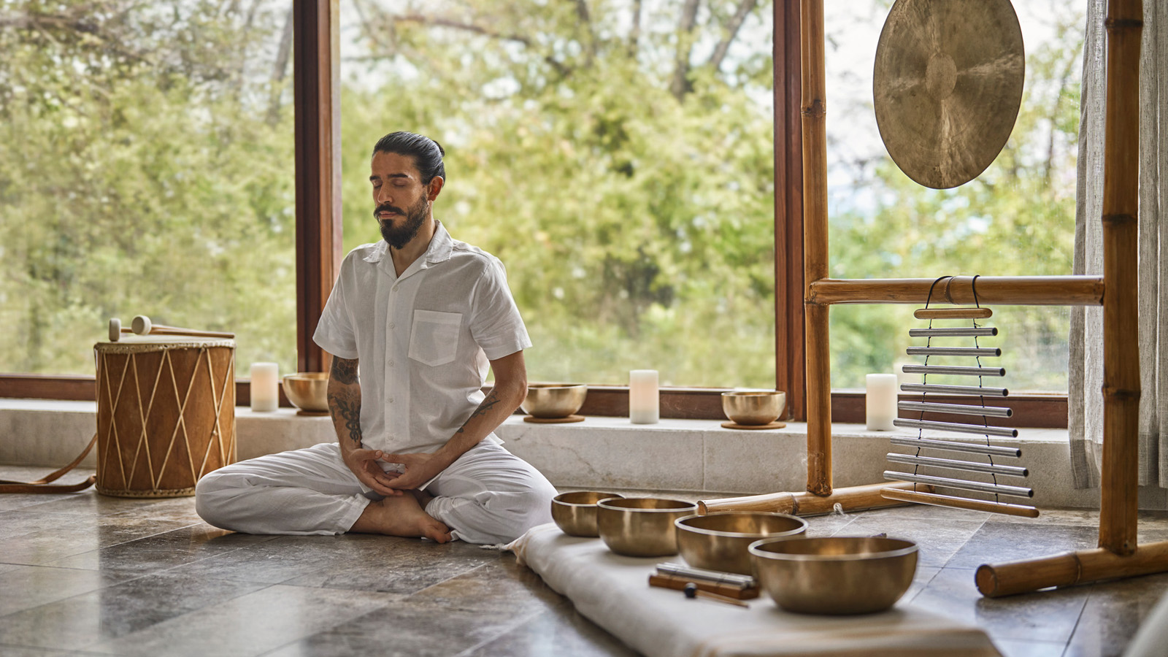
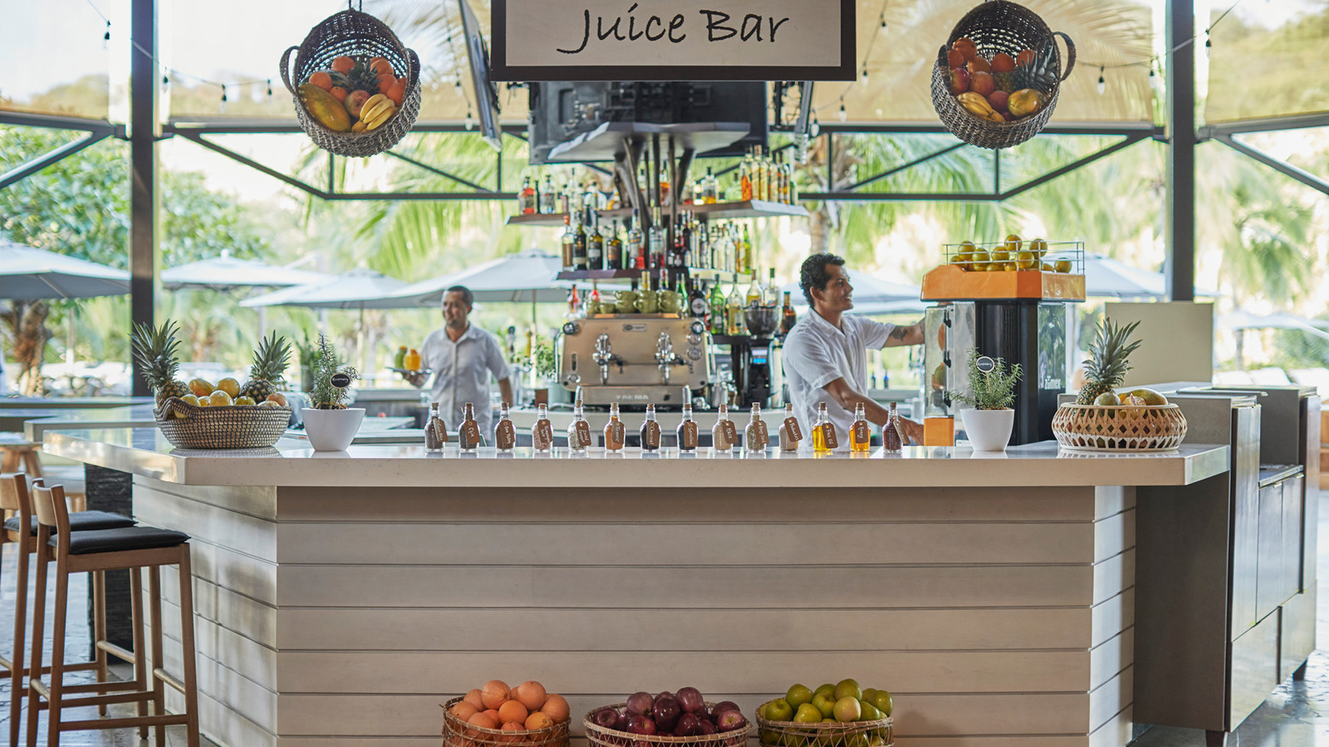 | 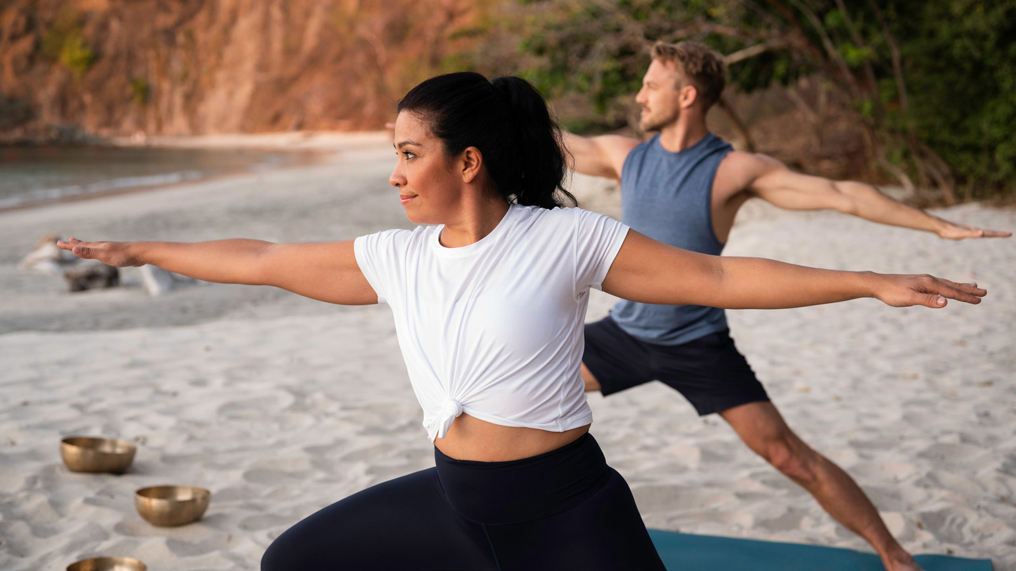
Wellness is an integral part of Four Seasons Resort Costa Rica at Peninsula Papagayo. From the miles of trails throughout, to kayaking, surfing and paddling on the surrounding waters, to ancestral rituals and modern wellness programs at The Spa, the expansive property is a true haven for wellness-minded guests.
“On Global Wellness Day and every day, Four Seasons Resort Costa Rica is an ideal destination for those who are focused on health and wellness,” says Ian Ciappara, General Manager of the Resort. “Whether seeking a physical, spiritual or mental recharge, or simply an escape to truly relax and rejuvenate, the Resort offers something for everyone to prioritize wellbeing.”
This year, the Resort celebrates Global Wellness Day and its #ThinkMagenta theme for 2022, a reminder of a positive lifestyle and choosing joy with multiple events and touchpoints. On June 11, 2022, the Resort will celebrate wellness throughout the day with complimentary sound healing meditation, chair massage treatments, creating homemade power bars and many more activities.
Guests can join the celebration with the following activities and use #ThinkMagenta and #FSCostaRica when sharing on social media. The schedule of activities for June 11 includes:
- 7:30 am, Opening Crystal Bowl Meditation: Set the mood for the day with a morning meditation to the sound of the crashing waves and crystal signing bowls at Blanca Terrace.
- 7:30-10:30 am, Fresh Squeezed Healthy Juice Bar: Enjoy a healthy juice station throughout the morning or after the morning yoga sessions, at Blanca Terrace.
- 8:00 am, Awakening Yoga Flow: Yogis of all levels are welcomed to stretch with this Vinyasa flow class at Blanca Terrace.
- 8:00-10:30 am, Chair Massages: Stop by Blanca Terrance for a relaxing chair massage treatment provided by certified Spa therapist.
- 9:15 am, Sound Healing and Gong Bath: Tune into the calming sounds of a healing gong and crystal singing bowls at Blanca Terrace.
- 10:30 am, Mindfulness Workshop: Learn to calm the mind and be fully present with wellness ambassador Jose Pablo Rodriguez at Blanca Terrace.
- 11:00 am, Healthy Juice Class: Create a personal blend of healthy juice from Costa Rica’s natural superfoods and fruits at Bahia.
- 11:40 am – Homemade Power Bars: Create individual power bars with super foods and fruits with Sous Chef Sergio Montoya Garcia at Bahia
In addition to the above activities, the Resort is also offering a new complimentary tea service provided nightly at turn-down, with a different flavour of tea for each night of the guest’s stay. The custom tea blends, created exclusively for the resort by Sencha Tea Co., are provided along with teacups and a prepared kettle, which can be heated at the guest’s preferred time. The teas include Citrus Boost, Zesty Ginger, Tropical Berry Delight, and Calming Coconut, among other blends. The soothing herbal teas are intended to aid in relaxation and de-stress, preparing oneself for the perfect night’s slumber.

RELATED

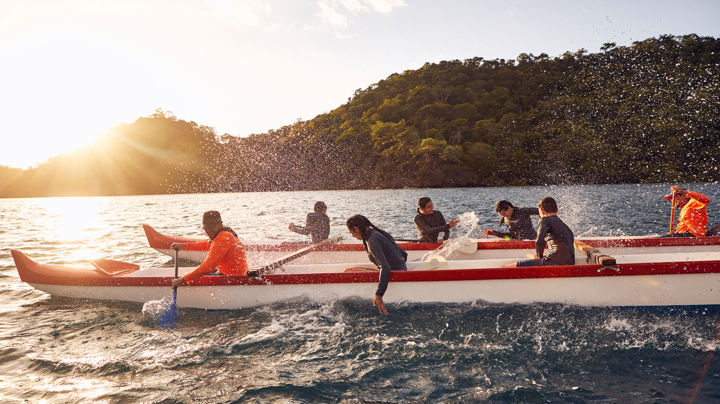 | May 13, 2022, Costa Rica  Adventure Awaits This Summer at Four Seasons Resort Costa Rica at Peninsula Papagayo  https://publish.url/costarica/hotel-news/2022/summer-activities.html
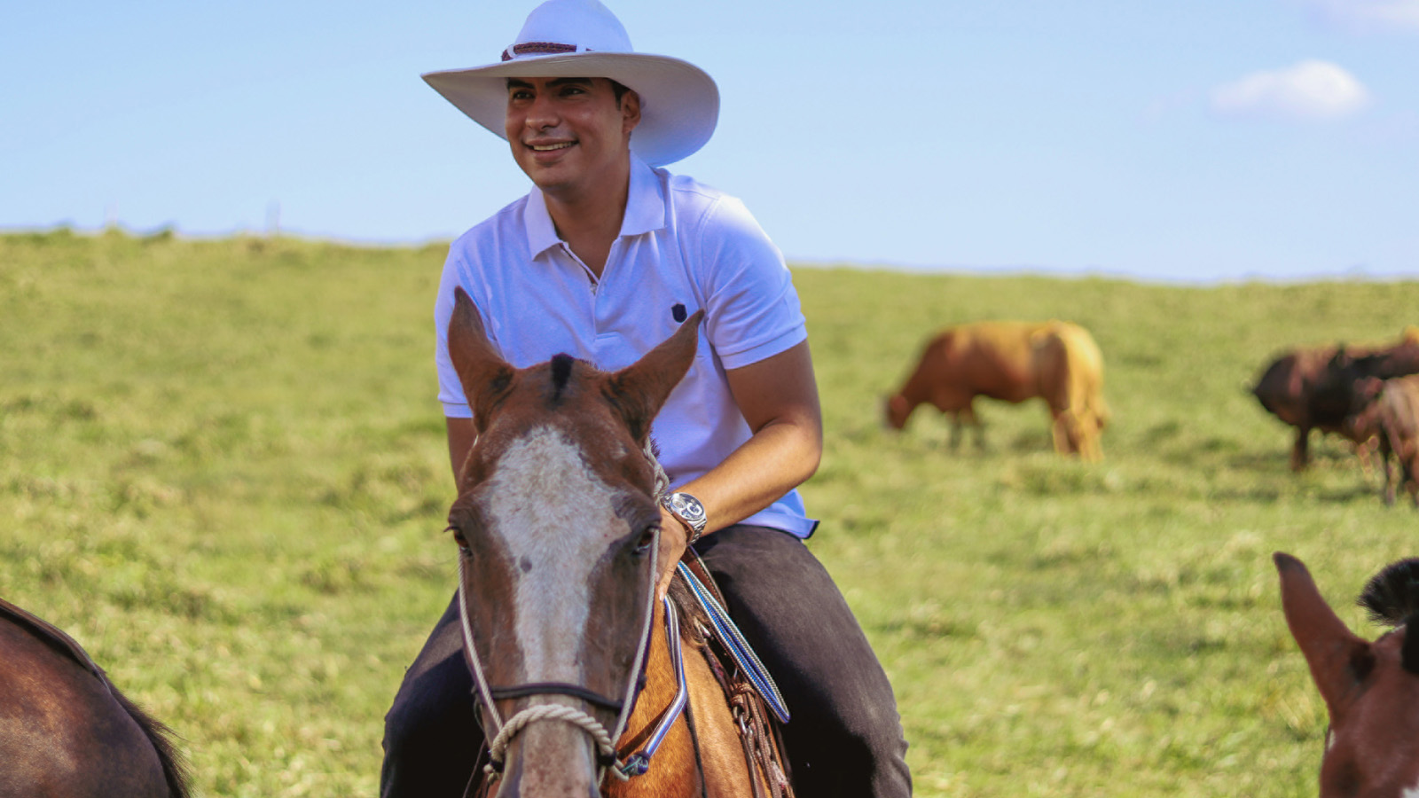 | May 4, 2022, Costa Rica  Experience an Authentic Latin American Asado, A Pop-Up Culinary Event at Four Seasons Resort Costa Rica at Peninsula Papagayo  https://publish.url/costarica/hotel-news/2022/asado-culinary-event.html

PRESS CONTACTS

Dana Berry
Director of Public Relations
10100 Dream Tree Boulevard
Orlando
USA
dana.berry@fourseasons.com

1 407 313 7777

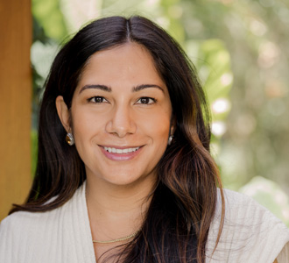 | Melissa Quiñones DeShields  Public Relations Director  Peninsula Papagayo  Costa Rica  melissa.quinones@fourseasons.com  +506 8510 9242

