Four Seasons Resort The Nam Hai, Hoi An Readies to Reopen with Renewed Energy and Optimism

Welcoming guests back with open hearts and purposeful minds
June 26, 2020, Hoi An, Vietnam

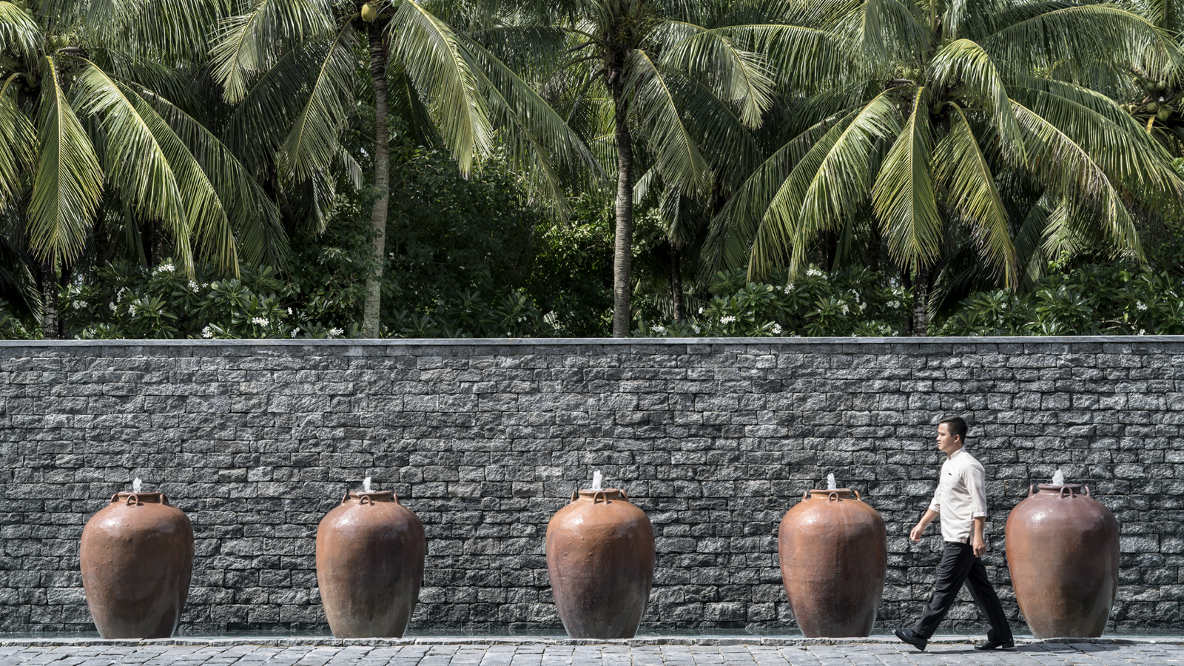
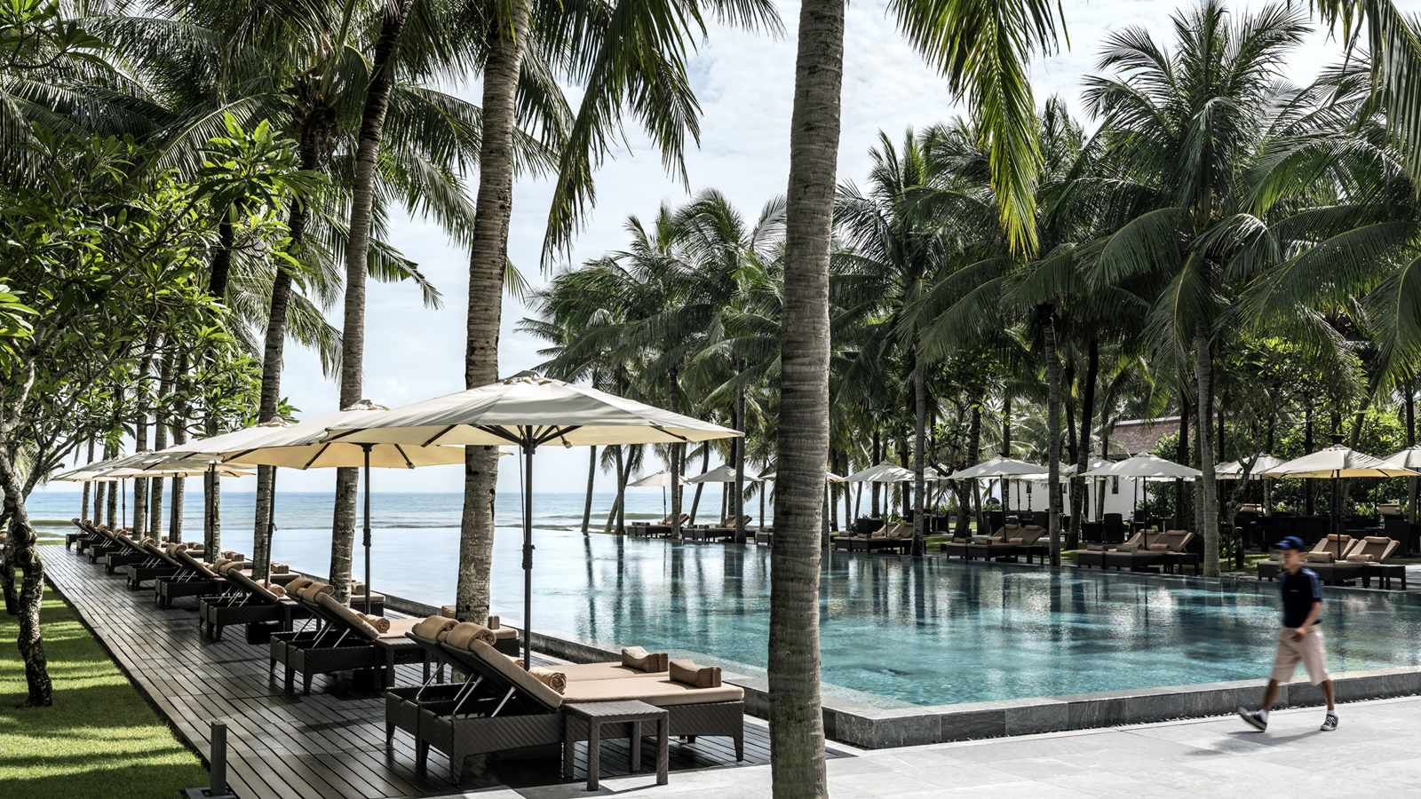
For many, the restrictions of lockdown have been prohibitive. But the team at Four Seasons Resort The Nam Hai, Hoi An has made the most of downtime to come together as a collective, improving facilities and enhancing community spirit in readiness for the Resort’s reopening on July 1, 2020.
From helping to grow new vegetables at the on-site farm to reaching out to vulnerable locals with food packages, it has been a time of growth leading up to a new start with a refreshed sense of purpose.
“Our team’s driving force has always been to connect guests to our unique central coast community,” comments General Manager Blaise Montandon. “The past few months have given us an opportunity to strengthen our ethos through inner and outer work – on the Resort and on ourselves – so that we reopen our doors with an even deeper sense of who we are, what we do, and why we do it. Every action, from extending care to our neighbours to polishing pool decks, has been a team effort.”
While some things have remained consistent during the closed period – like the staff’s heartfelt gratitude rituals in the on-site temple – others have been inspired by this time of reflection, including a comprehensive staff training and learning initiative focused on service, health and safety.
Fresh Paintwork, All-New Menus
Lockdown refurbishment projects include the creation of new decks for the Family and Lap pools and a central sprinkler system as the Resort gears up for summer. Staff from various departments joined forces to repaint walls and roof beams, prune trees and take care of buggies and bicycles among other essential jobs. Keeping spirits high – while raising the healing vibration of the Resort – singing bowl artist Oanh Ngo led a mesmerising staff session on Global Wellness Day on June 13. This time of the year, an abundance of new lotus flowers in the spa lagoon reflect the team’s readiness to welcome guests back with a profusion of passion.
All 4,500 of the Resort’s coconut trees have been lovingly tended to by coconut master Nguyen Dung, while more than 30 gardeners have been taking care of the vast herb and vegetable garden. Thriving plants include Vietnamese basil, rosemary, thyme and curry leaves, alongside new additions of heirloom tomatoes, eggplants, and an abundant mango orchard. Guests returning in July can expect exciting new menus with the freshest seasonal fruits from dragon fruit to avocado, reworked in creative ways.
The quieter period has given new Executive Sous Chef John Oh Jaeyoung (formerly Four Seasons Hotel Seoul) and his team the chance to create a breakfast menu that brings the buffet to the table, while Chef Pham Thi Ly and her pastry aficionados have devised melt-in-the-mouth desserts with local coconut, rambutan and lychee.
A playful children’s menu has also been conceived for families vacationing with youngsters, as well as a revamp of Vietnamese and international favourites. Chef Yamlal Kendel has been stirring up magic with Indian curries; Chef A Lang Phoung and his crew have been refining Western plates; while Chef Nguyen Yen and his team have been imparting ever-more modern twists into their Vietnamese delicacies.
A Heart for the Community, Self and One Another

RELATED

February 25, 2020, Hoi An, Vietnam
Make Every Moment Count in 2020 at Four Seasons Resort The Nam Hai, Hoi An
https://publish.url/hoian/hotel-news/2020/take-your-time.html

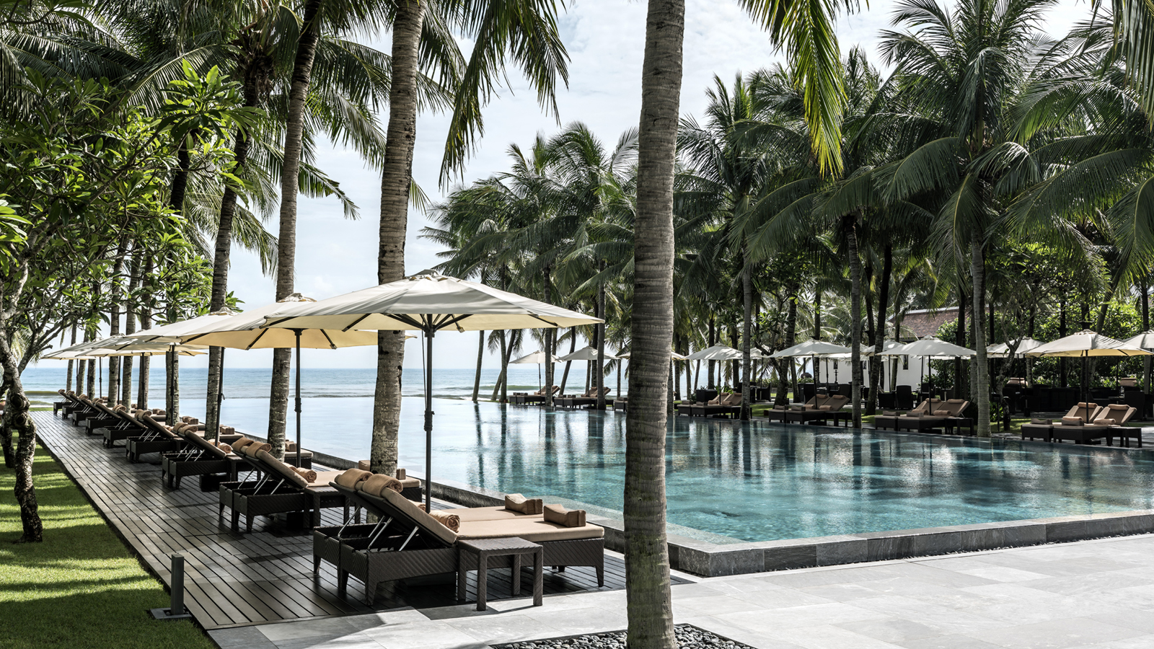 | February 18, 2020, Hoi An, Vietnam  Four Seasons Resort The Nam Hai, Hoi An, Vietnam Retains Its Forbes Five Stars Status  https://publish.url/hoian/hotel-news/2020/forbes-five-star-hotel.html

PRESS CONTACTS

Cuili Ng
Director of Public Relations and Communications
Block Ha My Dong B, Dien Duong Ward
Dien Ban Town
Vietnam
cuili.ng@fourseasons.com

+65 9650 9564

Vu Ho
Public Relations & Communications Executive
Block Ha My Dong B, Dien Duong Ward
Dien Ban Town
Vietnam
vu.ho@fourseasons.com

+84 235 394 0000

