Seasons Power Breakfast is Back at Four Seasons Hotel Washington, DC

May 26, 2021, Washington, DC, U.S.A.

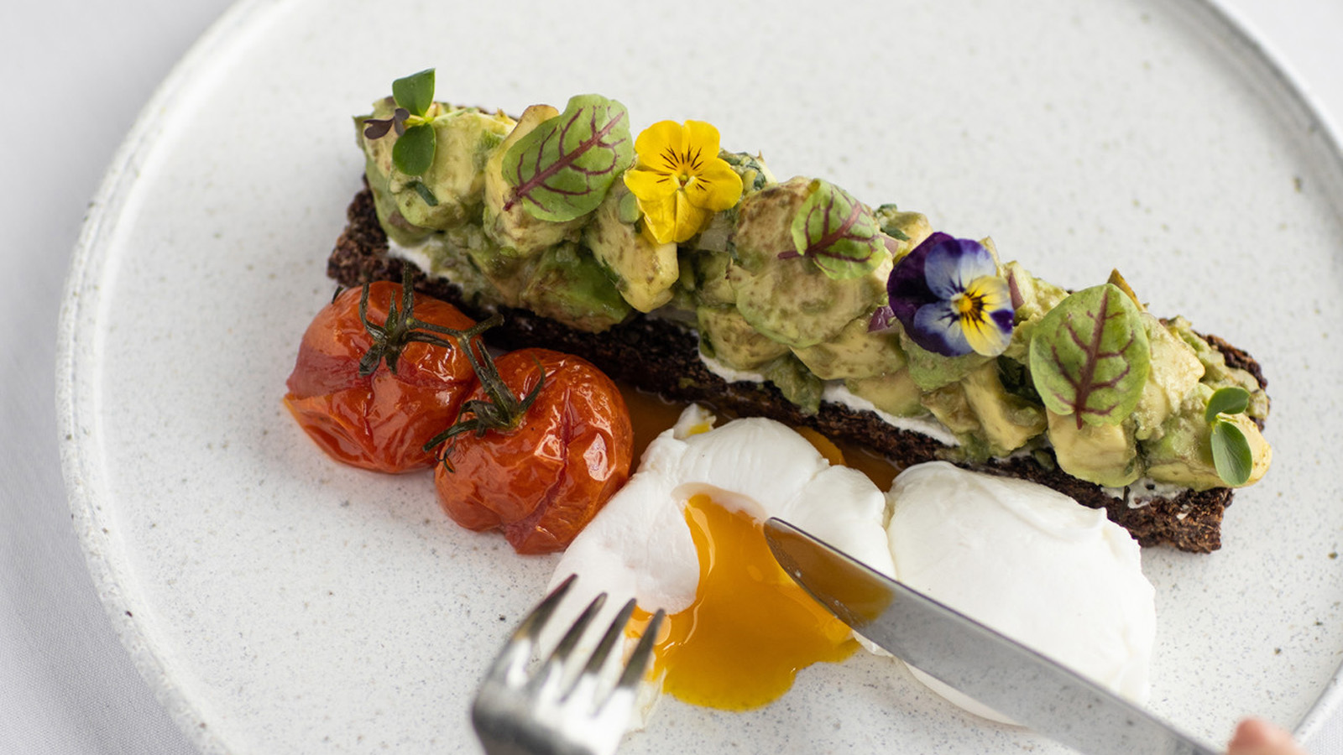 | 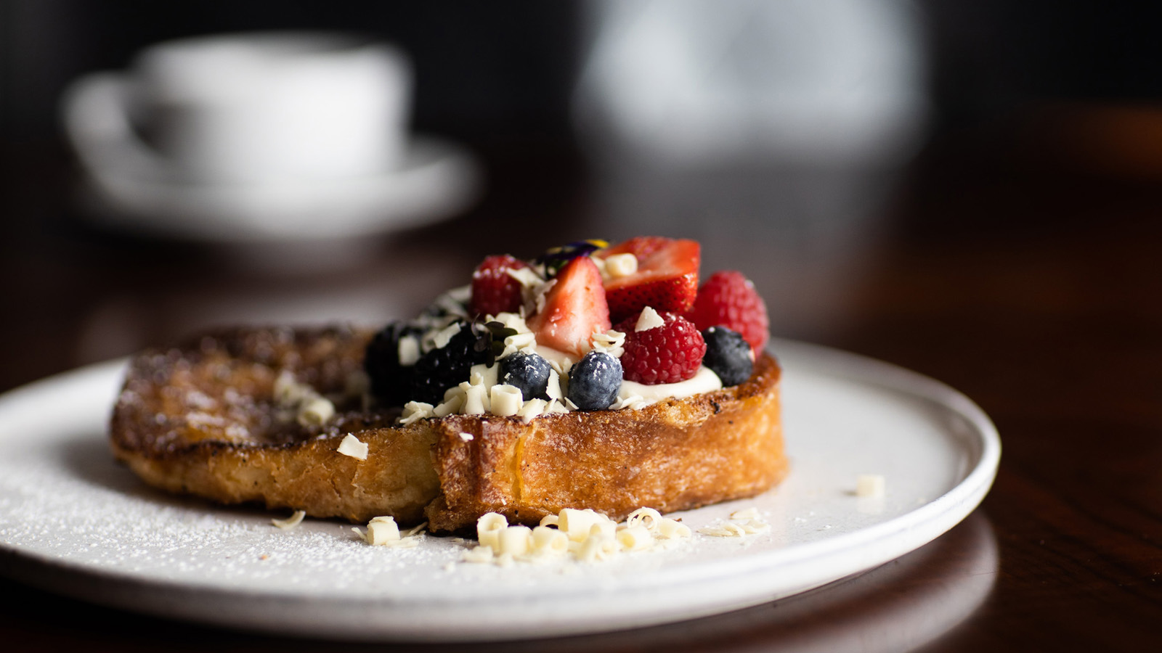 | 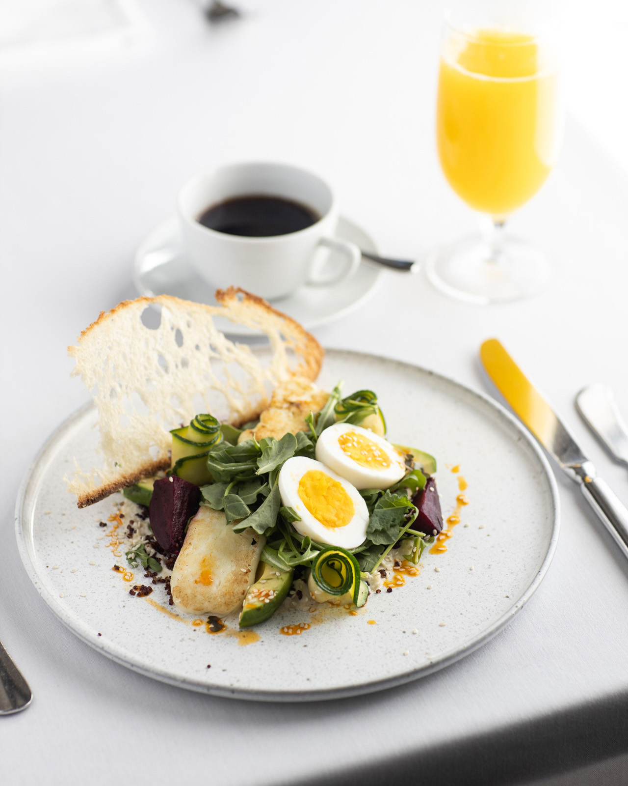
Four Seasons Hotel Washington, DC announces the return of its iconic power breakfast at Seasons Restaurant, beginning June 16, 2021.
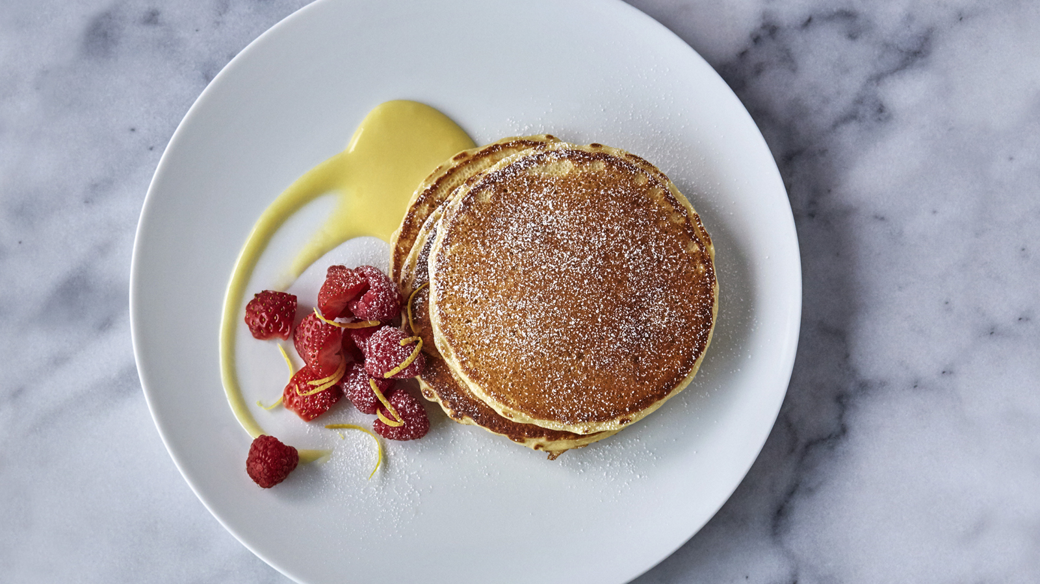 | 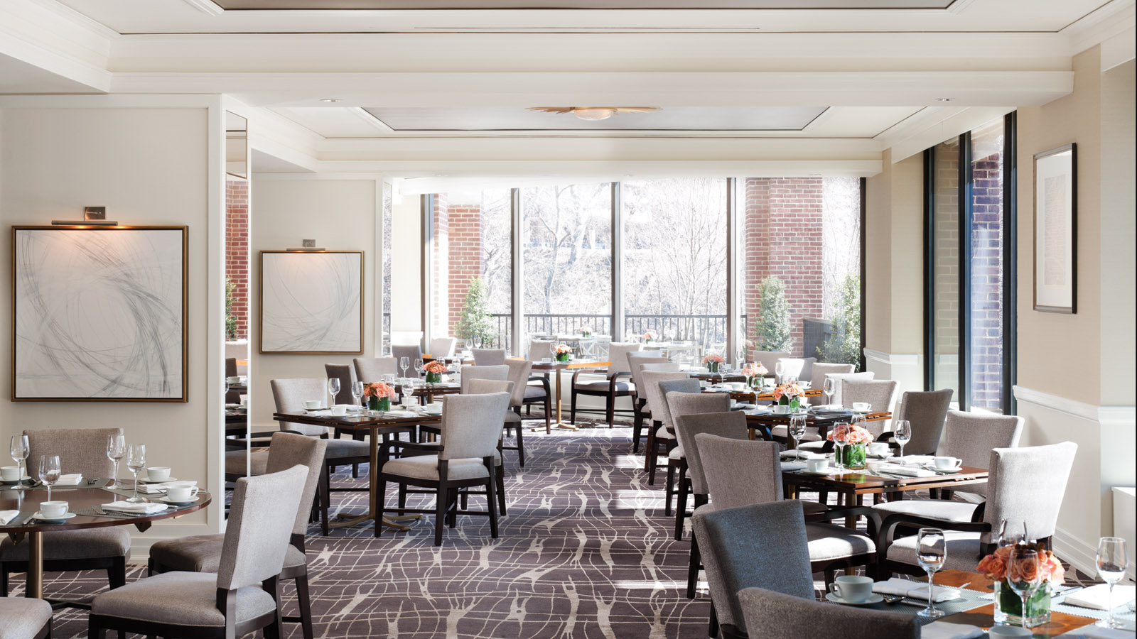
As DC reopens and restrictions are lifted, so returns an institution that has left a void in the DC restaurant scene: the power breakfast. An event to be experienced, a power breakfast, like Seasons Restaurant is known for, is a culinary happening like no other.
The service is warm yet reserved. The coffee appears as if by magic. Discretion is key and there is a hushed din of important conversations. The hum is broken each time a familiar face enters the room. Exclamations of delight, greetings at tables along the way. The host intuitively knows when to lead a guest slowly to their table.
These are the subtleties that are the hallmark of an excellent power breakfast. Seasons at Four Seasons Hotel Washington, DC has welcomed thought leaders and opinion makers of the world for nearly three decades with its unique brand of hyper-personalised service.
Now, the team at Seasons is eager to welcome guests back to its elegant, plush dining room or on its outdoor terrace overlooking the C&O Canal to sample a creative yet health-focused menu.
“We couldn’t be happier to re-open Seasons,” exclaims Senior General Manager Marc Bromley. “The team is back and looking forward to seeing their regular guests again. Breakfast at Seasons is like nowhere else in the world. It is the dynamism of Washington, DC mixed with the refinement of the service and culinary presentations that make it so special.”
The Seasons Revitalizer juice, a favourite elixir among patrons, is a balanced blend of freshly squeezed spinach, celery and apple with a hint of lemon. The avocado toast, one of the best in the city, is served over house-made, gluten-free quinoa bread and accompanied with confit tomatoes. Of course, for those looking to indulge, the French toast is back, served with a generous dollop of whipped cream and fresh berries, as well as the delectable lemon ricotta pancakes, dusted with icing sugar and a swirl of lemon curd.
Seasons Restaurant at Four Seasons Hotel Washington, DC is open for breakfast 7:00 to 11:00 am Monday through Sunday and for lunch from Monday to Friday from 11:30 am to 2:00 pm starting June 16, 2021. Garden Brunch will continue to be served at BOURBON STEAK DC from 11:00 am to 2:00 pm on the weekends. Reservations recommended. Call +1 202 342 0444 or book on Open Table.

RELATED

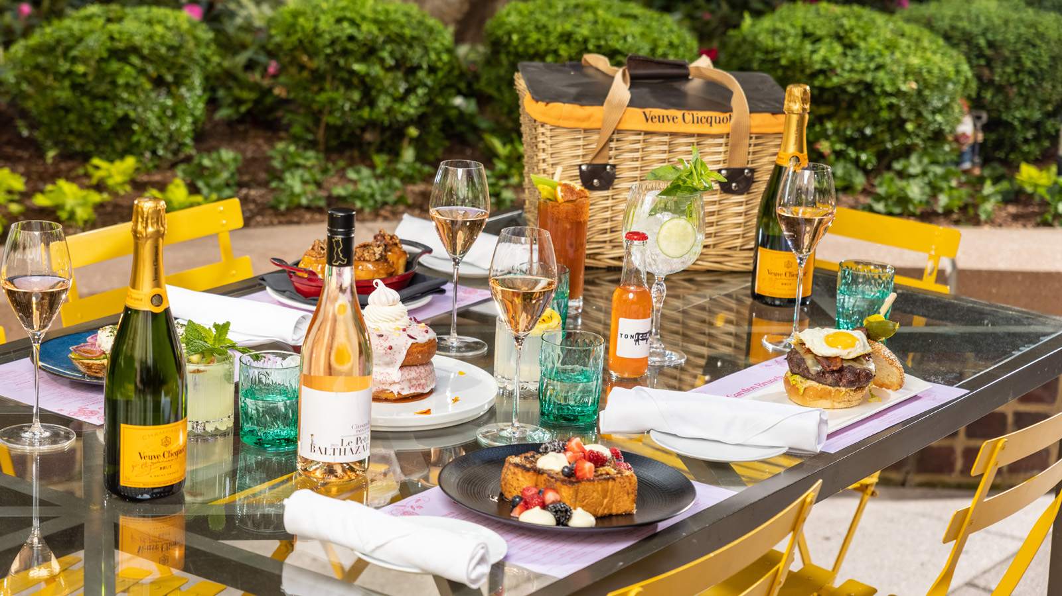 | June 2, 2021, Washington, DC, U.S.A.  Four Seasons Hotel Washington, DC Celebrates PRIDE with a Vibrant Bottomless Brunch at BOURBON STEAK DC  https://publish.url/washington/hotel-news/2021/pride-brunch-at-bourbon-steak.html
May 19, 2021, Washington, DC, U.S.A.
Marc Bromley Returns to the Nation’s Capital as Senior General Manager of Four Seasons Hotel Washington, DC
https://publish.url/washington/hotel-news/2021/new-general-manager-marc-bromley.html

PRESS CONTACTS

Anina Belle Giannini
Director of Public Relations
2800 Pennsylvania Avenue N.W.
Washington
U.S.A.
aninabelle.giannini@fourseasons.com

+1 202 944 2074

