Four Seasons Hotel Gresham Palace Budapest Has Been Awarded with Five Stars in Forbes Travel Guide 2023 for the Seventh Consecutive Year

March 14, 2023, Budapest, Hungary

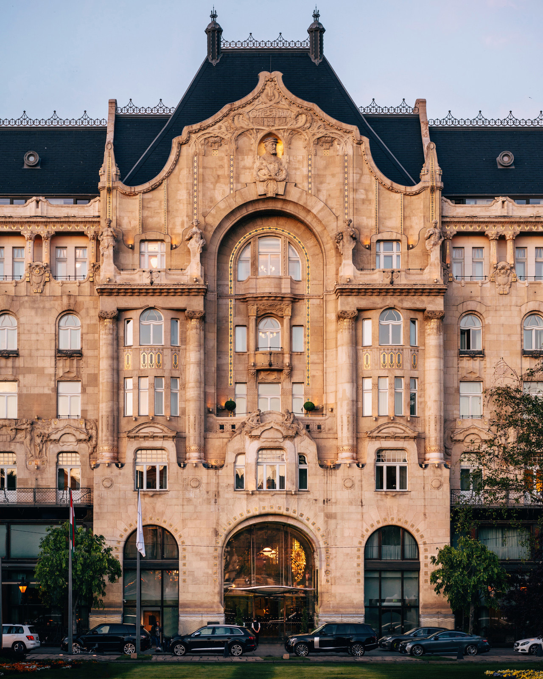
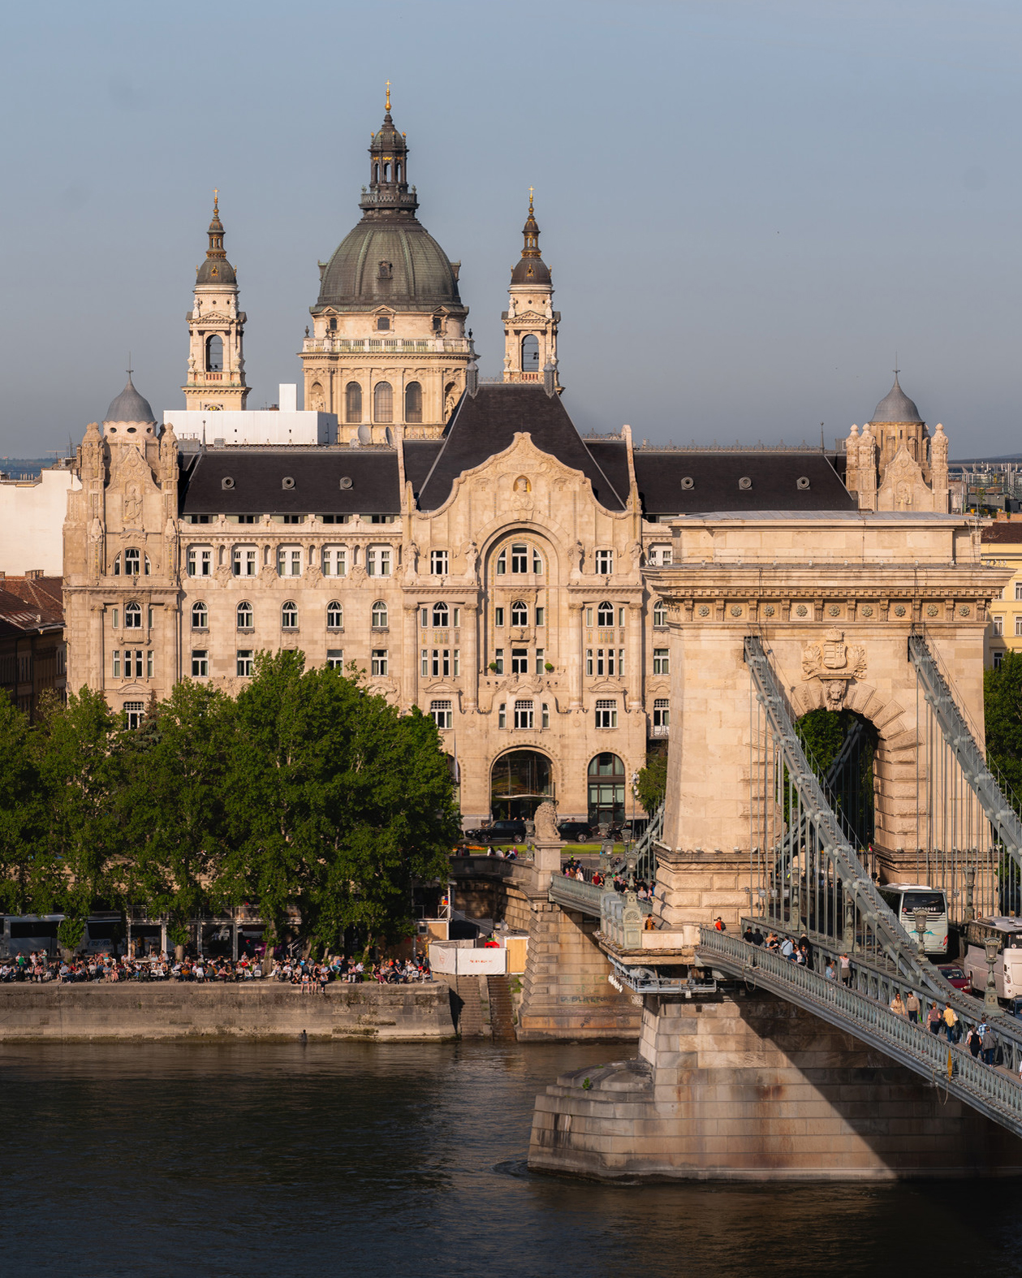 | 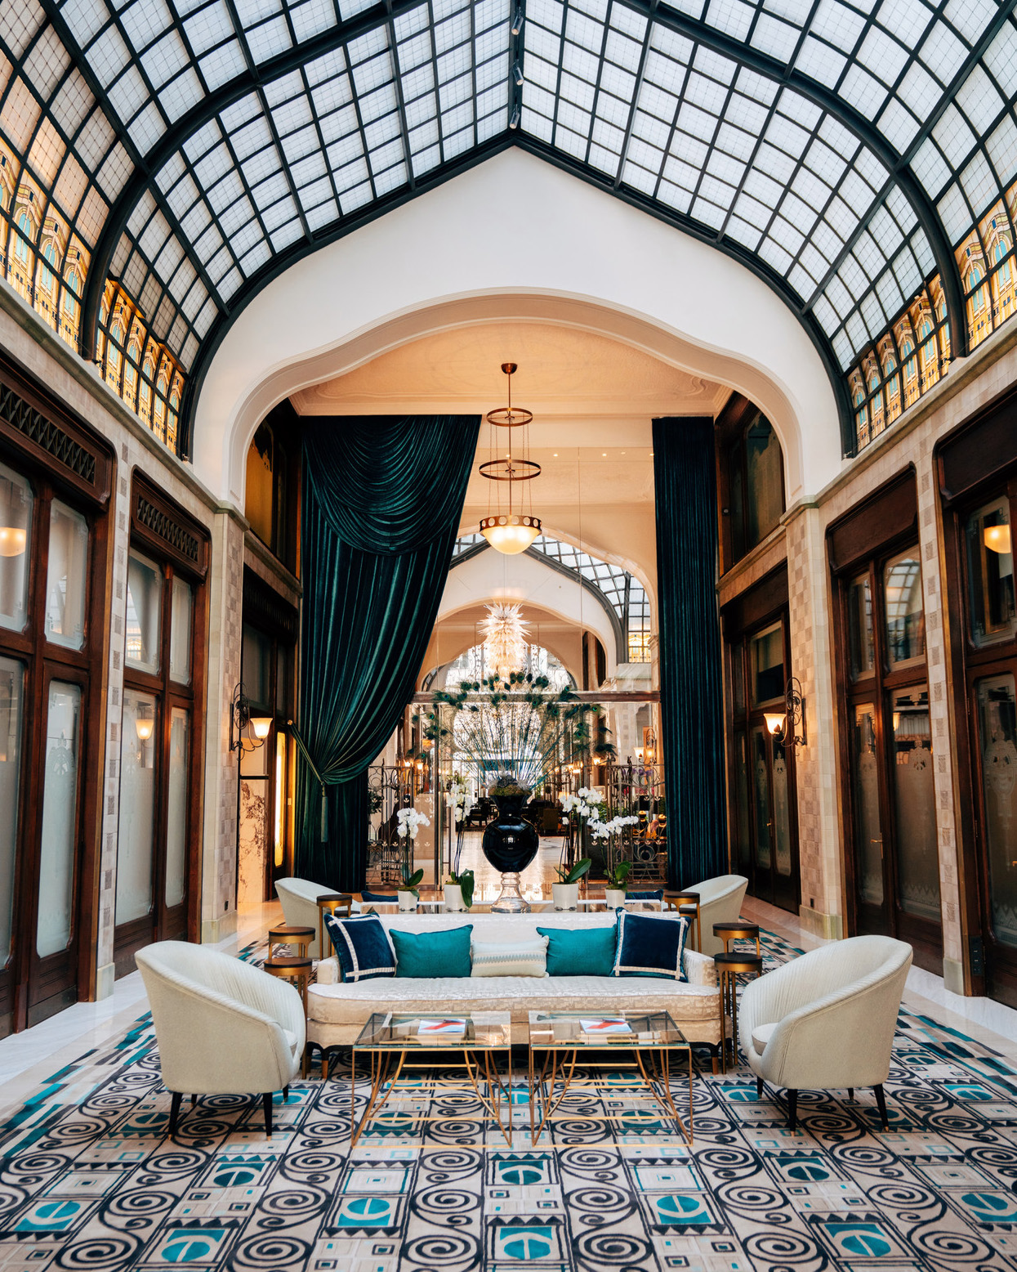
Forbes Travel Guide, the only global rating system for luxury hotels, restaurants and spas, announced its latest Star Awards on February 15, 2023. Four Seasons Hotel Gresham Palace Budapest earned the exquisite accolade of Five Star rating, being the only hotel in Hungary that received the highest designation, in addition to the Four Star award that its Spa acquired, which is also unique to the Hungarian market.
"It is a great honour to receive the prestigious distinction of Forbes Travel Guide Five Star rating for the seventh consecutive year," says General Manager Thibaut Drege of Four Seasons Hotel Gresham Palace Budapest. "This award is a recognition of the exceptional dedication of the teams at Gresham Palace to ensure memorable experiences and seamless services for all guests. My warmest thanks and compliments to the whole team."
Located in the heart of Budapest, the Art Nouveau landmark embodies the spirit of Budapest’s Golden Era glamour. With 160 luxurious guest rooms, 19 expansive suites and spectacular, grandiose event spaces, the property is a true gem on one of Europe’s most scenic rivers. Forbes Travel Guide is the world-renowned authority in genuine Five Star service, and the team at Four Seasons Hotel Budapest is honoured to be featured on this Star rating list.
“The achievements of Four Seasons in this year's Forbes Travel Guide awards once again demonstrate the company’s longstanding commitment to exemplary service,” says Hermann Elger, CEO, Forbes Travel Guide.

RELATED

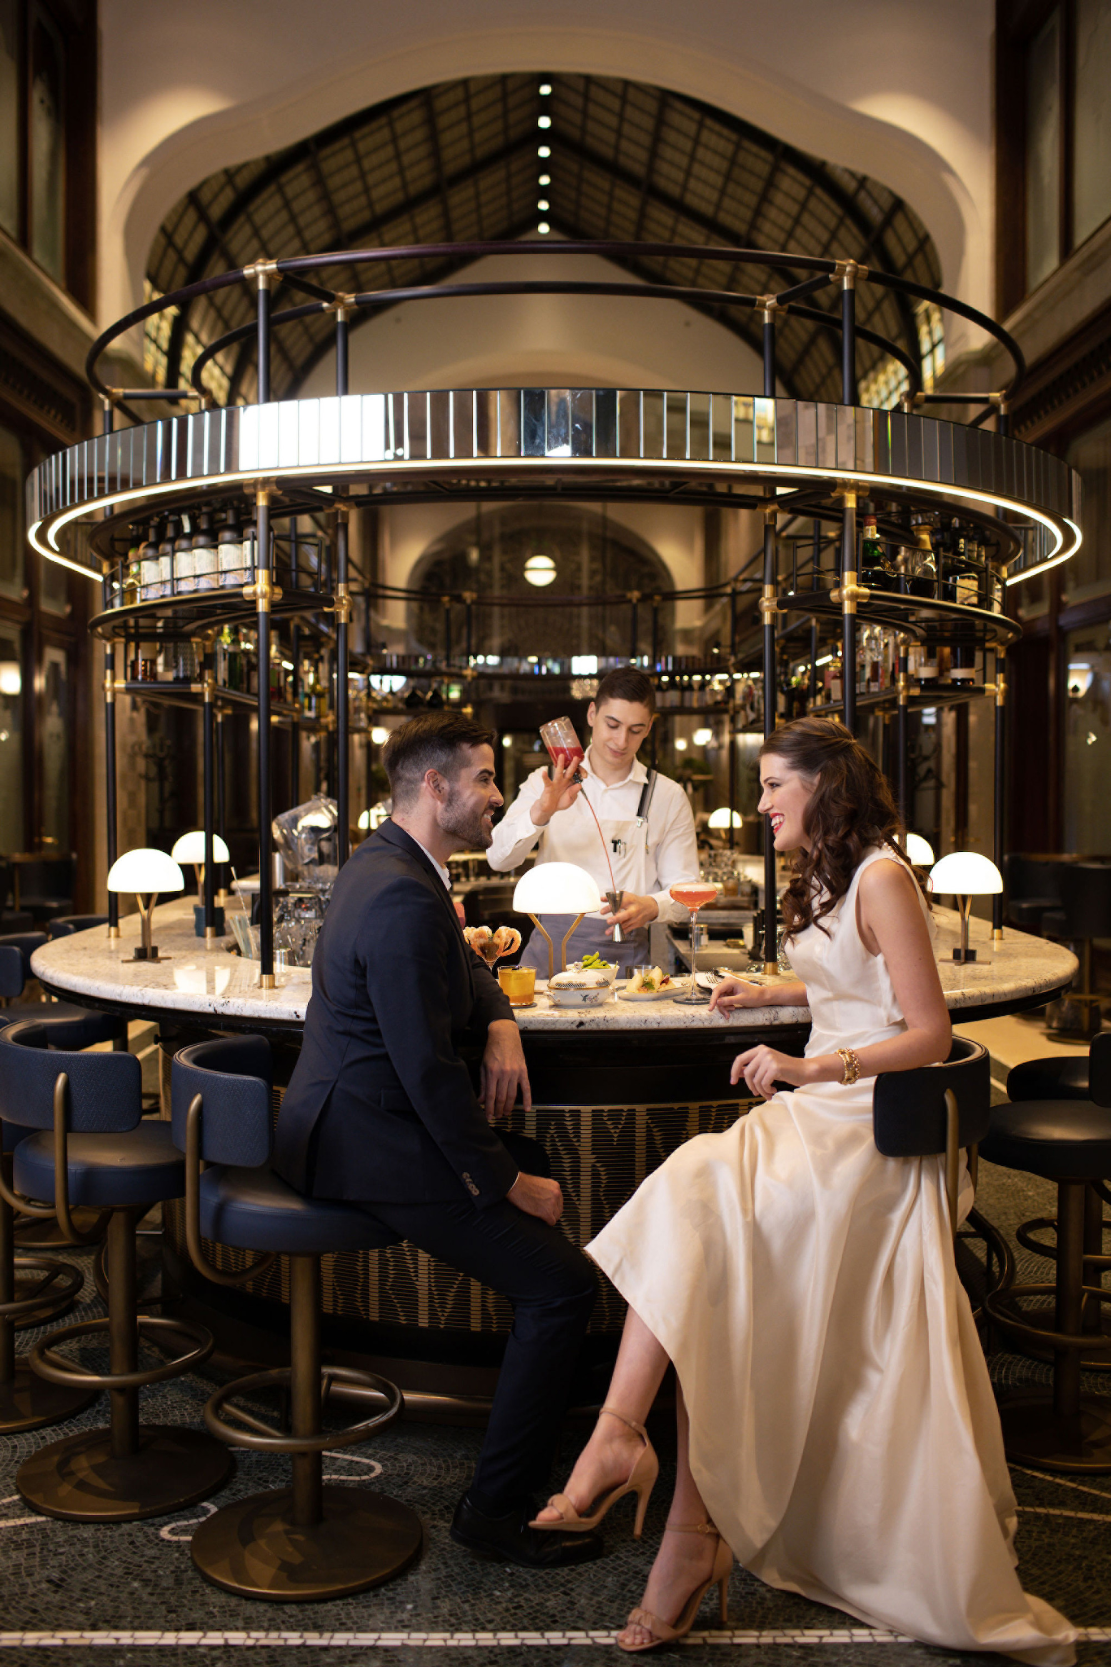 | February 3, 2023, Budapest, Hungary  Culinary Encounter with Aphrodisiacs on the Day of Love at Four Seasons Hotel Gresham Palace Budapest  https://publish.url/budapest/hotel-news/2023/valentines-day.html
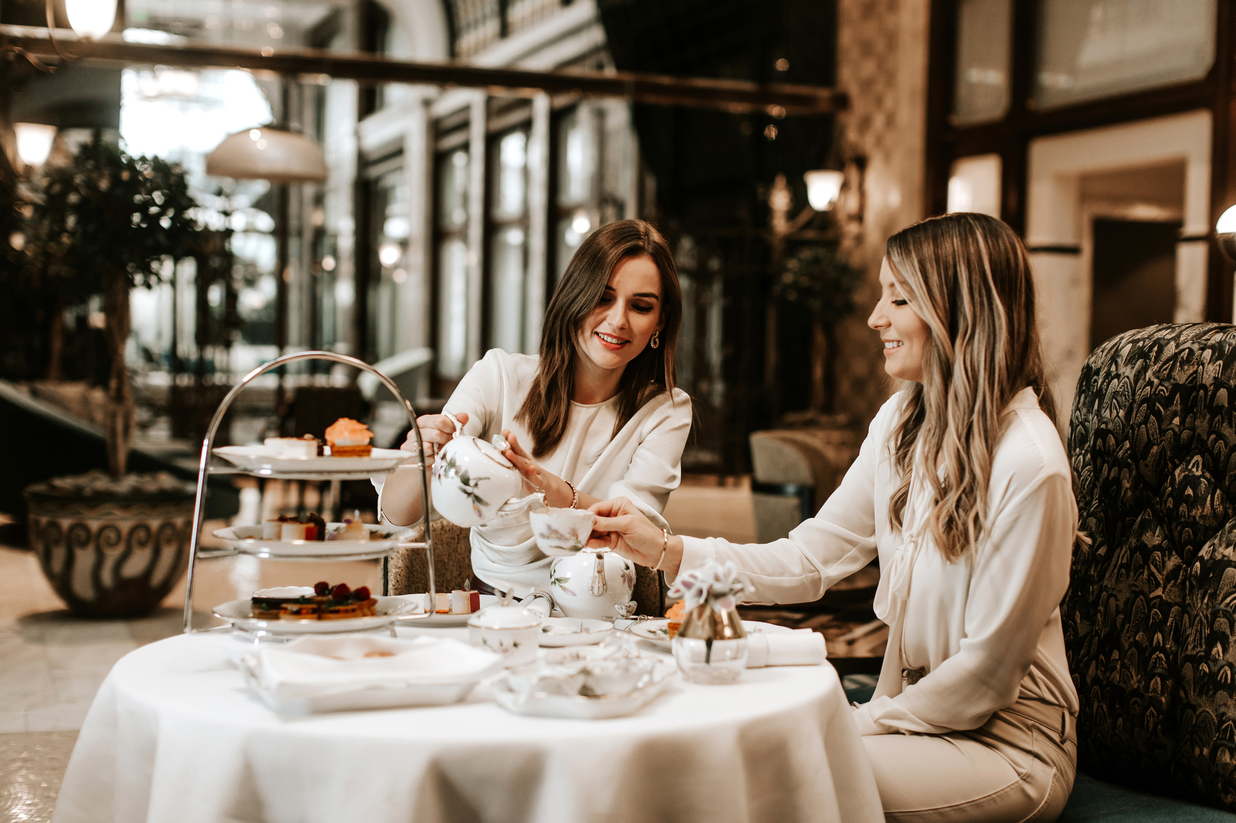 | December 12, 2022, Budapest, Hungary  Experience the Wonders of Herend Afternoon Tea This Festive Season with Four Seasons Hotel Gresham Palace Budapest  https://publish.url/budapest/hotel-news/2022/herend-afternoon-tea.html

PRESS CONTACTS

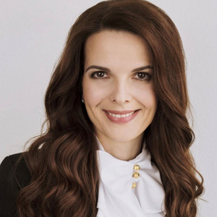 | Judit Esküdt  Director of Public Relations and Communications  Széchenyi István tér 5-6.  Budapest  Hungary  judit.eskudt@fourseasons.com  +36 1 268 5452
Fruzsina Otto
Assistant Public Relations Manager
Széchenyi István tér 5-6.
Budapest
Hungary
fruzsina.otto@fourseasons.com

+36 1 268 5419

