Architecture, Design and Art at Four Seasons Hotel Montreal Collect International Accolades and Reintroduce the City to the Global Luxury Hotel Conversation
- Four Seasons Hotel Montreal brings back the city to the forefront of the global luxury hotel conversation
- Architecture and design highlight Montreal’s first luxury hotel in decades
- Sensual and elegant interiors by Gilles & Boissier and Philip Hazan
- MARCUS Restaurant: modern spaces designed by Atelier Zébulon Perron for Chef Marcus Samuelsson
- Emblematic eight-floor art installation by Montreal sculptor Pascale Girardin
- Lemay and Sid Lee Architecture contemporary style
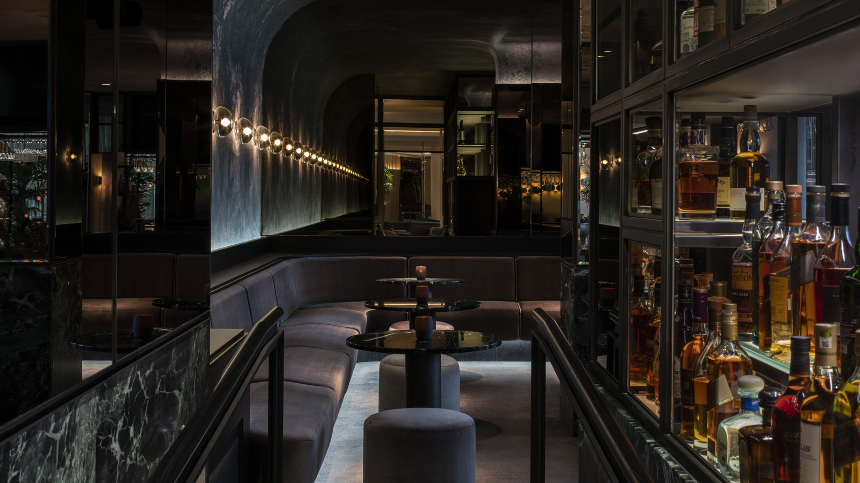 | 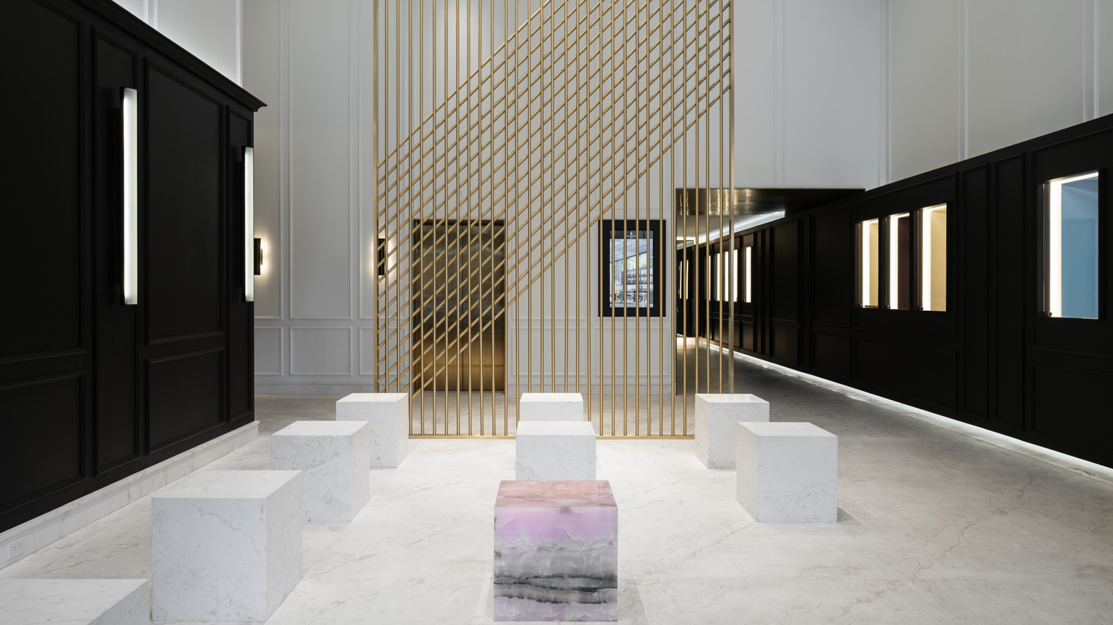 | 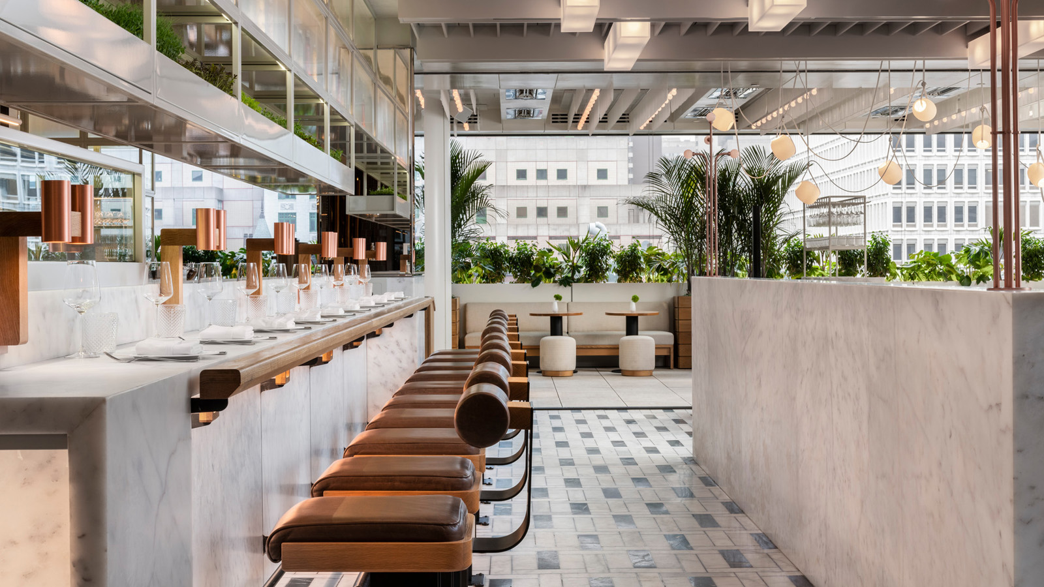

December 4, 2019, Montreal, Canada

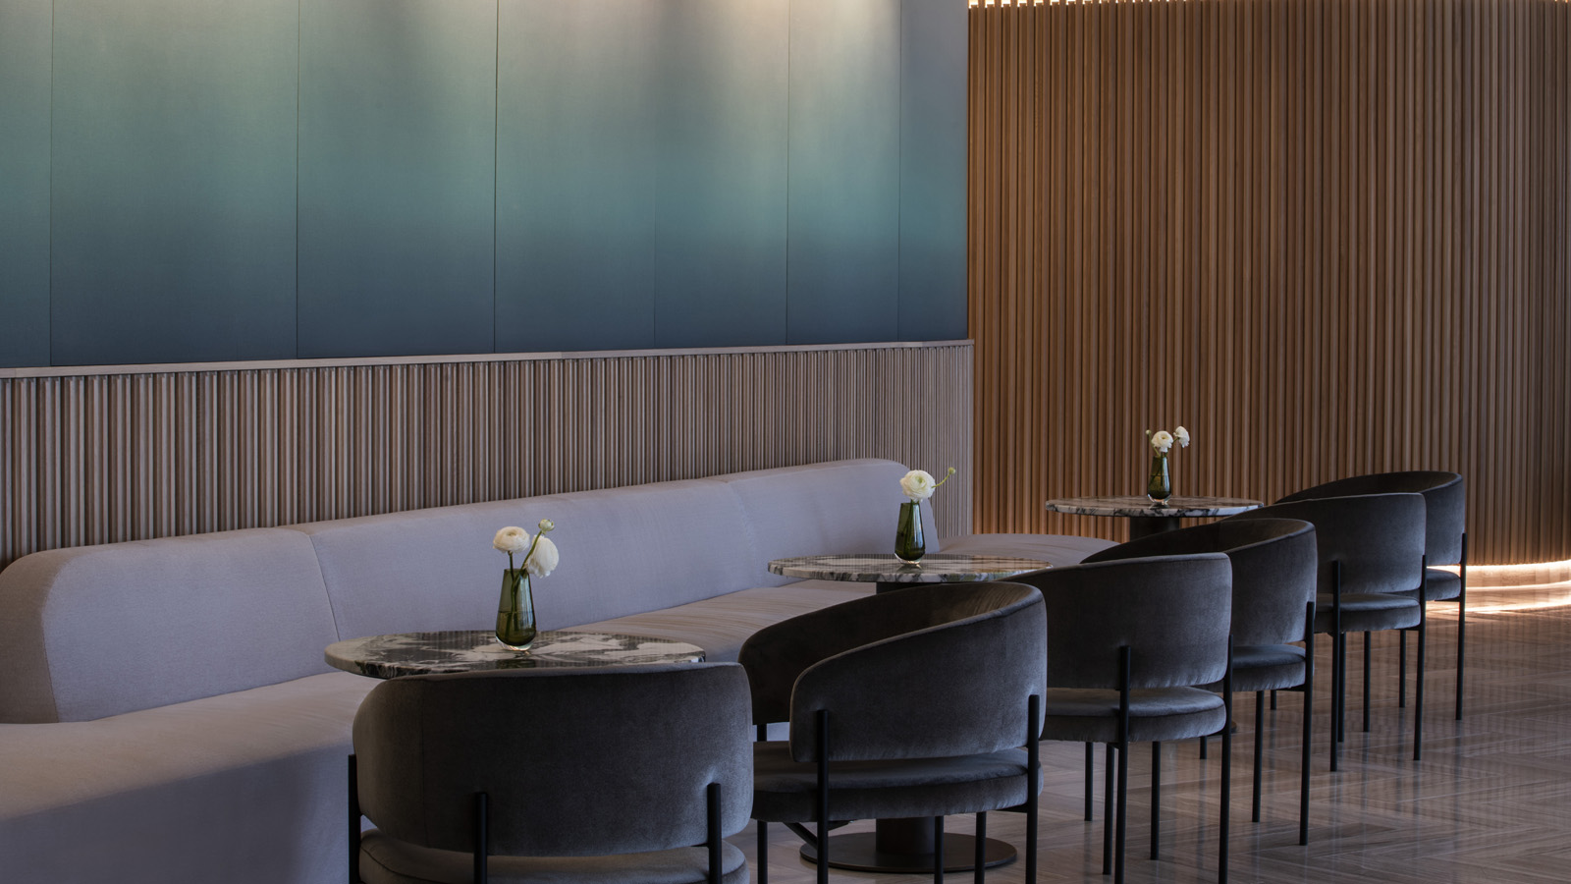
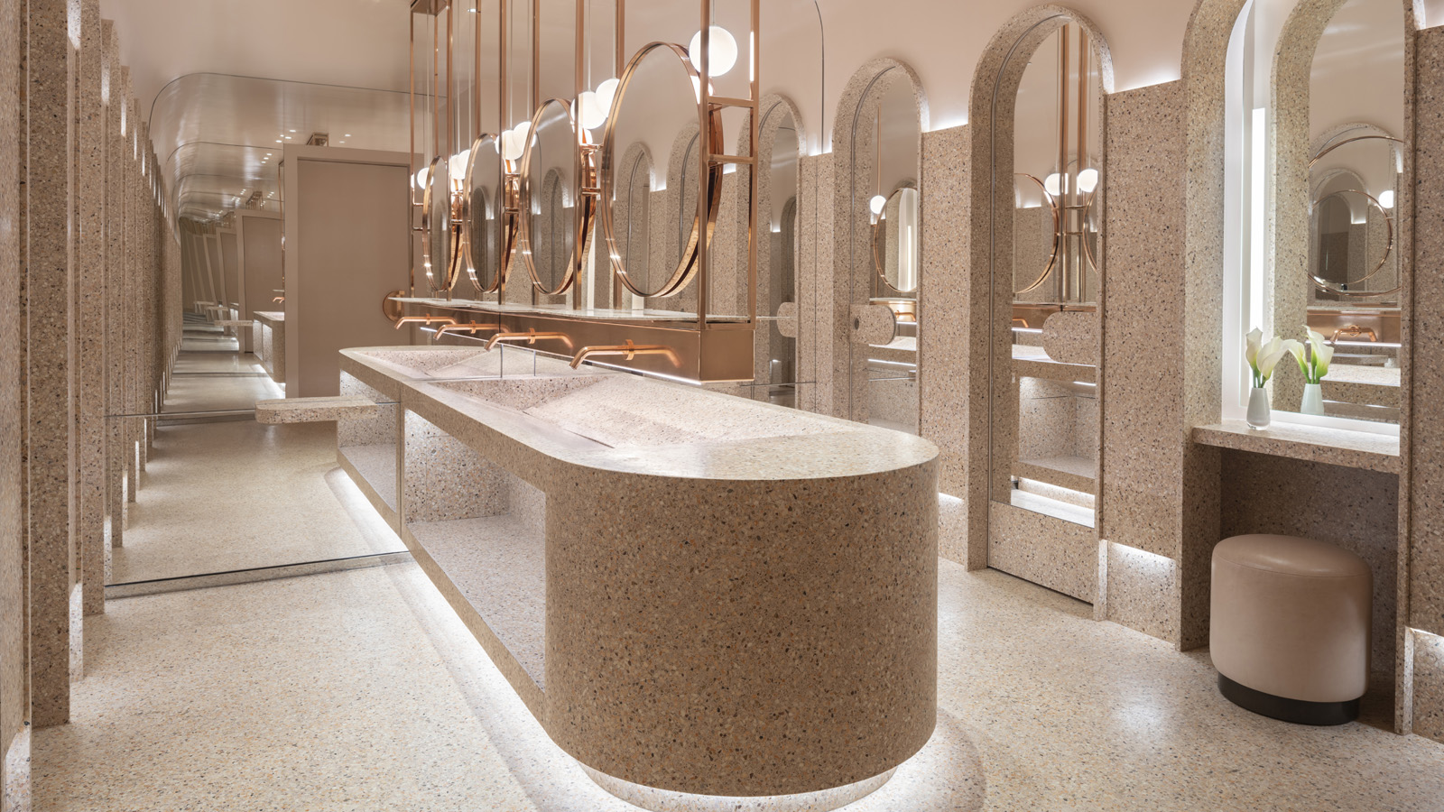 | 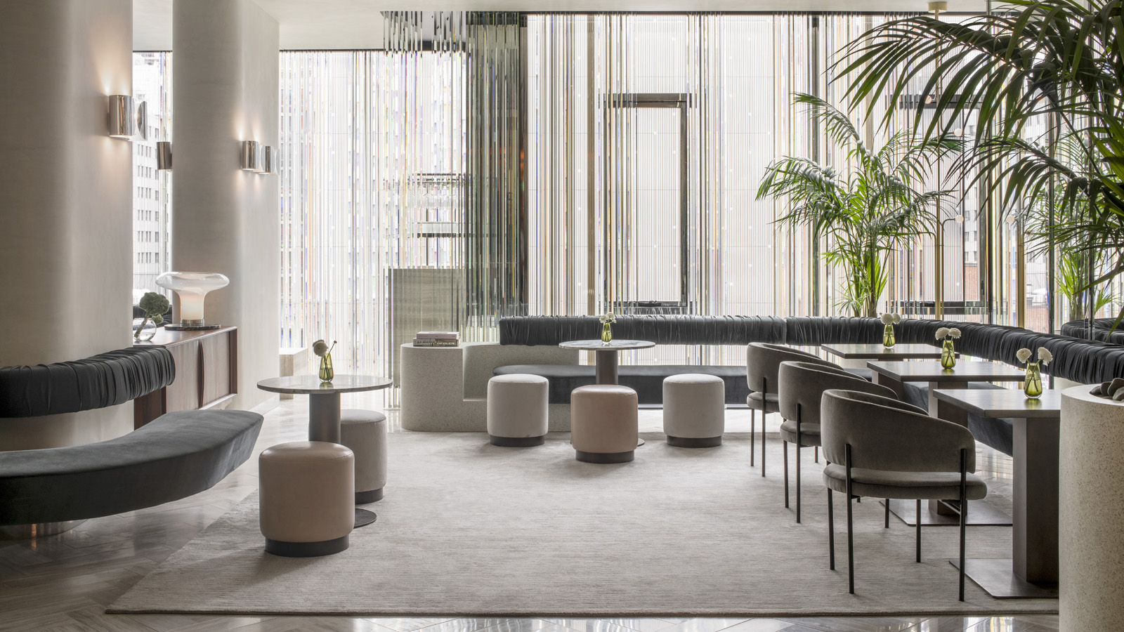 | 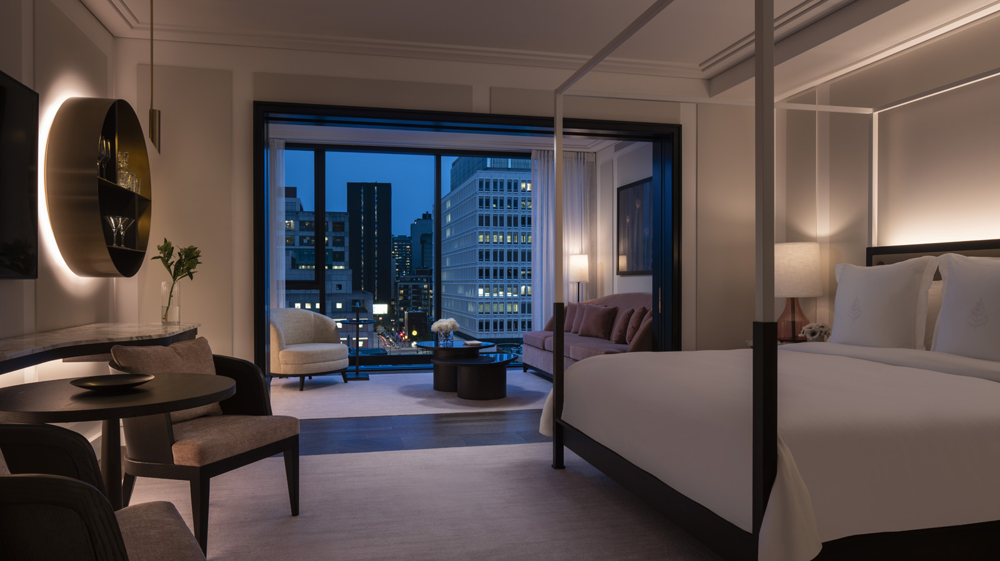
Since opening its doors in May 2019, Four Seasons Hotel Montreal has brought its city back to the forefront of the global luxury hotel design conversation with outstanding international media accolades, including features in AD Magazine, Condé Nast Traveler, Deezeen and Wallpaper, and a nomination to the 2019 Surface Magazine Travel Awards. As a result of continuous interest, Four Seasons Hotel Montreal accommodates leading architecture and design journalists to tour the property or meet the visionary architects, designers and artists who conceived an emblematic hotel where sensuality meets intelligent design, and where art and design enchant, surprise and delight local Montrealers and global travellers at every turn.
The thoughtfulness and imagination of the team’s creative minds imbues every corner of the Hotel’s unique social ecosystem, which englobes graceful and sensual modern guest rooms; lively dining and drinking environments; a spa and wellness sanctuary; the city’s newest venue for top level business meetings and glittering social galas; and an exclusive community of private residences in the heart of Montreal’s Golden Square Mile, steps away from the city’s best shops, galleries, restaurants and museums.
The Building - The Elegance of a Gold Chain on a Classic Black Dress
Designed by Lemay and Sid Lee Architecture, the building that houses Four Seasons Hotel Montreal combines classic elegance and contemporary style. The 18-storey multifunctional building includes a 169-room hotel and 18 private residences. It makes an iconic statement with its streamlined, uniquely offset volumes and richly textured accents that embody luxury and refinement.
Boldly swathed in black, the tower captures light differently on each floor and interacts with Montreal's ever-changing skyline and seasons. The façade’s main volumes are divided according to its functions by a golden bas-relief that folds inwards and spreads vertically, creating a thin blade in the centre of the building that alters its visual aspect. The dark colour of the glass lays a delicate veil over the interior spaces and creates a subdued appearance at nightfall, framed by granite side façades that reflect the rhythm of the glass panels as their textures come to life with the changing ambient light.
The Design – Sensual Interior Design by Paris-based Gilles & Boissier in Collaboration with Philip Hazan
The Hotel’s chic interiors by designers Gilles & Boissier in collaboration with Philip Hazan are a stark contrast to the building’s black glass façade.
Guests enter through a lobby of white marble with gold elevators and can discover pink and grey velvet walls that demand to be touched when they access the feminine third floor reception. Graceful and sensual, the 169 guest rooms are imbued with modern classicism, bathed in comforting colours of cloud white, with ethereal backlighting, smooth velvet textures, mirrored surfaces, swathes of marble and bronze, and gold and dark wood accents.
The feeling of sophisticated, modern luxury is completed by glamorous rose velvet furniture, a circular bar étag&egrave;re for make-your-own cocktails, minimalist four-poster beds, and corpulent backlit mirrors that reflect the spectacular city views that slip in through floor-to-ceiling windows. The west-facing side of the building offers best views in the city to admire the iconic Leonard Cohen mural.
Atelier Zébulon Perron - MARCUS Restaurant + Terrace and MARCUS Lounge + Bar
For Four Seasons Hotel Montreal, celebrated Montreal design firm Atelier Zébulon Perron helped develop a new concept: The Social Square. This sprawling third-floor Social Square encompasses both the Hotel’s lobby as well as MARCUS Restaurant + Terrace and MARCUS Lounge + Bar, by celebrity Chef Marcus Samuelsson.
MARCUS lounge, bar, restaurant and terrace are four distinct, immersive worlds that overlap and complement each other, while each seamlessly blending into the Hotel’s contemporary architecture. Sophisticated yet approachable, refined yet organic, they fuse design and experience based on social ergonomics and contemporary taste. They are inspired by circadian rhythms in which each moment is imagined to be a novel, one-of-a-kind experience, from the floating velvet bench in the lounge to the prismatic lighting cast by the crystal wall, the leather banquettes in the restaurant and the terrace’s sun-drenched tables overlooking the city.
In a reference to chef Samuelsson’s seafood creations, the restaurant and terrace suggest a theme reminiscent of the ocean. The restaurant’s charm is a combination of opposites, balancing elegance and warmth with minimalism and modernity. In contrast, the intimate night bar gives the impression of entering an enchanted forest. With quirky features, such as the crab exoskeleton in an infinity glass cube that greets visitors in the foyer and the colourful cold room display of seafood charcuterie at the restaurant’s entrance, the designers remind us that, at MARCUS, it is ultimately the cuisine of Chef Marcus Samuelsson that takes centre stage.
Materials: marble, terrazzo, brass, prismatic glass, white oak, velvet.
Art - An Eight-floor Art Installation by Montrealer Pascale Girardin
Tucked away inside the building and only accessible to Hotel guests, Pascale Girardin’s floral-inspired installation cascades down the building’s open-air atrium. Suspended in the Hotel’s private open-air atrium, the sculpture, entitled Contemplation, creates an elegant counterpoint to the Hotel’s linear architecture by evoking nature in the heart of the luxurious urban establishment.
Made of lightweight aluminum, the all-white installation with gilded accents of 24-karat gold is made up of more than ninety floral suspensions ranging from 30 centimetres (12 inches) to one metre (40 inches) in diameter. These garlands cascade through the atrium from the 18th to the 9th floor, reflecting the cycles of nature - the blossoms of spring flowers, the movement of petals adrift on a summer breeze, the spill of autumnal leaves and the lightness of falling snow.

RELATED

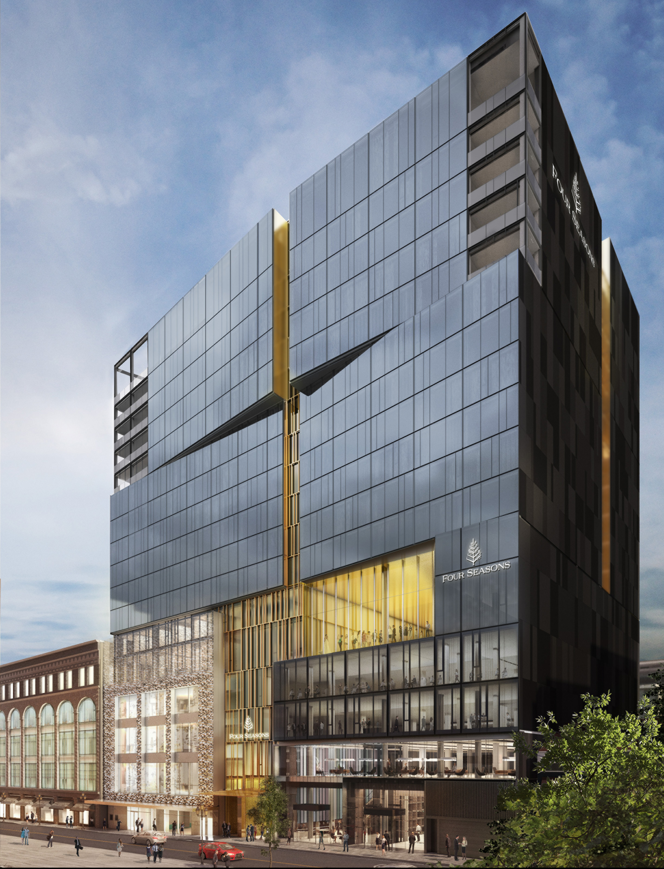 | July 20, 2020, Montreal, Canada  Une touche de style brille de nouveau au carré doré avec la réouverture du Four Seasons Hôtel Montréal  https://publish.url/fr/montreal/hotel-news/2020/reopening-2.html
July 20, 2020, Montreal, Canada
Style Returns to the Golden Square Mile with the Reopening of Four Seasons Hotel Montreal
https://publish.url/montreal/hotel-news/2020/reopening.html

PRESS CONTACTS

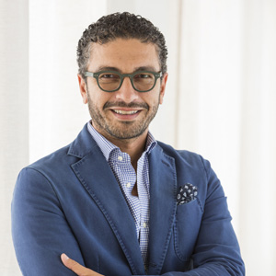 | Mohamed Abou Doh  Director of Marketing / Directeur du Marketing  1440 Rue de la Montagne  Montréal  Canada  mohamed.aboudoh@fourseasons.com  +1 514 843 2730

