Introducing the Lagoon Paddleboard Adventure from Four Seasons Residence Club Aviara

An exclusive opportunity to explore San Diego’s scenic Agua Hedionda Lagoon on a luxury Beau Lake paddleboard
April 23, 2018, San Diego, Aviara

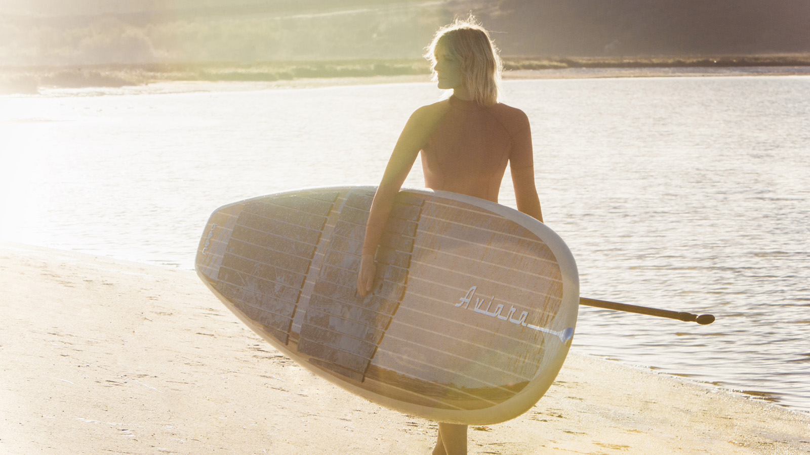
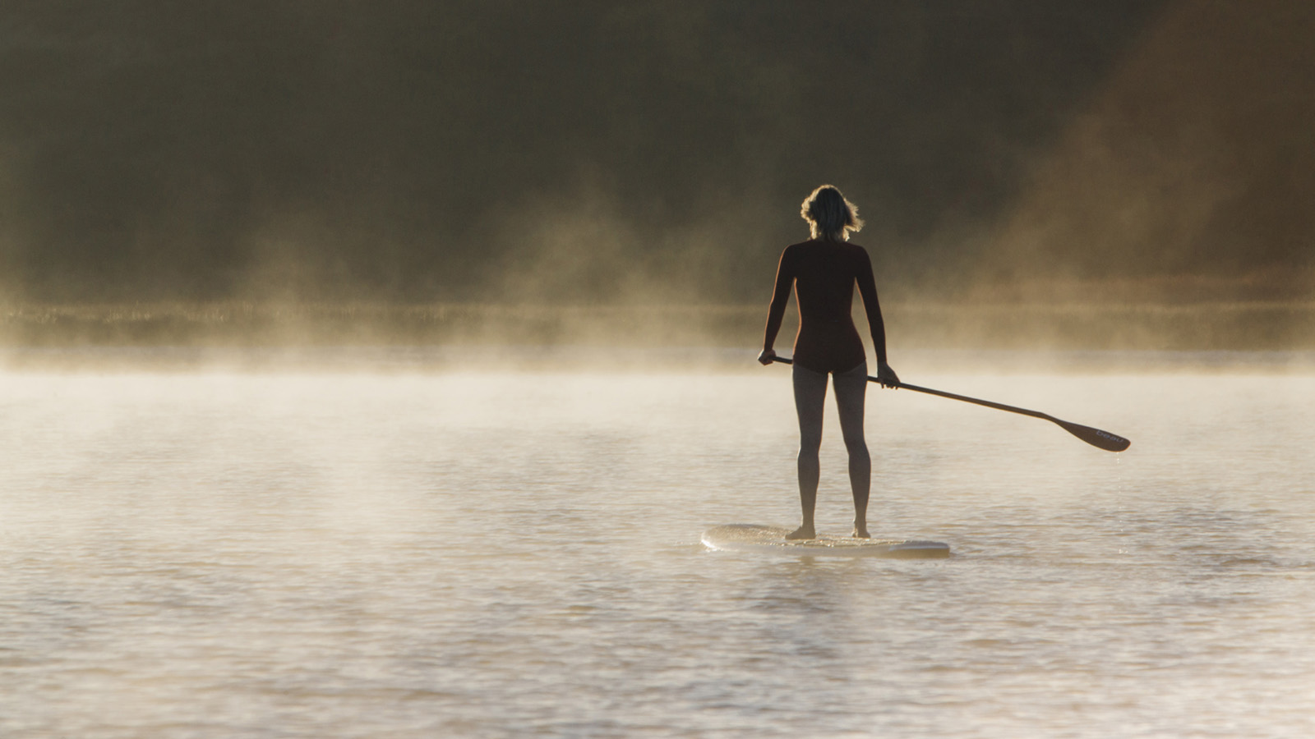 | 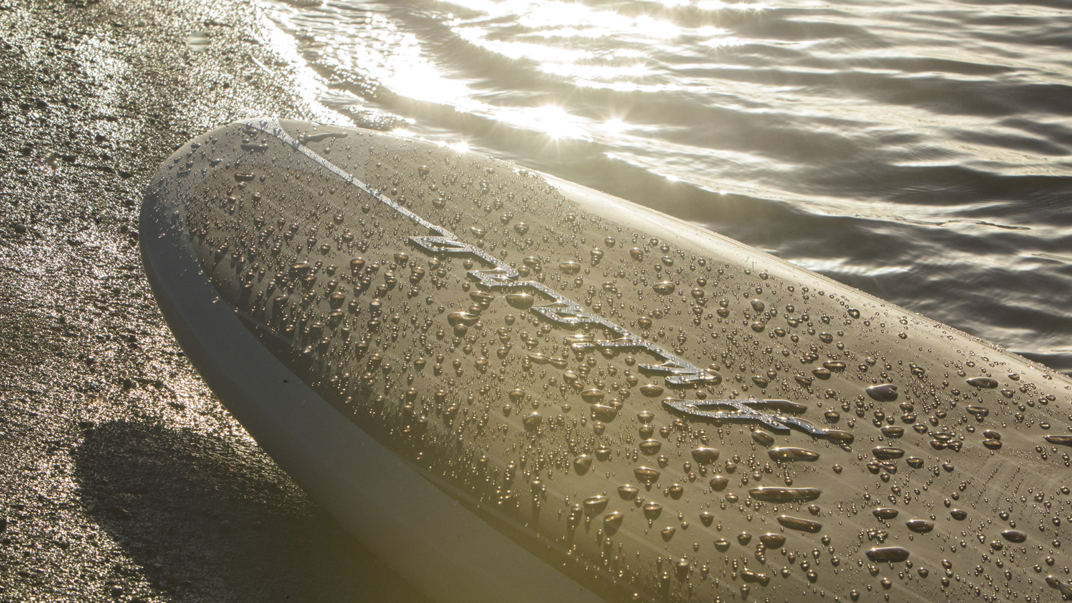
Feeling connected to nature is an essential part of the Southern California lifestyle, and it’s the inspiration behind the latest vacation experience from
Four Seasons
Residence Club Aviara: a one-of-a-kind Lagoon Paddleboard Adventure, showcasing luxury paddleboards by Beau Lake.
It’s a chance to experience the pristine beauty of San Diego’s Agua Hedionda Lagoon, a 400-acre (160 hectare) nature sanctuary just 15 minutes from Four Seasons. This is unique environment where freshwater creeks meet a saltwater marsh connected to the Pacific. During the paddleboard expedition – ideal for either beginners or experienced paddleboarders – guests might spot some of the 70 species of local fish, including flounder, clams and white seabass. The lagoon is also home to 192 species of birds, such as California towhees, red-tailed hawks and Anna’s hummingbirds.
“We’re always eager to introduce our guests to the real lifestyle of Southern California,” says Demi Ortega, Regional Vice President and General Manager of
Four Seasons
Residence Club Aviara. “This is a great way for us to share secret hideaways such as the Agua Hedionda Lagoon and popular local activities such as paddleboarding. We like to think of our property as a vacation home for our guests, and we offer a variety of recreation options they can enjoy while they’re staying with us.”
Among the latest recreation options are the luxury Beau Lake paddleboards. Custom-crafted for Aviara, these premium boards are just over 11 feet (3.4 metres) long and offer increased buoyancy and stability – perfect for beginners. Hand-shaped and adorned with a veneer of real wood, these vintage-inspired boards are as beautiful as they are functional. For guests who fall in love with the boards, they’re available for purchase at the Residence Club’s Driftwood Spa.
As Demi Ortega explains, “Beau Lake’s dedication to luxury craftsmanship and personalisation makes the company an ideal partner for
Four Seasons
Residence Club – helping us create the ultimate paddleboarding experience. These luxury boards can’t be found anywhere else in this area.”
Four Seasons
Residence Club Aviara’s one -hour luxury paddleboard excursion includes use of the custom Beau Lake boards, expert personal instruction, as well as fresh-pressed juices and chilled towels to refresh after the adventure. The fee for the experience is USD 120 for one person, or USD 100 each for up to four people. Transportation to the Agua Hedionda Lagoon in Carlsbad may be arranged for USD 30 round trip, covering up to four people.
The Lagoon Paddleboard Adventure adds to Aviara’s collection of Southern California lifestyle experiences, including Beachtown Tours and a Coastal Photo Safari with Aaron Chang.
To book the Lagoon Paddleboard Adventure as part of a stay at
Four Seasons
Residence Club Aviara, contact the Concierge team at 760 603 3700 or concierge.avr@fourseasons.com.

RELATED

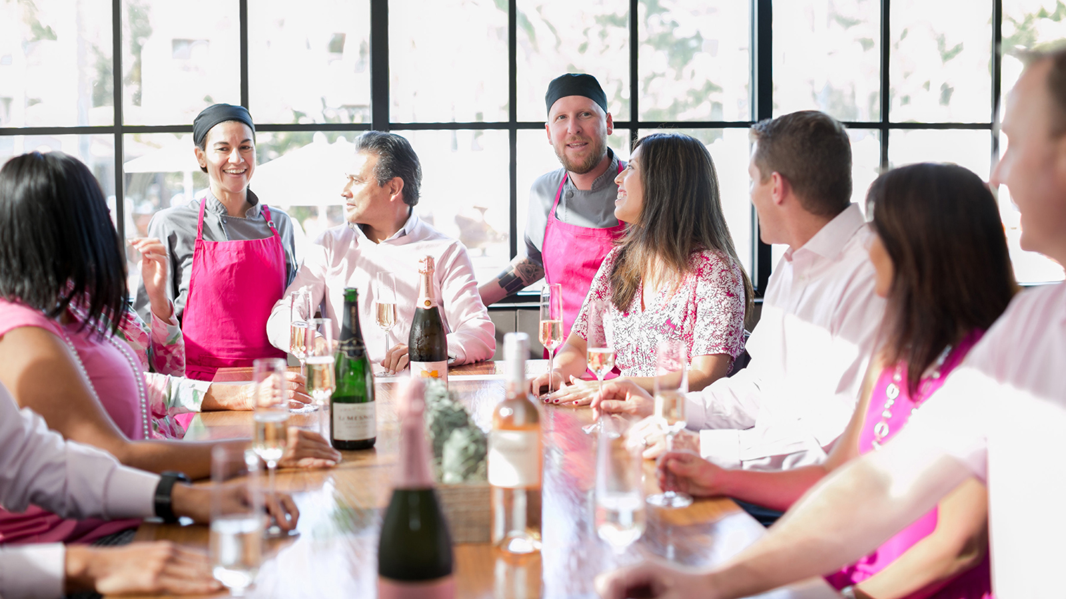 | September 18, 2017, San Diego, Aviara  Dress, Dine and Drink for Pink at Four Seasons Residence Club Aviara  https://publish.url/northsandiego/hotel-news/2017/breast-cancer-awareness-month.html
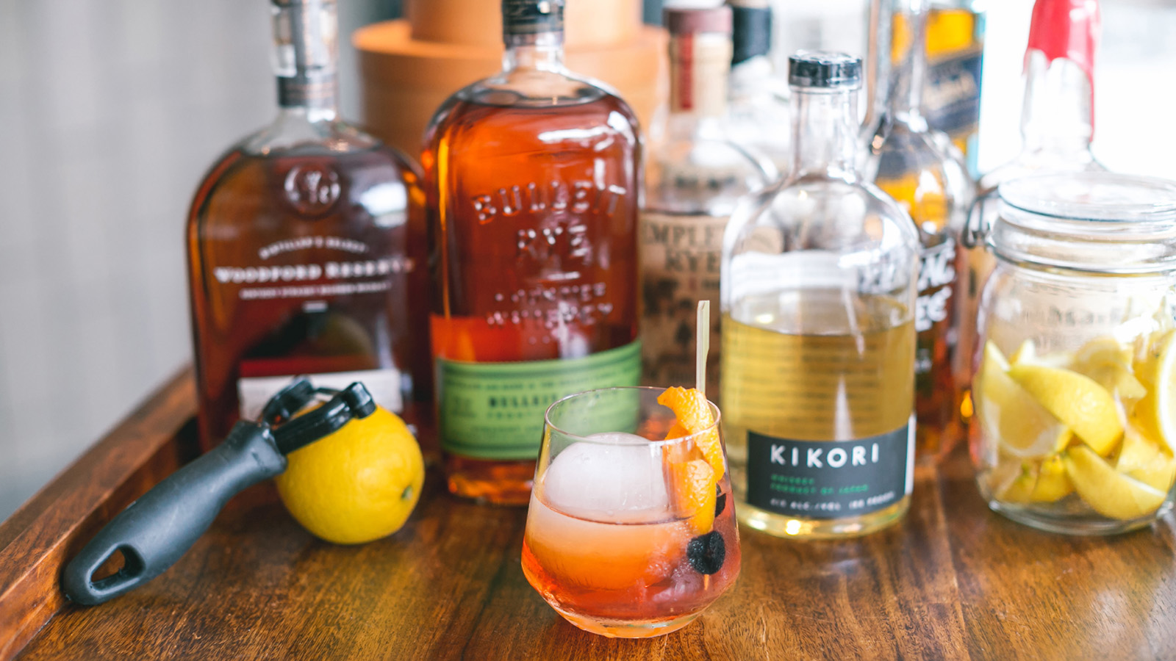 | June 8, 2017, San Diego, Aviara  Upgrade from the Traditional Father's Day with Handcrafted Drinks and Spa Treatments for Dad at Four Seasons Residence Club Aviara  https://publish.url/northsandiego/hotel-news/2017/fathers-day.html

PRESS CONTACTS

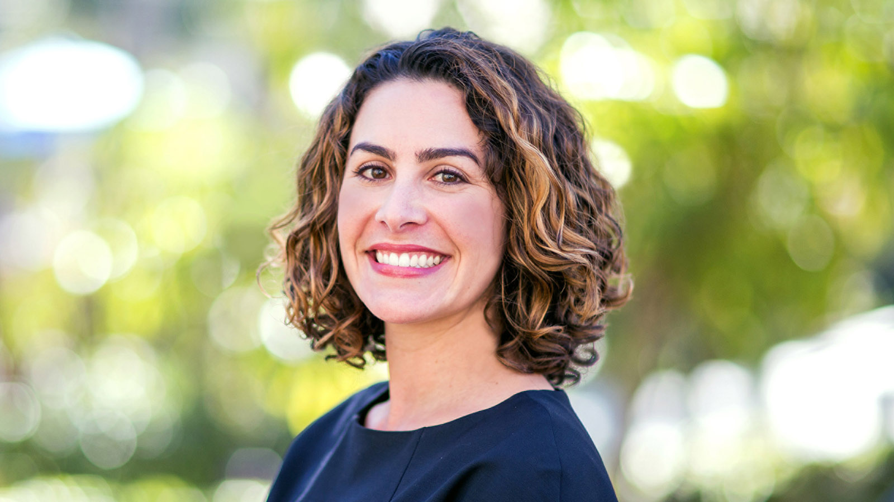 | Jessica M. Roach  Director of Villa Sales and Marketing  7210 Blue Heron Place  Carlsbad  U.S.A.  jessica.roach@fourseasons.com  1 (760) 603-3739

