Mimo Restaurant and Bar at Four Seasons Hotel Nashville Announces Nashville Restaurant Week Menu

The flagship restaurant of Four Seasons Hotel Nashville supports month-long food celebration Dine Nashville: The Music City Way program, featuring Nashville's chefs and diverse food scene, with three-course menu offering for Nashville Restaurant Week
February 1, 2023, Nashville, USA

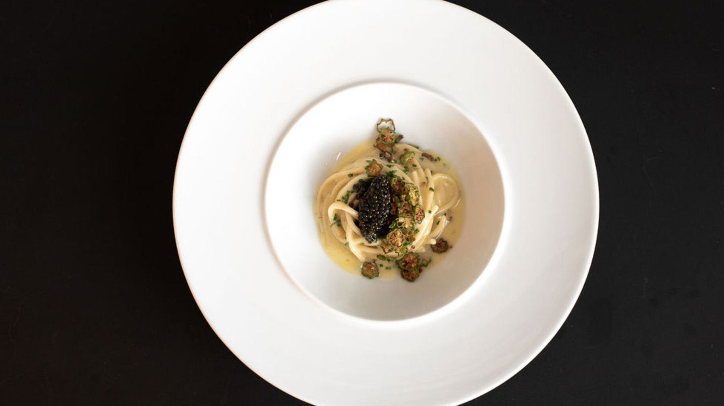
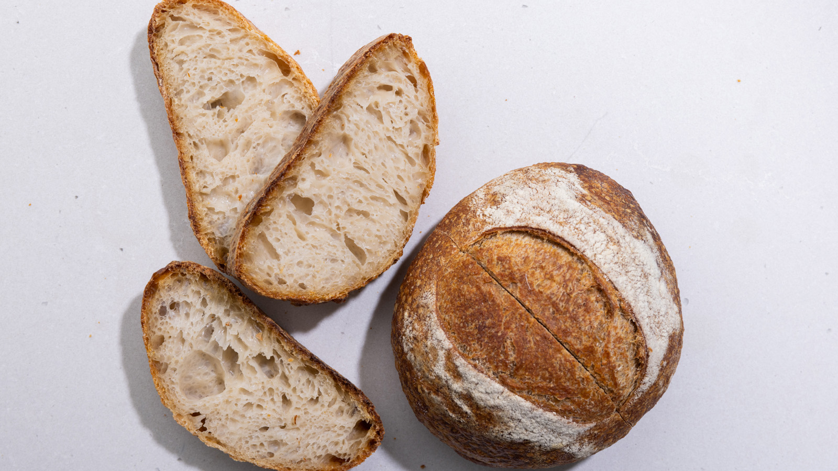 | 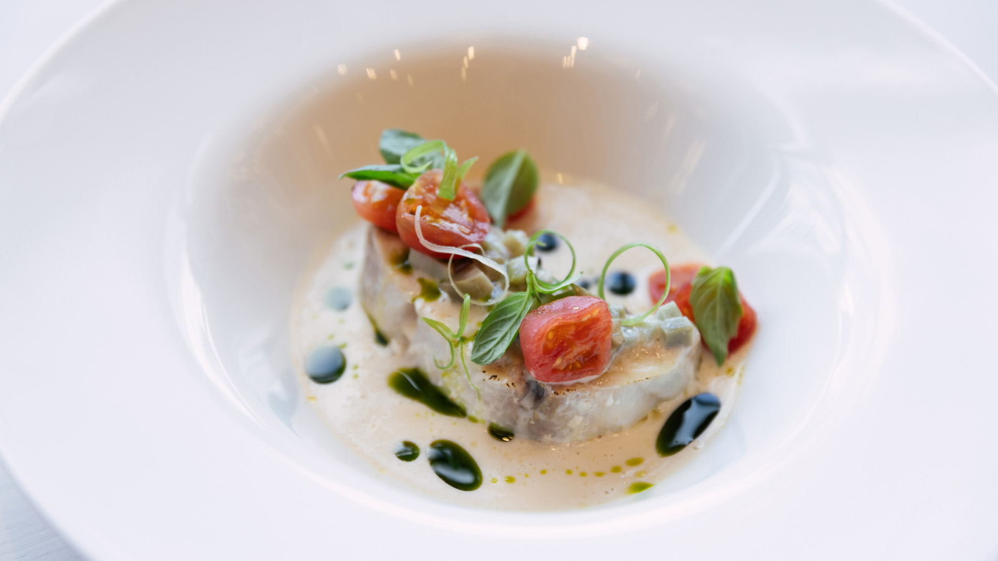 | 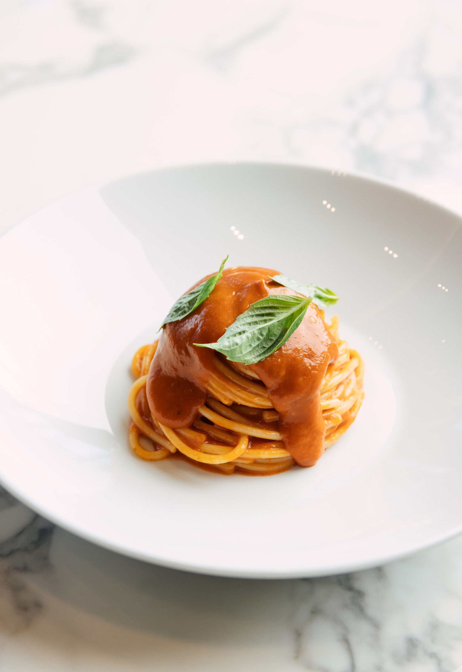
Mimo Restaurant and Bar, the flagship restaurant of Four Seasons Hotel and Private Residences Nashville led by Michelin-starred Chef Aniello “Nello” Turco, is celebrating its first Nashville Restaurant Week with a three-course prix fixe menu. The menu will be available for lunch and dinner at Mimo Restaurant and Bar during Dine Nashville’s annual restaurant week, February 20-26, 2023.
“I'm excited to be supporting the Dine Nashville program with our three-course menu for Restaurant Week,” says Chef Nello Turco. “I want everyone to feel welcome at Mimo, sample some of our dishes, and enjoy the lively atmosphere. I'm looking forward to celebrating Nashville’s incredible dining scene alongside so many of my favourite chefs and restaurants.”
Blending Southern Italian cuisine with Southern hospitality, Mimo Restaurant and Bar’s Restaurant Week menu will give diners the opportunity to choose from some of the restaurant’s most popular dishes for just USD 55 per person. The three-course meal begins with a choice of three of the restaurant’s most beloved starters: porcini mushroom soup, citrus poached prawns with Mimo cocktail sauce, or roasted broccoli with rapini pesto and almond bagna cauda.
Chef Nello’s Southern Italian heritage shines in the entrée selections, which include mushroom and truffle paste risotto, three tomato spaghetti, or radiatori pasta with southern ragu. For an additional USD 15, guests can enjoy Mimo’s famous caviar linguine, or for an additional USD 10, they can feast on the catch of the day with acqua pazza sauce and seasonal vegetables. The meal ends on a high note with the nearly impossible choice of a yuzu dessert with citrus chocolate whipped ganache and yuzu heart or Mimo’s brown sugar tart with aged balsamic vinegar and cherry gel. Every meal is served with Mimo’s homemade artisanal sourdough bread and whipped olive oil.
Pricing for the three-course Nashville Restaurant Week menu is USD 55 per person. Reservations can be made by calling +1 615 610 6990 or through the Mimo website.
Experience a stay at the all-new Four Seasons Hotel Nashville by calling +1 615 610 6995, or by booking a stay online.

RELATED

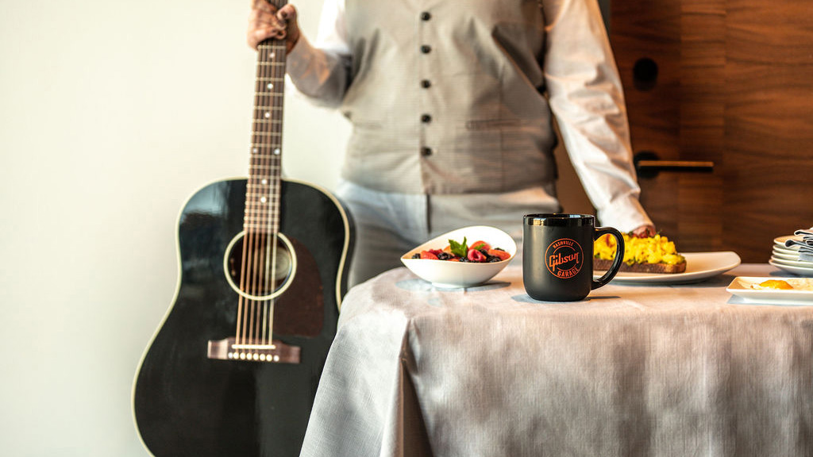 | January 25, 2023, Nashville, USA  Four Seasons Hotel Nashville Announces Exclusive Gibson Guitars Stay Package  https://publish.url/nashville/hotel-news/2023/gibson-guitars-stay-package.html
December 7, 2022, Nashville, USA
Mimo Restaurant and Bar Reveals Holiday Specials and Menus at Four Seasons Hotel Nashville
https://publish.url/nashville/hotel-news/2022/festive-season.html

PRESS CONTACTS

Robert Chinman
Director of Public Relations and Communications
100 Demonbreun Street
Nashville
USA
robert.chinman@fourseasons.com

+1 629 250 8912

