Four Seasons Resort Bali at Sayan Expands Wellness Program with Qigong, Crystal Reiki

The Balinese resort where the world is getting closer
May 25, 2021, Bali at Sayan, Indonesia

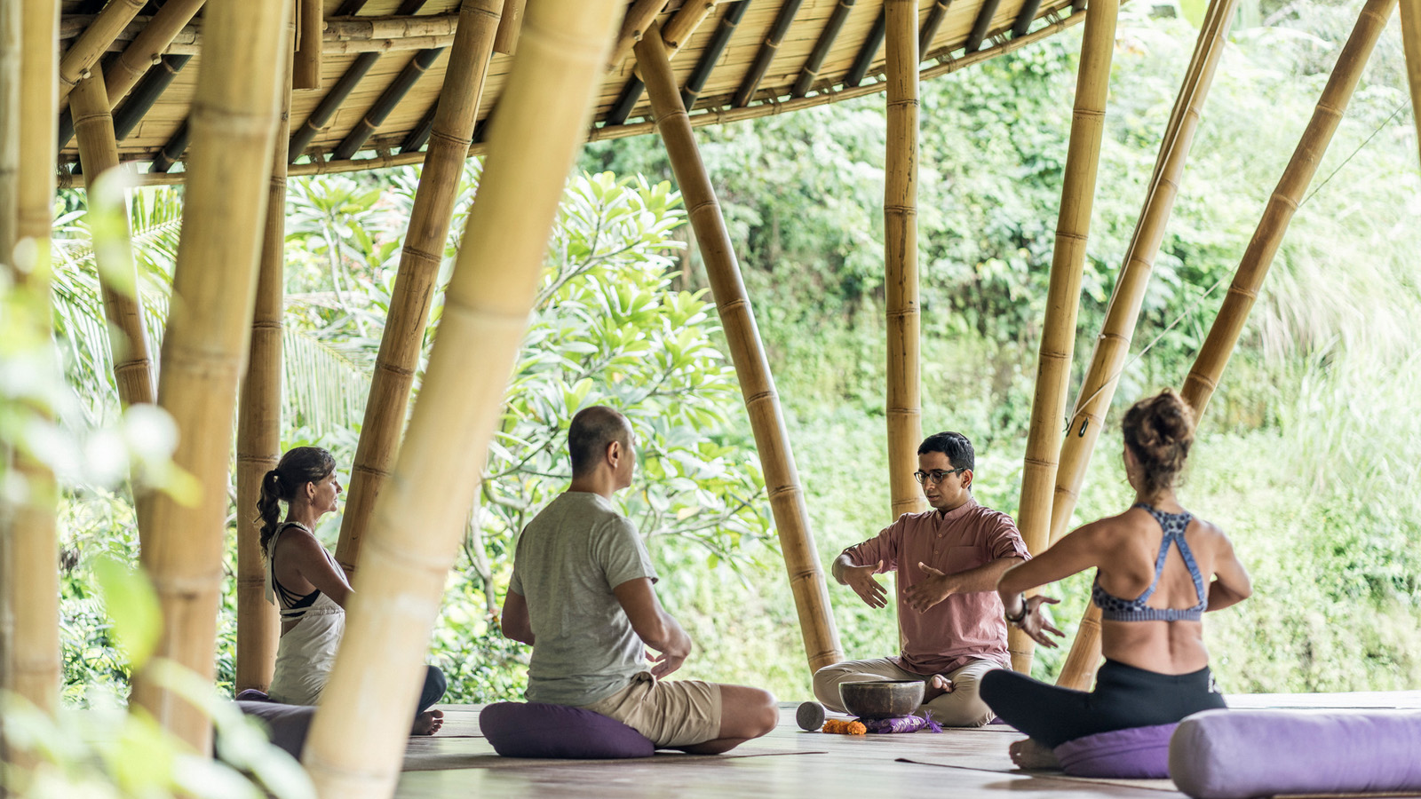
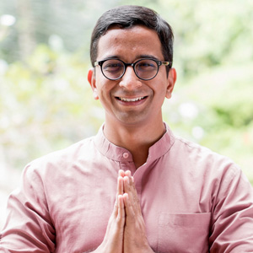 | 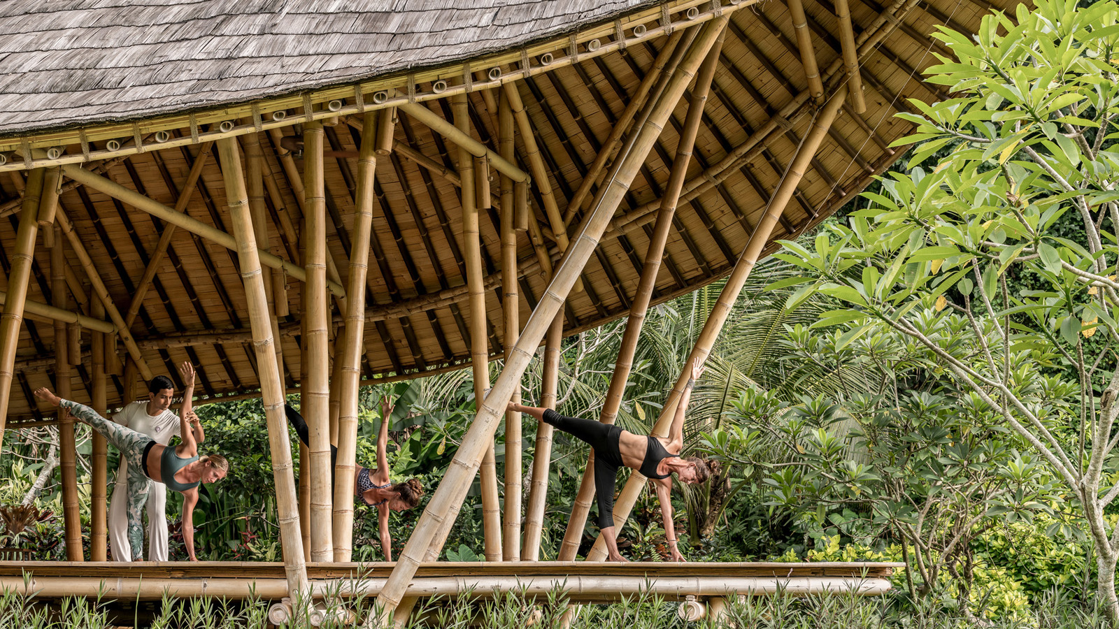 | 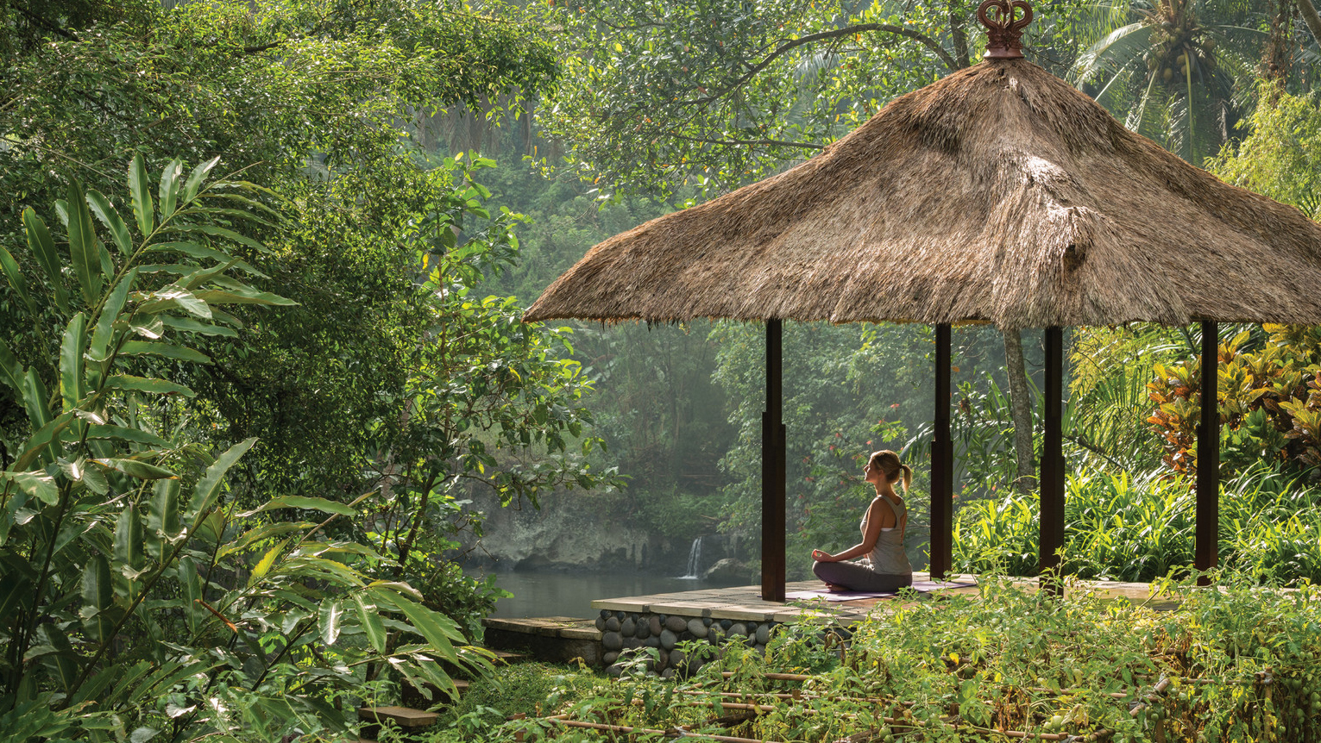
The world may seem a little smaller these days, but global expertise has expanded at Four Seasons Resort Bali at Sayan with new wellness programming by internationally qualified resident teachers.
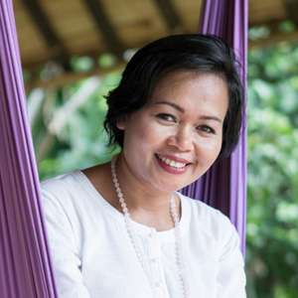 | 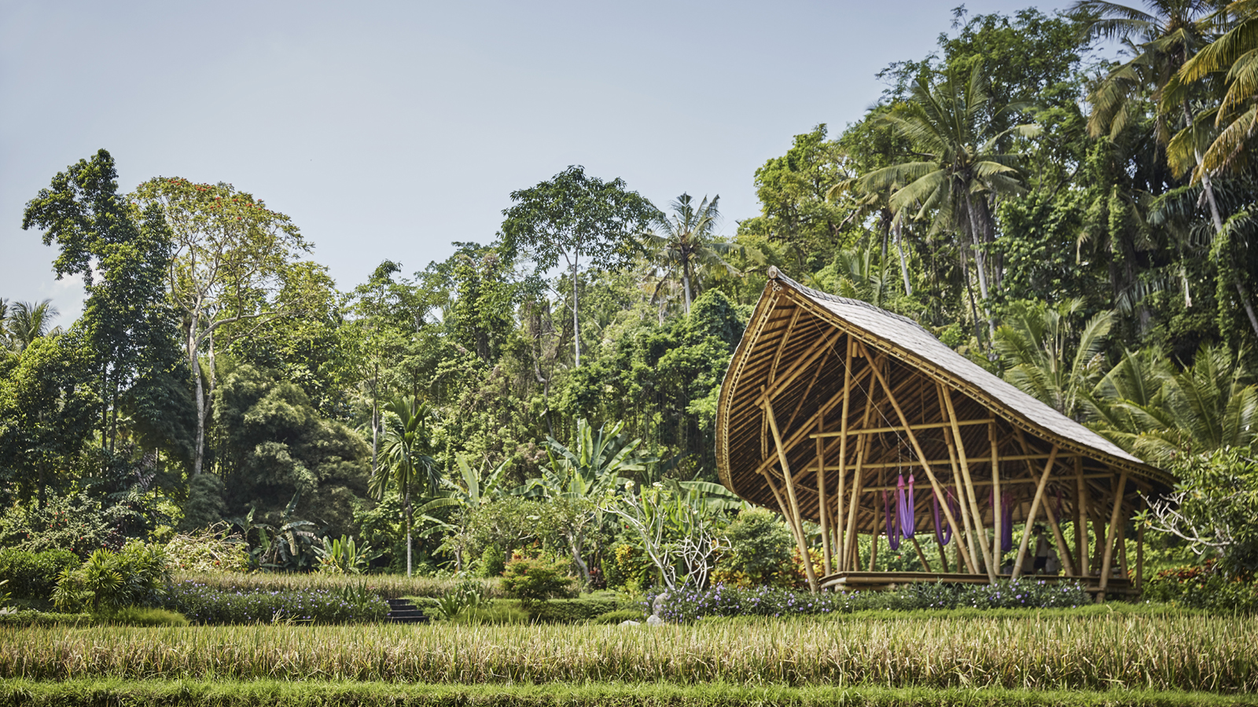
Aimed at boosting self-care, resilience and awareness, the ancient Chinese art of Qigong is now being offered by the Resort’s Spa & Wellness Manager Faraaz Tanveer. Awarded Asia’s Best Spa Manager in the 2020 Hall of Wellness Awards, Faraaz is a qualified qigong, meditation, yoga and reiki teacher, and leads one of the most dynamic teams on the island, reporting to Regional Spa Director Luisa Anderson.
Energy work is also at the centre of a new Crystal Reiki session by Resident Wellness Mentor and former Buddhist nun Heny Ferawati, who combines the Japanese art of reiki with crystal singing bowls, mantra chanting, gemstones and aromatherapy, to induce a deep sense of peace and security. Especially beneficial for those suffering from insomnia and fatigue, Crystal Reiki is another nurturing form of sleep therapy from the creator of the renowned Sacred Nap.
“These new experiences reflect the continual evolution of our wellness-centred program at Four Seasons Resort at Sayan,” says Faraaz. “Our team used the time granted to us by lockdown last year to review the gaps in our program and gain new qualifications to enhance the guest experience, so that we can support their personal wellness journeys even better than before.”
Since reopening last August, the Resort has also introduced a new vegetarian menu inspired by Ayurvedic Sattvic culinary principles, and Cancer Care Massage to improve the quality of life for those touched by cancer.
Faraaz specialises in curating multi-day retreats for guests, combining Indian-inspired chakra balancing treatments at The Sacred River Spa with Balinese massage and traditional healers, and a selection of 15 different yoga classes led by 8 full-time resident instructors with a combined 60+ years of teaching experience. From Hatha, Yin and AntiGravity to Restorative Hot Stone, Full Moon and Laughter Yoga, guests can do a different yoga class every day as part of a personalised retreat itinerary. The spa team is also active in the local community, leading complimentary yoga sessions at orphanages and remote villages, and providing free Cancer Care Massage to women touched by cancer.
“Our aim is to help our guests and the broader community to have a full cup emotionally and energetically, so they can really meet life with open arms and be ready for whatever each day brings,” says Faraaz. “It’s not only the experiences we offer at the Resort, but about sharing practices for people to incorporate into their daily lives at home, so they can continue to enjoy the benefits of qigong, yoga, meditation and other forms of self-care.”
To share Sayan’s wellness experiences with guests around the world, Faraaz and Fera will host complimentary virtual sessions, open to the public via @fsbali Live Instagram:
- Saturday, June 12, 2021, 4:00 pm GMT+8: In celebration of Global Wellness Day, Ibu Fera invites participants to join her on the treetop lotus pond at Four Seasons Resort at Sayan, for a 45 minute meditation focused on increasing awareness and mindfulness to boost resilience.
- Wednesday, June 30, 2021, 4:00 pm GMT+8: Amid the rice fields of Dharma Shanti Bale, join Faraaz for Qigong, the first of 9 monthly “Live Well” experiences curated by Four Seasons Resorts of Asia. The series will continue the last Wednesday of each month through to December, featuring on-site experts from Bali, Maldives, Langkawi, Thailand and Vietnam Resorts.
For details on these complimentary virtual sessions, message @fsbali on Instagram or email spa.ubu@fourseasons.com.

RELATED

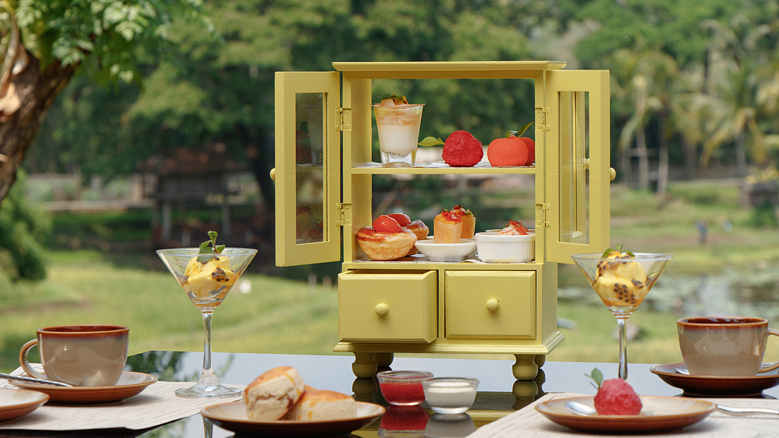 | May 20, 2021, Chiang Mai, Thailand  “ทรอปิคอล ซันเซ็ท” อาฟเตอร์นูนทีคอนเซ็ปท์ใหม่ ที่โฟร์ซีซั่นส์ รีสอร์ท เชียงใหม่  https://publish.url/th/chiangmai/hotel-news/2021/new-tropical-sunset-afternoon-tea-menu-2.html
May 20, 2021, Chiang Mai, Thailand
The Perfect “Tropical Sunset” Afternoon Tea at Four Seasons Resort Chiang Mai
https://publish.url/chiangmai/hotel-news/2021/new-tropical-sunset-afternoon-tea-menu.html

PRESS CONTACTS

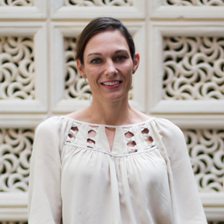 | Marian Carroll  Regional Director of Public Relations and Communication  Jimbaran  Indonesia  marian.carroll@fourseasons.com  +62 (361) 701010

