Chef Naruchit Taintrong Brings Khao Restaurant to Far & East at Four Seasons Hotel Bengaluru

May 18, 2023, Bengaluru, India

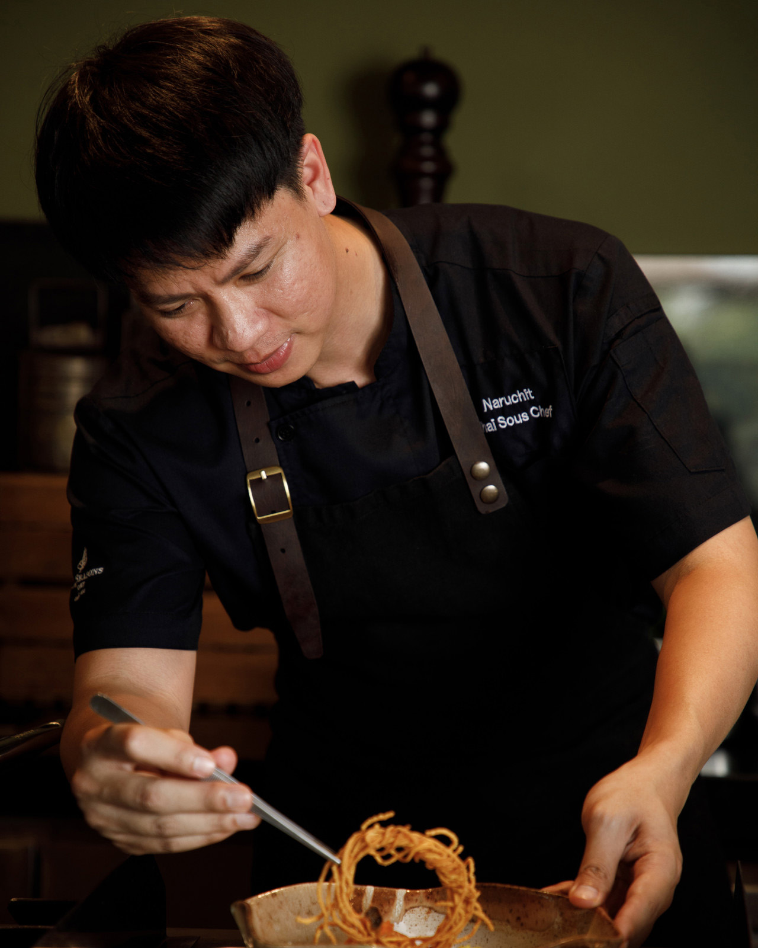
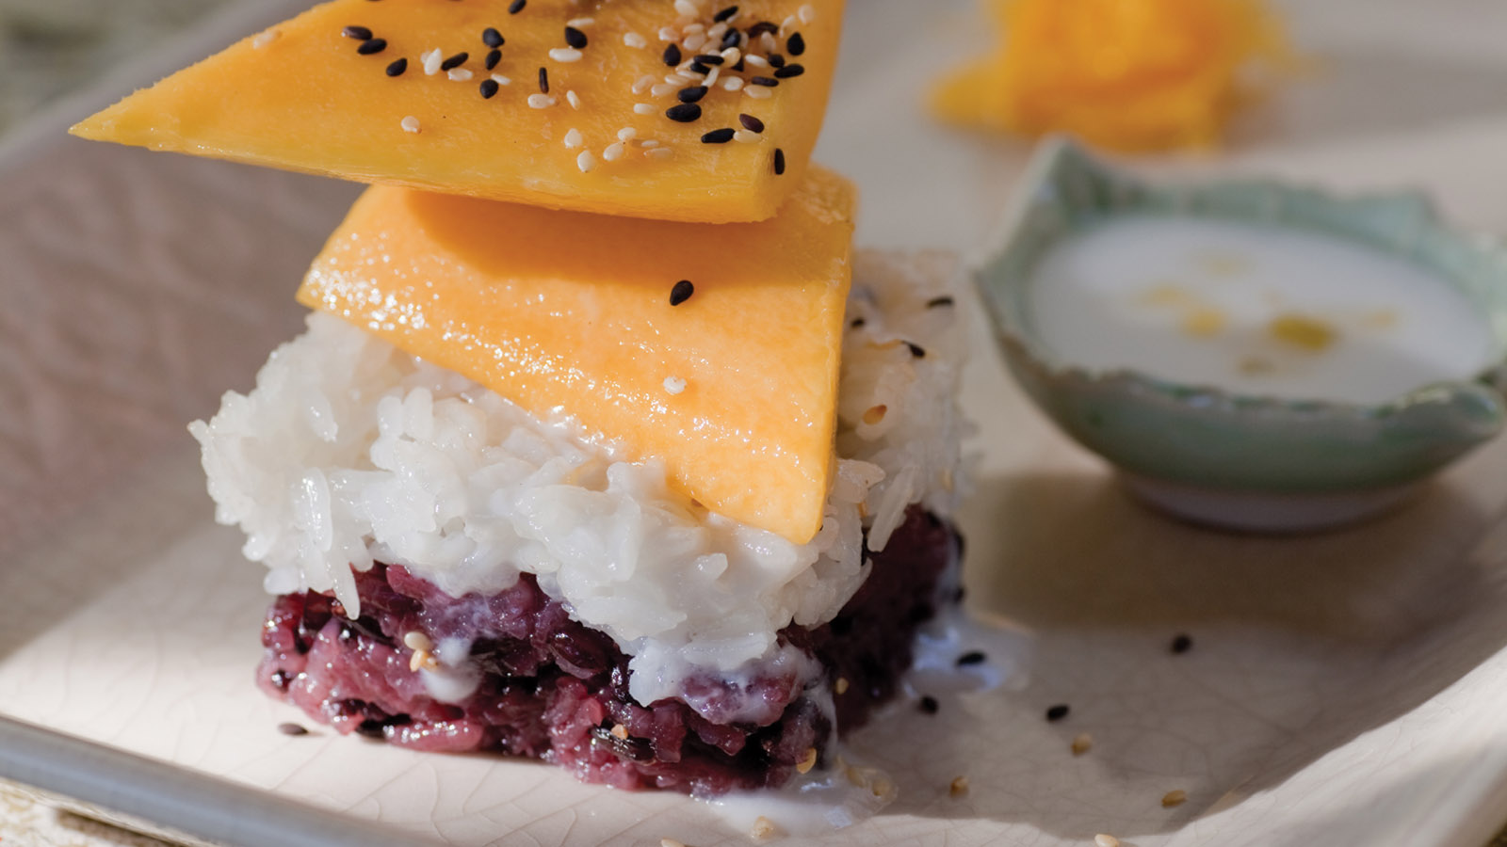 | 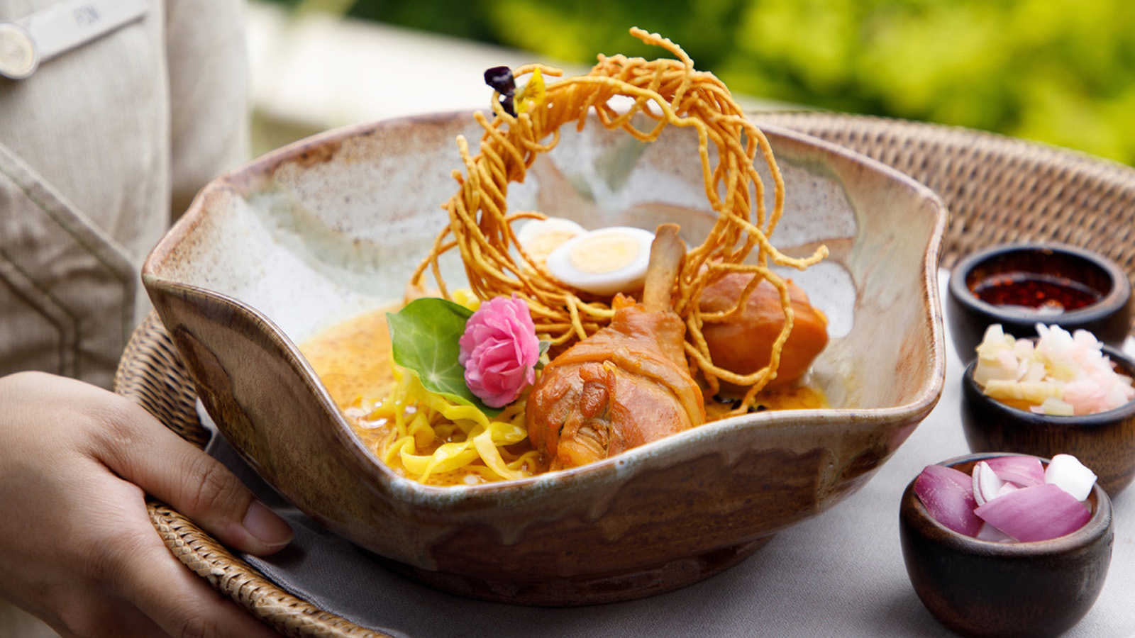
The award winning Asian brasserie Far & East at Four Seasons Hotel Bengaluru is known for its elevated Japanese, Thai, and Chinese flavours served with an inventive twist by the experts Chef Atsushi Yonaha and Chef Wong Chin Sheong. The restaurant reaffirms its position as a gastronomical paradise with an exciting Thai delicacy led by Chef Naruchit Taintrong - aka Chef Golf - from the renowned restaurant Khao at Four Seasons Resort Chiang Mai, known for its innovative approach to Thai cuisine. This special Thai showcase will take place from June 22 to 26, 2023 with a menu for lunch and dinner drawing inspiration from the culinary diversity of Thailand. Expect classic recipes in a modern and evocative style, and an immersive experience that takes diners on a journey across Thailand’s delectable culinary landscape.
Having started out as an apprentice more than a decade ago, Chef Golf has earned his stripes through dedication and a keen eye for detail. Young at heart but a traditionalist in the kitchen, Chef Golf brings with him significant experience in both classic and modern Thai cuisines, as well as a keen eye for presentation. Proficient in Mediterranean, Oriental, and French cuisines, he has a robust banqueting pedigree that is very beneficial to defining the dining experience at Four Seasons.
Chef Golf’s culinary repertoire of dishes highlights the finest locally sourced ingredients, with a focus on regionality and sustainability. Look out for signature dishes from Khao, such as Yum Gai Yang (Grilled Chicken Spicy Salad), Phad Kee Mow Moo (Stir fried Pork with Finger Root and Hot Basil), Pal Kapong Tod Nam Pal (Deep Fried Seabass with Fish Sauce and Mango Salad) and for desserts indulge in Thai classics such as Khao Niew Ma Muang (Mango with Sticky Rice) or enjoy vegan and vegetarian favourites. Whatever be the choice, Chef Golf's unique flair for timeless Thai techniques will be an indulgence of exquisite flavours and aromas.
A-la-carte pricing allows guests to navigate selection conveniently, and the only thing left to say is "Gin Khao" – and let the feast begin!
- When: June 22-26, 2023
- Lunch: 12:30 to 3:00 pm
- Dinner: 6:00 to 11:30 pm
- Where: Far & East, Four Seasons Hotel Bengaluru
- Reservations: +91 96064 87956

RELATED

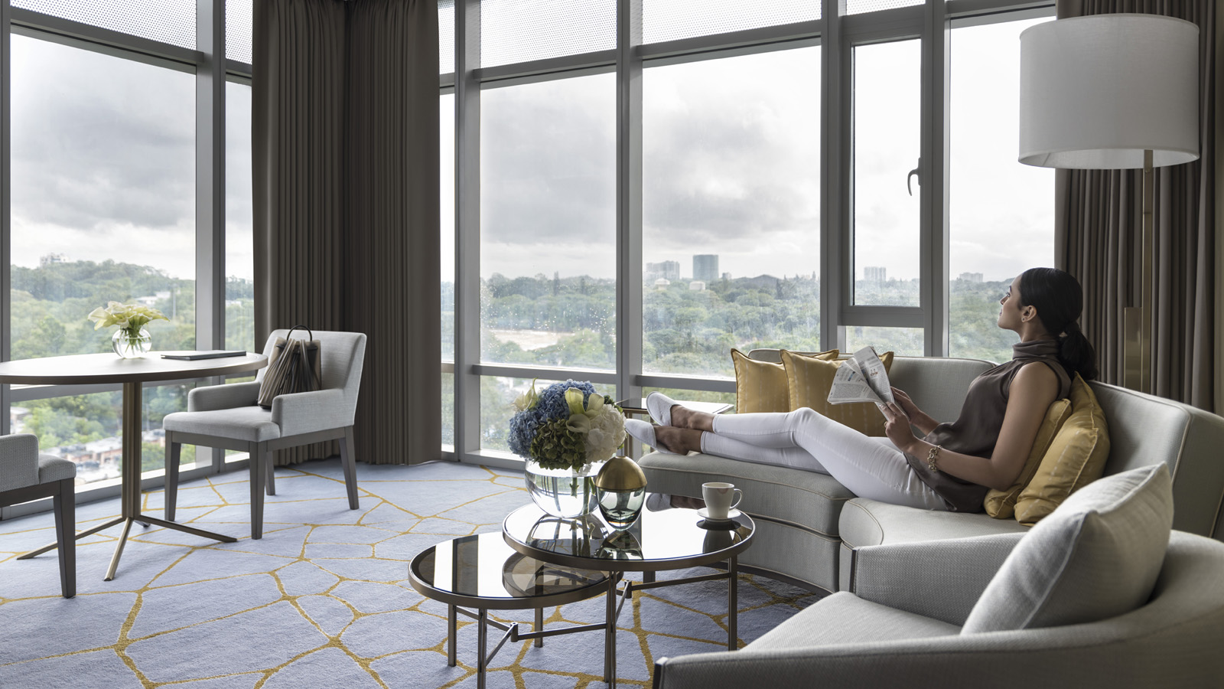 | May 3, 2023, Bengaluru, India  #FSMOMents of Love: A Gloriously Indulgent Mother’s Day Celebration at Four Seasons Hotel Bengaluru  https://publish.url/bengaluru/hotel-news/2023/mothers-day.html
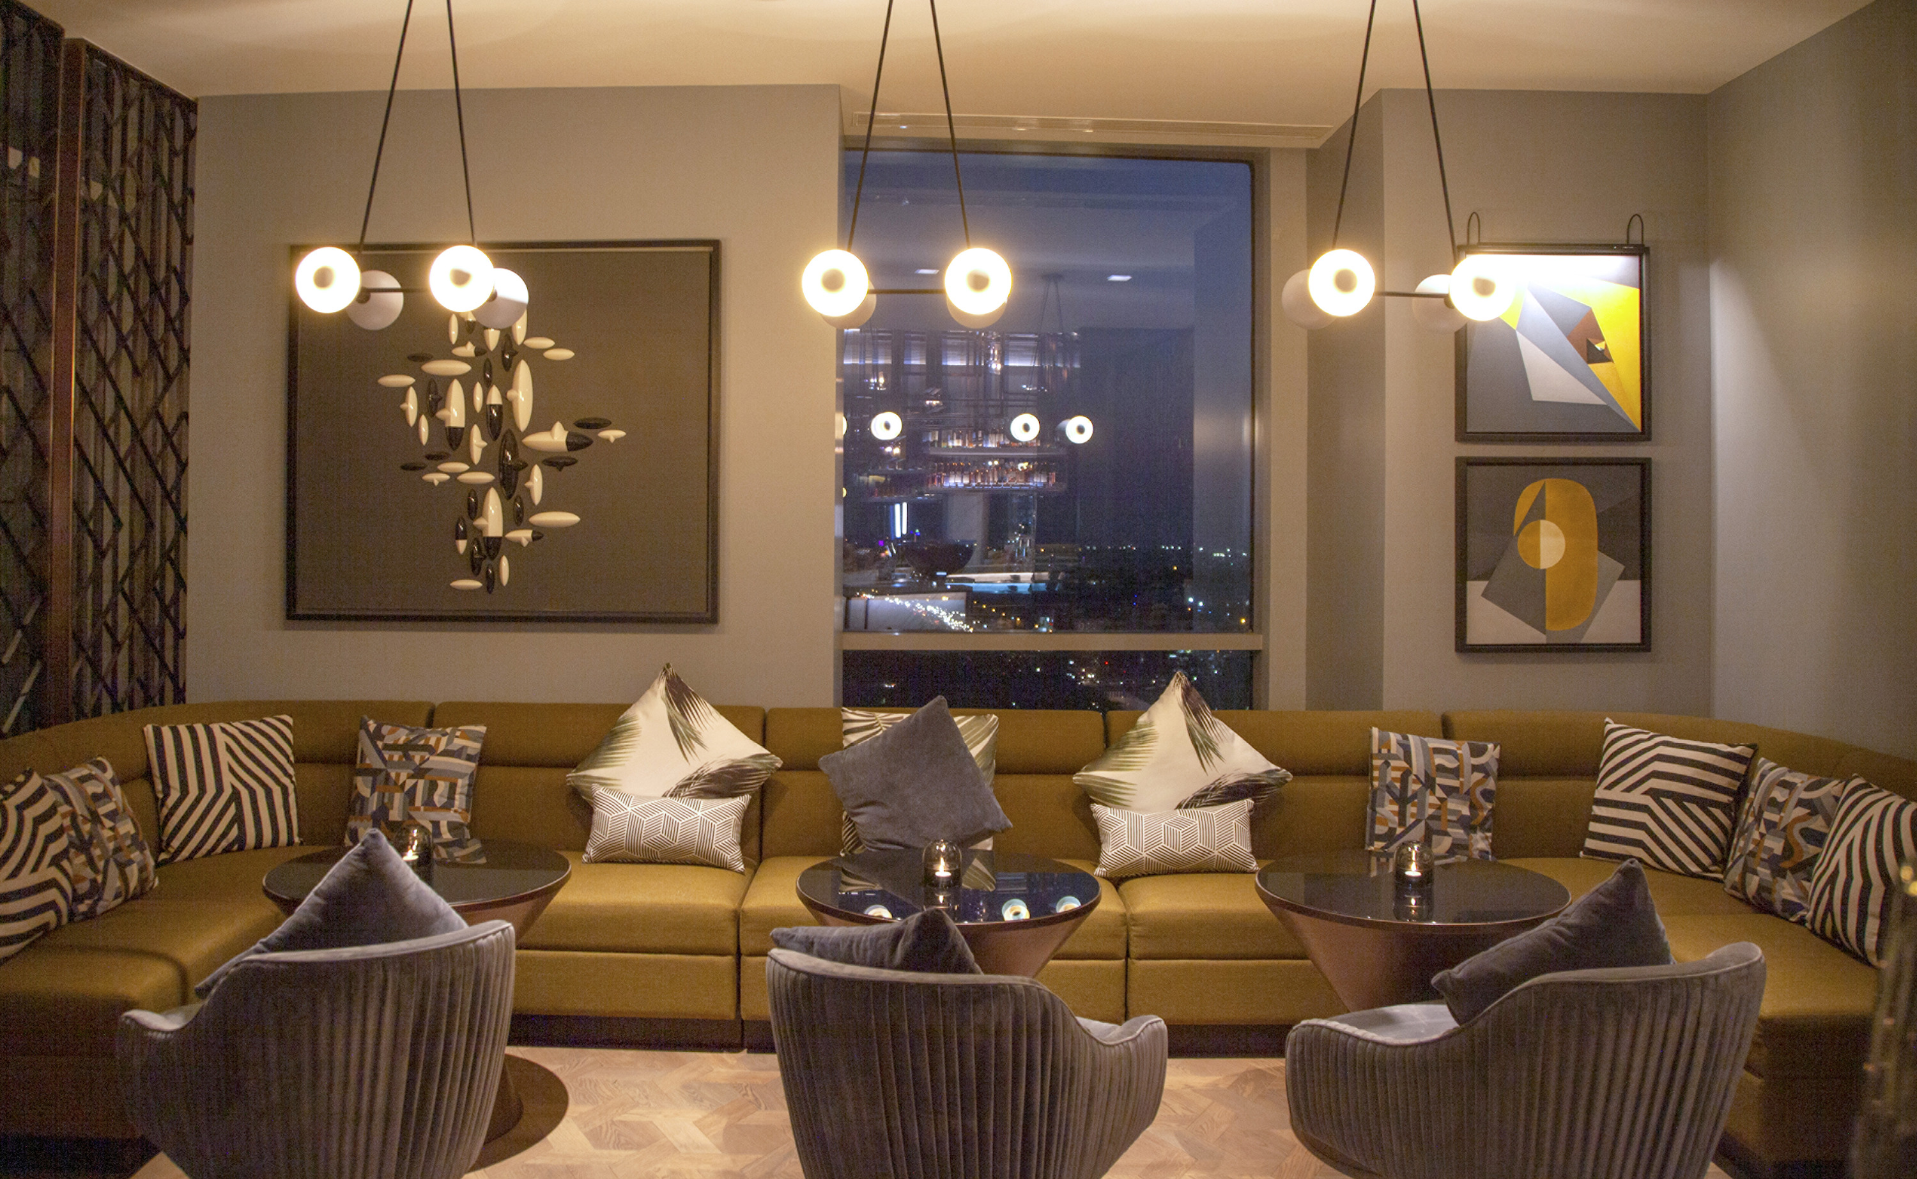 | April 20, 2023, Bengaluru, India  Singapore's Burnt Ends Takes Over Copitas at Four Seasons Hotel Bengaluru  https://publish.url/bengaluru/hotel-news/2023/burnt-ends-at-copitas-takeover.html

PRESS CONTACTS

Meghna Trivedy
Director of Public Relations and Communications
8, Bellary Road, Ganganagar
Bengaluru
India
meghna.trivedy@fourseasons.com

+91 96064 87956

