Lose Yourself in a Collectors’ Paradise

February 20, 2020, Tokyo, Japan

Eclectic and edgy, urban and traditional, it could take a lifetime to get to know Tokyo, which is why our expert Concierges at Four Seasons Hotel Tokyo at Marunouchi are on hand with insider knowledge that will have you weaving through the backstreets like a local in no time. Step off the beaten track into a collectors’ paradise with our recommended half-day immersion into the city’s quirky world of memorabilia, and mementoes, books and sundries, from the vintage to the avant-garde, the low-key to the outlandish. All you need is a spare morning or afternoon and a honed sense of curiosity.
Nothing beats the thrill of finding a space dedicated to your niche, tucked down a backstreet in a thriving metropolis. Tokyo’s districts are a haven for collectors: Jimbocho for second hand bookstores; Ogawamachi for outdoor and sports equipment, and Ochanomizu for music lovers.
Jimbocho
Jimbocho is bibliophile bliss: 180 second hand and new bookstores, from cat-lovers’ paradise Nyankodo, to fashion-friendly Magnif. Marvel at more than 12,000 volumes within the stunning architectural surrounds of Kitazawa Bookstore. Discover two peaceful wood-panelled floors of rare and antique finds in The Isseido Booksellers. Then quench your thirst in one of the area’s cosy cafes, such as those tucked within Tokyodo and Jimbocho Book Center.
Jimbocho doesn’t just meet your literary needs. Pick up interior gifts at Sanseido Books’ five-storey flagship store; catch art and photography exhibitions at Komiyama; and browse for antique maps and traditional woodblock prints.
Ogawamachi
Sports enthusiasts should head to Ogawamachi district, east of Jinbocho Station. Murasaki Sports is a surfer’s paradise including second hand boards at competitive prices, while London Sports opens from a small exterior into a tardis of bargains with great end-of-season sales.
Ski Shop Vail is the place to go for the latest collections of slope-wear and kit. A golf paradise awaits at Victoria Golf (seven floors, including a practice corner!). Or if cycling’s your thing, don’t miss L-Breath Bike for a tantalising range of bikes and accessories.
Ochanomizu
Tourists and professional musicians alike find their nirvana in Ochanomizu: a lively hub of more than 50 musical instrument stores, jazz bars and music clubs tucked down a series of side streets. Budding rockstars should look no further than Ochanomizu’s Meidai Dori – better known as “Guitar Street.” Salivate at the vintage Gibsons, electric beauties, basses and banjos in Woodman or wile away an afternoon trying out the stock and chatting with the knowledgeable staff. For classical musicians, Shimojura Violin wows with glass cases of handcrafted wonders and is a great place to spot little virtuosos getting kitted out with their first instrument.

RELATED

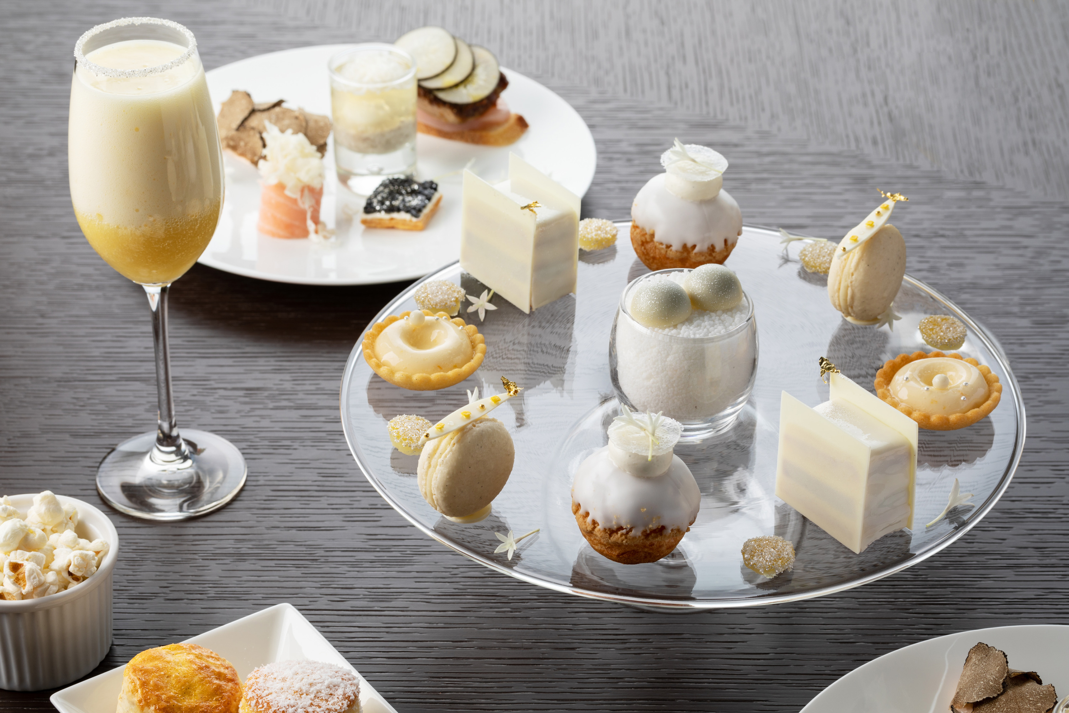 | September 12, 2019, Tokyo, Japan  GABRIELLE CHANEL Afternoon Tea at Four Seasons  https://publish.url/jp/tokyo/hotel-news/2019/gabrielle-chanel-afternoon-tea-2.html
September 12, 2019, Tokyo, Japan
CHANEL’s Fragrance-Inspired Afternoon Tea at Four Seasons Japan
https://publish.url/tokyo/hotel-news/2019/gabrielle-chanel-afternoon-tea.html

PRESS CONTACTS

Junko Kajihara
PR Manager
Pacific Century Place Marunouchi, 1-11-1 Marunouchi
Tokyo
Japan
junko.kajihara@fourseasons.com

81 3 5222 5305

