Four Seasons Hotel Washington, DC Transforms into a Hotel on Ice this Winter, with Can’t-Miss Cool Experiences Throughout

This sensational seasonal event tops travel bucket lists, with dining in heated ice domes at BOURBON STEAK, icy spa treatments, ice wine at ENO Wine Bar, and so much more
November 9, 2018, Washington, DC, U.S.A.

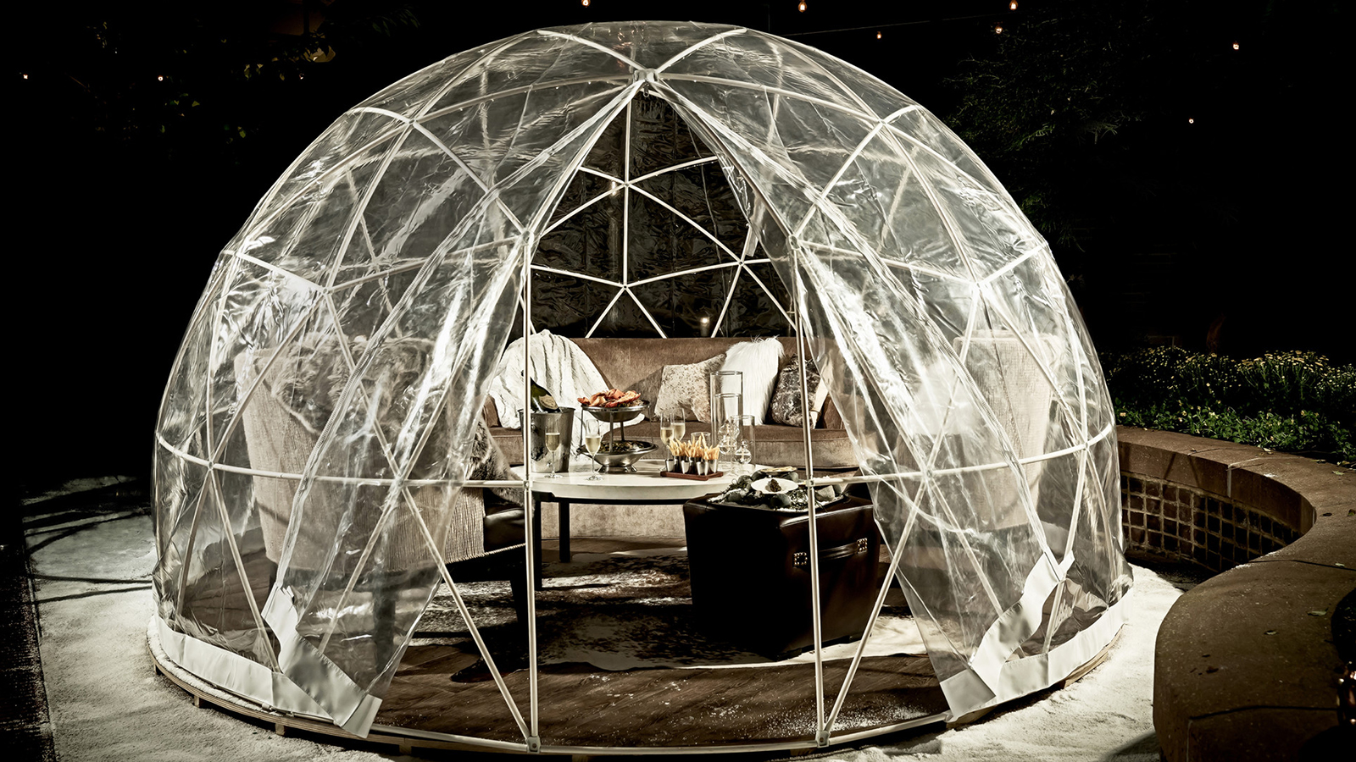
Four Seasons Hotel Washington, DC tops everyone’s winter “must” list as it transforms into a Hotel on Ice all season long. Can’t-miss cool experiences span every area of the Hotel, from the glistening exterior and Iced Spa to dining in a heated ice dome on the BOURBON STEAK patio and sipping iced wines at ENO Wine Bar. And that’s not all: kids are invited to sleep “under the stars” in their guest rooms in glow-in-the-dark domes. Coupled with extraordinary events taking place just steps away in the nation’s capital, Four Seasons Hotel Washington, DC is a can’t-miss cold-weather getaway.
The wintry magic begins just outside the Hotel, where, from December 1, 2018 through January 6, 2019, glowing modern art instillations (part of Georgetown GLOW) will act as shining beacons welcoming visitors to the city’s charming Georgetown neighbourhood.
This cool transformation continues inside with Light Up the Season, a lobby holiday event showcasing festive decorations fashioned by the city's top local designers, all for a worthy cause (proceeds benefit the Children's National Health System). Post-holiday, domed florals will be an equally enchanting must-see display.
At BOURBON STEAK, the restaurant's patio becomes BOURBON on Ice all season long. This dining sensation features three heated ice domes, each with their own enticing theme: Cozy & Chic, Caviar & Champagne, and Cigar & Cognac. Diners are invited to sip signature iced and hot cocktails while enjoying a full BOURBON STEAK menu - with specials such as a show-stopping domed baked alaska dessert - all the while playing snowy lawn games such as light-up bean bag and ring toss. A veritable adult playground, and a memory-in-the-making beyond doubt.
ENO Wine Bar is Iced ENO all season long, with weekly ice wine tastings for guests staying in house, plus an irresistible Alpine menu. And at the Forbes 4-Star “Iced Spa,” a Fire and Ice Facial combats winter skin maladies, delivering visible results including smoother, hydrated skin and reduced inflammation. Afterwards, take advantage of the steam room, sauna and whirlpool, or cosy up with a mug of piping hot spiced cider.
For guests travelling with children, the magic continues in-room with icy amenities and glow-in-the-dark sleeping domes, creating a fun and wondrous experience, not to mention a perfect photo op too (use #HotelonIce). There’s truly something for everyone at this urban wonderland this winter, with romantic activities for two, group attractions galore, and boundless family offerings. It’s a winter destination beyond compare, for all ages and stages.
Visit pre-Christmas to take-in holiday sites such as National Christmas Tree, or arrive post winter holidays for a skate on Washington Harbor, just a short walk away. And that’s just the start of the many extraordinary adventures to be had citywide, and within the walls of Four Seasons Hotel Washington, DC. Plan that winter getaway to Four Seasons Hotel Washington, DC now, with rates starting at just USD 495. Call +1 202 342 0444.
Follow @FSWashington and #hotelonice on Instagram.

RELATED

November 9, 2018, Washington, DC, U.S.A.
BOURBON STEAK Patio at Four Seasons Hotel Washington, DC Unveils “BOURBON on Ice,” DC’s Coolest Wintertime Culinary Event
https://publish.url/washington/hotel-news/2018/bourbon-on-ice.html

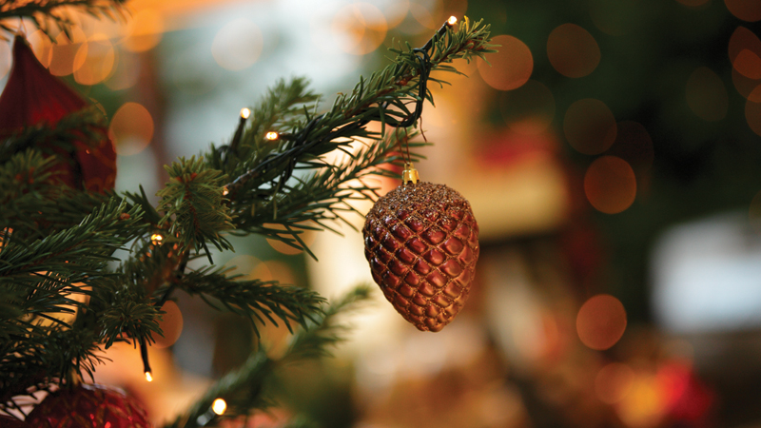 | October 15, 2018, Toronto, Canada  Four Seasons Hotels Offer Special City Getaways This Holiday Season  https://publish.url/news-releases/2018/stay-longer-with-four-seasons-this-winter.html

PRESS CONTACTS

Anina Belle Giannini
Director of Public Relations
2800 Pennsylvania Avenue N.W.
Washington
U.S.A.
aninabelle.giannini@fourseasons.com

+1 202 944 2074

Nicole Otero
Public Relations Coordinator
2800 Pennsylvania Avenue N.W.
Washington
U.S.A.
nicole.otero@fourseasons.com

+1 (202) 944-2059

