Stun a Special Someone with Love-Inspired Experiences at Four Seasons Resort Sharm El Sheikh

February 11, 2019, Sharm El Sheikh, Egypt

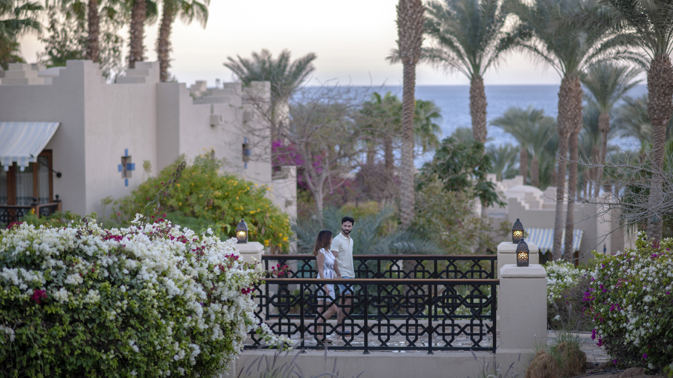
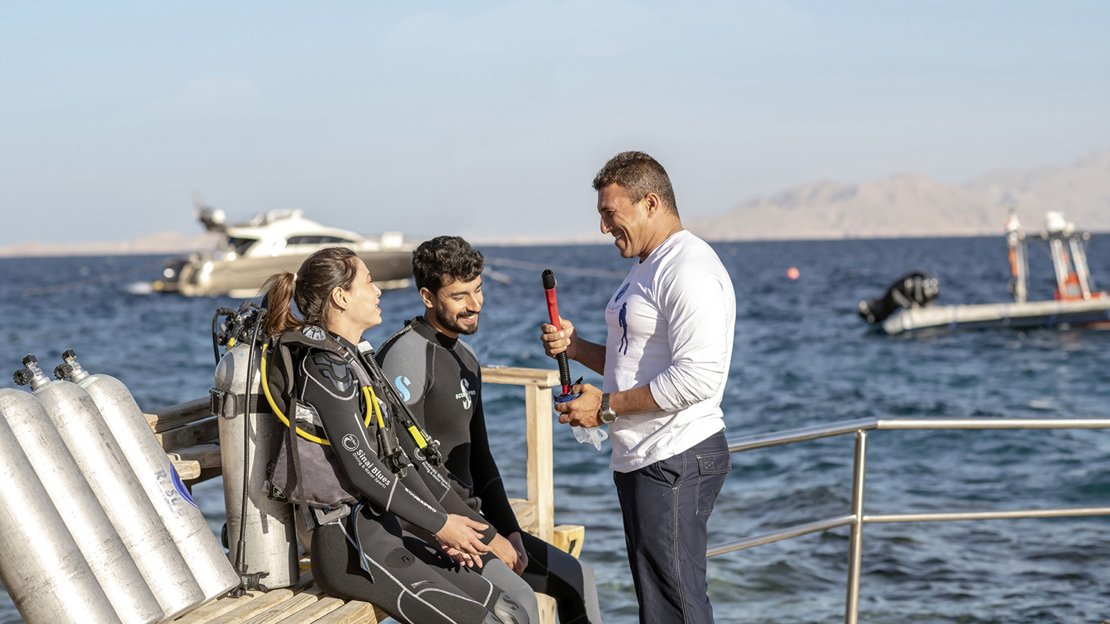 | 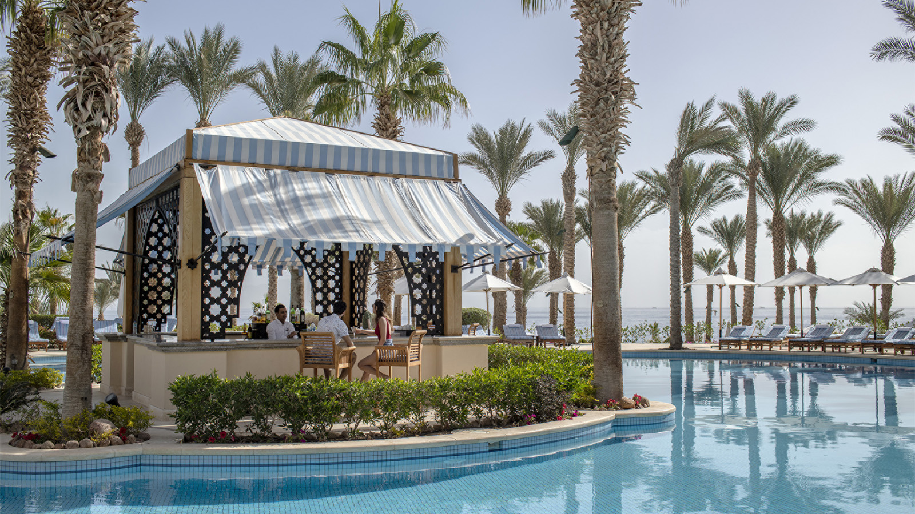
Did your love story begin at Four Seasons Resort Sharm El Sheikh? Whether love memories started here like so many couples who come back to celebrate milestone anniversaries or the journey is just beginning, then look no further than our Resort to celebrate romance with privacy, natural beauty, gorgeous scenery and an array of love-inspired experiences.
Celebrate love all year long with any of these passionately-crafted experiences:
- Picture-perfect scenery: In a rare desert-and-sea hideaway, start your day with endless views and endless blues; between the sea and the sky lie our hillside oasis of cool greenery. Soothe your soul with boundless picture-perfect scenery from our Egyptian resort, where every room and suite brings you a breezy terrace, most with views of the Red Sea.
- Gems just off-shore: Meet George, our Napoleon fish that is resident in our Resort’s house reef. Explore the only on-site diving experience in the destination with our two jetties and team of experts and biologists, allowing divers and snorkellers easy access to the world’s warmest sea, bursting with reef systems and coral gardens. Don’t forget to say hi to George!
- Red Sea wreck adventures: Dive amid WWII shipwrecks. One dive beneath the surface of the Red Sea and you’ll discover why it’s one of the world’s most breathtaking diving destinations. Clear waters, reefs, an abundance of marine life and several notable shipwrecks have enthralled researchers and historians, including Jacques Cousteau, for decades. Rise early and board one of the Dive Centre’s high-speed powerboats, some of the fastest in the Red Sea, your destination is the historical resting place of a British munitions ship the SS Thistlegorm. Our dive instructors will serve as your personal historian, sharing the stories and secrets of one of the world’s most intriguing dive sites.

RELATED

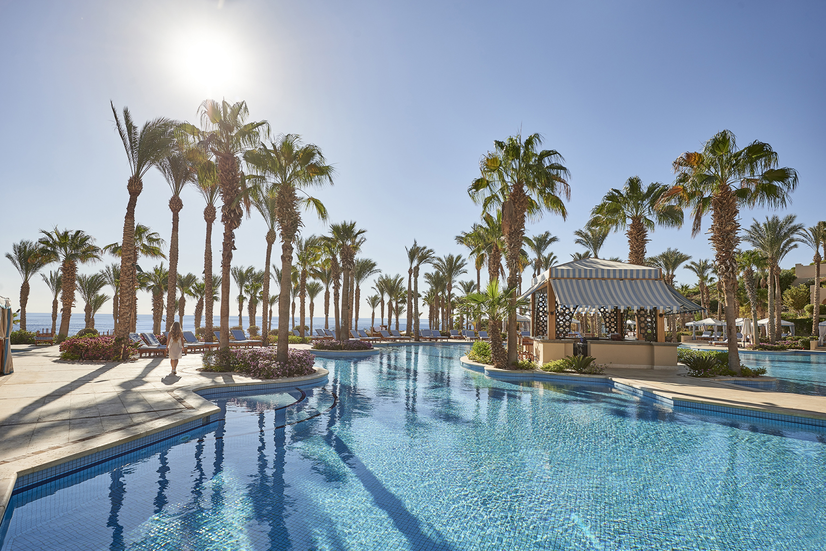 | December 16, 2018, Sharm El Sheikh, Egypt  A Season of Festive Fun at Four Seasons Resort Sharm El Sheikh  https://publish.url/sharmelsheikh/hotel-news/2018/festive-season.html
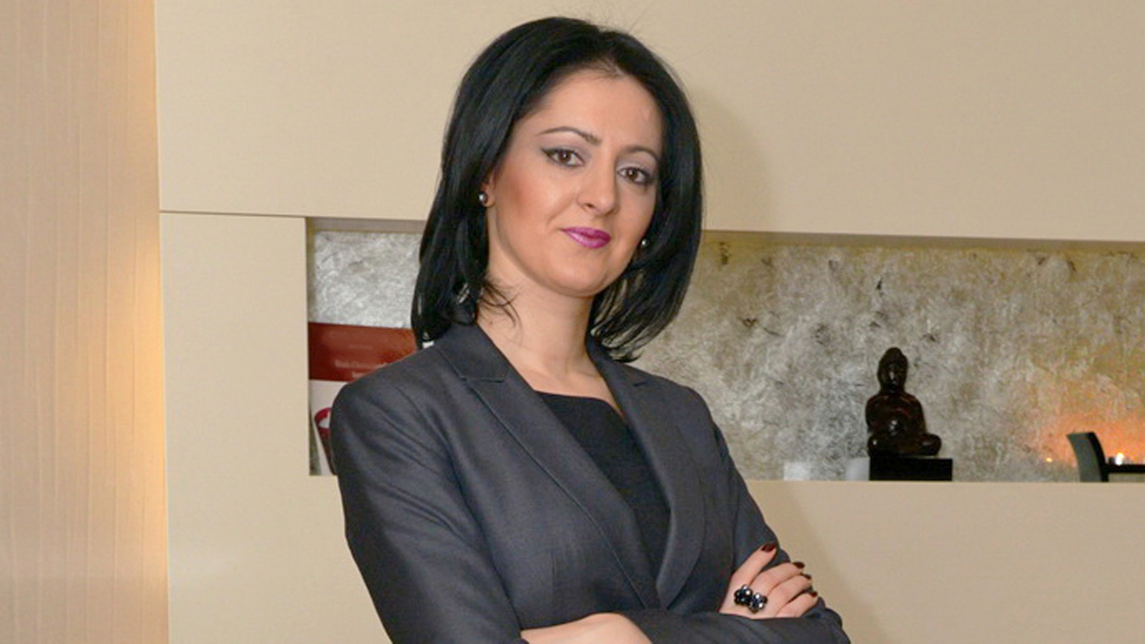 | December 16, 2018, Sharm El Sheikh, Egypt  Four Seasons Resort Sharm El Sheikh Introduces New Director of Spa  https://publish.url/sharmelsheikh/hotel-news/2018/new-spa-director-larisa-marinica.html

PRESS CONTACTS

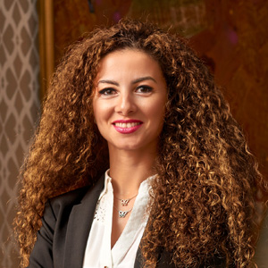 | Sherry Adel  Senior Director of Public Relations and Marketing Communications - Egypt  1089 Corniche El Nil, P.O. Box 63 Maglis El Shaab  Garden City 11519, Cairo  Egypt  sherry.adel@fourseasons.com  +20 (2) 2791 7000
Sally Hamdy
Public Relations Manager
1089 Corniche El Nil, P.O. Box 63 Maglis El Shaab, Garden City
Cairo
Egypt
sally.hamdy@fourseasons.com

+20 (2) 2791 7788

