Salute the Sun from Sunrise to Sunset with the Gateway Arch as Your Backdrop

Four Seasons Hotel St. Louis offers private yoga sessions
September 6, 2018, St. Louis, U.S.A.

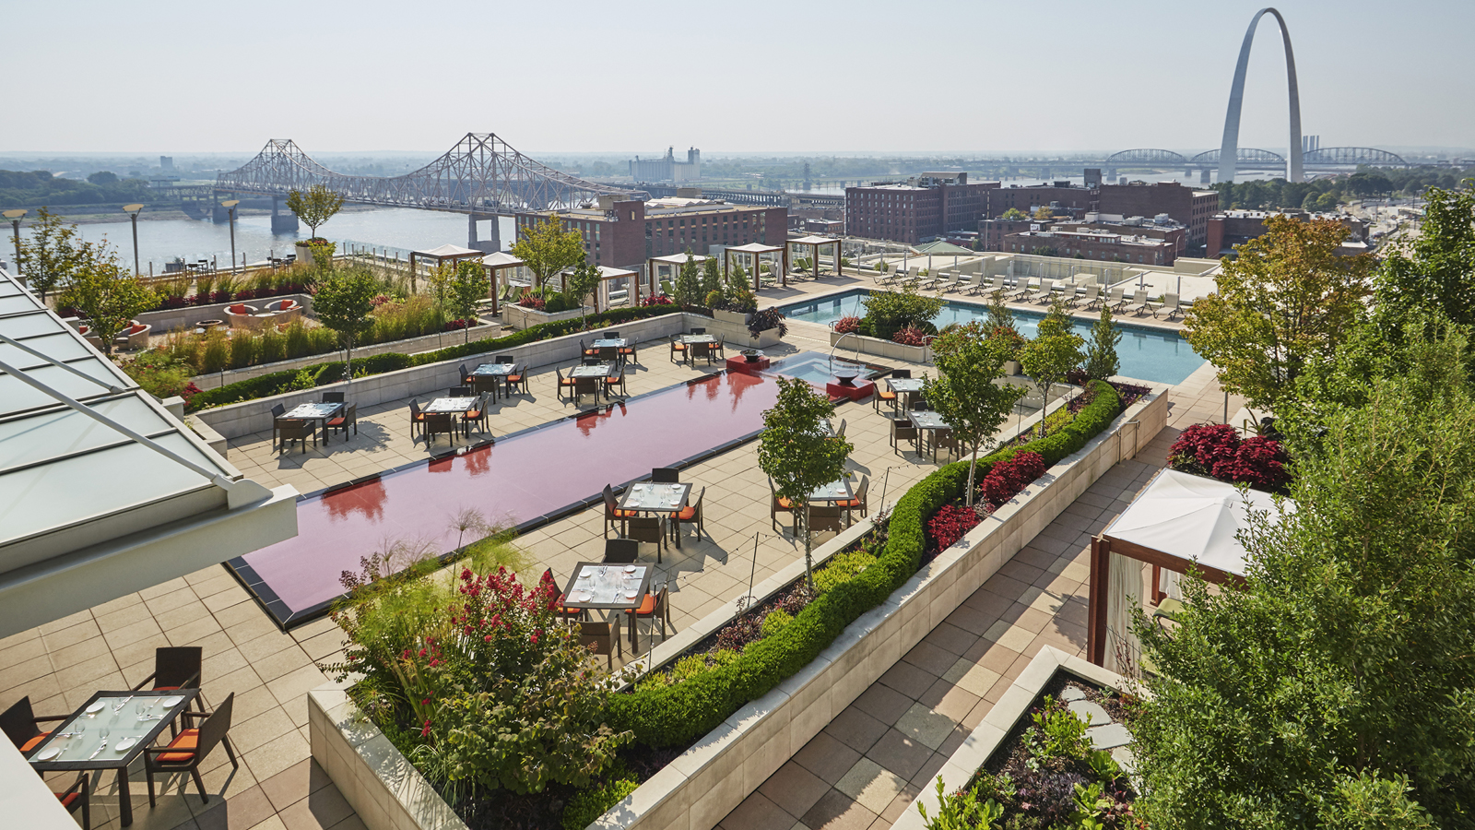
With one of the most iconic and arguably Instragammable views in the city, the Sky Terrace at Four Seasons Hotel St. Louis offers guests yoga with a view.
Salute the sun with the Gateway Arch as the backdrop as the Hotel's Yoga Instructor Debby Siegel, MSA, RYT offers personalised yoga sessions for groups ranging from 10 to 100.
Focus the mind and relax the body prior to attending wedding festivities or a business meeting. A plant-fueled daydream believer who calls herself the Yoga Evangelist, Debby inspires joy and dispels fear while leading guests through thoughtfully planned 60 minute restorative yoga or vinyasa flow classes. This activity can assist a group in connecting and decompressing while bringing about a greater sense of well-being. Group classes are tailored as closely as possible to suit various skill levels, interests and goals of everyone within the group.
“It is easy to get caught up in all the activity of special events. Yoga provides an opportunity to slow down and become more present. It can contribute to stress relief, better focus and an increase in morale,” says Siegel.
So bring your mat and join Debby for a journey bound to embolden you to relax and better enjoy your special event.
Private yoga classes can be booked directly through the Catering Department by calling 314 881 2031. Consider adding a pressed juice bar, catered breakfast or early evening appetisers to further enhance your group’s experience.
For additional wellness programs, follow #FSWellness on all social channels to learn about the latest health initiatives available at Four Seasons Hotels and Resorts worldwide.

RELATED

August 4, 2020, St. Louis, U.S.A.
Four Seasons Hotel St. Louis Offers Magical Setting for Intimate Sunrise and Sunset Wedding Celebrations
https://publish.url/stlouis/hotel-news/2020/outdoor-weddings.html

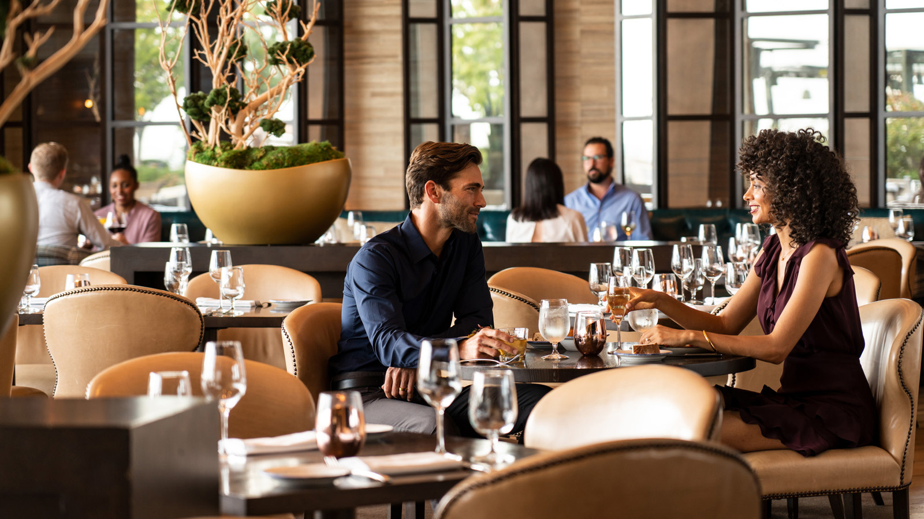 | July 17, 2020, St. Louis, U.S.A.  Cinder House at Four Seasons Hotel St. Louis Earns Wine Spectator Restaurant Award in 2020  https://publish.url/stlouis/hotel-news/2020/cinder-house-wine-spectator-award.html

PRESS CONTACTS

Chloe Caylor
Director of Public Relations and Communications
999 North 2nd Street
St Louis
USA
Chloe.Caylor@fourseasons.com

+1 (314) 881-2021

