Paradise Found: The Ocean Club, A Four Seasons Resort, Bahamas Debuts Today

Four Seasons assumes management of legendary Caribbean beach resort
November 30, 2017, Paradise Island, Bahamas

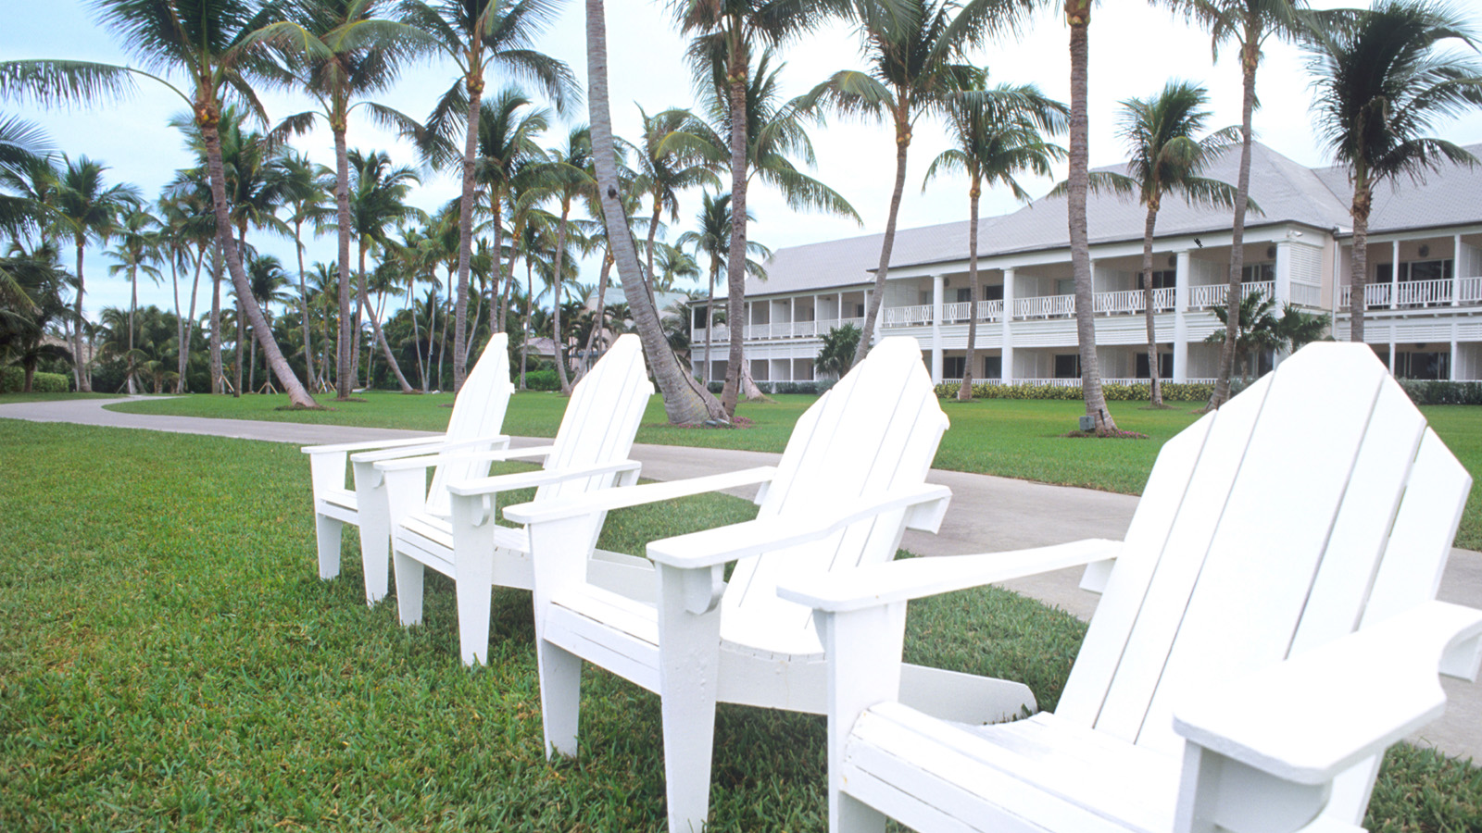
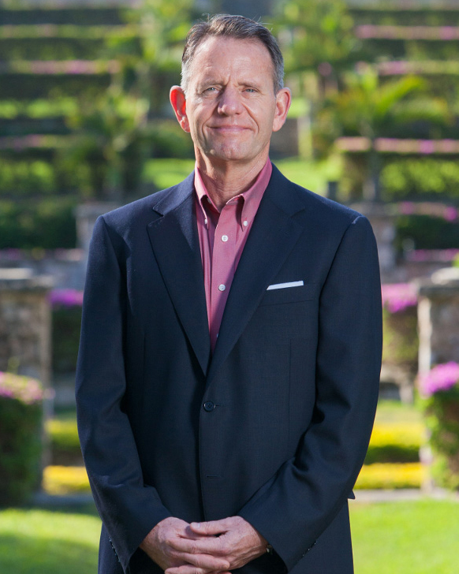 | 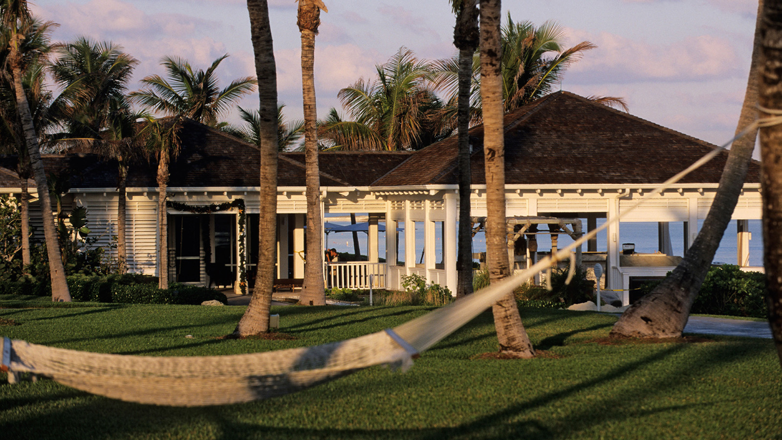 | 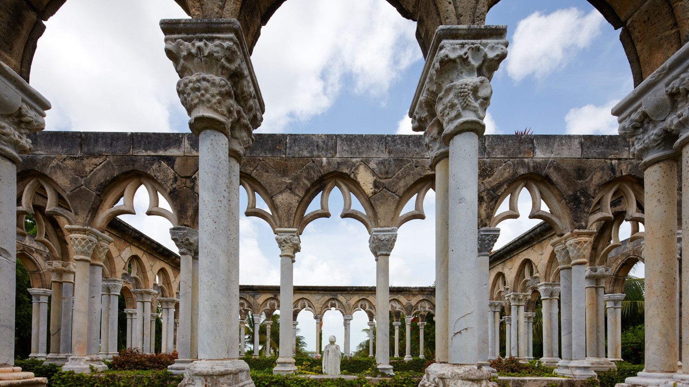
One of the world’s most celebrated beach resorts is now a Four Seasons experience: The Ocean Club, A
Four Seasons
Resort, Bahamas invites travellers to a very private enclave where five miles (eight kilometres) of pristine white sand edge the dazzling blues of sea and sky. Originally conceived as a playground for celebrities and elite travellers, The Ocean Club’s traditional Caribbean style buildings are surrounded by 35 acres (14 hectares) of beautifully maintained gardens, with world-class dining, spa and sports and recreation facilities.
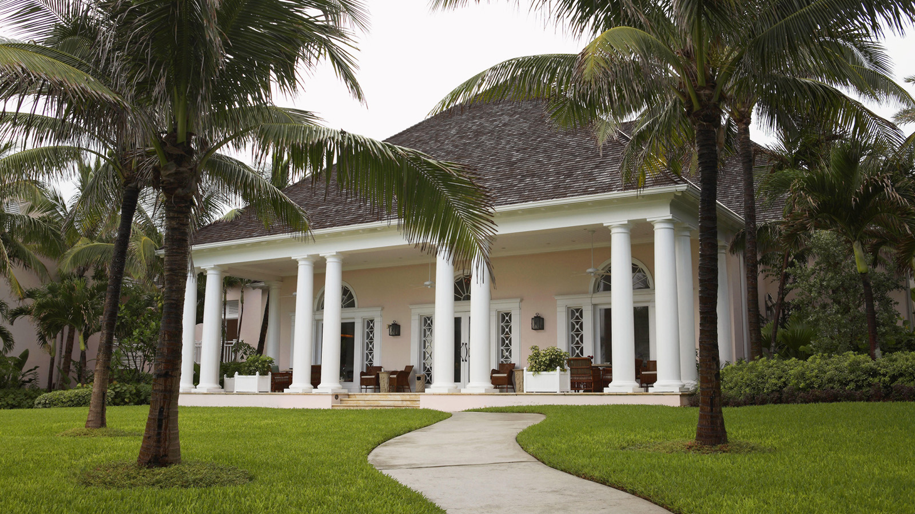 | 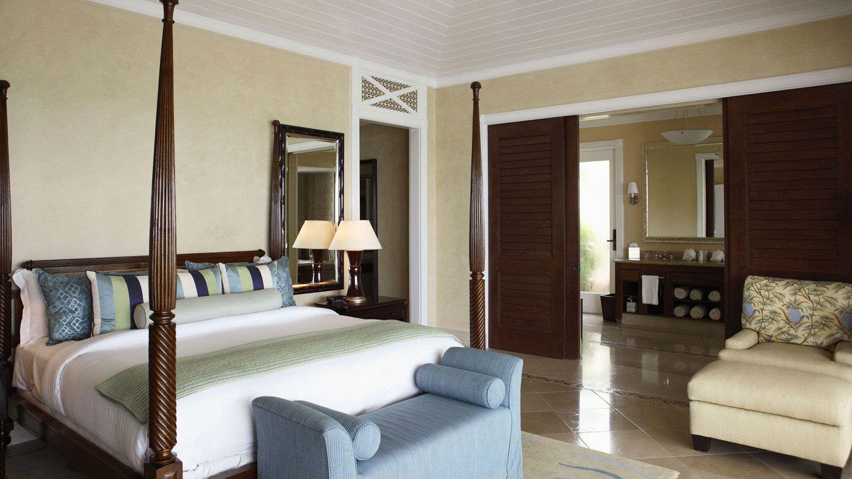 | 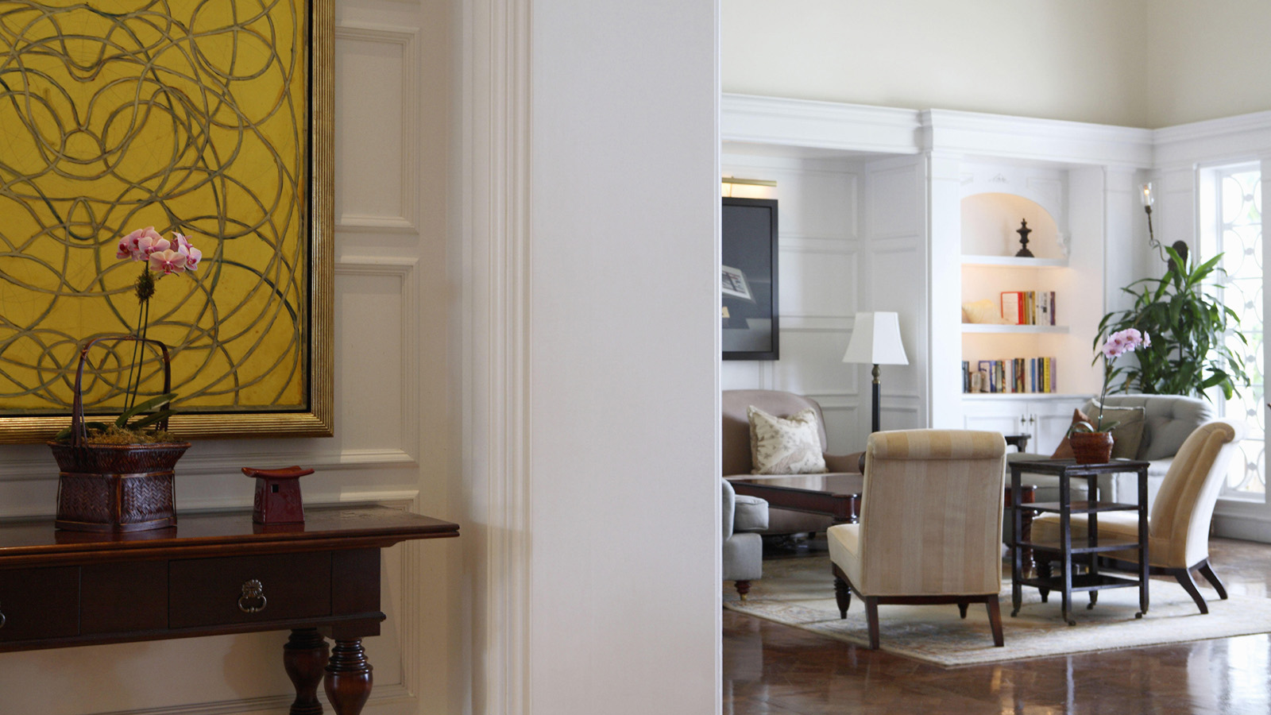
“The Ocean Club is a perfect addition to our growing portfolio – already one of the finest beach resorts in the world, and now enhanced by the personalised touches for which
Four Seasons
is renowned,” says Vince Parrotta, President, Hotel Operations - Americas. “On this occasion we are also pleased to announce that General Manager John Conway continues as your host at this very special resort.”
Hospitality veteran John Conway arrived at The Ocean Club in 2013, and now brings three decades of experience to
Four Seasons
following an accomplished career at several other Paradise Island resorts, and ten years with another luxury hotel brand in the United States and Asia.
“Our dedicated team – many of whom are well known to our loyal guests who return year after year - look forward to welcoming vacationers with the warm and caring nature that characterises the Bahamas,” says Conway.
Be among the first to experience The Ocean Club, A
Four Seasons
Resort: The Ocean Club is welcoming back guests and inviting first-time visitors to take advantage of the Stay Longer package, offering a complimentary fourth night with every three paid nights. Reservations may be made by calling +1 (954) 809-2716, or booking online.
Located just a little more than three hours by air from New York, Paradise Island is accessed by Nassau’s airport – just 40 minutes from The Ocean Club - via numerous carriers with dozens of non-stop flights daily from North America and easy connections through Miami for international travellers.
Laid Back Caribbean Style, Chef-Driven Dining, Top Class Sports and Recreation, and a Picture-Perfect Beach
The Ocean Club, A
Four Seasons
Resort offers timeless elegance in 107 luxurious accommodations in several low-rise buildings with sea and garden views. Traditional island-style rooms and suites open to ever-present sea breezes among the palm trees and gentle sounds of ocean waves, while three villas are each serviced by a personal butler during one’s stay. A team of gardeners tends the French-inspired grounds, which include a 12th century Augustinian cloister shipped piece by piece and reconstructed on site, a stunning backdrop for events and wedding photos.
Dining is highlighted by Michelin-starred Chef Jean-Georges Vongerichten’s DUNE and the adjacent DUNE Bar, serving French-Asian cuisine with a touch of Caribbean spice, as well as OCEAN for freshly grilled island fare and poolside Versailles Terrace. As the sun sets and umbrella drinks are traded for more sophisticated libations, the Martini Bar and Lounge serves up classics James Bond would approve of, along with island favourites and creative inspirations by the bar team. Although located in its own quiet enclave, The Ocean Club is also just minutes from the dining, shopping and other entertainments offered at Atlantis.
The Resort’s wide beach, located on the quiet north side of Paradise Island, is ideal for romantic strolls, sunbathing and playing in the sand, as well as adrenalin raising water sports. Those who prefer poolside swimming and relaxation have three pools to choose from, including a family pool, another for adults only, and a third set alongside the ocean with attentive
Four Seasons
staff at the ready with cool refreshments and fluffy towels.
In addition to water sports, active vacationers have their pick of six Har-Tru tennis courts and access to the adjacent Tom Weiskopf-designed Ocean Club golf course. For younger guests, Kids for All Seasons offers a fully supervised program of creative activities, and babysitting can also be arranged when adults want a quiet dinner or a few hours on the golf course or in the Spa.
At the tranquil Spa, skilled therapists infuse global techniques with island ingredients as they offer both indulgent and results-driven treatments in eight spa villas. There’s also a hair salon, nail salon, and a fitness centre for solo workouts or sessions led by on-site personal trainers.
The Ocean Club also offers 11,250 square feet (1,045 square metres) of indoor and outdoor meeting and event spaces coupled with expert event planning and execution, making it the ideal choice for a corporate retreat, family celebration or destination wedding.
About The Ocean Club, A
Four Seasons
Resort, Bahamas
Originally opened in 1962, The Ocean Club has long been a favourite hideaway for luxury travellers, with its picture-perfect oceanfront setting, immaculate grounds and stellar service. Over the years and through several evolutions, as it earned numerous international awards and accolades, and importantly, a fiercely loyal clientele. In recent years, The Ocean Club received global attention as the setting for key scenes in the 2006 remake of the James Bond classic Casino Royale.
Now managed by
Four Seasons
, The Ocean Club begins the next chapter in its storied history, joining a growing global portfolio of historic properties managed by
Four Seasons
including: Grand-Hôtel du Cap-Ferrat, A
Four Seasons
Hotel;
Four Seasons
Hotel George V, Paris;
Four Seasons
Hotel Gresham Palace Budapest;
Four Seasons
Hotel des Bergues Geneva; Beverly Wilshire, A
Four Seasons
Hotel;
Four Seasons
Resort The Biltmore Santa Barbara; and
Four Seasons
Hotel at The Surf Club, Surfside Florida, among many others.

RELATED

October 7, 2019, Paradise Island, Bahamas
The Ocean Club, A Four Seasons Resort, Recognised with Condé Nast Traveler 2019 Readers’ Choice Award
https://publish.url/oceanclub/hotel-news/2019/top-ranked-resort.html

September 6, 2019, Paradise Island, Bahamas
How You Can Support Hurricane Dorian Relief Efforts with The Ocean Club, A Four Seasons Resort, Bahamas
https://publish.url/oceanclub/hotel-news/2019/hurricane-dorian-relief-efforts.html

PRESS CONTACTS

Monica Majors
Director of Public Relations and Communications
777 Yamato Road, Suite 502
Boca Raton
USA
monica.majors@fourseasons.com

561-931-0614

