The Lost City of Alexandria

Did you know that the renowned Alexandria Lighthouse is one of the Seven Wonders of the Ancient World?
October 10, 2019, Alexandria, Egypt

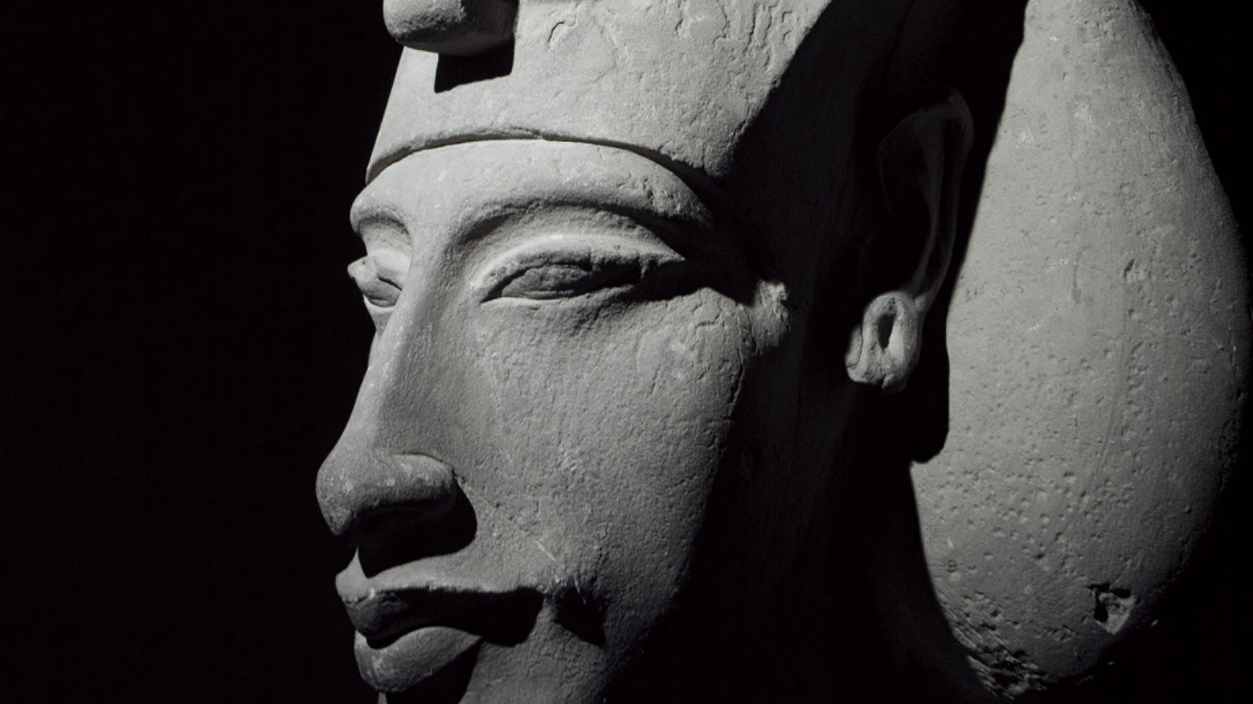
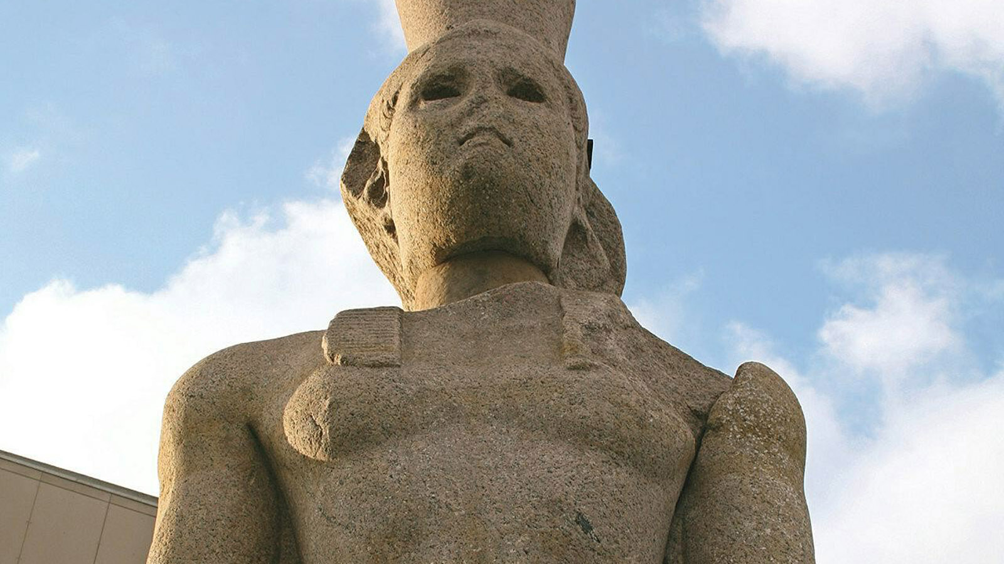
On the edge of the Mediterranean lays Alexandria, "The Pearl of the Mediterranean," with its own unique ambience and cultural heritage. Founded by Alexander the Great in 332BC, Alexandria became the capital of Greco-Roman Egypt. Its status as a beacon of culture was symbolised by the legendary lighthouse: the Pharos.
The lighthouse built between (280–247 BC) was an icon that represented a strong cultural city that offered guidance and enlightenment to the world, where many scientist and philosopher came to study at the Ancient Library of Alexandria. Later, an earthquake destroyed the lighthouse, yet the remains of its stones used to build the Quait Bay Citadel still stand on the Harbor.
In 1994, The French archaeologists Jean-Yves Emperor re-discovered the physical remains of the lighthouse on the floor of Alexandria Harbour. Through his expedition, he found several remains of statues, columns, and obelisks that belonged to various historical time, and now our visitors can visit the sunken city remains at the National Museum of Alexandria.

RELATED

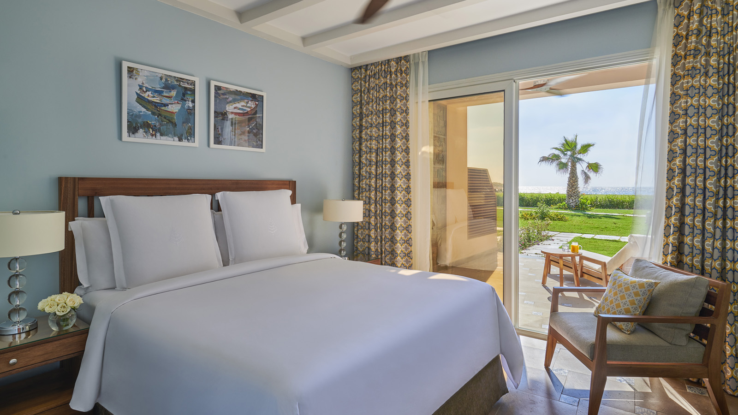 | March 14, 2019, Alexandria, Egypt  Four Seasons Hotel Alexandria at San Stefano Offers a Unique Resort Experience in the City on the Beach  https://publish.url/alexandria/hotel-news/2019/new-beach-features-and-experiences.html
March 14, 2019, Alexandria, Egypt
فندق فورسيزونز الإسكندرية سان ستيفانو يقدم تجربة فريدة تحاكي المنتجعات على ساحل البحر الأبيض المتوسط
https://publish.url/ar/alexandria/hotel-news/2019/new-beach-features-and-experiences-2.html

PRESS CONTACTS

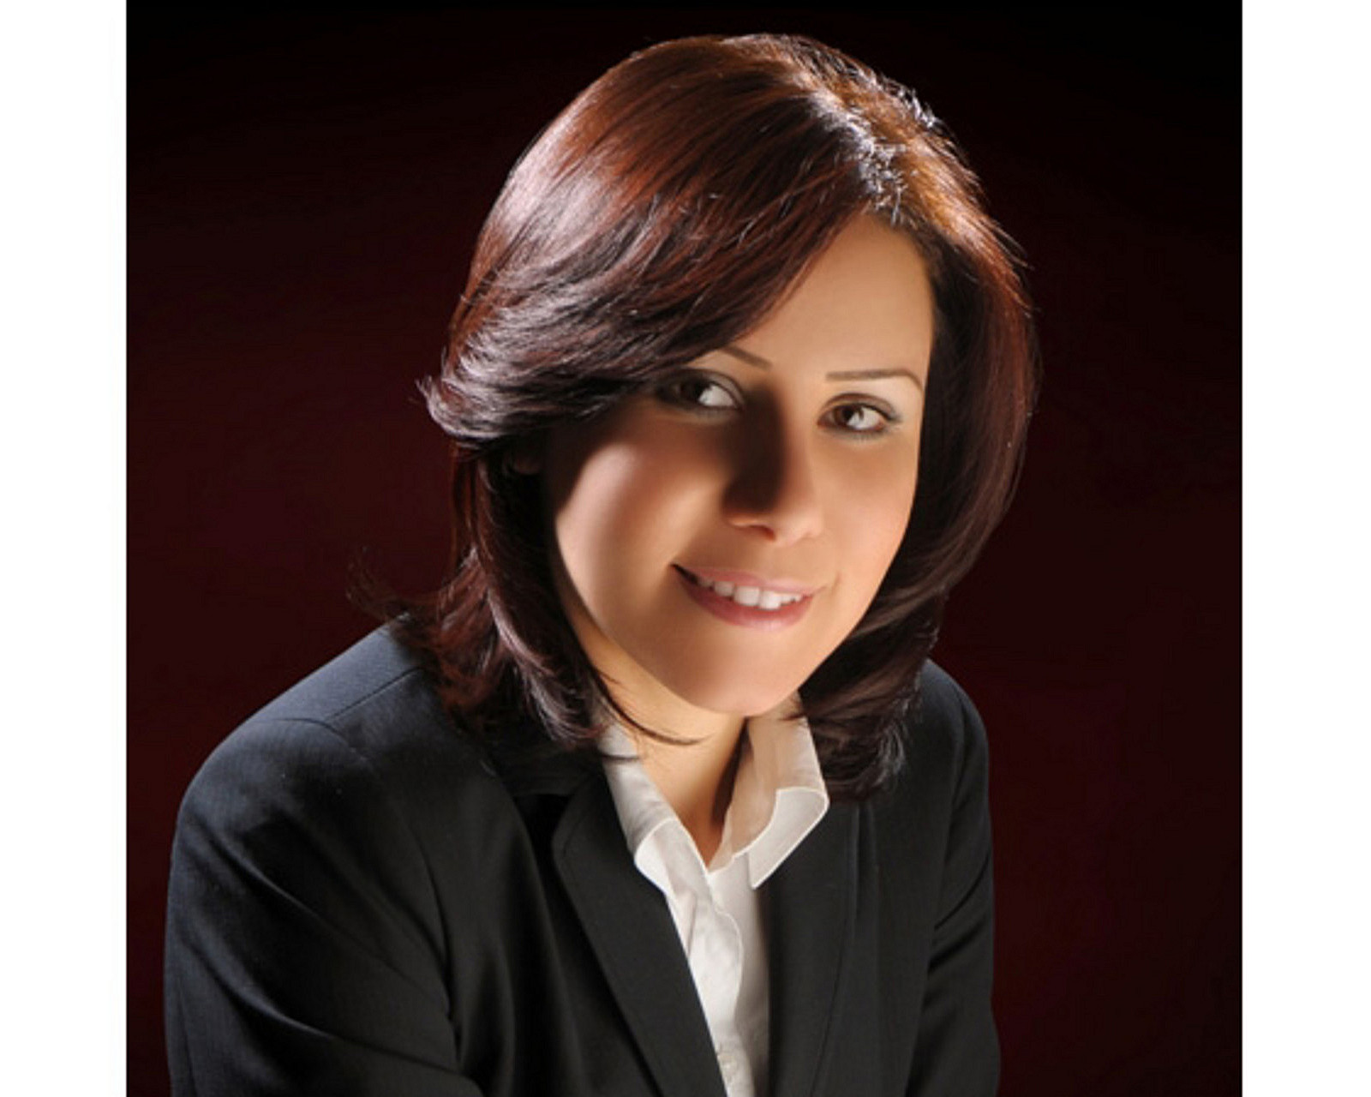 | Sarah Nabil  Director of Public Relations  399 El Geish Road  Alexandria  Egypt  sarah.nabil@fourseasons.com  20 3 581 8000

