Sakura Afternoon Tea at Four Seasons Hotel Bengaluru

Memories of the cherry blossom season
April 26, 2022, Bengaluru, India

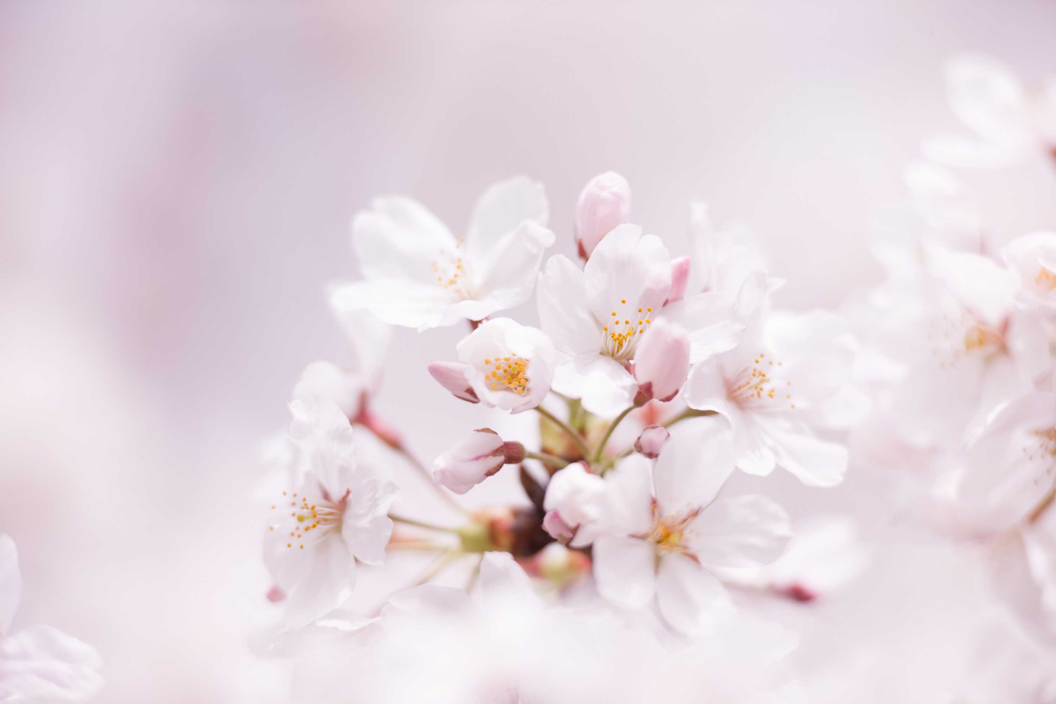
Spring may have well segued into early summer, but the waning fragrance of cherry blossom lingers on in the minds of those who love its pale pink haze.
There’s nothing more symbolic of the fleeting nature of life and beauty than fresh flowering cherry blossom branches. Pastry chefs at Four Seasons Hotel Bengaluru have captured the departing cherry blossom dreamscape in an exquisite pink-themed afternoon tea, straight out of Pinterest. Made from fresh cherry blossom jam and tea, brought by Chef Atushi Yonaha from his holiday back home, the delicate sweet treats are an exquisite craftsmanship by the pastry team.
Sakura Afternoon Treat (week long)
The beloved Afternoon Tea starting April 25, 2022 will be an exquisite display of pastries in delicate pink. This dainty affair featuring a range of handcrafted delights made from sakura flowers and savoury lite bites is best enjoyed at leisure. Guests can expect a delightful range of pastries such as berry sakura swiss roll, sakura vert baked yoghurt, sakura rocher and a fudge incorporating the lush richness of chocolate.
Along with the sweet treats, there will be the customary classic and cranberry scones served with chantilly cream, strawberry preserve, Coorg honey and other savoury delights including a sandwich, brioche and puff.
- Where: The Lobby Lounge
- When: April 25 to May 2, 2022
- Time: 3:00-5:30 pm
- Price: INR 1250 + taxes per person (inclusive of a selection of tea and coffee)
To know more, guests can call +91 76191 46004. Afternoon Treat available only on prior reservation.

RELATED

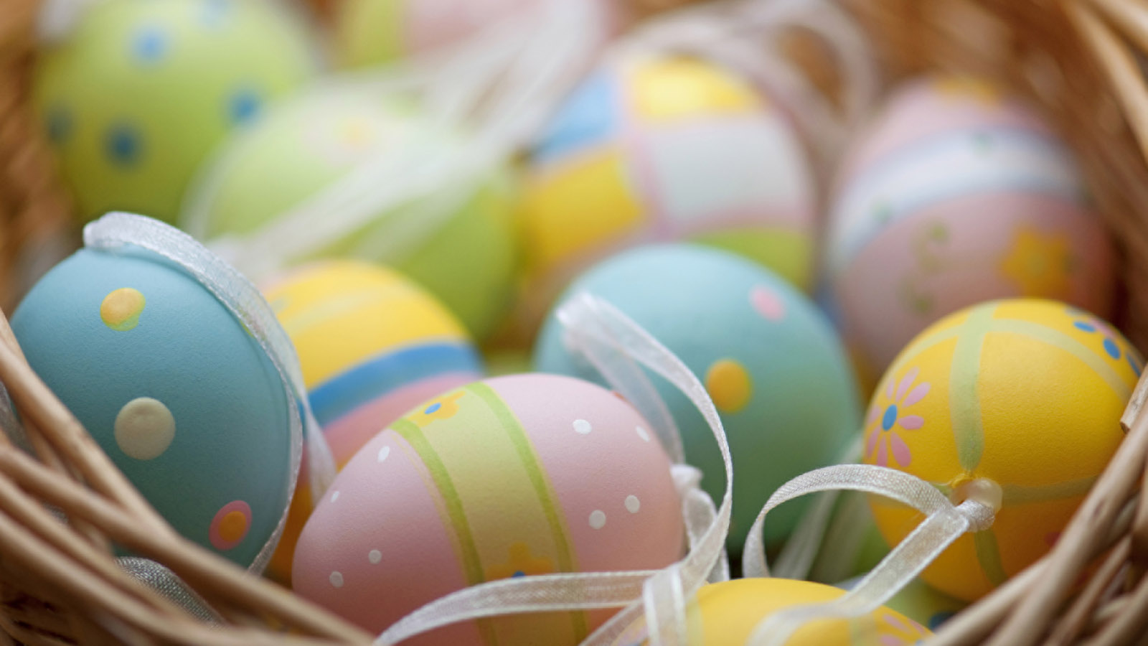 | April 11, 2022, Bengaluru, India  Easter by Four Seasons Hotel Bengaluru  https://publish.url/bengaluru/hotel-news/2022/easter.html
March 28, 2022, Bengaluru, India
Copitas at Four Seasons Hotel Bengaluru Named Among 30 Best Bars in India
https://publish.url/bengaluru/hotel-news/2022/best-bars-in-india-awards.html

PRESS CONTACTS

Gargi Guha
Director of Public Relations
8, Bellary Road, Ganganagar
Bengaluru
India
gargi.guha@fourseasons.com

+91 80 4522 2222

