Relax and Recharge at Four Seasons Hotel Hampshire with the New Self-Care Spa Experiences

Four Seasons Hotel Hampshire creates three new self-care spa experiences, encouraging guests to take time out, focus on themselves and explore the outdoors
June 6, 2022, Hampshire, England

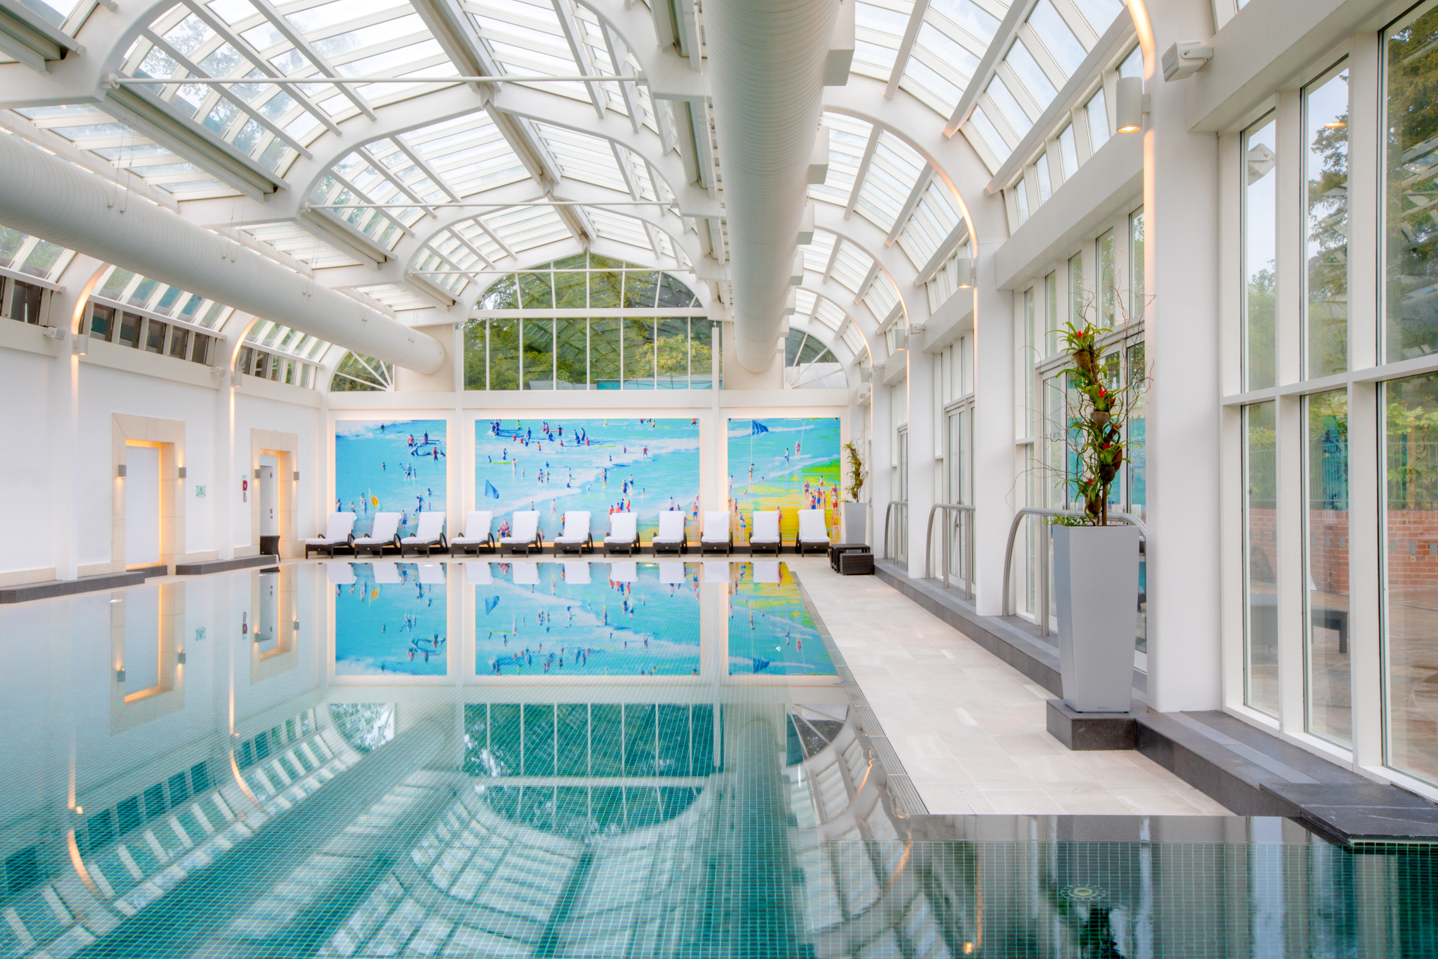
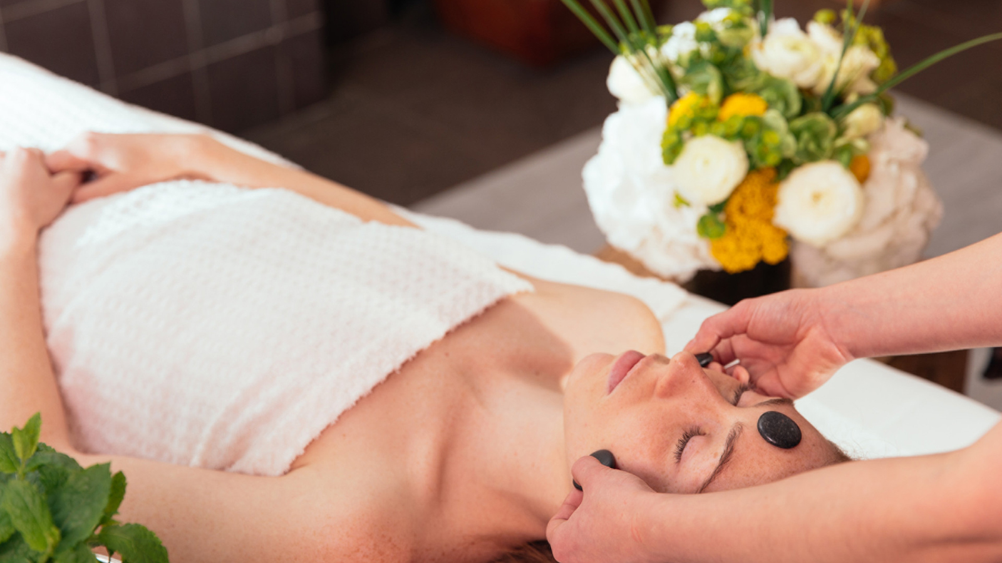 | 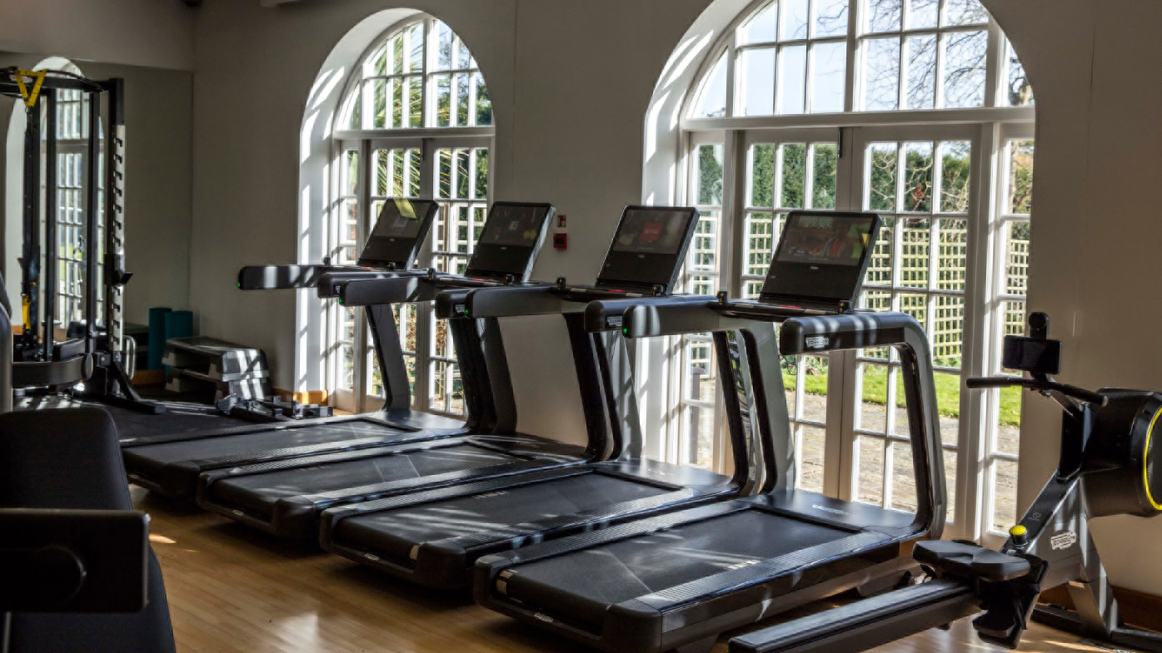
On Monday, June 6, 2022, Four Seasons Hotel Hampshire introduce its new self-care spa experiences designed to support both physical and mental health and wellbeing. With three distinct packages, each is created to help guests work towards their personal wellness goals, while they relax and unwind in the calming British countryside.
Free Your Mind
Research shows that approximately one in four people in the UK will experience a mental health issue each year. The Free Your Mind Spa experience is designed to support mental health and help clear guests mind of the stresses of day-to-day life.
Begin with a one-hour session from property’s trained hypnotherapist Mark Williams, offering a unique Deep Mind Massage therapy, which works with guests on their specific needs. Whether they want to lose weight, reduce stress, combat sleep disorders, break a bad habit or overcome a phobia, Mark personalises the process to fit individual requirements.
After the session, discover some of the Hotel’s peaceful walking trails. Guests can take time to recharge and explore the outdoors as they wander around the estate, taking in the idyllic views of the charming English countryside.
Connect with Nature
Escape to the countryside and reconnect with nature by beginning the day with The Citrus Essence, a hydrating one-hour facial by premium skincare brand Natura Bissé. Using antioxidants and vitamin C, this calming facial works to help rejuvenate the skin, leaving guests feeling refreshed and revitalised.
Later take one of the Spa’s mountain-bikes and spend the afternoon exploring the grounds, reconnecting with nature while enjoying a cycle around the Hotel’s estate. Take in the beautiful landscape and discover the wildlife, watching the birds, horses and new little ducklings that can be found roaming around the Hotel grounds.
Move Your Body
Start the day the right way and get the body moving with one of the Spa’s fitness classes. Whether it’s endurance, strength, balance or flexibility, there’s a class to fit every guest’s needs. From high intensity HITT to holistic yoga or Pilates, the range of activities is designed to get the body working.
After the class, choose from one of the 60-minute massages. Opt for a Deep Tissue Massage, a firm pressure relieving treatment that uses low strokes and finger pressure to release tightness, or try the Therapeutic Massage using Swedish techniques to energise the body and relieve tension.
Available Monday–Friday at GBP 195, the new spa experiences come with a three-course lunch at the recently reopened Spa’s Café Sante and use of all the spa facilities including the indoor conservatory style pool, outdoor vitality pool, sauna and steam room.
For reservations, contact the Spa on 01252 853 000.

RELATED

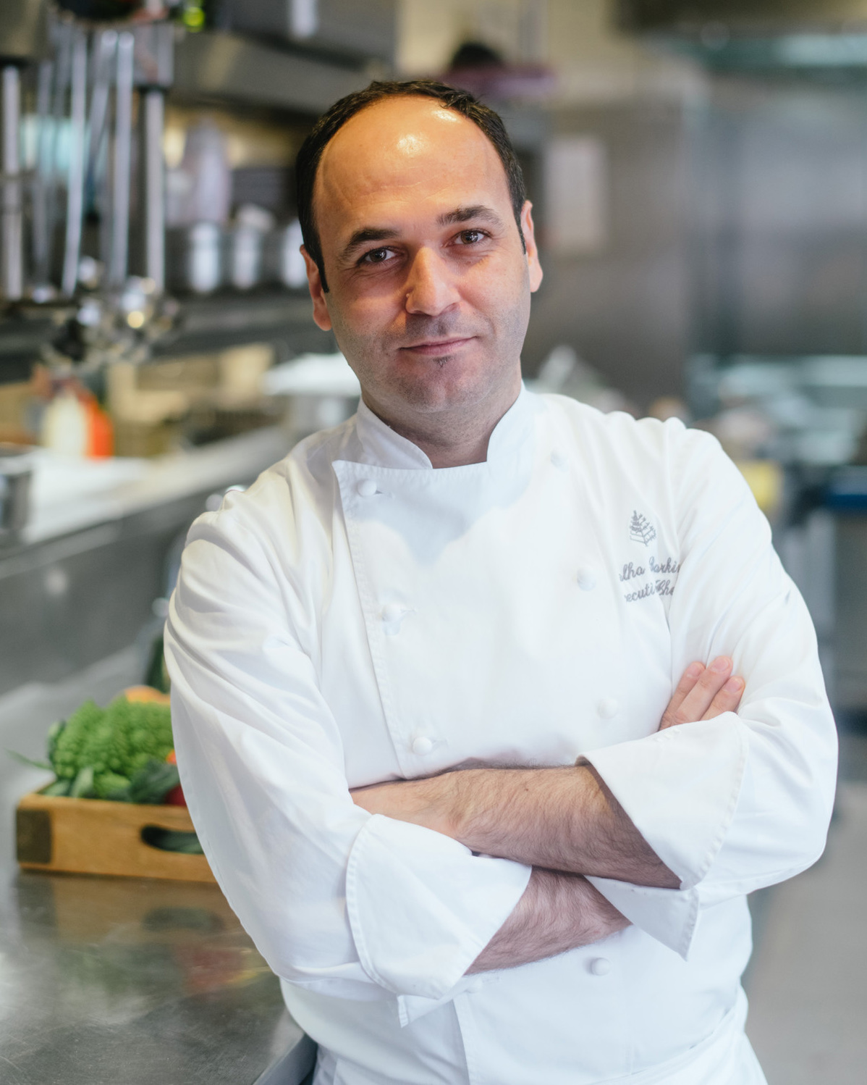 | May 30, 2022, Hampshire, England  Four Seasons Hotel Hampshire Appoints Talha Barkin as Executive Chef  https://publish.url/hampshire/hotel-news/2022/new-executive-chef-talha-barkin.html
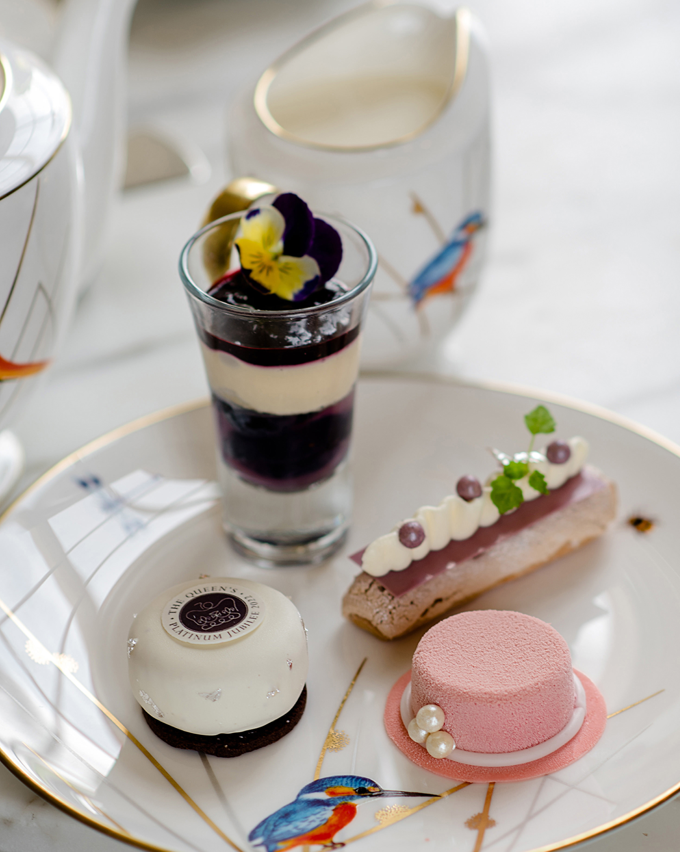 | May 18, 2022, Hampshire, England  Celebrate the Platinum Jubilee with Four Seasons Hotel Hampshire  https://publish.url/hampshire/hotel-news/2022/jubilee-celebrations.html

PRESS CONTACTS

Poppy Law
Public Relations Manager
Dogmersfield Park, Chalky Lane
Hook
United Kingdom
poppy.law@fourseasons.com

+44 (0)1252 853 000

Freya Costello
Senior Director of PR & Communications
Hamilton Place, Park Lane
London
England
freya.costello@fourseasons.com

+44 7788232969

