Four Seasons Hotel Miami Unveils Redesign of Meetings and Events Spaces

Brickell hotel enhances function spaces with mid-century modern décor
October 3, 2018, Miami, U.S.A.

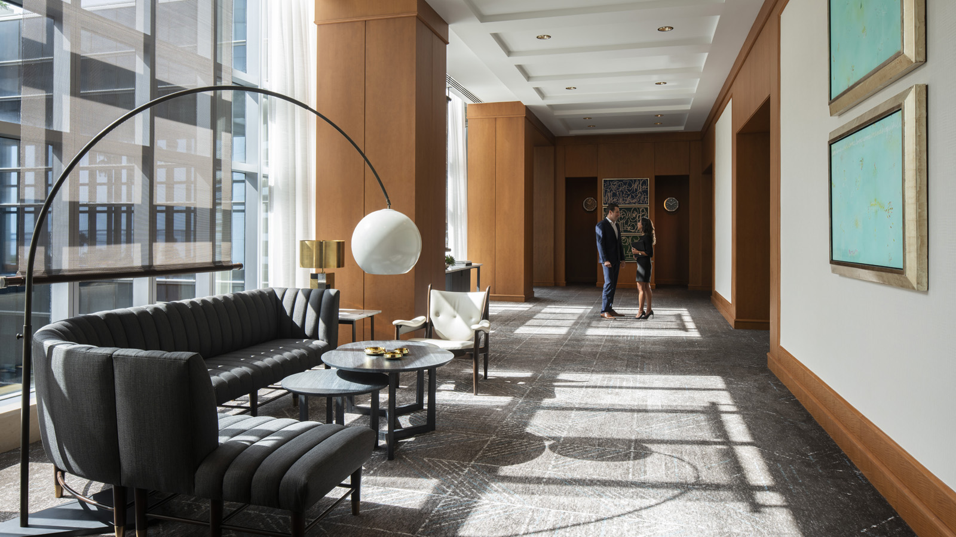
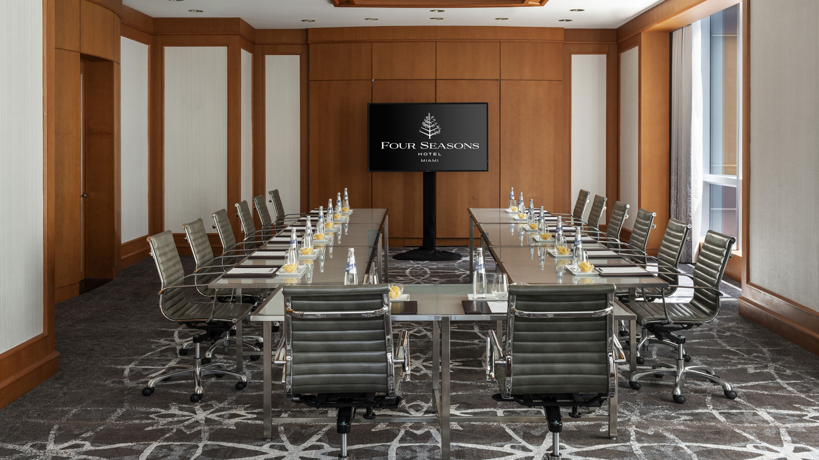 | 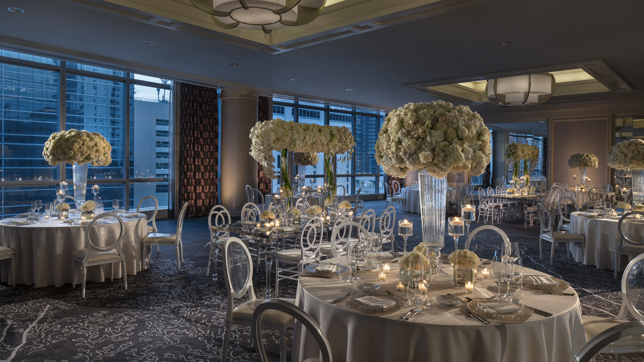 | 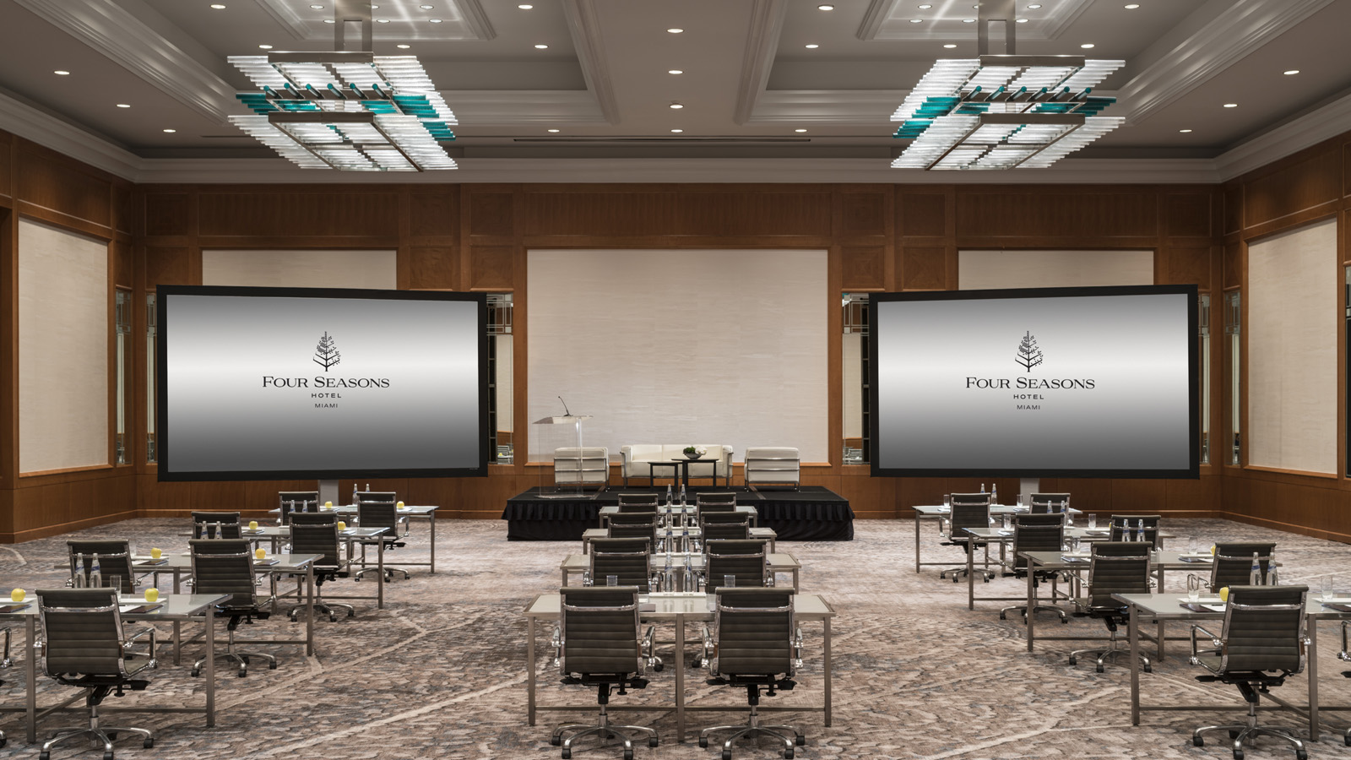
Named as “One of the Best Hotels in Miami” in 2018 by the US News & World Report, Four Seasons Hotel Miami is a leading urban resort in Brickell exemplifying the best in the service industry. Recently, the property unveiled a completed redesign of its 6th floor function spaces as well as its 7th floor lobby that blend flawlessly with one another.
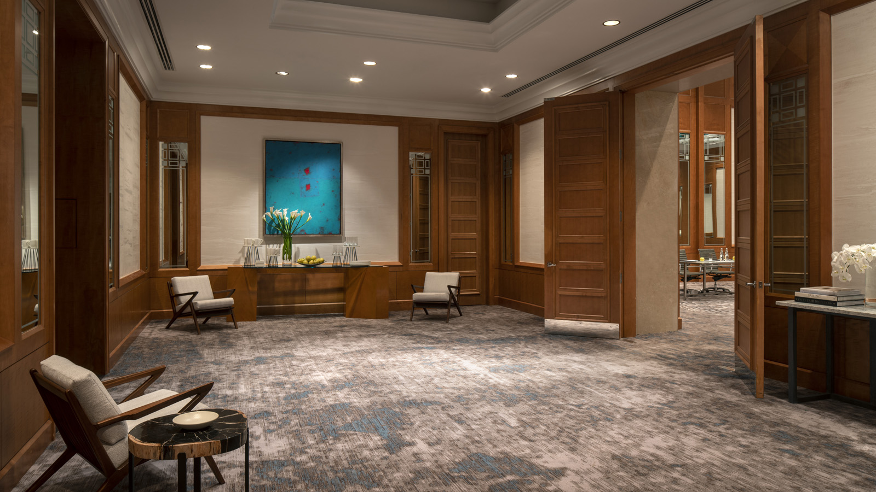 | 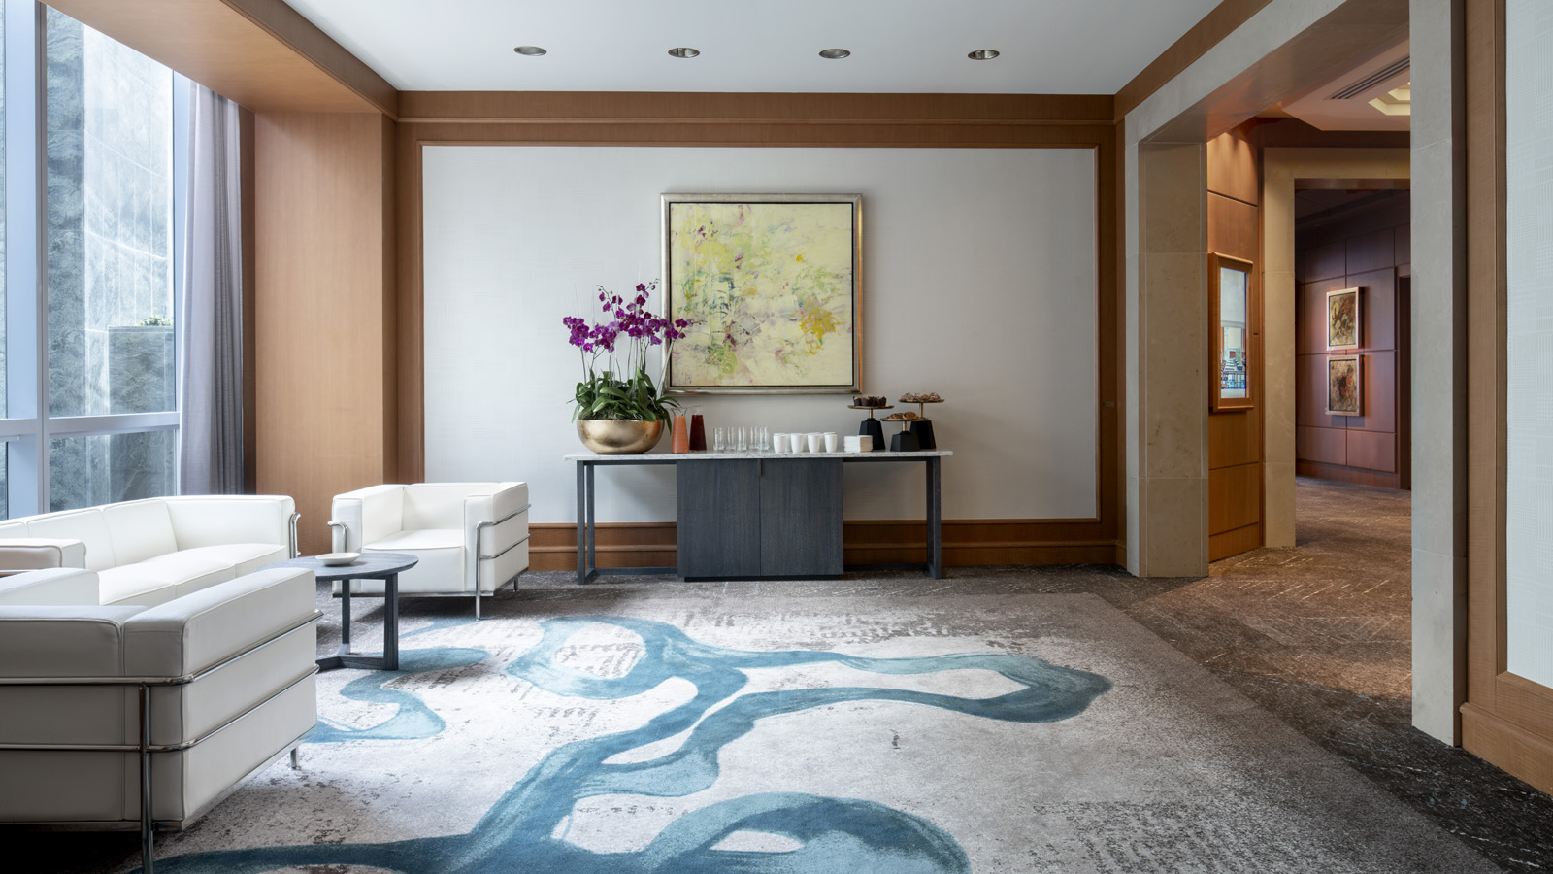 | 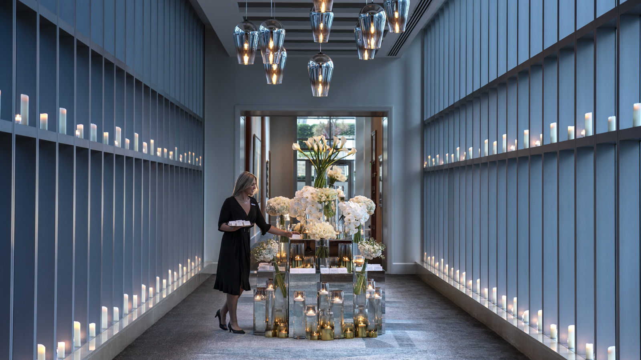
“Four Seasons Hotel Miami executes unforgettable meetings and events throughout the year, offering modern venues with views of Biscayne Bay and Brickell Avenue and these enhancements harmoniously reflect our destination of modern Miami and our vibrant surroundings,” says Dan Normandin, General Manager.
The Hotel’s main theme and vision transpired throughout the redesign was a mid-century modern look influenced by the ocean that surrounds the urban resort. The Hotel partnered with Rockwell Group, a New York City award winning design firm specialising in hospitality.
“We aimed to better define and delineate the spaces and provide lounge areas with a luxurious, high-end residential feel,” says Hilli Wuerz, Rockwell Group.
Sea botanicals, fans, and coral designs on carpets are complimented with muted neutral tones and strong blue hues. Wall treatments are textured with a chic array of light and airy accents throughout the spaces. The Hotel’s Grand Ballroom displays hand-painted wall treatments by renowned artist Maja Romanoff. Custom-made furniture includes ceruse pieces with ash and white quartz tops and large sofa furniture with dark, deep tones. The prominent Sky Bridge displays impeccable views from all angles and was transformed into an additional function space, rather than a corridor. Fresh carpet, elevated ceilings, and a glamorous light installation by distinguished British designer Tom Dixion offers a serene setting optimal for day or evening functions.
“We are confident the redesign will speak to our guests from around the globe while offering a modern touch that complements our Hotel, its destination, and add an element of style to all events moving forward,” says Javier Munoz, Catering Director.
About Rockwell Group
Based in New York with a satellite office in Madrid, Rockwell Group is an interdisciplinary architecture and design firm that emphasises innovation and thought leadership in every project. Founded by David Rockwell, FAIA, and led by David and partners Shawn Sullivan and Greg Keffer, the 250-person firm merges theater, performance and architecture to create extraordinary experiences and built environments across the globe. Projects include Union Square Cafe (New York); W Hotels (New York, Paris, Madrid, Suzhou, Singapore and Vieques); Nobu restaurants and hotels worldwide; Dream Hollywood; the Hayes Theater restoration (New York); The Shed and 15 Hudson Yards in New York in collaboration with Diller Scofidio + Renfro; NeueHouse (New York and Los Angeles); TED Theater (Vancouver); and set designs for the Public Theater’s 2017 season of Shakespeare in the Park, She Loves Me, and Kinky Boots. Honours and recognition include 2016 Tony and Drama Desk Awards for Best Scenic Design for She Loves Me; the AIANY President’s Award; the Cooper Hewitt National Design Award; and the Presidential Design Award.

RELATED

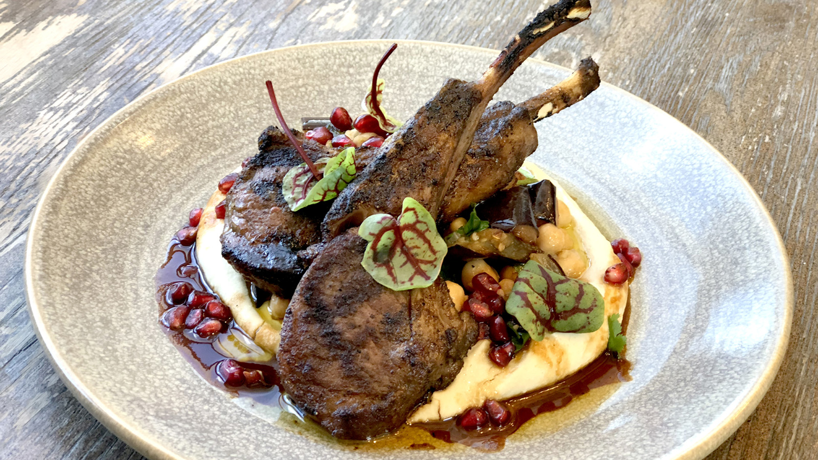 | July 19, 2018, Miami, U.S.A.  EDGE, Steak & Bar at Four Seasons Hotel Miami Reveals Summer Menu  https://publish.url/miami/hotel-news/2018/edge-summer-menu.html
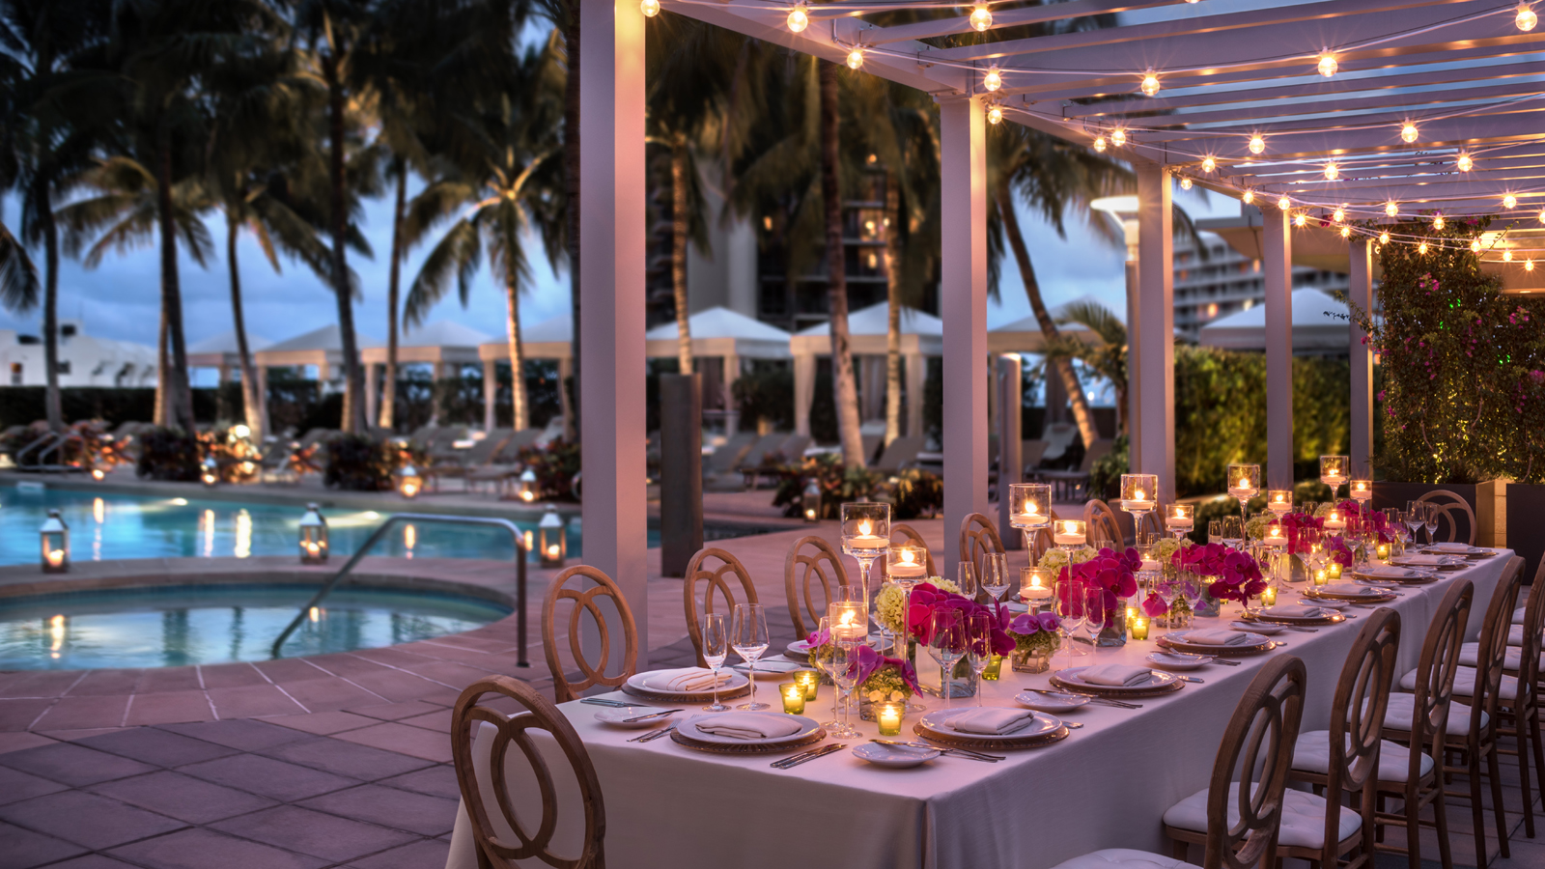 | June 20, 2018, Miami, U.S.A.  Gather at Brickell's Finest Hotel for Your Next Notable Function at Four Seasons Hotel Miami  https://publish.url/miami/hotel-news/2018/group-offers.html

PRESS CONTACTS

Mikaela Vourtsis
Public Relations and Communications Manager
1435 Brickell Avenue
Miami
U.S.A.
Mikaela.Vourtsis@fourseasons.com

1 (305) 381-3037

