Get into the Holiday Spirit with Festive Happenings, Holiday Package and Special Menu Offerings at Four Seasons Hotel San Francisco at Embarcadero

December 21, 2022, San Francisco, U.S.A.

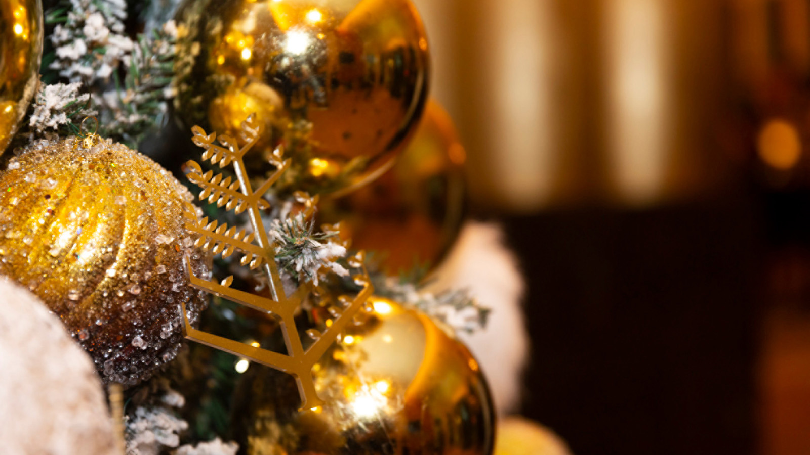
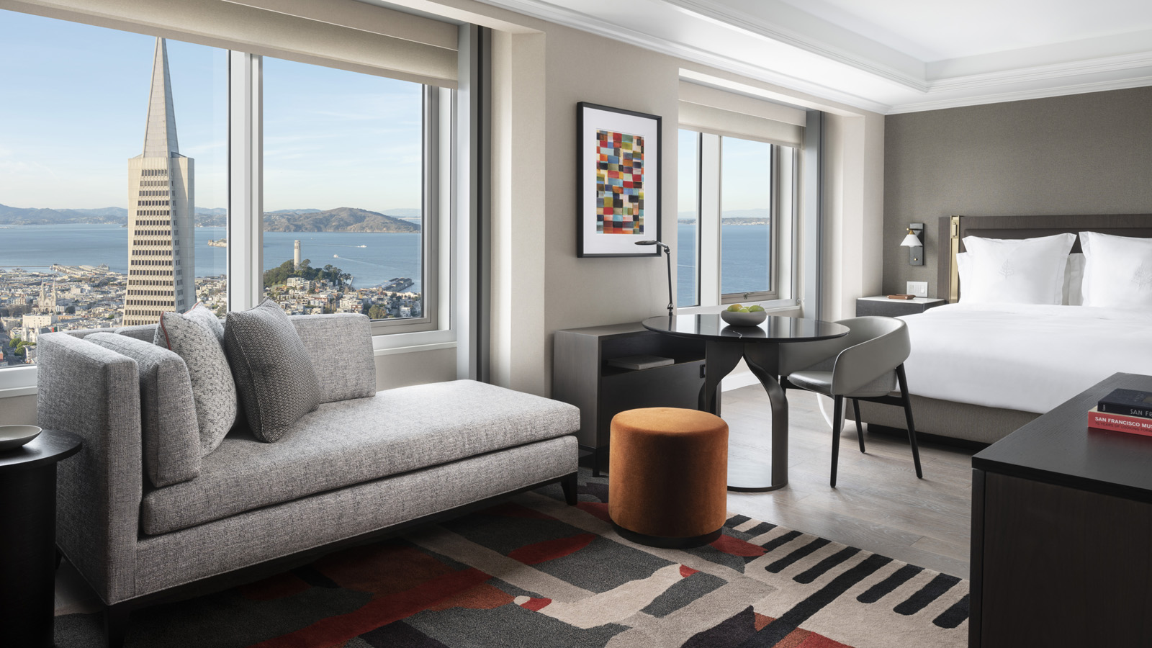
Four Seasons Hotel San Francisco at Embarcadero has curated festive experiences for locals and guests to make the most out of this holiday season. From chestnut roasting to Christmas carolling and a special seasonal package, the property is filled with holiday spirit and cheer.
The Holiday Escape package offers guests a city getaway near San Francisco’s waterfront, close to premium shopping and cultural experiences. Guests will enjoy a bottle of holiday bubbles on arrival, complimentary monogramming or engraving on any purchased item from upscale retailer of watches, bicycles, leather goods and curated gift items Shinola in Jackson Square, and two complimentary tickets to a festive orchestra performance hosted by the renowned San Francisco Symphony at Davies Symphony Hall.
This year, the Hotel’s lobby plays host to a non-stop lineup of holiday happenings including a live chestnut roaster for a quintessential nostalgic holiday treat, carolling performances by the St. Augustine Children’s Choir, and special performance by San Francisco harpist Eleonora Pellegrini.
San Francisco locals and Hotel guests are welcome to experience Holiday Menus at The Lounge & Bar by Chef-in-Residence Rupert Blease, who previously earned a Michelin star at his local San Francisco outpost Lord Stanley. Christmas menu highlights include the Classic Oysters Rockefeller with parsley, parmesan cheese, and breadcrumbs; Aged Beef Prime Rib with red wine sauce, apple and Yukon potato gratin, roasted sprouts, and shallot jam; and the delicious Mont-Blanc with chestnut, dark chocolate and Chantilly to end on a sweet note, of course. Celebrate the New Year at Four Seasons Hotel San Francisco at Embarcadero with a family-style menu on New Year’s Eve and New Year’s Day from 11:30 am to 10:00 pm. Standout dishes include the Beef Carpaccio with aged balsamic, arugula, and parmesan; Chickpea à la Catalan with poached eggs, peppers, and pine nuts; and the Eton Mess with meringue and vanilla cream.
Reservations are recommended. To book, visit The Lounge & Bar, or call 415 276 9888.

RELATED

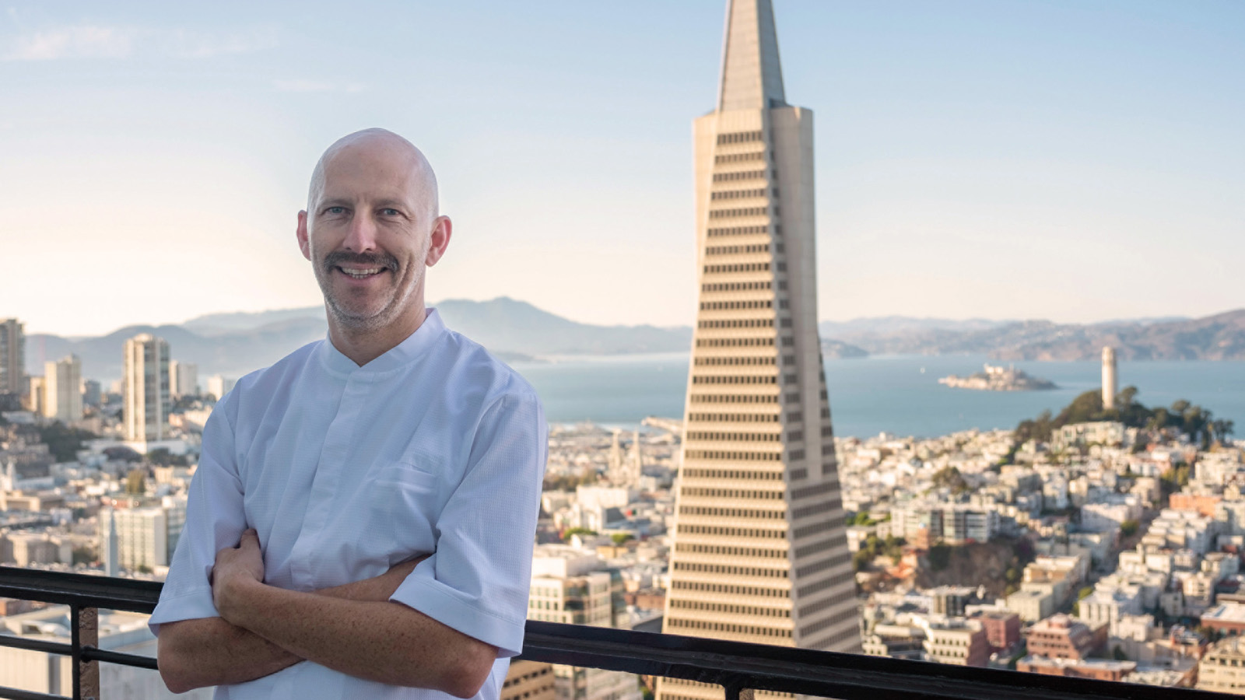 | November 1, 2022, San Francisco, U.S.A.  Four Seasons Hotel San Francisco at Embarcadero Welcomes Renowned Local Chef Rupert Blease as Chef-in-Residence  https://publish.url/embarcadero/hotel-news/2022/turntable-at-four-seasons-pop-up-restaurant.html
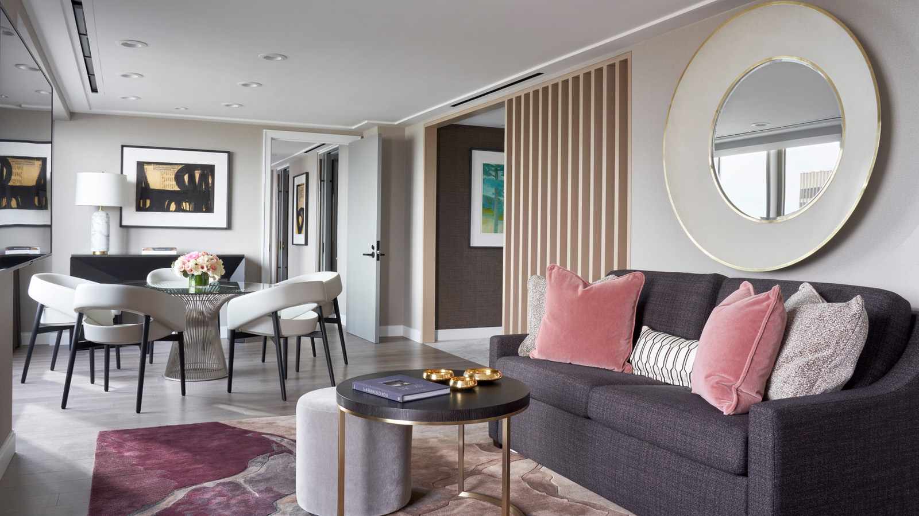 | July 11, 2022, San Francisco, U.S.A.  Four Seasons Hotel San Francisco at Embarcadero Reveals Highly Anticipated Enhancements, Commemorates its Complete Opening  https://publish.url/embarcadero/hotel-news/2022/guest-room-renovations-complete.html

PRESS CONTACTS

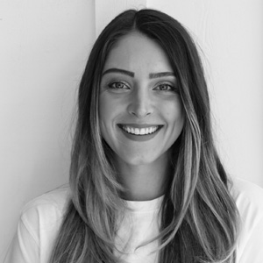 | Blake Willahan  J. Wade Public Relations  550 15th Street, Suite 25  San Francisco  USA  fsembarcaderopr@jwadepr.com  +1 949 395 1751

