Experience the Height of Wellbeing at Four Seasons Resort Seychelles

Le Syel spa launches tailored new wellness programs and Wellness Cabanas
March 9, 2020, Seychelles

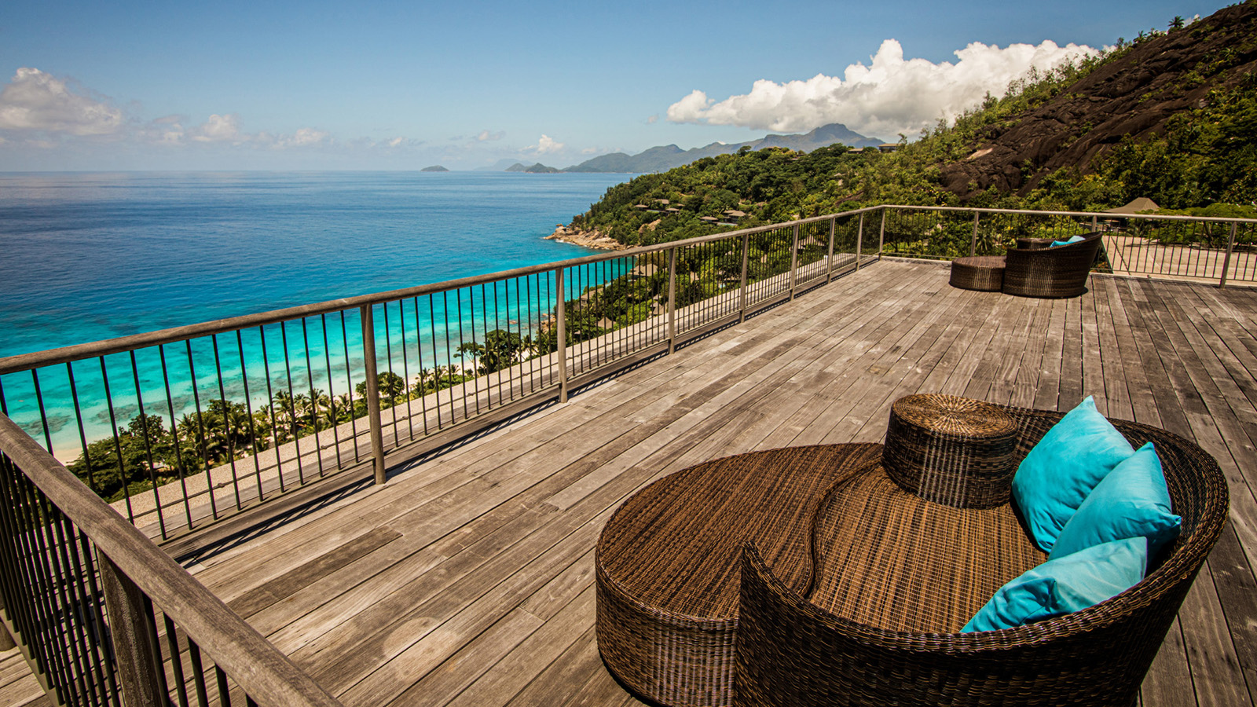
 | 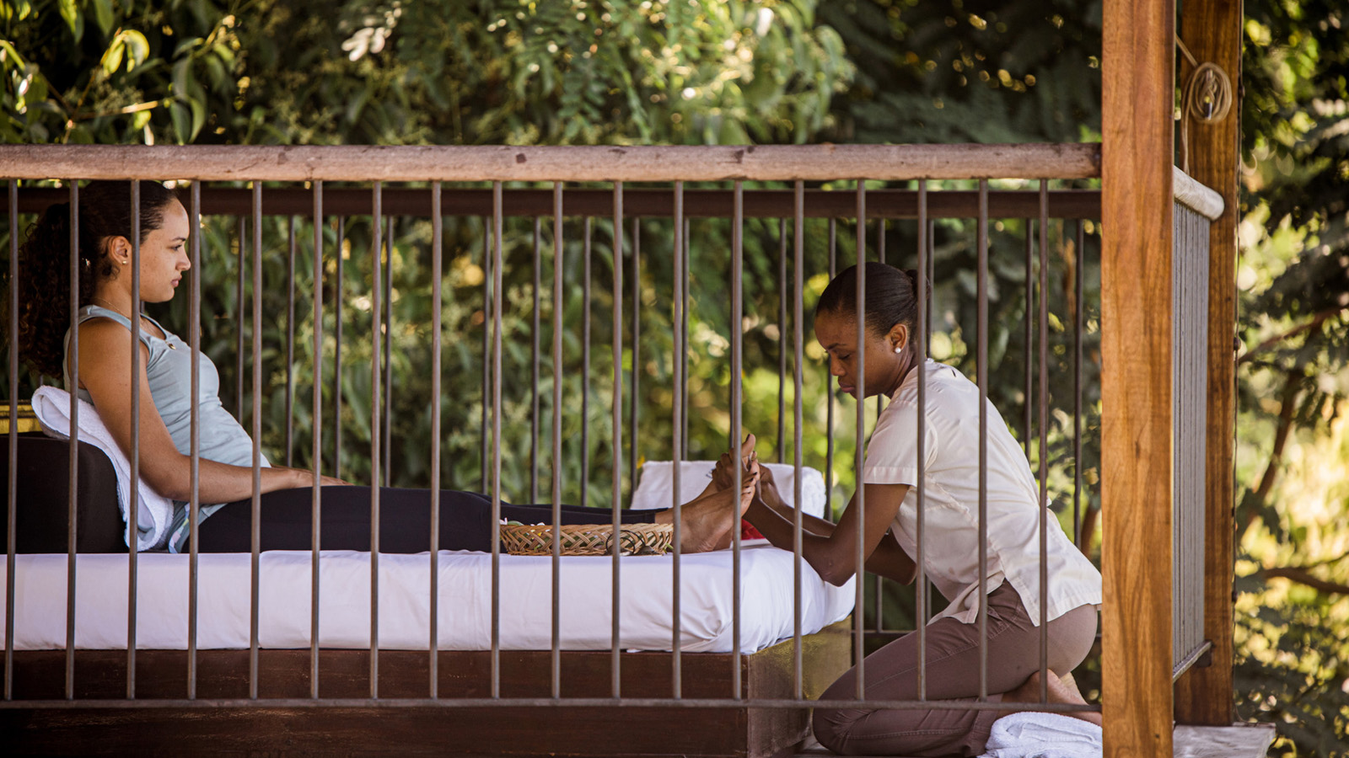 | 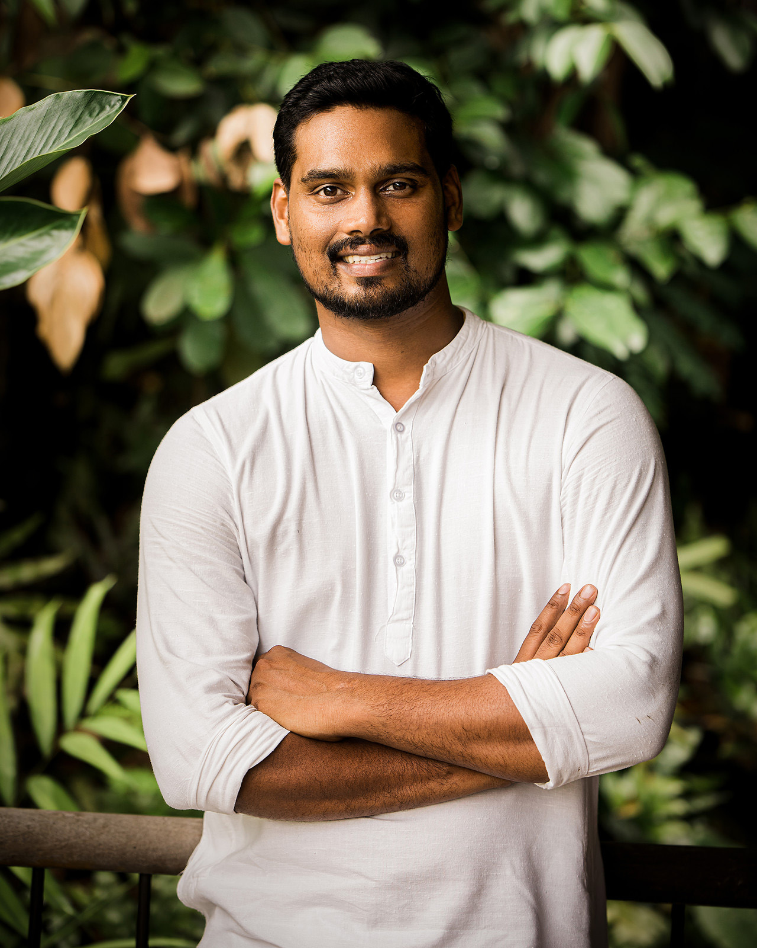
At the uppermost point of Four Seasons Resort Seychelles, Le Syel Spa looks out to panoramic views of Petite Anse bay, inviting elevation of inner and outer self. To complement an extensive menu of rituals, massages, facials and body treatments, Le Syel Spa has revealed the launch of a series of new wellness programs alongside the introduction of in-villa Wellness Cabanas.
Personalised Wellbeing
Following the appointment of Naturopathic Doctor Deepu Vijayan Latha Kumari earlier this year, Le Syel spa is now enhancing its tailored wellness offerings with the introduction of three wellness programs that will all be available as three, five and seven day programs. Each program, no matter the selected theme or duration, begins with a 45-minute consultation with Dr. Deepu to allow complete personalisation of the experience to achieve the greatest sense of wellbeing for each and every guest.
- Transformative Wellness Program: Designed to manage stress, insomnia or anxiety, this program helps promote a deeper level of relaxation. Highlight program inclusions: In-villa Aroma Hydrobath with special Ashwagandha tea, acupuncture/acupressure, and Chakra meditation.
- Therapeutic Wellness Program: Created for people suffering from physical pain and stiffness, this program helps those suffering from digestive problems and aims to provide curative long term results. Highlight program inclusions: Personalised therapeutic yoga, in-villa therapeutic bath with cinnamon and basil tea, and a private cupping and reflexology session.
- Detox Wellness Program: Designed to remove toxins from the body to regain health and to protect against diseases. Highlight program inclusions: Energising and detoxifying body scrub, facial lymphatic drainage, and detox yoga and pranayama.
Prices for the new Wellness Programs start as from EUR 587 for a three-day program, EUR 1,195 for a five-day program and EUR 1,651 for a seven-day program.
A New Perspective on Wellness
With each of the 67 hillside pool villas and suites in Petite Anse bay offering panoramic views of the surrounding nature, the accommodations present a natural setting for self-awareness and disconnection. To further enhance this environment, the pavilions of each villa and suite will become Wellness Cabanas to offer a series of guided classes and treatments:
- Seated Yin yoga (60 minutes): Hold poses for longer – supported by props – in this gentle, calming and therapeutic practice, designed for relaxation and balance. Suitable for all levels.
- Pranayama (60 minutes): Strengthen the respiratory system, soothe the nervous system and reduce cravings with slow, deep rhythmic breathing – the life force and mind-body connector. Suitable for all.
- Yoga Nidra (60 minutes): A meditation and conscious relaxation practice that is intended to induce total physical, mental, and emotional relaxation.
- Meditation (60 minutes): A process of training the mind to focus and redirect thoughts to increase awareness of self and one's surroundings.
- Reflexology (60 minutes): This focused therapy stimulates reflex points in the feet to alleviate tiredness and soothe different parts of the body, aided by the invigorating fragrance of local mint.
The Wellness Cabana experiences will be presented to guests on an in-villa menu, with bookings to be placed via the Spa.
Elevated Wellbeing
Speaking on the launch of the new wellness offering, Assistant Spa Manager Jean Malubdos, says: “The reason so many of our guests choose Seychelles as the destination for their vacation is to relax, but beyond that, what they are really craving is the chance to reset and feel healthy and fulfilled. With these new programs and experiences, we look to offer each guest a personalised path to follow that helps them make the most of their time away, achieving an inner sense of wellbeing that will stay with them long after departure.”
Le Syel Spa is located at the top of Petite Anse bay, crowned by Mahe’s most spectacular views. A choice of product lines is available for guests to choose from, while three signature oils, handcrafted by a trusted local distiller, allow guests to experience the power of rejuvenating cinnamon, moisturising coconut and relaxing lemongrass in their chosen treatment.

RELATED

January 20, 2020, Seychelles
Experience a Curated Celebration of Love This Valentine’s Day at Four Seasons Resort Seychelles
https://publish.url/seychelles/hotel-news/2020/valentines-day.html

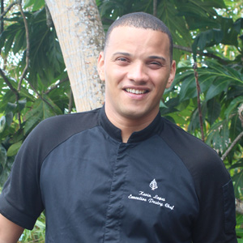 | November 29, 2019, Seychelles  Kevin Lopes Appointed Executive Pastry Chef at Four Seasons Resort Seychelles  https://publish.url/seychelles/hotel-news/2019/new-executive-pastry-chef-kevin-lopes.html

PRESS CONTACTS

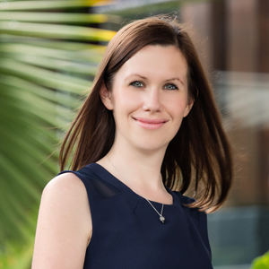 | Debbie Duval  Senior Director of Public Relations and Communications  Beau Champ  Mauritius  debbie.duval@fourseasons.com  (230) 402 3100

