Weddings at Four Seasons Hotel Bengaluru

April 19, 2023, Bengaluru, India

Celebrate the beginning of a lifetime together with a wedding at Four Seasons Hotel Bengaluru.
Whether it’s an intimate ceremony with the lush green garden and sunset view, or an avant garde reception party in the heart of the city, our dedicated team of experts will ensure every detail of your special day is a memorable one.
Get married in our beautiful garden terrace surrounded by fine floral arrangements. Then sip on cocktails as newlyweds, with friends, family and furry babies in our extravagant Grand Ballroom and savour #FSMasterdishes crafted by our expert chefs just for you.
Here, you have it all - flexible event spaces, exquisite cuisine and fine arrangements. Whatever your vision is, our state-of-art facilities, Four Seasons experience and dedicated expert team members will make it a reality.
Plan your dream #FSWedding with us.

RELATED

March 31, 2023, Bengaluru, India
Easter Bunnies, Egg Hunts and a Delectable Brunch at CUR8, Four Seasons Hotel Bengaluru
https://publish.url/bengaluru/hotel-news/2023/easter-brunch.html

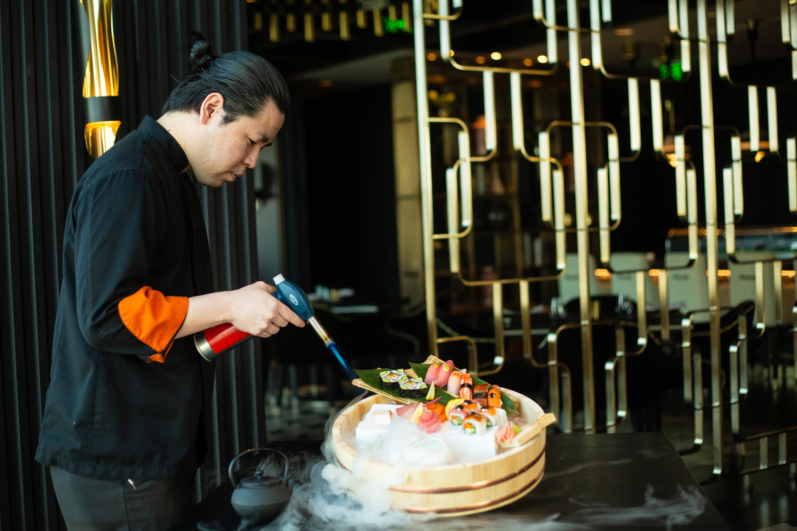 | March 30, 2023, Bengaluru, India  Four Seasons Bengaluru Introduces a Unique New Sunday Brunch Experience at Far & East  https://publish.url/bengaluru/hotel-news/2023/new-sunday-brunch-at-far-and-east.html

PRESS CONTACTS

Meghna Trivedy
Director of Public Relations and Communications
8, Bellary Road, Ganganagar
Bengaluru
India
meghna.trivedy@fourseasons.com

+91 96064 87956

