Four Seasons Hotels and Resorts Announces 2020 Private Jet Itineraries, Featuring the Return of Record-Selling 24-Day “World of Adventures” Journey

The new line-up includes three of the most coveted Four Seasons Private Jet Itineraries
December 13, 2018, Toronto, Canada

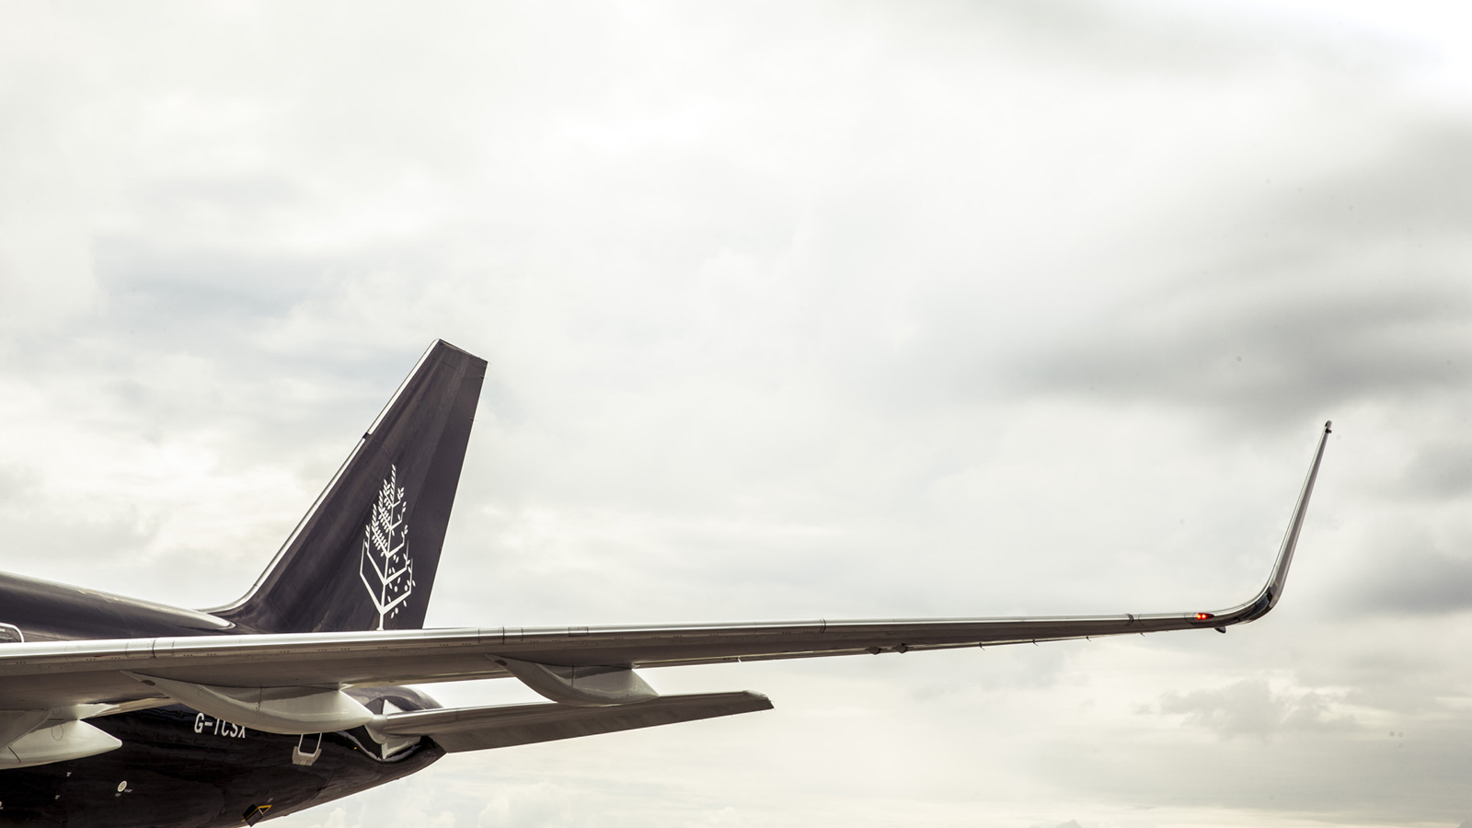
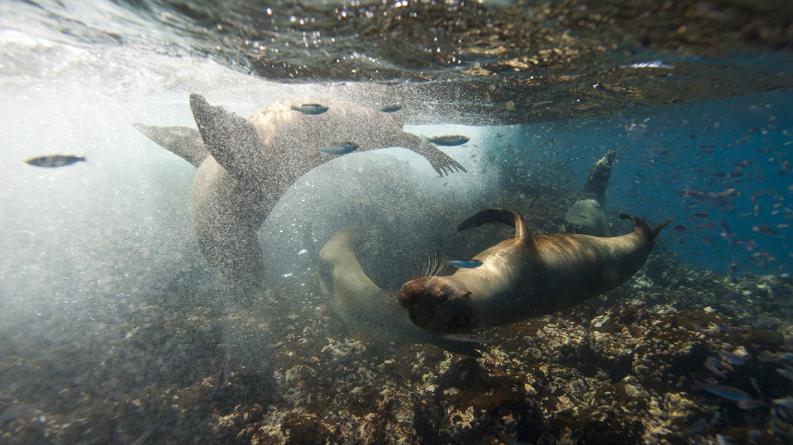 | 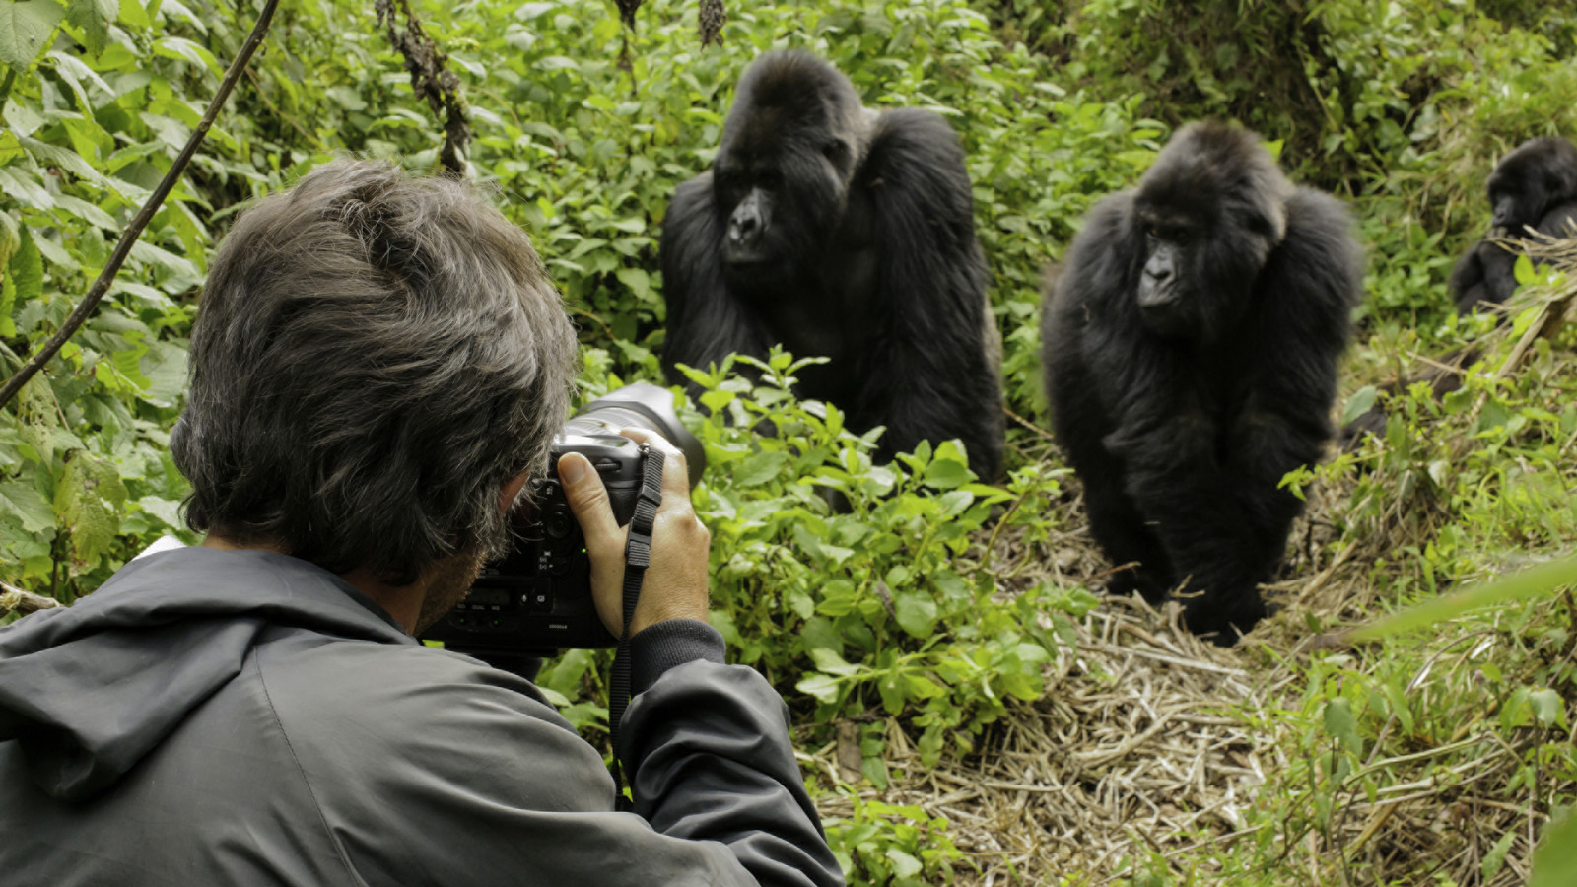 | 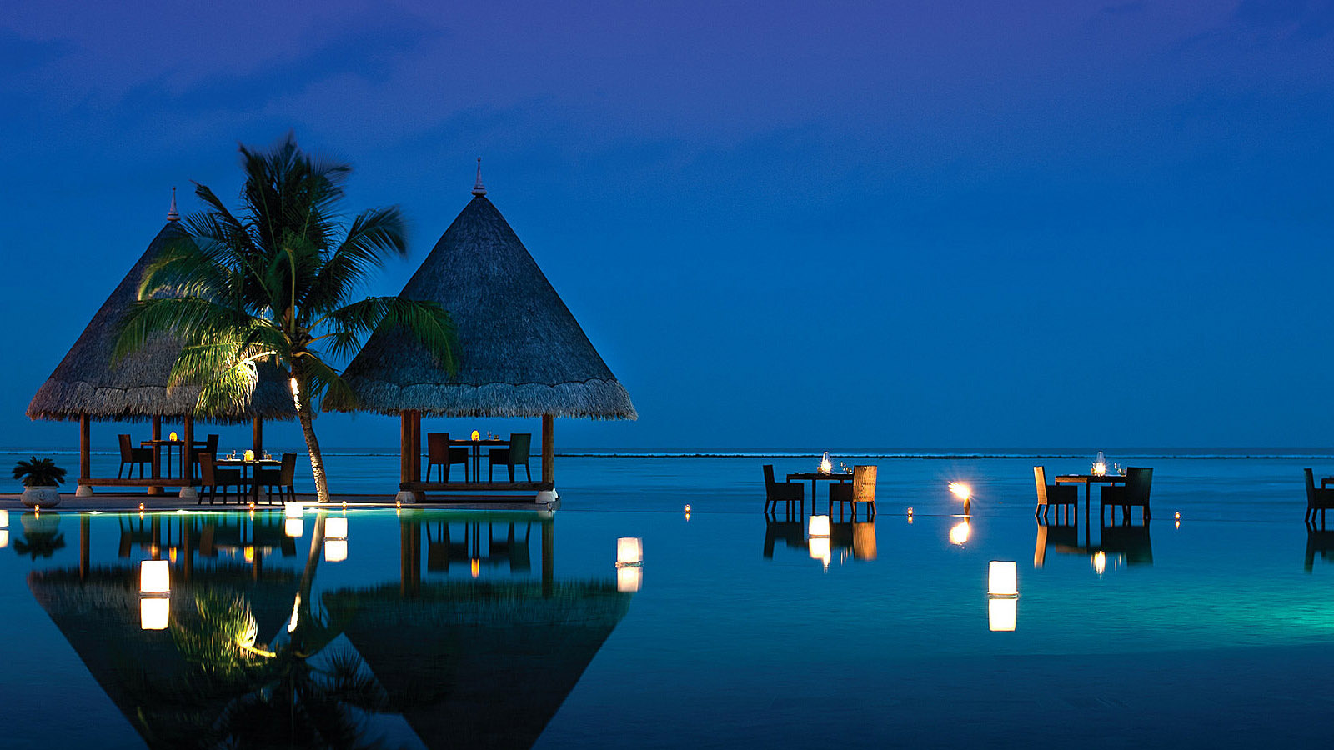
Four Seasons Hotels and Resorts, the world’s leading luxury hospitality company, announces a curated collection of three Four Seasons Private Jet itineraries set to take flight in 2020. Featuring the trip of a lifetime to Rwanda and the Galápagos as part of the fastest selling itinerary to date, World of Adventures, the trio of international expeditions gives travellers the opportunity to discover the rare, wild and beautiful in the comfort and care of Four Seasons, aboard the brand’s Boeing 757.
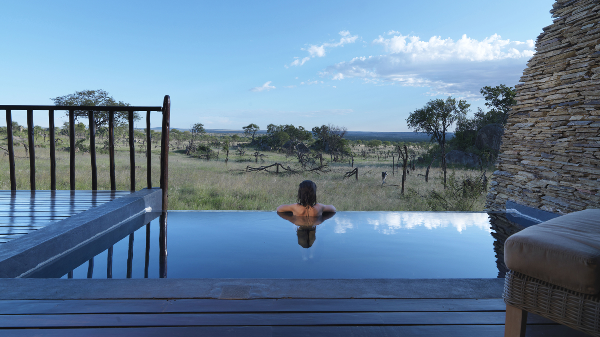 | 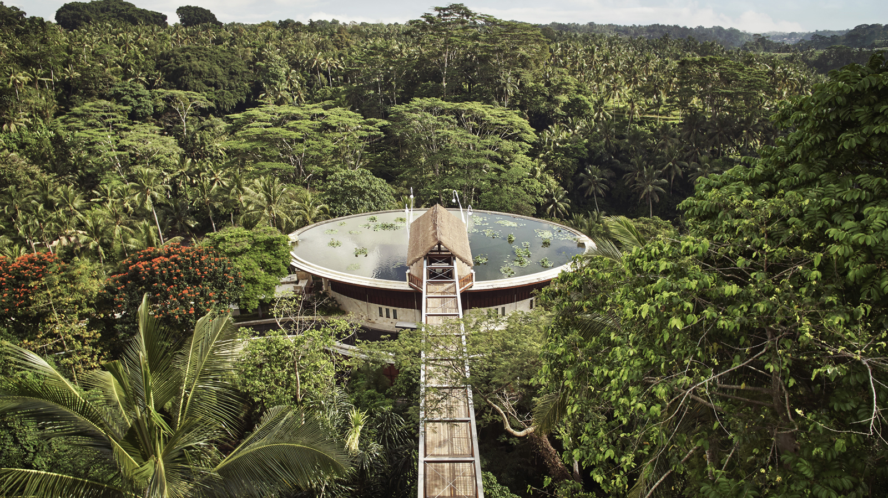 | 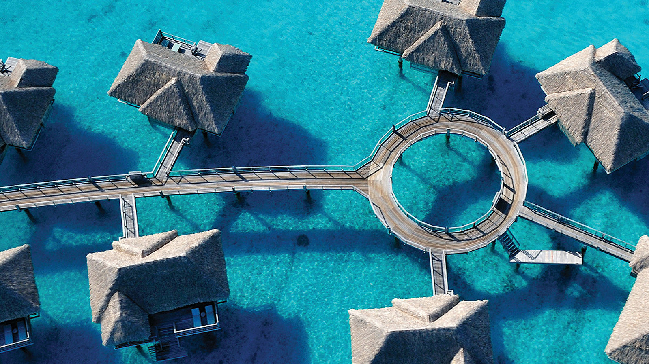
“The feedback we’ve received since launching our fully branded and customised Four Seasons Private Jet Experience in 2015 has been overwhelmingly positive,” says Peter Nowlan, Chief Marketing Officer at Four Seasons. “Guests are beyond thrilled they can now cross destinations off their bucket lists in the comfort and care of Four Seasons, resulting in record-pace bookings and subsequent wait lists for each of our 2019 itineraries. Travellers are clearly responding to the dedicated team and renowned high touch service that we offer both on the ground, and when cruising at 40,000 feet.”
Explore the 2020 Four Seasons Private Jet Itineraries
The all-encompassing itineraries feature air travel aboard the Four Seasons Private Jet, ground transportation, planned excursions, all meals and beverages, and luxurious accommodations at Four Seasons hotels and resorts.
International Intrigue (February 15 – March 9, 2020)
Seattle - Kyoto - Hoi An - Maldives - Serengeti - Marrakech - Budapest - St. Petersburg - Paris
Kicking off the 2020 line-up, travellers will take flight across four continents to visit thrilling cities and remote islands in celebration of vibrant cultures around the world. Adventurers will explore old Japan in Kyoto, discover the ancient temples of Hoi An in Vietnam, relax on pristine Maldives beaches, and taste the exotic flavours of Morocco. Jetsetters will also be witness to Serengeti sunsets and can enjoy a soak or two when visiting Budapest’s historic baths. A behind-the-scenes ballet experience awaits travellers in St. Petersburg before a final stop in the City of Light for a three-Michelin-starred farewell.
Timeless Encounters (March 12 - April 4, 2020)
Kona - Bora Bora – Sydney – Bali - Chiang Mai - Taj Mahal - Dubai - Prague - London
Over 24 days, travellers will relax on tranquil islands and celebrate one of the world’s most iconic architectural wonders. Beginning in Hawaii, Four Seasons Private Jet guests will then jet off to picture perfect Bora Bora, before making their way to Australia for a backstage tour of the Sydney Opera House. Bali’s jungles are next on the roster, ahead of a private Thai cooking lesson in Chiang Mai. On the way to Dubai, a quick stop in Agra for the day gives guests the chance to explore the legendary Taj Mahal. A private concert at the only remaining theatre where Mozart performed is on offer in Prague, and a final stop in London has new friends sailing down the Thames by twilight.
World of Adventures (June 3 - June 26, 2020)
Seattle – Kyoto - Bali - Seychelles - Rwanda - Marrakech - Bogotá - Galápagos Islands – Miami
With the 2018 journey sold out, and the 2019 journey also sold out within a record-breaking two months, the trip of a lifetime returns for another run in 2020. In Seychelles, guests will stroll among cinnamon and takamaka trees with a local artist, sketching the panoramic vista atop a granite plateau. Mules will take guests through the Atlas Mountains of Marrakech to sit down with a local family over tea and traditional cuisine. In the forest-covered mountains of Rwanda, guests will come face-to-face with a family of mountain gorillas in the company of a naturalist guide for up-close observation. When visiting the Galápagos Islands, guests will cruise through the crystal-clear waters of the remote archipelago, spending three nights aboard an exclusively chartered ship. The journey concludes in Miami, giving guests ample opportunity to explore the Magic City’s diverse arts scene.
From the 52 handcrafted flatbed leather seats to the exclusive in-flight amenities, the dedicated Four Seasons Private Jet team takes care of every need to ensure an unforgettable journey from take-off to landing. Designed to eliminate the added stress of planning while allowing guests to uncover what makes each destination truly unique, the newly announced itineraries for 2020 are predicted to sellout once again.
Journey Aboard the Four Seasons Private Jet
International Intrigue and Timeless Encounters itineraries begin at USD 147,000 per person based on double occupancy. World of Adventures begins at USD 155,000 per person based on double occupancy. While visiting the Galápagos Islands and Rwanda, guests will stay at accommodations carefully selected by the Four Seasons team.
Visit fourseasons.com/privatejet and follow the #FSJet hashtag on Twitter and Instagram for the latest news and to continue exploring the Four Seasons Private Jet. To follow the Four Seasons Private Jet on YouTube, visit https://www.youtube.com/fourseasonshotelsandresorts.
Travel the World in 90 Seconds on the Four Seasons Private Jet with long-time travel journalist Laura Begley Bloom here.

RELATED

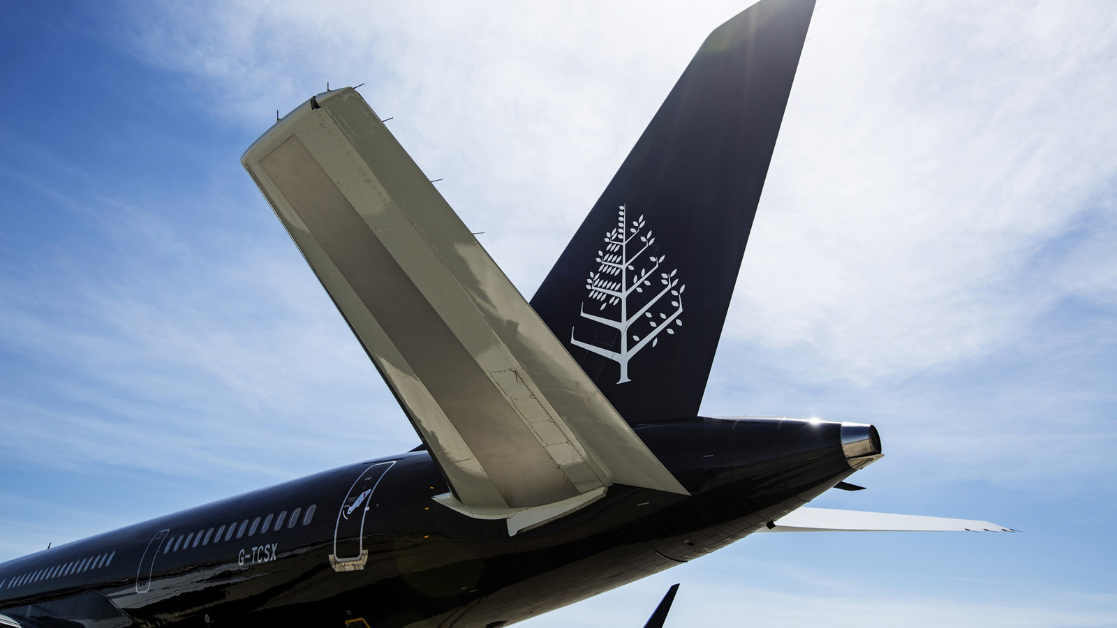 | June 12, 2018, Toronto, Canada  フォーシーズンズ ホテルズ アンド リゾーツ、2019年のプライベートジェットツアーで 「ワールド オブ アドベンチャーズ」の催行を発表  https://publish.url/jp/jet/hotel-news/2018/new-2019-world-of-adventures-tour-5.html
June 12, 2018, Toronto, Canada
Die Nachfrage nach dem Four Seasons Private Jet steigt mit der neuen Reiseroute „World of Adventures“ in 2019 weiter an
https://publish.url/de/jet/hotel-news/2018/new-2019-world-of-adventures-tour-10.html

PRESS CONTACTS

Sarah Tuite
Senior Director, Corporate Public Relations
1165 Leslie Street
Toronto
Canada
prsm@fourseasons.com

+1 (416) 441-4350

